Supplementary Information

This supplementary information document describes further details of our experimental setup, an optimization of an electroosmotic (EO) pump using traditional EO pump theory, details on the fabrication of our two-liquid pump, substrate porosimetry data, and measurements showing the strong linear relation between applied voltage and pump flow rate versus applied current.

- Experimental Setup

Figure S1 shows a schematic of the experimental setup we used to quantify flow rate, pressure, and current.

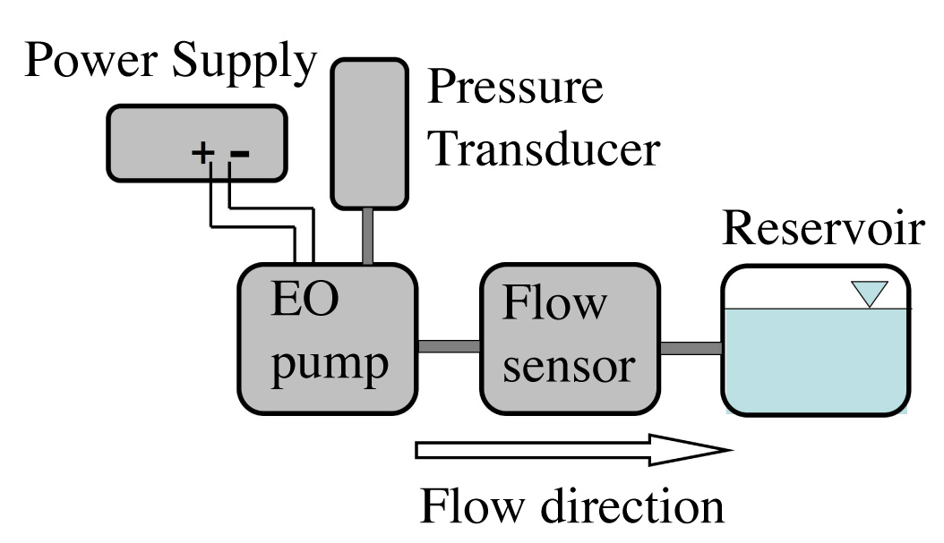
Figure S1: Schematic of the experimental setup for testing the two-liquid EO pump. A sourcemeter (2410 Sourcemeter, Keithley Instruments, Inc., Cleveland, OH) supplied power to the EO pump in the galvanostatic mode while simultaneously measuring voltage. A MEMs-based liquid flow sensor (Sensirion, Westlake Village, CA) measured instantaneous flow rates at a frequency of 1 Hz. We measured pressure in the cathode buffer reservoir with a pressure transducer (Omega PX303-015G5V, Stamford, CT).

- EO pump optimization

We here describe the optimization of an EO pump using traditional theory. We note this theory ignores concentration polarization (CP) but shows that performance optimization leads to a design where CP should be important. We present it here to motivate further studies of EO pumps which include CP effects. Kim et al. [1] presented theory which describes the ratio of flow rate per power, , for a specified pressure load, , and flow rate, :

In this expression, the power required for electrolysis and the Ohmic power loss between the pump substrate and electrode are neglected. The ratio is important figure of merit in the design of practical EO pump systems. The relationship above shows strong effect of the pumped liquid properties on performance through the zeta potential and electrolyte conductivity ().
When evaluating the effect of bulk electrolyte concentration, , on Q/P, we should account for the concentration dependence of conductivity and zeta potential. For conductivity, the relationship for dilute conditions can be approximated as

where and are the molar conductivities of the dominant ions in the system, namely and respectively Na⁺ and B₄O₇²⁺ [2]. We estimate the zeta potential as a function of pH and concentration with the correlation by Yao and Santiago [3]:

Figure illustrates the influence of pore radius, a, and concentration, , on the flow rate per power, , for a fixed operating condition of a 10 μl/min flow rate and a pressure load of 1.5 kPa. Flow rate per power initially increases as pore radius is decreased from large values, as less applied potential is required to generate sufficient pressure. Flow rate per power also initially increases when concentration is reduced from high values as parasitic electromigration current decreases with lower conductivity. However, as shown in the surface plot, there are lower bounds to which pore radius and concentration can each be reduced without decreasing flow rate per power. For both parameters, this lower bound arises from the effects of finite EDL thickness and finite EDL current carrying capacity [3]. Finite EDL effects strongly increase current and lower flow rate. At these conditions, the model suggests the maximum flow rate per power is obtained with a 280 nm pore diameter and 16 μM concentration. However, robust operation are likely not achievable with a buffer concentration of 16 μM as there is insufficient buffering capacity [2]. Nevertheless, these values of pore diameter and electrolyte ion concentration are also associated with the regime where CP is important [4].
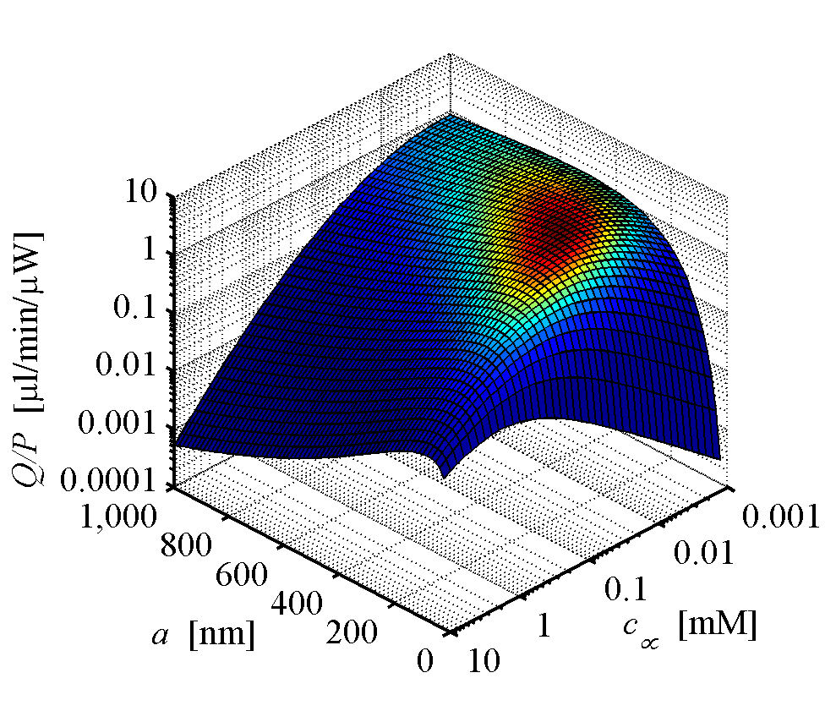
Figure S2: Theoretical dependence of flow rate per power on pore radius, a, and concentration, c∞, for a flow rate of 10 μl/min and a backpressure of 1.5 kPa. The peak flow rate per power of 3.2 μl/min/μW is obtained with a pore radius of 280 nm and a concentration of 16 μM. For 1 mM borate buffer, the flow rate per power is 0.64 μl/min/μW for an optimum pore radius of 140 nm (280 nm diameter). The modeled pump area is 1 cm² and the thickness is 2 mm.

- EO pump fabrication and porosimetry

We here provide additional details on the fabrication of the two-liquid pump shown in Figure 1b of the main text. The acrylic (McMaster-Carr, Los Angeles, CA) package was 30 x 30 x 17 mm and machined using laser machining (Universal Laser Systems, Scottsdale, AZ). The porous glass substrate was mounted in an acrylic frame and sealed along the perimeter with 5 Minute® Epoxy (ITW Devcon, Danvers, MA). The membranes were oversized, 39 x 39 mm, and we laser machined bolt holes. The membranes were mounted on the bolts, and the excess membrane material was crumpled into internal reservoirs of the pump. The internal reservoir dimensions are 20 x 20 x 4.5 mm. We used polytetrafluoroethylene (PTFE) gaskets (McMaster-Carr) for sealing, with eight 0-80 bolts for aligning and compressing the PTFE gaskets, membranes and frame.
Figure S3 shows results of mercury intrusion porosimety measurements on our porous glass substrate (Porous Materials Inc., Ithaca, NY). Shown here is the derivative of cumulative pore volume with respect to the logarithm of pore diameter, dV/d(logd_{p}) as a function of pore diameter, d_{p}. High y-axis values indicate a large amount of pores are characterized by the corresponding x-axis diameter. The median pore diameter is 453 nm

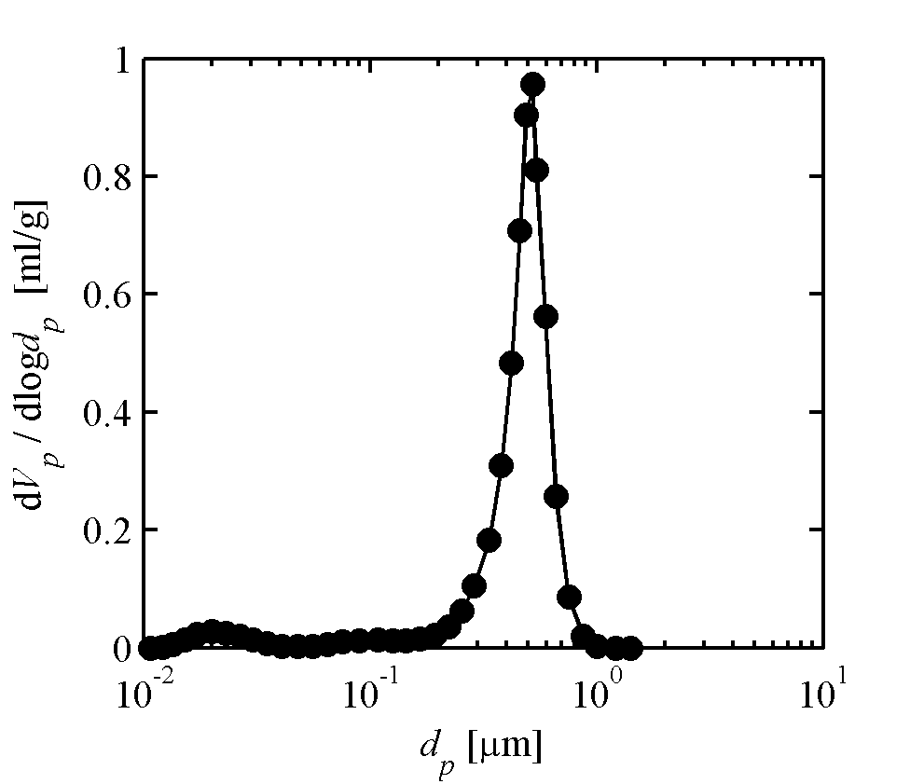
Figure S3: Plot of the derivative of cumulative pore volume with respect to the logarithm of pore diameter as a function of pore diameter of our porous glass substrate. The median pore diameter is 453 nm.

- Voltage and flow rate versus current

As described in section 3.1 of the main text, we measured the maximum flow rate, Q_{max}, and applied voltage, V_{app}, versus applied currents ranging from 25 to 200 μA (Fig. S4). The data points are the instantaneous values after 0.1 C of charge transfer, which is a representative steady-state value (for currents under 175 µA). Maximum flow rate is defined as flow rate at zero pressure load.

a)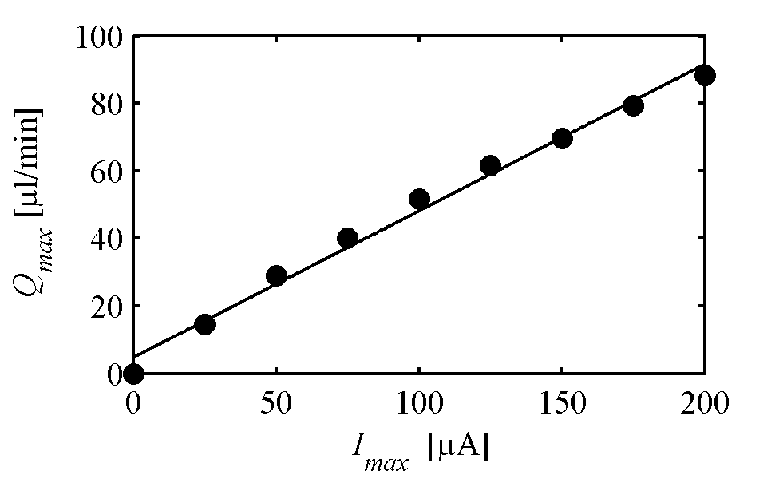
b)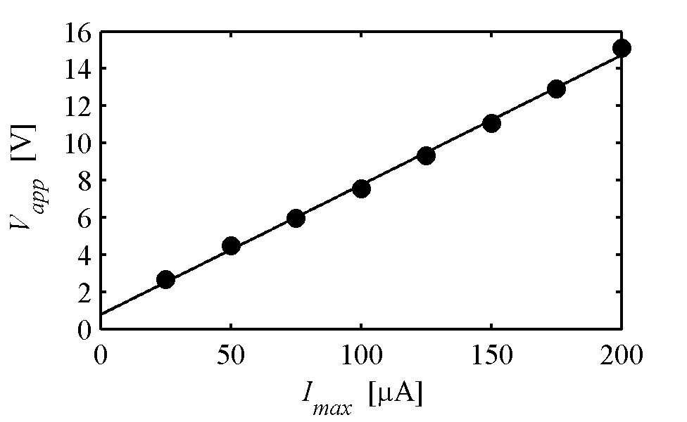
Figure S4: Maximum flow rate (a) and applied voltage (b) versus applied constant current. Flow rate data is the instantaneous value after 0.1 C of charge transfer. The lines are linear fits to the data with R² values of 0.9905 and 0.9989 for flow rate and voltage, respectively.

References

[1] D. Kim, J.D. Posner, J.G. Santiago, High flow rate per power electroosmotic pumping using low ion density solvents, Sens. Actuators, A 141 (2008) 201-212.
[2] S.H. Yao, D.E. Hertzog, S.L. Zeng, J.C. Mikkelsen, J.G. Santiago, Porous glass electroosmotic pumps: design and experiments, J. Colloid Interface Sci. 268 (2003) 143-153.
[3] S.H. Yao, J.G. Santiago, Porous glass electroosmotic pumps: Theory, J. Colloid Interface Sci. 268 (2003) 133-142.
[4] D.G. Strickland, M.E. Suss, T.A. Zangle, J.G. Santiago, Evidence shows concentration polarization and its propagation can be key factors determining electroosmotic pump performance, Sens. Actuators, B In Press, Corrected Proof.

