
Tutti

Because learning is better when we all grow together

Final Report
CS147 Fall 2024
AI in the Classroom
Jonah Blaydes-Greeberg | Jennifer Lew | Meghana Paturu | Alex Yansouni

Table of Contents

1) Project Name & Value Proposition

2) Team Member Names & Roles

3) Problem/Solution Overview

4) Needfinding

5) POVs and Experience Prototypes

6) Design Evolution

7) Final Prototype Implementation

8) Reflection & Next Steps

Project Name & Value Proposition
Project Name
Tutti
Value Proposition
On-demand tutoring you can trust, featuring a free marketplace for students to connect with tutors and leverage AI-enhanced learning experiences​

Team Member Names & Roles


Jonah B-G.
Major: Computer Science (AI) + Music
Roles: User Researcher + Mobile/Web Developer



Jennifer L.
Major: Computer Science (AI) + Economics
Roles: Product Manager, UX Designer



Meghana P.
Major: Computer Science (HCI) + Economics
Roles: User Researcher, UX Designer, Mobile/Web Developer



Alex Y.
Major: Computer Science (HCI)
Roles: User Researcher + Mobile/Web Developer

Problem/Solution Overview
Students often face challenges in finding effective academic support that ensures impactful learning experiences, while aspiring tutors struggle to build confidence and refine their teaching without adequate feedback. Tutti bridges this gap by connecting students with relatable peers who have mastered their courses and offering tools for collaborative growth. Through AI-generated reports, the app enhances both tutoring effectiveness and learning outcomes, fostering a shared, informal space for academic success. By providing a platform where tutors can gain teaching experience and students can access personalized support, Tutti empowers a community of learners to grow together.

Needfinding
Interviews
Our goal was to uncover the barriers students face in accessing help, evaluate the effectiveness of current systems, and identify the gaps in academic support that prevent students and educators from achieving their goals. Using a structured set of guiding questions, we aimed to explore both sides of learning experiences, including perspectives from students (high school, college, etc.) and educators (tutors, researchers, teachers).




We interviewed a total of six individuals: a community college pre-law student, a high school student, a private college business student, a pre-med student-athlete, an EdTech researcher, and a retired teacher who is now a freelance tutor. To recruit these participants, we used a combination of cold emails, Nextdoor, and referrals from people both on and off campus. We ensured the participants we selected were unbiased and could provide an authentic understanding of their challenges, regardless of their relationship with us or our affiliation with Stanford University. To compensate them, we offered to pay for coffee or lunch. Some participants were happy to share their thoughts without compensation, even after we insisted.
Figure 1. Different places/ways of conducting interviews and recruiting members
Our interviews were conducted in various settings, including Zoom, Coupa Cafe, Santa Clara, and downtown coffee shops in Palo Alto. Two interviews were virtual, while the other four were conducted in person. For each interview, up to three project team members were present: one focused on asking questions and engaging with the interviewee, while the other two took notes and recorded observations. We used traditional handwritten note-taking methods as well as speech-to-text transcription tools like Otter.ai.
One of the most insightful interviews was with Alex, an accounting student at Santa Clara University. He described his school’s well-structured academic support system, where students can book 20-30 minute sessions with tutors recommended for their academic excellence. Despite the system’s accessibility, Alex admitted he rarely used it, relying instead on professors when needed. He hesitated to seek help from tutors due to a lack of trust in their abilities, and this shows us how trust significantly impacts students’ willingness to utilize academic support systems.
Grace, the community college pre-law student, shared her perspective on AI in the classroom, noting its potential to organize and present information more effectively. However, she felt current restrictions on AI use limited its effectiveness. She believed integrating AI more intentionally into classroom learning could enhance its value, particularly in structuring course content and providing better support. This sentiment was similarly expressed by Ada, the EdTech researcher, who also emphasized the potential of AI but in the light of helping aspiring educators improve their skills. However, she noted the lack of professional development opportunities for tutors and the need to adapt AI tools to support both students and teachers effectively.
James, a freelance tutor and former teacher in a low-income district, shared a different challenge. He described how talented students often expressed an interest in teaching but faced significant barriers due to lengthy certification processes and a lack of accessible pathways into the profession. He called for systems that not only provide academic support for students but also empower individuals interested in teaching to become effective educators.
Recurring themes from both students and educators highlighted the need for academic support systems that are flexible, accessible, and tailored to individual needs. This aligns with both of their frustrations, which included rigid schedules, crowded office hours, and a lack of personalized support, which often left both students and teachers feeling isolated or underserved. Additionally, students valued relatable help from peers and trusted mentors, while educators stressed the importance of reliable systems that allow them to provide personalized guidance and grow in their roles. Both groups saw potential in leveraging AI and other tools to bridge gaps, but they also identified structural barriers—such as limited access to resources and inefficient certification processes—that hinder progress on both ends. These conversations showed our group the importance of creating systems that not only connect students with the right support but also equip educators with the tools and opportunities they need to succeed.

Synthesis
To synthesize these interviews, we created empathy maps that captured what participants said, thought, felt, and did. This approach allowed us to identify recurring themes and key takeaways across all interviews. A central theme was the difficulty of finding tailored academic support, especially for students with unique schedules or needs, such as student-athletes or those balancing multiple commitments. Participants frequently expressed frustration with the inefficiency and inaccessibility of TAs, noting that limited availability and overcrowded office hours made it challenging to get the help they needed. We also learned that the process of becoming a tutor or TA was often cumbersome and lacked sufficient training, and this left many tutors ill-equipped to effectively support their peers. The process of becoming a tutor, TA, or professor all were lengthy, overly selective, and sometimes biased, and this required applicants to fit a specific profile to be considered. Those who were rejected often received little to no feedback, which based off of the needfinding interviews, left them unsure how to improve or leverage their skills elsewhere. Emotionally, this created frustration, especially for college students seeking opportunities to earn extra income while contributing academically.
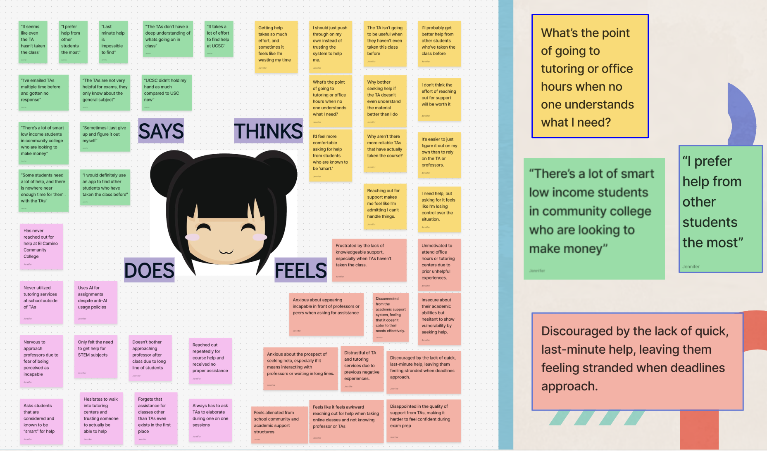
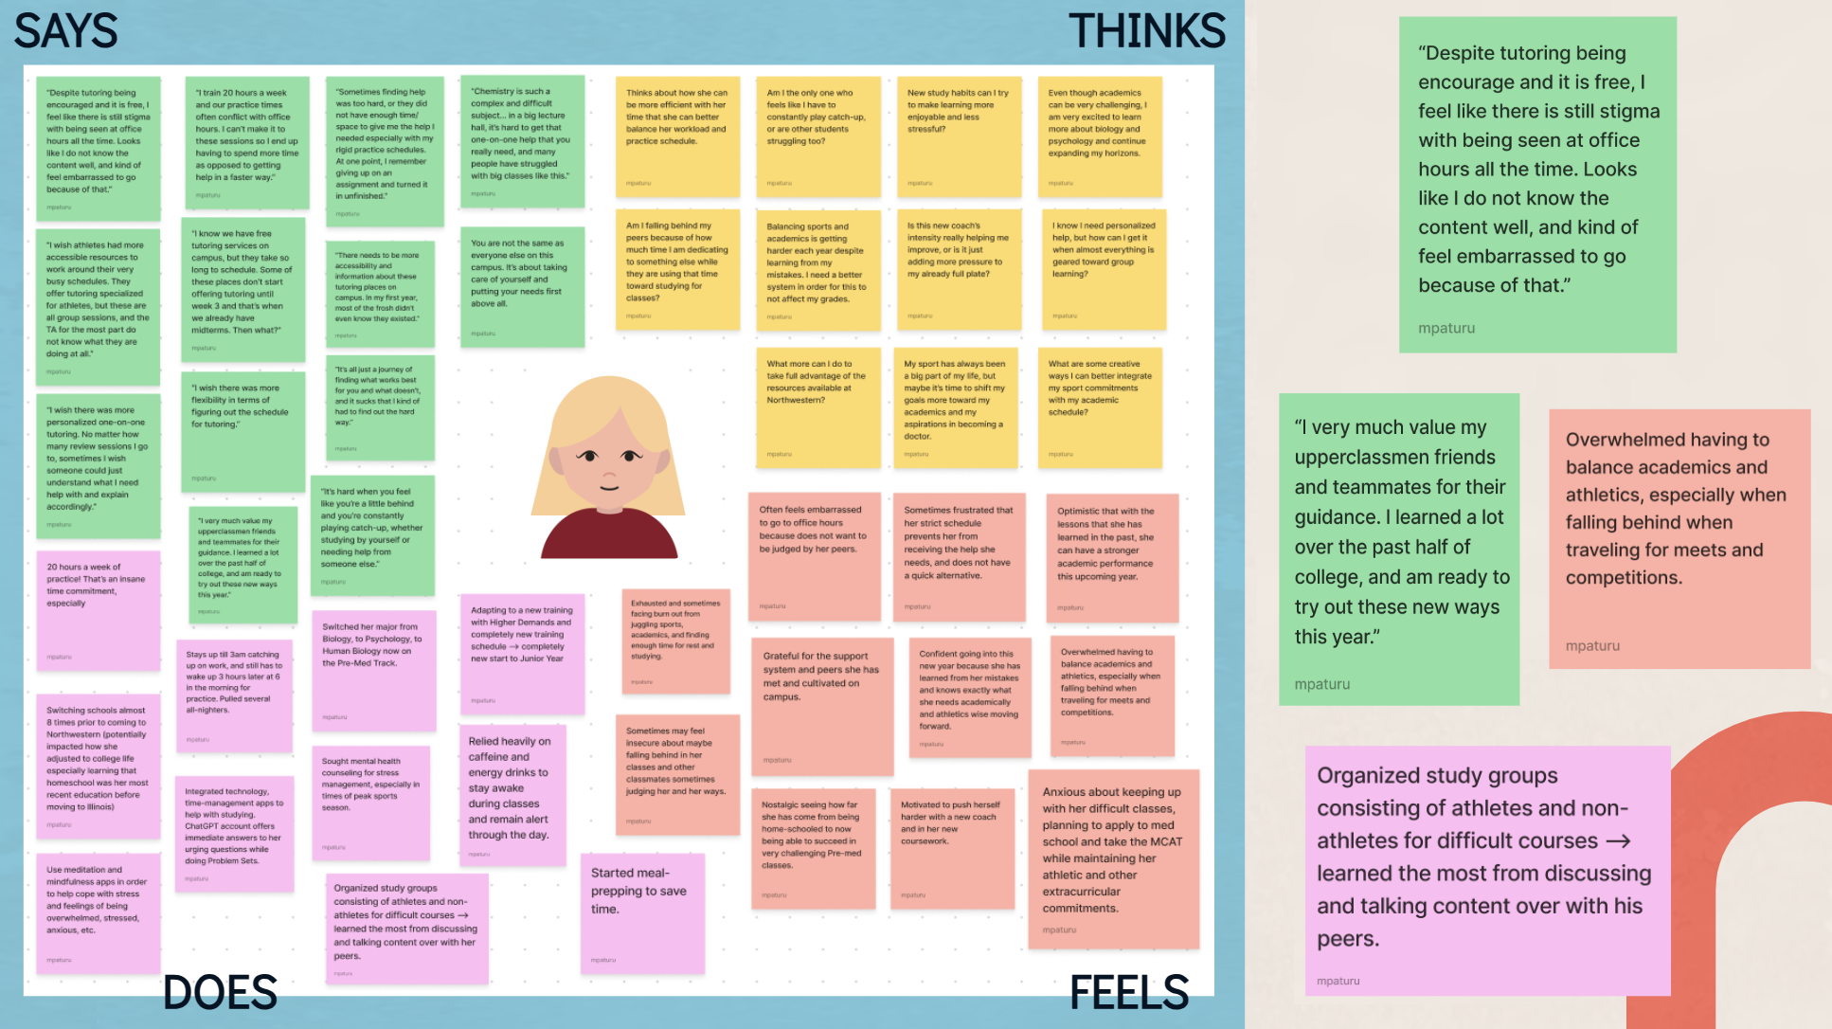
Figure 2. Creating empathy maps helped organize interviewees’ thoughts, which allowed us to identify patterns and highlight the most notable insights. These key findings were instrumental in guiding us as we developed potential solutions.

Another major takeaway was the importance of peer-to-peer support. Students consistently preferred seeking help from peers who had excelled in their courses, as they found this type of assistance more relatable and specific to their needs. Additionally, they felt like having a more informal way of getting help would allow them not to feel publicly judged or ashamed by others. These students noted that there existed a lack of systems to facilitate these connections with their peers.
Trust also emerged as a recurring issue—many students were hesitant to rely on peers they perceived as less capable, which highlighted the need for a structured and vetted system of peer tutoring. Additionally, we observed a growing reliance on AI tools for academic support. While students appreciated AI’s ability to organize and present information, they emphasized that it could not replace the value of human interaction and guidance. Instead, they saw AI as a complementary tool that could enhance traditional support systems by providing organization, structure, and efficiency.
These insights pointed us toward developing a solution that combines the strengths of both peer-to-peer learning and AI tools. Our focus is on creating a platform that connects students with experienced peers who understand their struggles, while also leveraging AI to optimize the tutoring and learning experience. This dual approach addresses the need for relatability, flexibility, and structure in academic support, filling the gaps identified through our interviews.

POVs and Experience Prototypes
UCSB Graduate POV
We met "Sam Altman," a recent UCSB graduate who extensively used AI tools during his studies. We were surprised to notice that his reliance on AI seemed to stem from the structural challenges at his university—introductory STEM courses were intentionally made excessively difficult, and the academic resources provided were scarce, redundant, or irrelevant. We wonder if this means that a lack of effective, personalized academic support drives students to depend on AI tools to compensate for these gaps. It would be game-changing to develop resources and systems that encourage students to seek in-person help, reducing their reliance on AI shortcuts while fostering a deeper understanding of the material.
How Might We (HMW) Statements:
- HMW redesign a 2000-person lecture to be more engaging and personalized?
- HMW ensure that TAs have time to teach concepts during office hours rather than just provide answers?
- HMW democratize peer tutoring so that every student has equal access to personalized help?
- HMW increase collaboration among students in large lecture settings to foster community and shared responsibility for learning?
- HMW reduce the over-reliance on AI tools by improving in-person academic support quality?
EdTech Researcher POV
We met "Ada Lovelace," a full-time teaching assistant and EdTech researcher at Stanford University. We were surprised to notice how the TA hiring process at her institution was long, rigorous, and selective, yet it lacked adequate training for those who were hired. This narrow, rigid system excluded many promising candidates while failing to prepare the ones selected to teach effectively. We wonder if this means that systemic inefficiencies and biases in the hiring process prevent TAs from achieving their full potential. It would be game-changing to create a streamlined, unbiased system that broadens opportunities for TAs while providing proper training to enhance their teaching abilities.
How Might We (HMW) Statements:
- HMW streamline the TA hiring process to reduce bias?
- HMW ensure proper training for TAs to increase their effectiveness?
- HMW create a standardized training program for TAs to improve consistency across departments?
- HMW develop mentorship programs where experienced TAs can guide new hires?
- HMW use technology to support a fair and efficient TA selection process?
Former Teacher POV
We met "James Gosling," a former high school English teacher with 20 years of experience who transitioned into freelance tutoring and educational counseling. We were surprised to notice how constrained he felt by rigid institutional expectations, which limited his ability to teach creatively and connect meaningfully with students. We wonder if this means that traditional academic structures stifle educators' potential to innovate, leading them to leave formal teaching roles in search of more freedom. It would be game-changing to create systems that promote academic freedom, allowing educators to tailor their teaching methods to foster engagement and accountability without being bound by bureaucratic constraints.
How Might We (HMW) Statements:
- HMW create flexible tools that allow educators to design dynamic learning experiences?
- HMW develop a platform where tutors and educators can teach independently from traditional institutions?
- HMW incentivize teaching practices that emphasize critical thinking and real-world application?
- HMW reduce barriers for educators transitioning from traditional roles to freelance tutoring or innovative teaching roles?
- HMW create collaborative teaching opportunities that allow educators to experiment with cross-disciplinary approaches?
These POVs and accompanying HMWs reflect a broad spectrum of issues—from systemic inefficiencies in academic support to the need for more flexible and innovative teaching environments. They provide a strong foundation for generating impactful solutions that address both student and educator needs.

Experience Prototypes + Top 3 Solutions
Prototype 1: Training Modules on Managing Student Expectations and Conflict Resolution
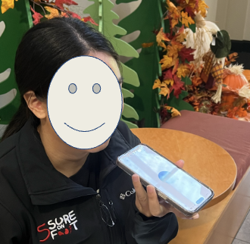
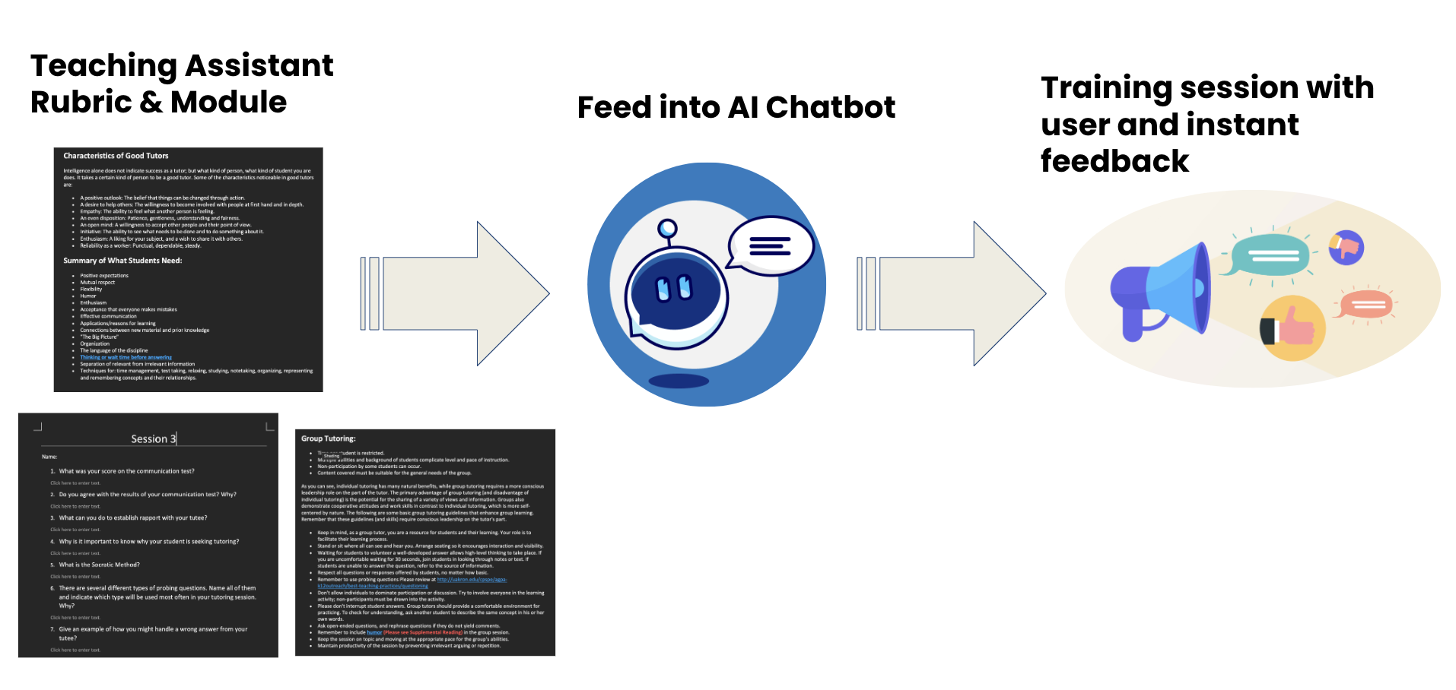



Figure 3. Diagram outlines a TA training process using an AI chatbot, where materials are fed into ChatGPT-4’s audio feature to provide interactive sessions with real-time feedback.
Solution: Develop training modules to help TAs manage student expectations and resolve conflicts effectively.
Overview: Managing student expectations and addressing conflicts is a recurring challenge for teaching assistants (TAs), particularly those who are new to teaching. This prototype focuses on equipping TAs with the skills and strategies needed to foster a supportive and inclusive learning environment while reducing their own stress and burnout. The modules include practical exercises to simulate real-life scenarios and provide actionable feedback.
Assumption being Tested: TAs lack training to manage expectations and conflicts, and structured modules will improve their confidence and effectiveness.
Key Components:
- Setting Clear Expectations: Train TAs to communicate their role, boundaries, and turnaround times at the beginning of the course. TAs practice delivering these messages in simulated scenarios to build confidence.
- Conflict Resolution Techniques: TAs are guided on how to mediate disputes, handle grading complaints, and defuse tense interactions with students using techniques like active listening and de-escalation.
- Cultural Sensitivity: Modules focus on fostering inclusivity, emphasizing the importance of respecting diverse communication styles and addressing cultural misunderstandings.
- Practical Exercises: Role-playing scenarios, such as responding to demanding students or mediating group conflicts, allow TAs to refine their skills.
Testing Methodology: The prototype was tested by offering mock training sessions to current TAs, followed by feedback surveys. Participants evaluated the usefulness of the modules, their confidence in applying the skills learned, and the relevance of the content to their teaching responsibilities.
Results/Implications: TAs found the modules on conflict resolution and setting boundaries particularly valuable. Role-playing exercises helped them practice handling real-world scenarios, and most participants reported feeling more confident in managing student demands. However, some TAs suggested adding more specific examples tailored to STEM-focused courses.

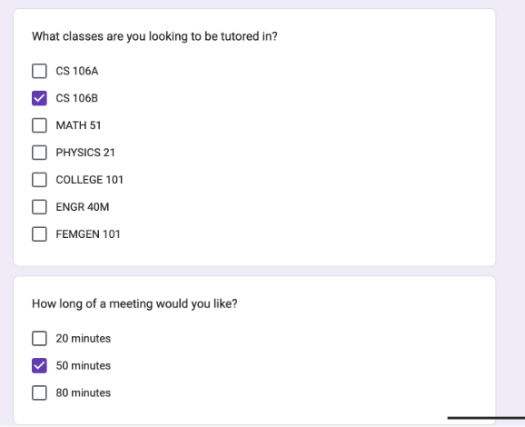
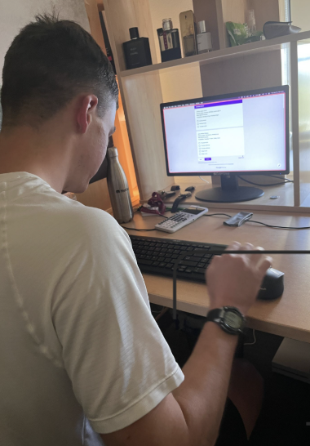
Prototype 2: Uber-like Tutor Booking App:

Figure 4. User is interacting with a Google Form prototype, designed to simulate the tutor booking process. Form allowed users to select courses, session durations, and preferences, providing insights into matching students with tutors effectively before developing the app.
Solution: Create a mobile app, "Tutti," that connects students with qualified tutors in real-time.
Overview: Inspired by the Uber model, Tutti simplifies the process of finding academic help by allowing students to browse tutor profiles, check availability, and book sessions instantly. The app supports both virtual and in-person tutoring and uses AI to match students with the best-fit tutors based on their academic needs and preferences.
Assumption being Tested: Students struggle to access tutoring, and a streamlined app will make finding and booking qualified tutors easier.
Key Features:
- Real-Time Scheduling: Students can book sessions on-demand or schedule ahead based on tutor availability.
- Geolocation: For in-person tutoring, the app displays nearby tutors, helping students find quick, local assistance.
- Rating and Review System: After each session, students rate their tutors, ensuring accountability and transparency.
- Payment Integration: Payments are processed within the app, streamlining the experience for both students and tutors.
- AI Matching Algorithm: The app matches students with tutors based on their subjects, learning styles, and previous interactions.
Testing Methodology: We tested a basic prototype using a Google Form to simulate the booking process. Participants acted as tutors and students, completing mock booking requests and providing feedback on the flow and usability.
Results/Implications: Participants appreciated the convenience of a real-time matching system, especially for urgent academic needs. However, students wanted more detailed tutor profiles, including specific qualifications and past student reviews. Tutors suggested clearer compensation rates and more flexibility in setting their availability.

Prototype 3: Group-Based Learning Sessions for TAs
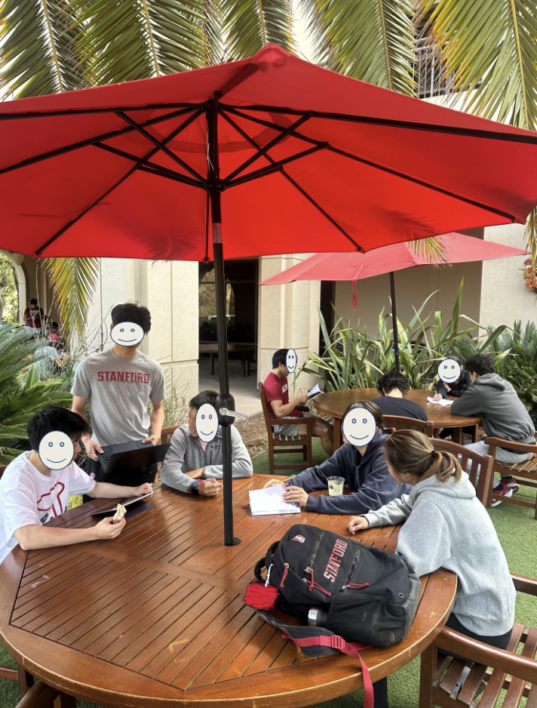
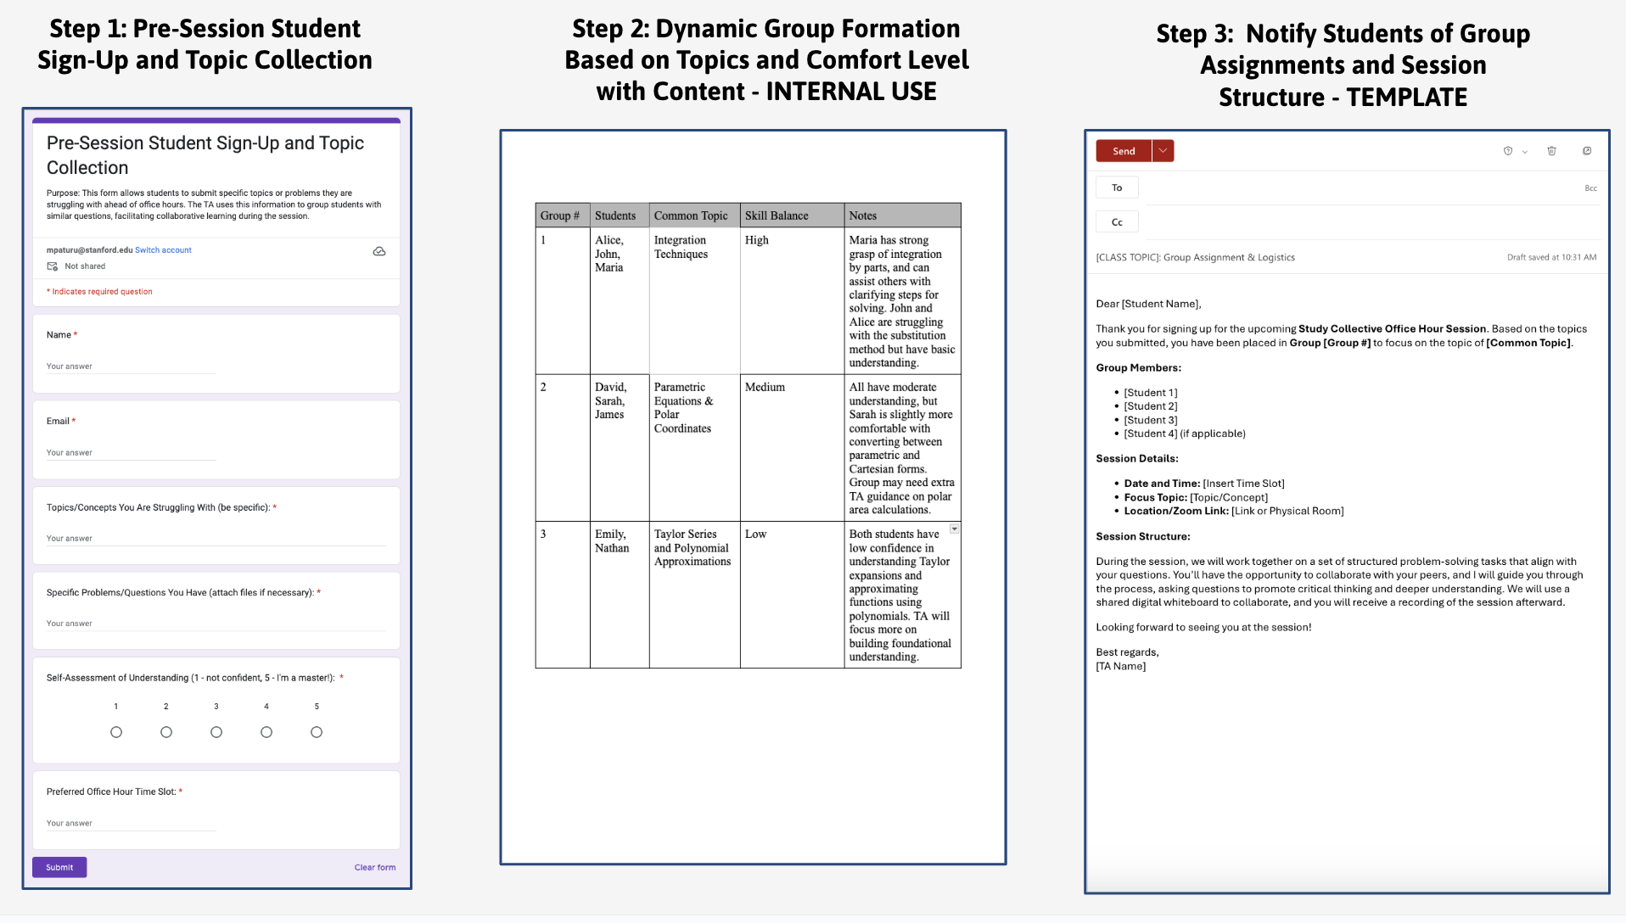

Figure 5. Tested experience prototype on group of Math 21 students and a math TA. Utilized small groups which were organized based on survey, pattern collection, and email templates.

Solution: Introduce "Study Collective," structured group-based office hours that emphasize peer learning and critical thinking.
Overview: This prototype reimagines traditional TA office hours by organizing students into small, topic-specific groups. TAs act as facilitators rather than direct problem-solvers, guiding students through collaborative exercises designed to encourage deeper understanding of the material.
Assumption being Tested: Traditional office hours are inefficient and intimidating, and group-based sessions will enhance engagement and learning.
Key Features:
- Dynamic Group Formation: Students are pre-grouped based on overlapping questions or topics submitted before the session.
- Structured Problem-Solving: Groups work through curated problem sets while the TA provides guidance and prompts analytical thinking.
- Digital Collaboration Tools: Groups use shared digital whiteboards to brainstorm solutions, which the TA monitors in real-time.
- Post-Session Resources: Students receive recordings of their group’s discussions and the TA’s feedback for future reference.
Testing Methodology: We tested this concept using Zoom sessions with shared Google Docs to simulate collaborative problem-solving. Students submitted their questions beforehand and were grouped accordingly. The TA guided the groups through their questions, providing feedback and encouraging discussion.
Results/Implications: Students enjoyed the collaborative environment, finding it less intimidating than traditional one-on-one office hours. They appreciated learning from peers and gaining exposure to different problem-solving approaches. Feedback highlighted the importance of balancing group sizes to ensure all participants had the opportunity to engage because it was hard to get special support from the teacher in a larger group dynamic.

Insights and Refinements
These prototypes revealed key insights:
- Training Modules: Effective conflict resolution and expectation-setting training can significantly improve TAs' confidence and reduce classroom stress. Future iterations should include subject-specific examples and advanced modules for experienced TAs.
- Tutti App: Students value convenience and transparency, but additional focus is needed on showcasing tutor qualifications and improving the booking interface.
- Group-Based Learning: Peer learning fosters collaboration and critical thinking but requires careful group composition and structured tasks to maintain engagement.
Together, these prototypes provided actionable feedback to refine our solutions, creating stronger tools to support both TAs and students in achieving their academic goals.

Design Evolution
Final Solution

Tutti is a mobile education app designed to connect students with peers who have mastered their courses, creating an accessible and reliable network for academic support. The app streamlines the tutoring process with features such as real-time scheduling, geolocation for in-person sessions, integrated payment systems, and tutor ratings to ensure accountability and ease of use. To enhance the learning experience, Tutti leverages AI to generate immediate progress reports for tutees and provides constructive feedback to tutors, helping them refine their teaching skills.

The rationale for Tutti was a result from what our group found from our needfinding interviews and testing of our experience prototypes. From our interviews specifically, students expressed frustration with limited academic support options. Instead, they preferred relatable peer help but needing accountability and trust in their tutors. Tutti addresses this by combining peer relatability with transparent ratings and reviews. On the other side, tutors appreciated the flexibility to set their availability and monetize their skills through a clear, structured platform. Tutti addresses this by giving flexibility of setting calendar and accepting/declining requests. Additionally, the AI-driven reports and progress tracking ensure personalized and effective support for both tutors and tutees, and this addresses the inefficiencies and lack of accessibility in traditional systems for both sides to improve. Also, our testing demonstrated that mobile applications are the most practical solution for college students, given the ubiquity of smartphones. Lastly, we decided on a one-on-one delivery model, as our group learning session prototype, though enjoyable, did not provide the same level of personalized benefit as one-on-one sessions.
TASK #1 (Simple Task): Sign Up, Log In, and Set Up Profile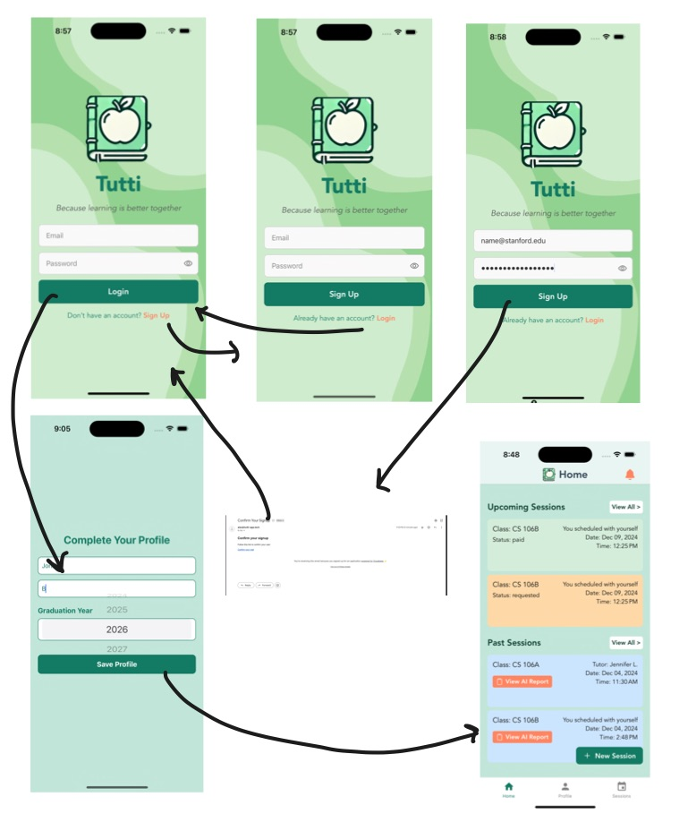
Figure 6. Simple task flow of signing up, verifying email, and entering home page
Description: The task is crucial to guide a new user through the initial setup process in the Tutti app, including signing up, completing their profile, and navigating to the home screen.
Task Steps
1. Sign-Up Flow
- Step 1: The user selects "Sign Up" from the login screen.
- Step 2: The user enters their email, password, and confirms the password in the provided fields.
- Step 3: After clicking "Sign Up," the app validates the input and redirects the user to the profile completion screen.
2. Profile Completion
- Step 1: The user enters their name and graduation year into the provided fields.
- Step 2: The user clicks "Save Profile," and upon successful submission, they are directed to the home screen with a confirmation message.
3. Home Screen Access
- Step 1: The user views the home screen, which displays sections for "Upcoming Sessions" and "Past Sessions."
- Step 2: The user can interact with the "New Session" button to schedule a session or view reports for past sessions.
Rationale for Task Design
- Simplicity: Minimal steps ensure new users can quickly complete the setup process.
- Clarity: Placeholder text and validation messages provide clear guidance and feedback.
- Engagement: Directing users to the home screen with upcoming and past sessions increases app engagement and usability.

TASK #2 (Moderate Task): Request and Handle a Session
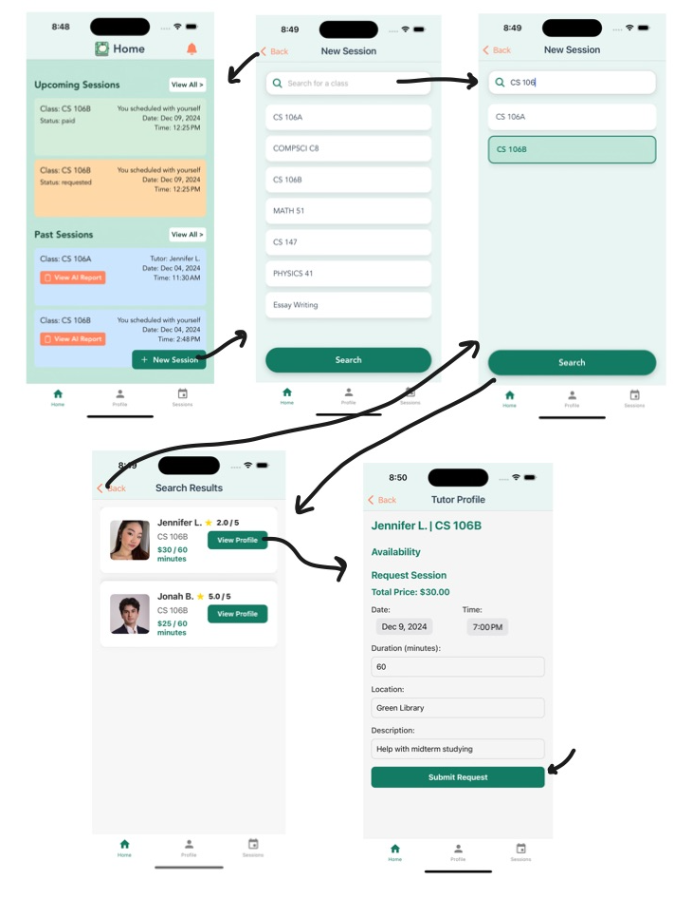
Figure 7. Moderate task flow of requesting a tutoring session

Description: The goal of this moderate task is to guide a user through requesting a tutoring session and handling the session process within the Tutti app. This involves searching for a class, selecting a tutor, and submitting a session request. This is a vital task to achieve the main purpose of the app of obtaining academic help and user’s goals.
Task Steps

1. Navigate to New Session
- Step 1: From the home screen, the user clicks the "New Session" button located in the "Upcoming Sessions" section.
- Step 2: The user is directed to a search screen where they can view all available classes.
2. Search and Select Class
- Step 1: The user types a class name (e.g., "CS 106B") into the search bar or scrolls through the list of available classes.
- Step 2: After selecting a class, the user clicks "Search" to view available tutors.
3. Browse Tutor Profiles
- Step 1: A list of tutors for the selected class is displayed, showing their name, rating, and price per session.
- Step 2: The user clicks "View Profile" on their preferred tutor to see detailed information.
4. Request Session
- Step 1: The tutor's profile displays their availability and session details.
- Step 2: The user selects the date, time, duration, location, and enters a description for the session.
- Step 3: After reviewing the session details, the user clicks "Submit Request" to send the request.
Rationale for Task Design
- User Empowerment: Providing a seamless search and request flow ensures users can find and book sessions easily.
- Clear Navigation: Each step directs the user logically to the next, reducing confusion.
- Transparency: Displaying tutor details and session costs helps users make informed decisions.
- Flexibility: Allowing users to customize session details caters to their individual needs.

TASK #3 (Complex Task): Schedule Availability, Edit Listings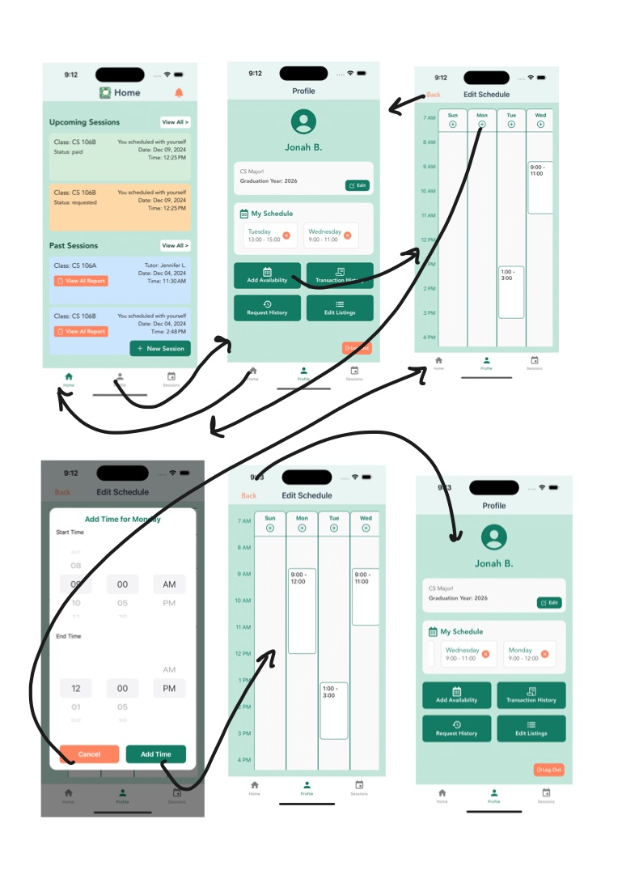
Figure 8a. Complex Task- schedule availability through profile setting
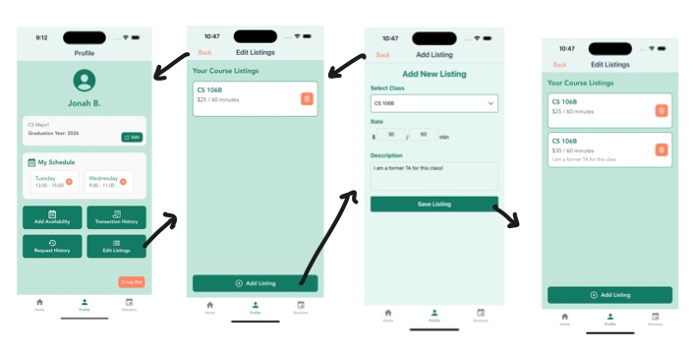
Figure 8b. Complex Task- add/delete course listing for subjects to tutor
Description: This complex task allows a tutor to manage their availability and edit their course listings in the Tutti app. The task involves scheduling times for availability and adding or updating course listings. This task is important to give users flexibility to achieve tasks based on their personal schedules.
Task Steps
1. Access Scheduling and Listings
- Step 1: From the "Home" screen, the tutor clicks on their profile icon in the navigation bar.
- Step 2: In the profile page, the tutor selects "My Schedule" to manage availability or "Edit Listings" to update their courses.
2. Manage Availability
- Step 1: In the "Edit Schedule" screen, the tutor views a calendar-style layout showing existing availability.
- Step 2: To add a new time slot, the tutor clicks the "+" button to open the "Add Time" modal.
- Step 3: In the modal, the tutor selects the start and end time using the time picker, then clicks "Confirm."
- Step 4: The new time slot is displayed on the schedule. The tutor can repeat this process for additional slots or delete existing ones as needed.
3. Edit Course Listings
- Step 1: From the profile page, the tutor clicks "Edit Listings" to see a list of their current courses.
- Step 2: To add a new course, the tutor clicks "Add Listing."
- Step 3: In the "Add New Listing" screen, the tutor selects a class from the dropdown menu, sets a rate and session duration, and provides a description.
- Step 4: The tutor clicks "Save Listing" to add the course to their listings.
- Step 5: The updated listings are displayed, allowing the tutor to edit or delete entries as needed.
Rationale for Task Design
- Time Management: The calendar view and ability to add specific time slots help tutors organize their availability effectively.
- Ease of Use: Intuitive buttons and modal windows streamline scheduling and editing tasks.
- Flexibility: Tutors can customize their course offerings and pricing to meet user demand.
- Clarity: Clearly labeled actions ensure tutors can quickly understand and manage their responsibilities.
TASK #4 (Complex Task #2): Manage and Start Sessions.
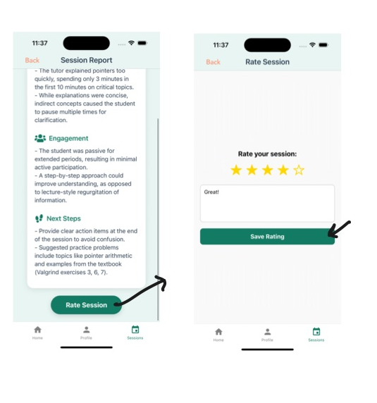
Figure 9a. Complex Task 2- Start session through manage sessions page, start session recording and generate AI report

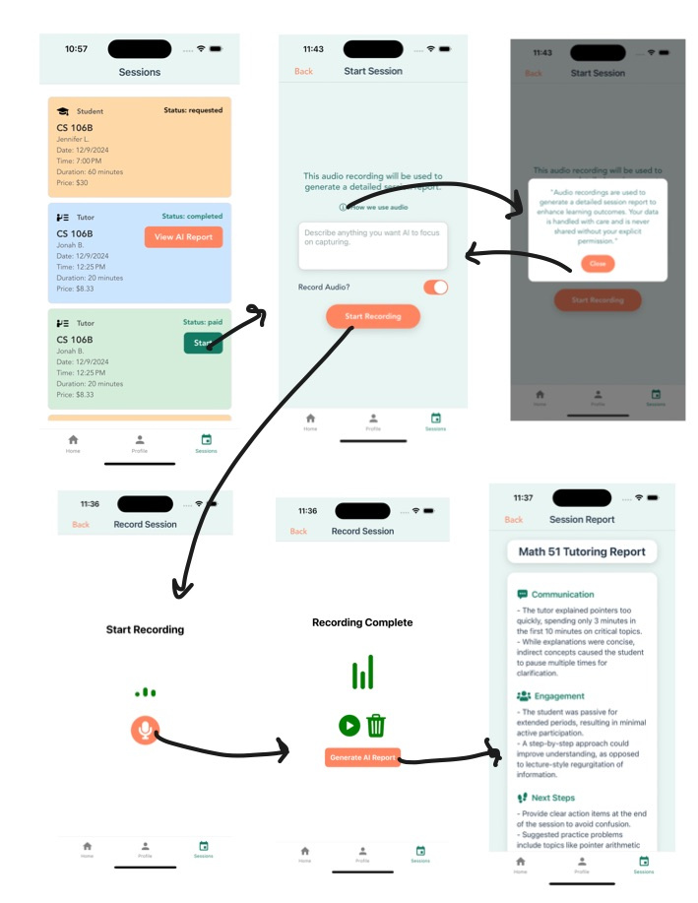
Figure 9b. Complex Task 2- Rate session after AI generated report and input comments

Task Description
This complex task enables both students and tutors to manage sessions efficiently and proceed through the workflow of starting, completing, and rating sessions in the Tutti app. It includes session handling from requests to payment, starting the session, generating reports, and providing feedback. This task is important so that users are aware and can easily interact with the multiple sessions and their processes.
Task Steps
1. Manage Sessions
- Step 1: From the "Home" screen, the user navigates to the "Sessions" tab in the navigation bar to view their session list.
- Step 2: In the "Sessions" tab, users can view "Upcoming Sessions" and "Past Sessions."
- Step 3: For each session, details like the class, date, time, and status (e.g., "requested," "accepted," or "completed") are displayed.
- Step 4: If the user is a tutor and the session is "requested," they are presented with "Accept" and "Decline" buttons for the session.
2. Pay for Accepted Sessions
- Step 1: If the user is a student and the session status is "accepted," they can navigate to the session details page.
- Step 2: On the "Session Details" page, the student clicks the "Pay Now" button to complete the payment.
- Step 3: After payment, the session status is updated to "paid" and reflected in the "Upcoming Sessions" list.
3. Start and Record Sessions
- Step 1: For "paid" sessions, tutors see a "Start" button in their session list.
- Step 2: Clicking "Start" navigates the tutor to the "Start Session" screen.
- Step 3: On the "Start Session" screen, the tutor has the option to enable or disable audio recording. They can provide notes about the session’s focus and begin recording.
- Step 4: If enabled, the audio is recorded, and the recording interface updates to show live status.
- Step 5: Once the recording is complete, the tutor generates an AI report.
4. Generate AI Reports and Rate Sessions
- Step 1: Upon completing the recording, an AI-generated session report is displayed. The report provides insights on communication, engagement, and suggested next steps.
- Step 2: The tutor or student clicks "Rate Session" at the bottom of the report to provide feedback.
- Step 3: On the rating screen, the user selects a star rating, provides optional comments, and clicks "Save Rating" to complete the process.
Rationale for Task Design
- Streamlined Workflow: Clear navigation and actions ensure users can manage sessions from request to completion efficiently.
- Transparency: Sessions are categorized by status – utilizing color for extra clarity, providing understanding on what actions are required.
- Engagement: Features like AI reports and session ratings enhance the overall learning experience.
- Customization: Options for recording and note-taking allow tutors to personalize each session for improved outcomes.

Initial Sketches

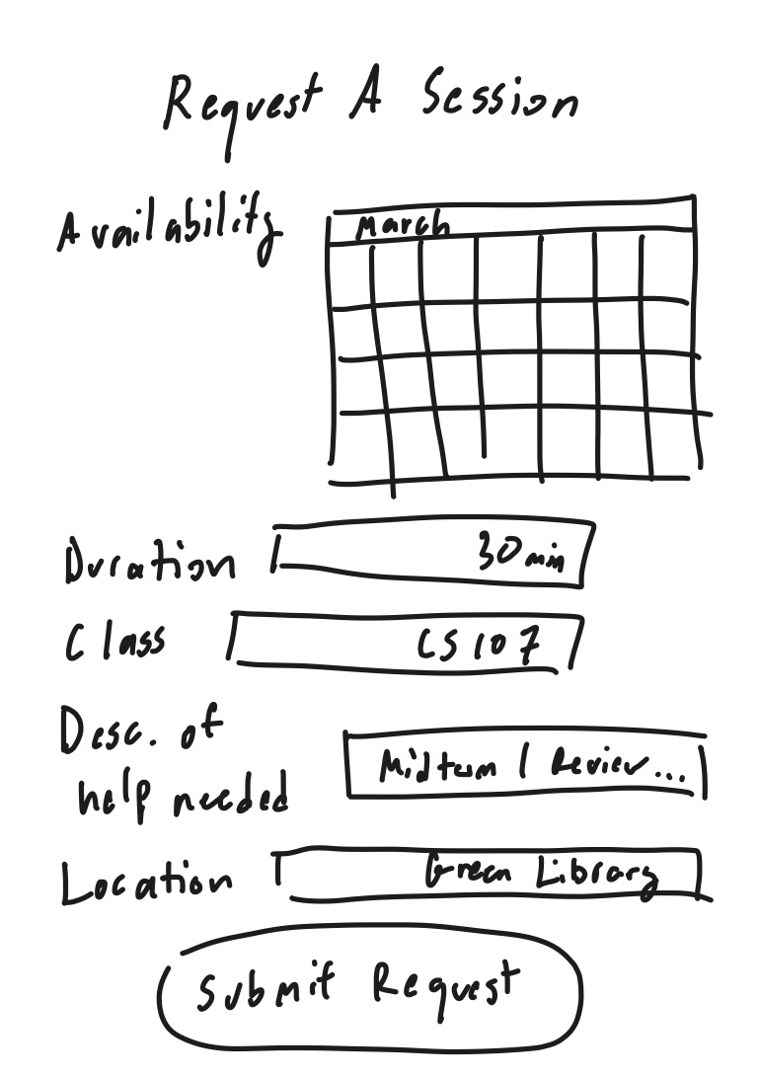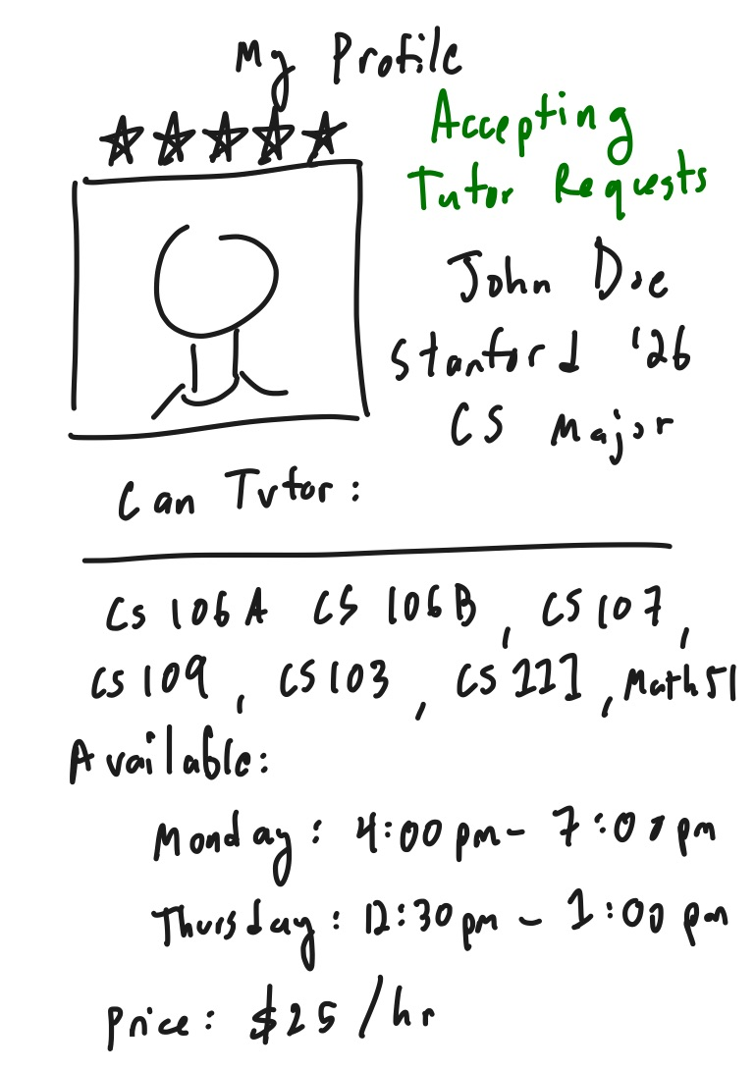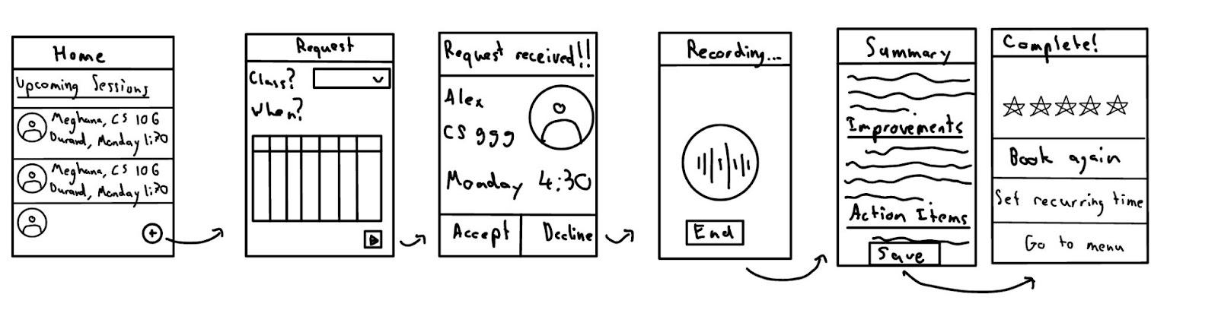

Figure 10. Top: Sketched screens of selecting a session with request details, viewing profile. Bottom: screen flow from home to completing session with summary

Low-Fi Prototype

Simple Task - Creating and Setting up Profile

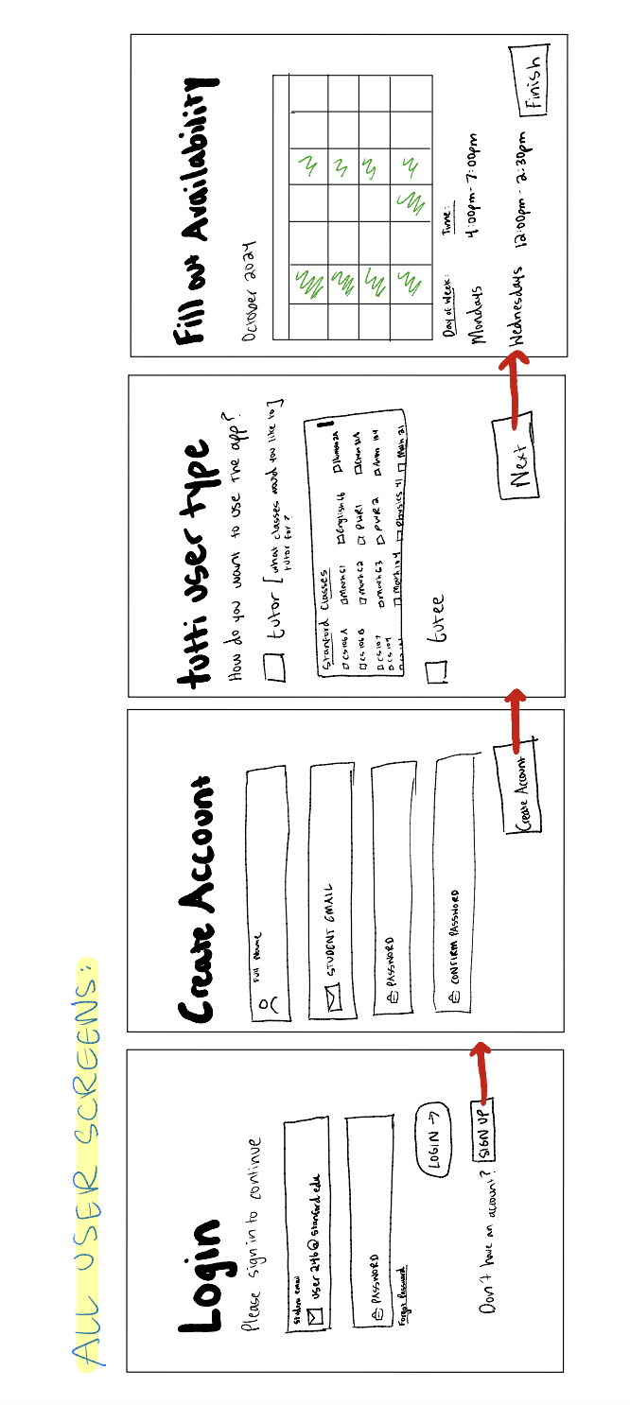
Figure 11. Simple task paper prototype of login and account creation flow

Moderate Task - Request Tutoring Session
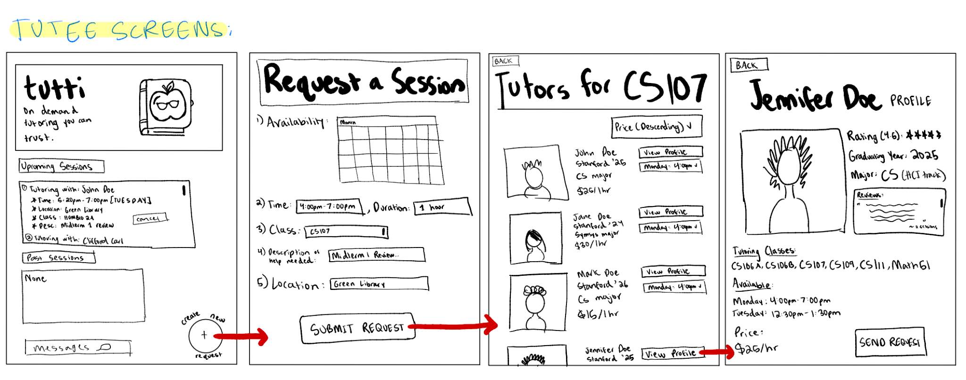
Figure 12. Moderate task paper prototype of request session with tutor flow

Moderate Task - Complete Tutoring Session and Receive AI-Generated Reports
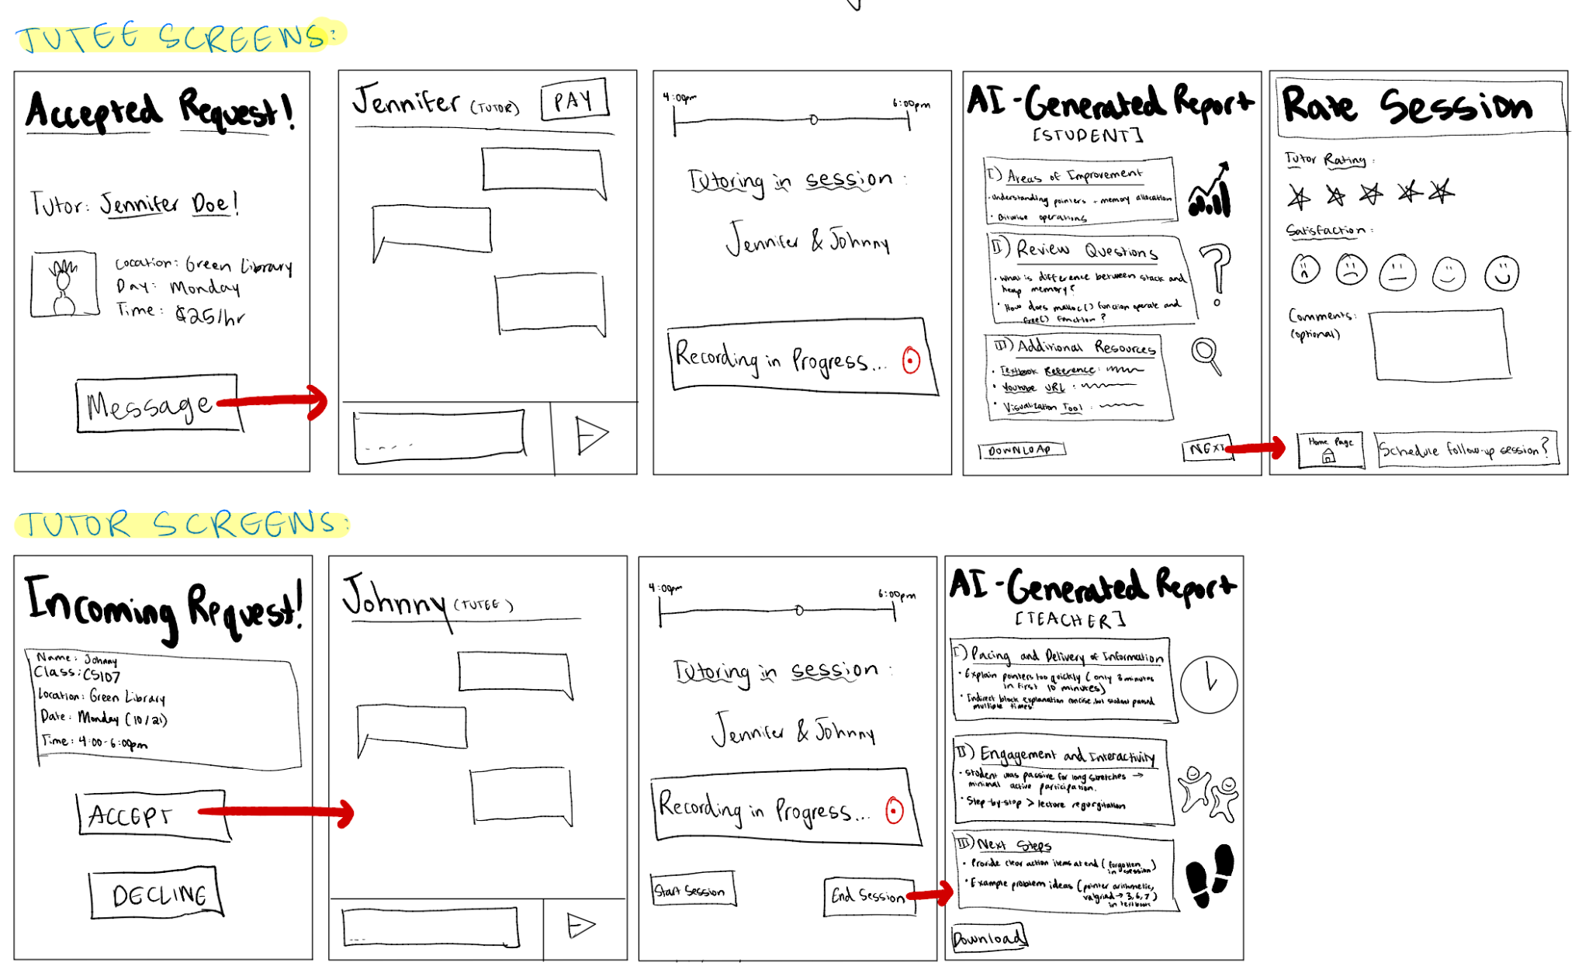
Figure 13. Moderate task. Top: Tutee side to receive AI report after session and rate session. Bottom: Tutor side to begin session and receive teacher AI report

Complex Task - Process Recurring Session Request
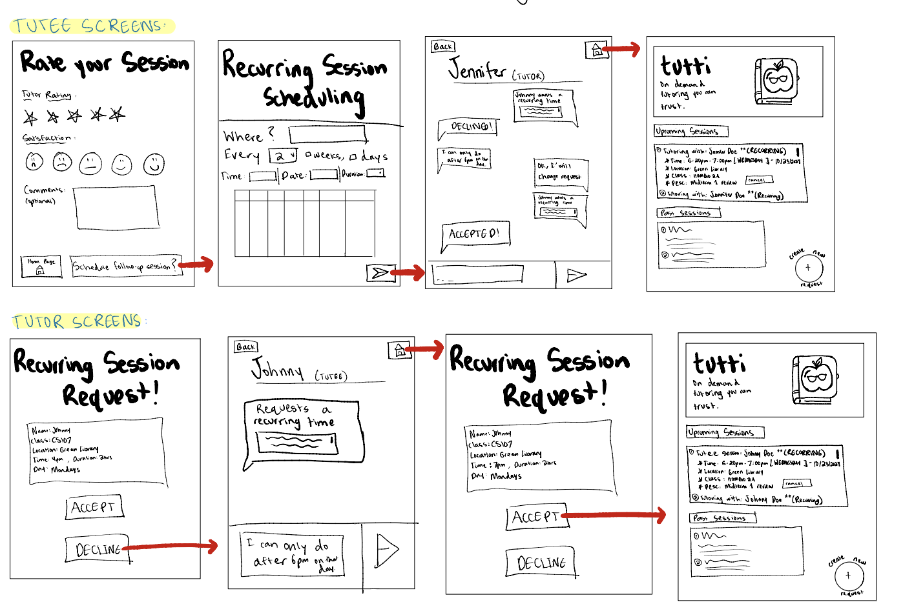
Figure 14. Moderate task. Top: Tutee side schedule recurring session. Bottom: Tutor side to accept/decline recurring session request

Med-Fi Prototype

Simple Task: Login and Set Profile

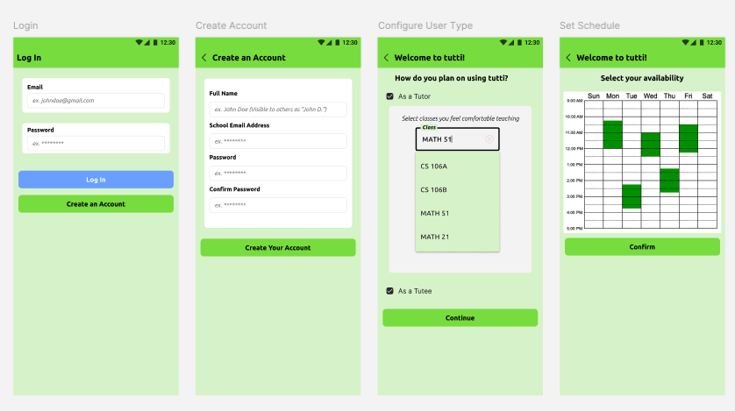
Figure 15. Simple task account creation process- Med-fi (Figma)

Moderate Task: Request Session

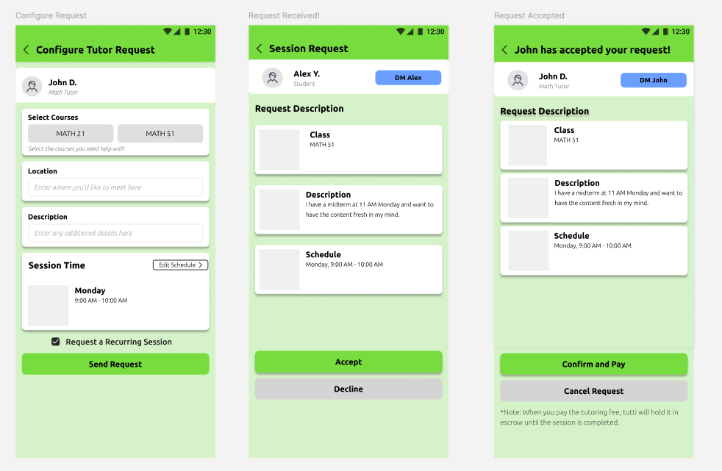
Figure 16. Moderate task tutoring session request flow Med-fi (Figma)

Moderate Task: Handle Session

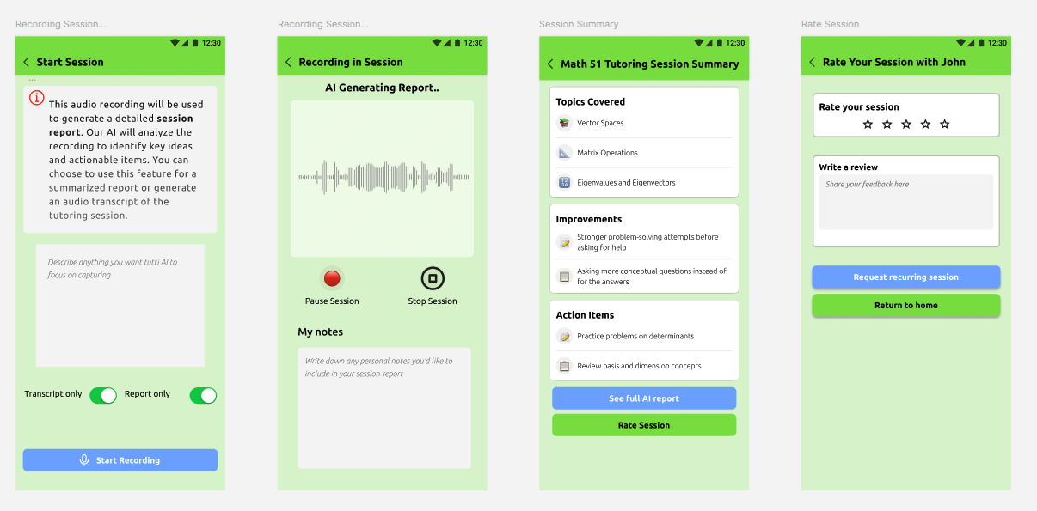
Figure 17. Moderate task to start session with recording and generate post session report and rate session (Figma)

Complex Task: Request a Recurring Session
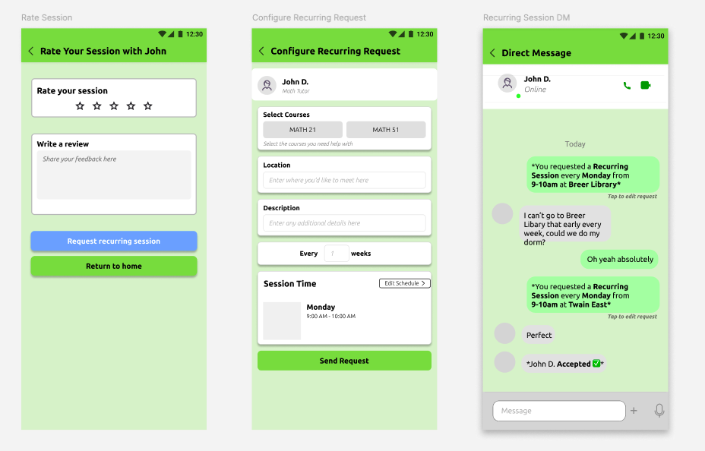
Figure 18. Complex task to configure recurring request and message tutor (Figma)

Med-Fi -> Hi-Fi

Login/Create Account Page:
Severity: 3
Issue | Fix/Rationale
H2: Login page lacking information about the app | Added logo and value proposition login/signup page
H9: Missing information for valid inputs and required fields | This change was not made in the final high-fi due to time constraints
H5: Users can go back after creating an account. | Removed back button to avoid repeat/confusing signup process
H12: Lacked pronouns for inclusivity | This change was not made in the final high-fi due to time constraints

Med-fi Revision:
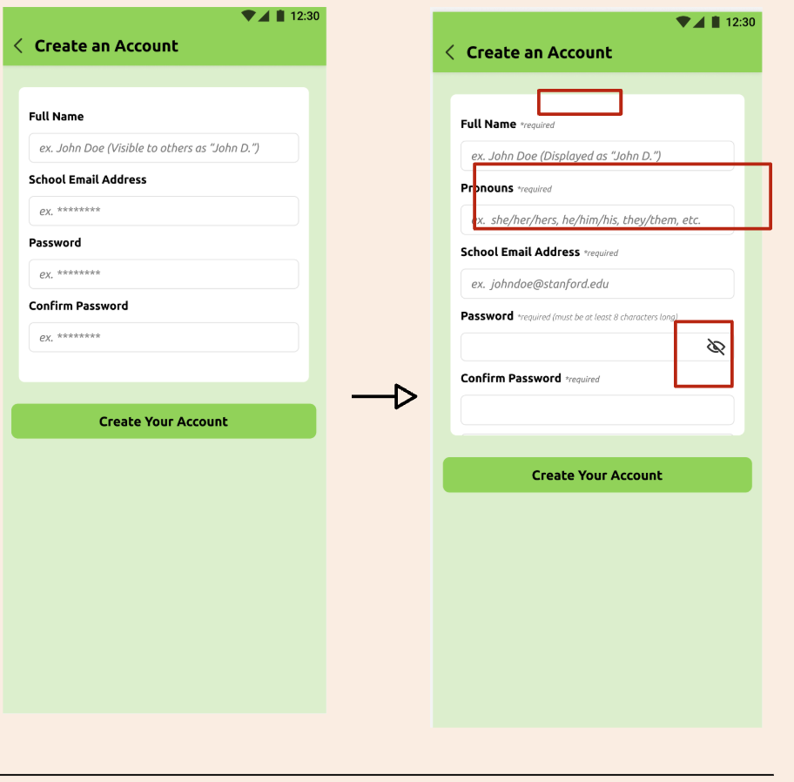
Figure 19. Left: old account creation page. Right: new account creation page with changes

High-fi Implementation: We refined the login page of the app to align with our brand and value proposition.
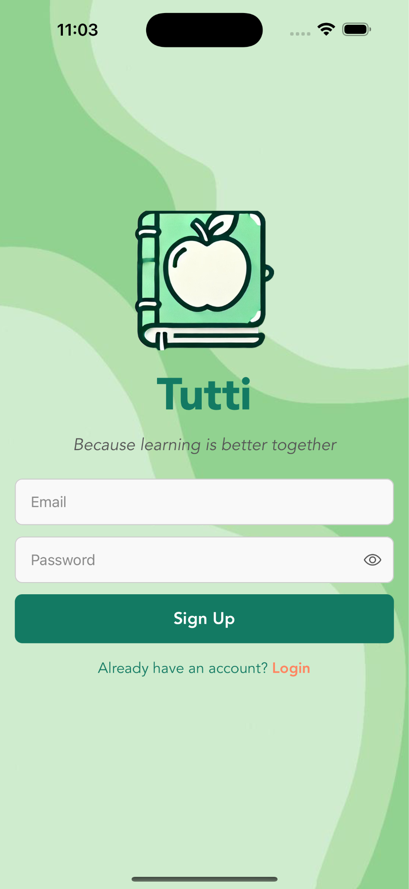
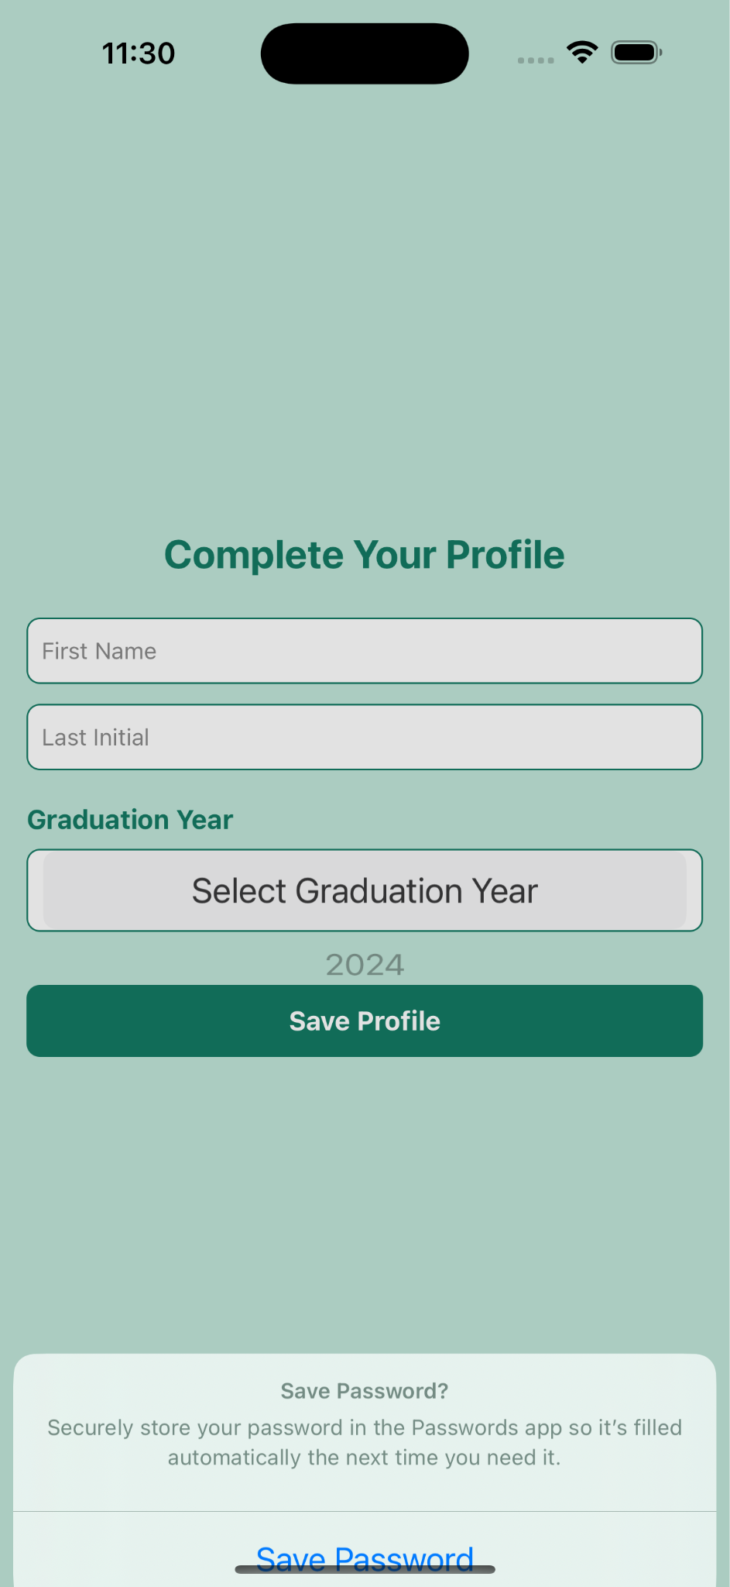
Figure 20. Left: Login/sign up page Right: profile set up page.

Home Page
Severity: 4
Issue | Fix/Rationale
H5: Unable to edit or cancel scheduled session | This change was not made in the final high-fi due to time constraints
H3: Need more noticeable “new session button” | This change was not made in the final high-fi due to time constraints
H7: Unclear that “Search tutors” leads to new session | Switched to a prominent new session button to clearly indicate entry point for new session
(Recurring sessions)  H3: Unable to cancel recurring session button  H6: No indication of recurring session  H1: No indicator showing active recurring sessions  H5: There's no way to change the recurrence pattern once it's made in the recurring session request. | We did not implement recurring sessions due because we decided that to focus on a different complex task instead
H7: DM button not accessible | We did not implement the messaging feature in our high-fi due to technical limitations and we decided that it was not the core focus of the app’s functionality

Med-fi Revision:
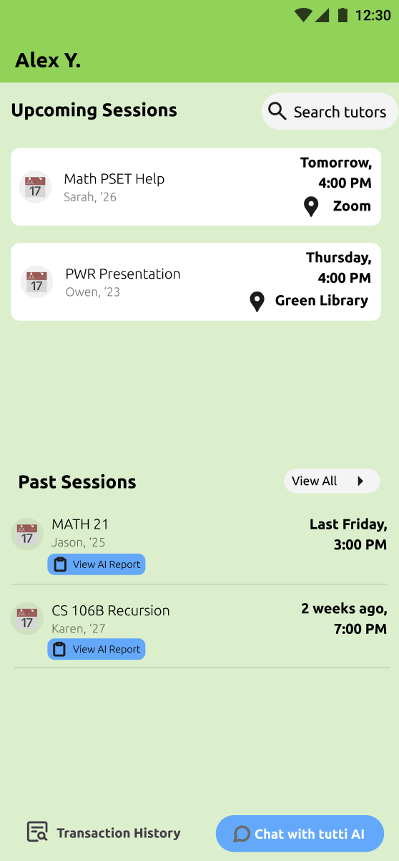

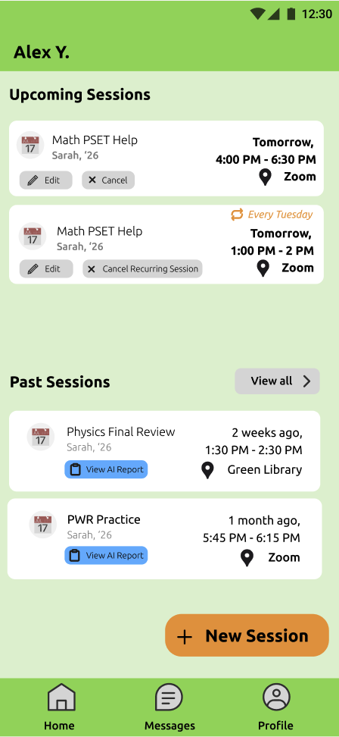

Figure 21. Left: Old home page Right: revised home page with new session button and footer

High-fi Implementation:
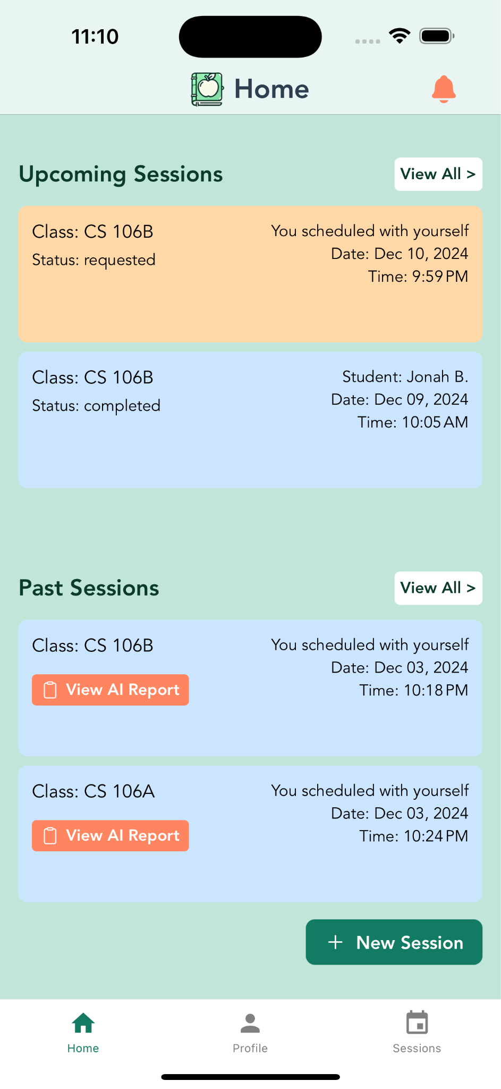

Figure 22. High-fi revised home page with footer and themed layout

New session request
Severity 3:

Issue | Fix/Rationale
H7: No filtering option -> less efficient | This change was not made in the final high-fi due to time constraints
H5: Lack input validation for session request | Added text in search bar to indicate to users what to input

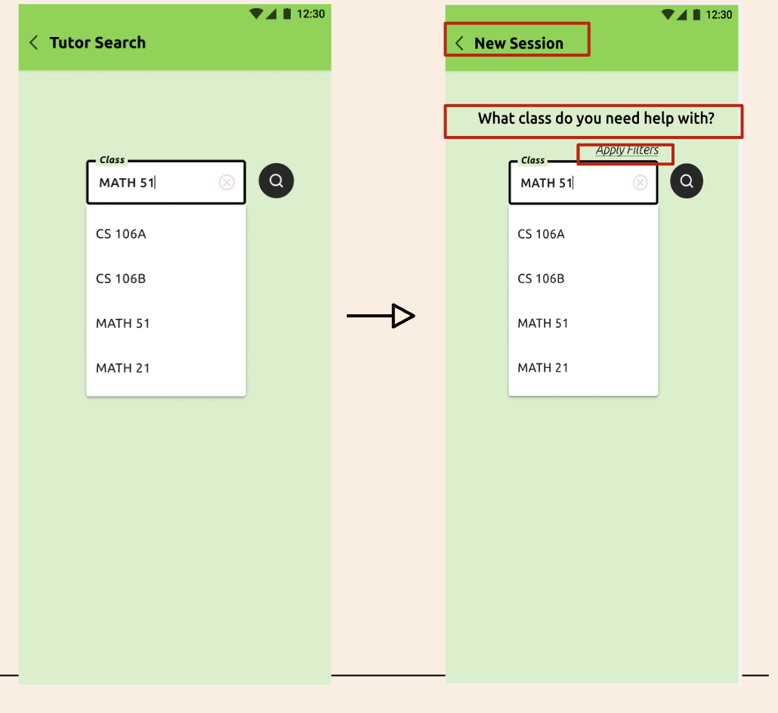
Med-fi Revision:
Figure 23. Left: old tutor search page Right: revised new session search with guiding text

High-fi Implementation:
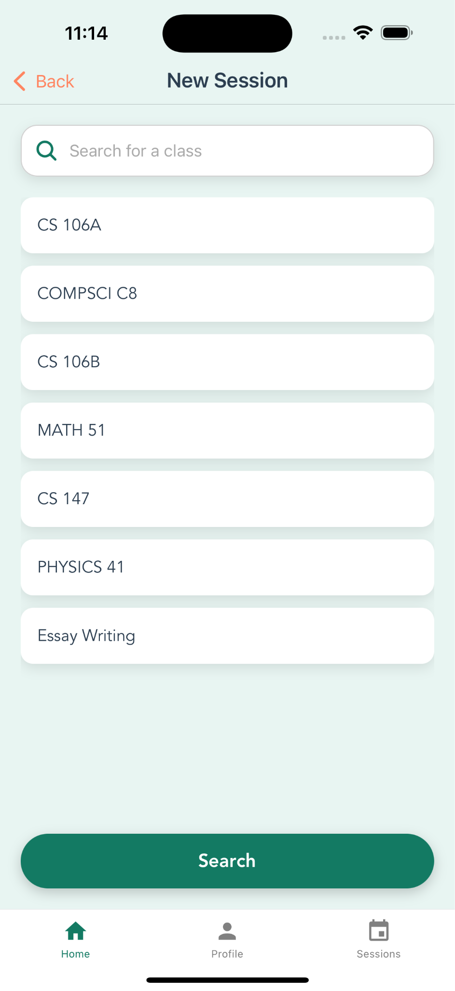
Figure 24. High-fi new session request class search page with query list

Transaction Details
Severity: 4

Issue | Fix/Rationale
H1: No indicator for payment state | We did not end up implementing a transaction details page given time constraints and because the payment process isn’t a main focus in our app

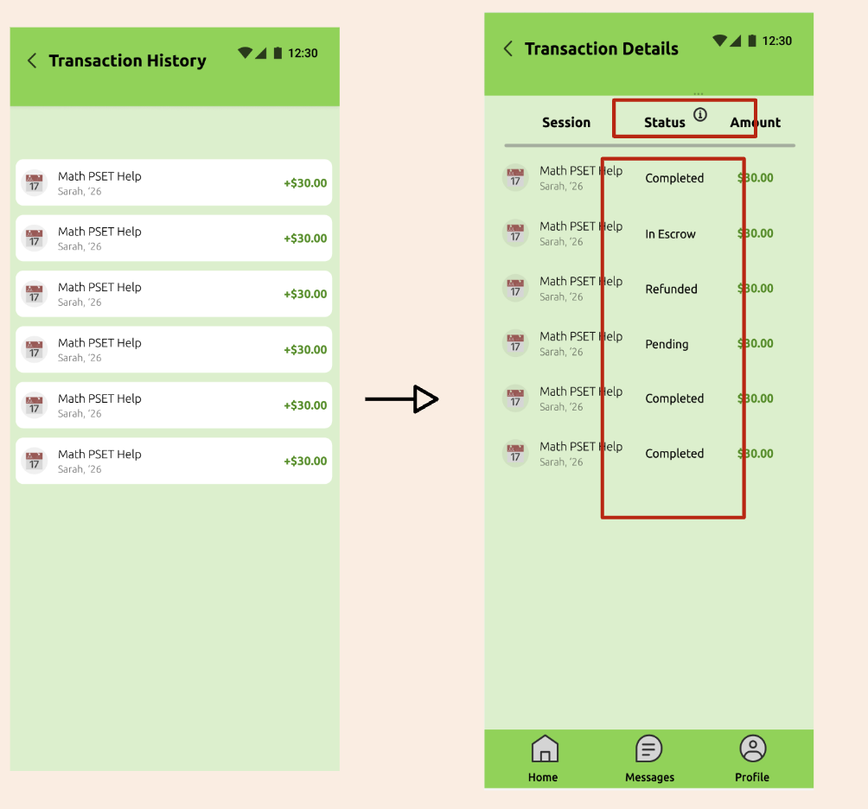
Med-fi Revision:
Figure 25. Left: old transaction history list. Right: Revised transaction details page with status and details
This revision reorganized the transaction list with clearer formatting of information such as transaction status, amount of payment, etc. However, our high-fi did not have a transaction page due to time limitations and other functionality priorities.
Recording Session

Issue | Fix/Rationale
(Severity: 4) H3: No option to skip recording | Added toggle button for user to opt out of recording
(Severity: 3) H12: No privacy policy | Added information pop up in recording page to describe to users how we’re using their data

Med-fi Revision
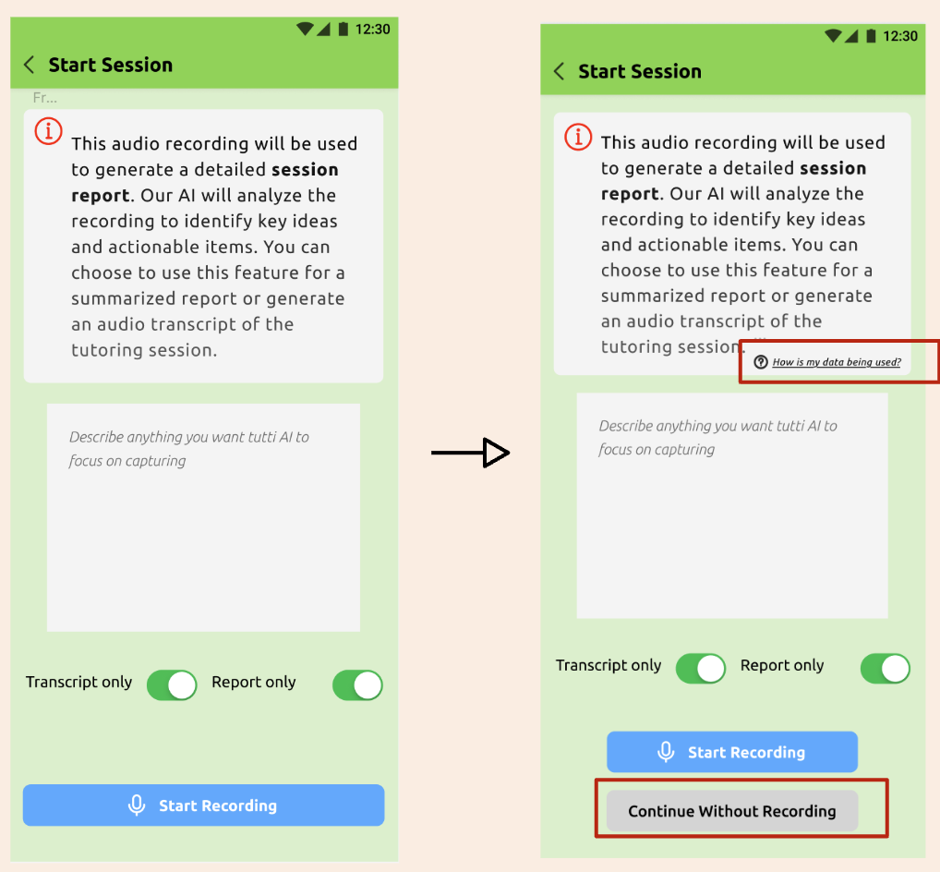

Figure 26. Left: old session start page Right: Revised page with data usage information

High-fi Implementation:
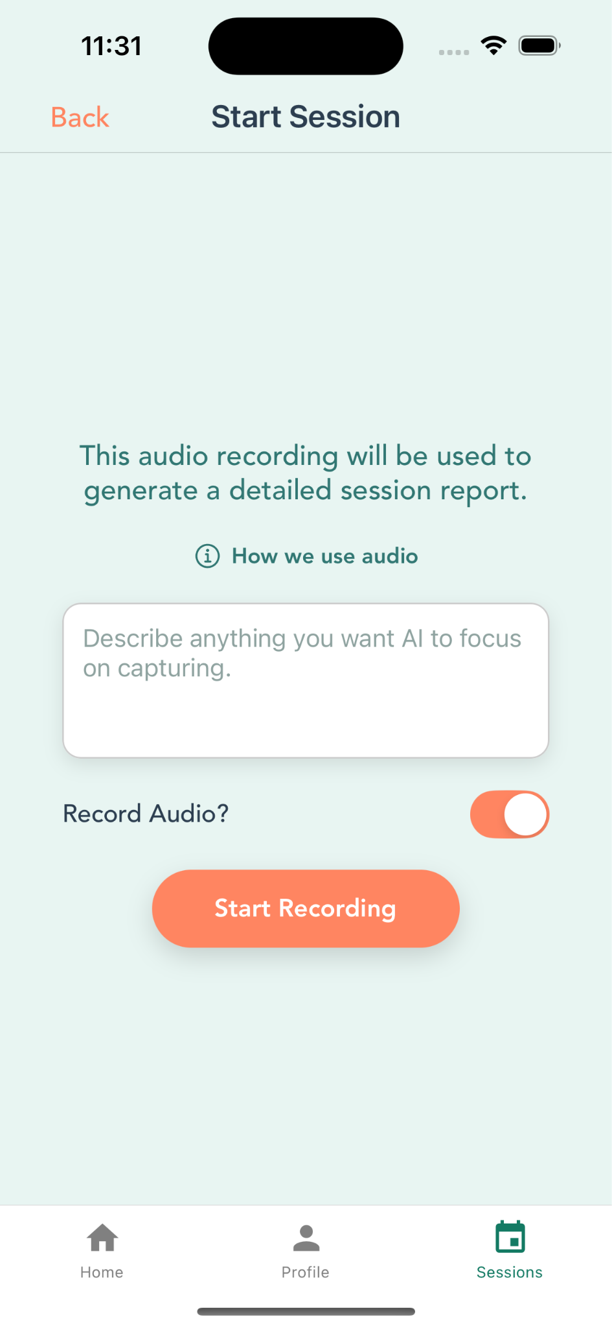
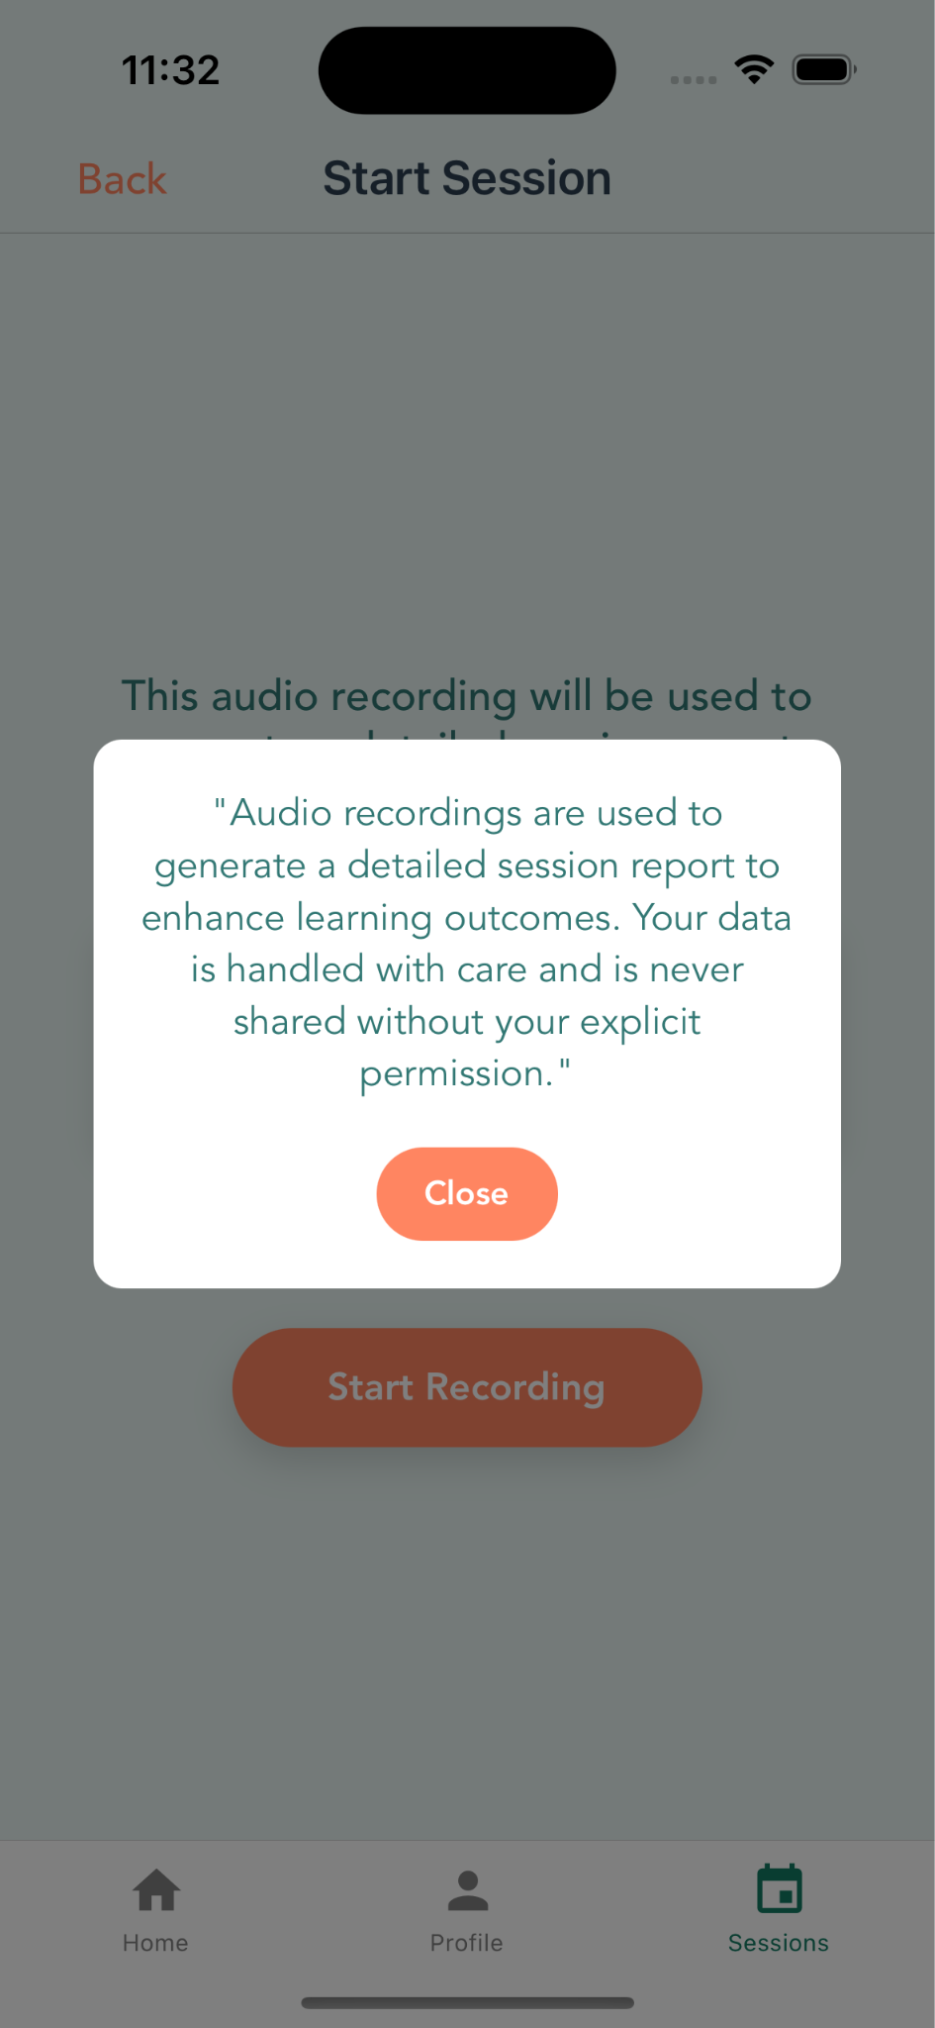
Figure 27. High-fi session recording start page with data information pop up
We redesigned our recording page to match the app’s theme and maintain a modern simple aesthetic.

Session information:

Issue | Fix/Rationale
(Severity: 4) H1: Description does not include session location | Ensured that session details showed selected location of session and clear display of all relevant information in notifications and session management page
(Severity: 3) H6: Unable to recall fee and payment | Ensured that session details showed fee of session
(Severity: 3) H11: The profile picture icon, other basic tutor info, visual info about session date, tutti create account checkboxes, when2meet during account creation, input placeholder text, and view AI report buttons are all really small and would be hard | Reorganized information and buttons for better visibility with revamped color, size, and formatting
(Severity: 4) H4: The button sizings and colorings are inconsistent, and might make it difficult for users with motor impairments to tap accurately and users, more broadly, to understand. | Ensured universal theme, font, coloring for our pages. Made important task buttons much prominent and easier to access

Med-fi Revision:
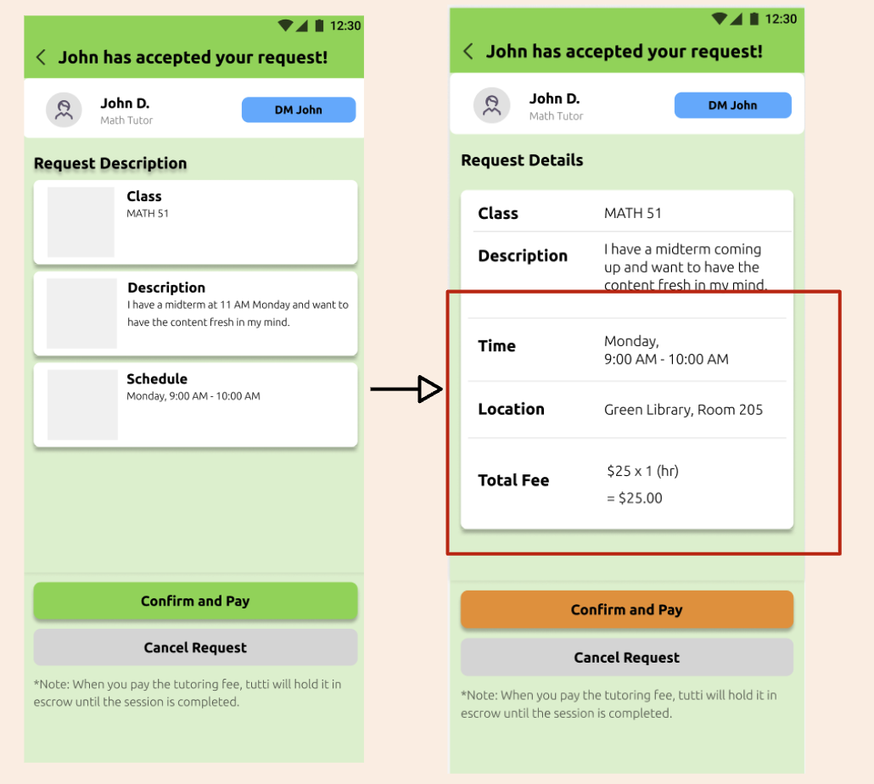
Figure 28. Left: old session request details page. Right: Revised session request information page with complete details (Figma)

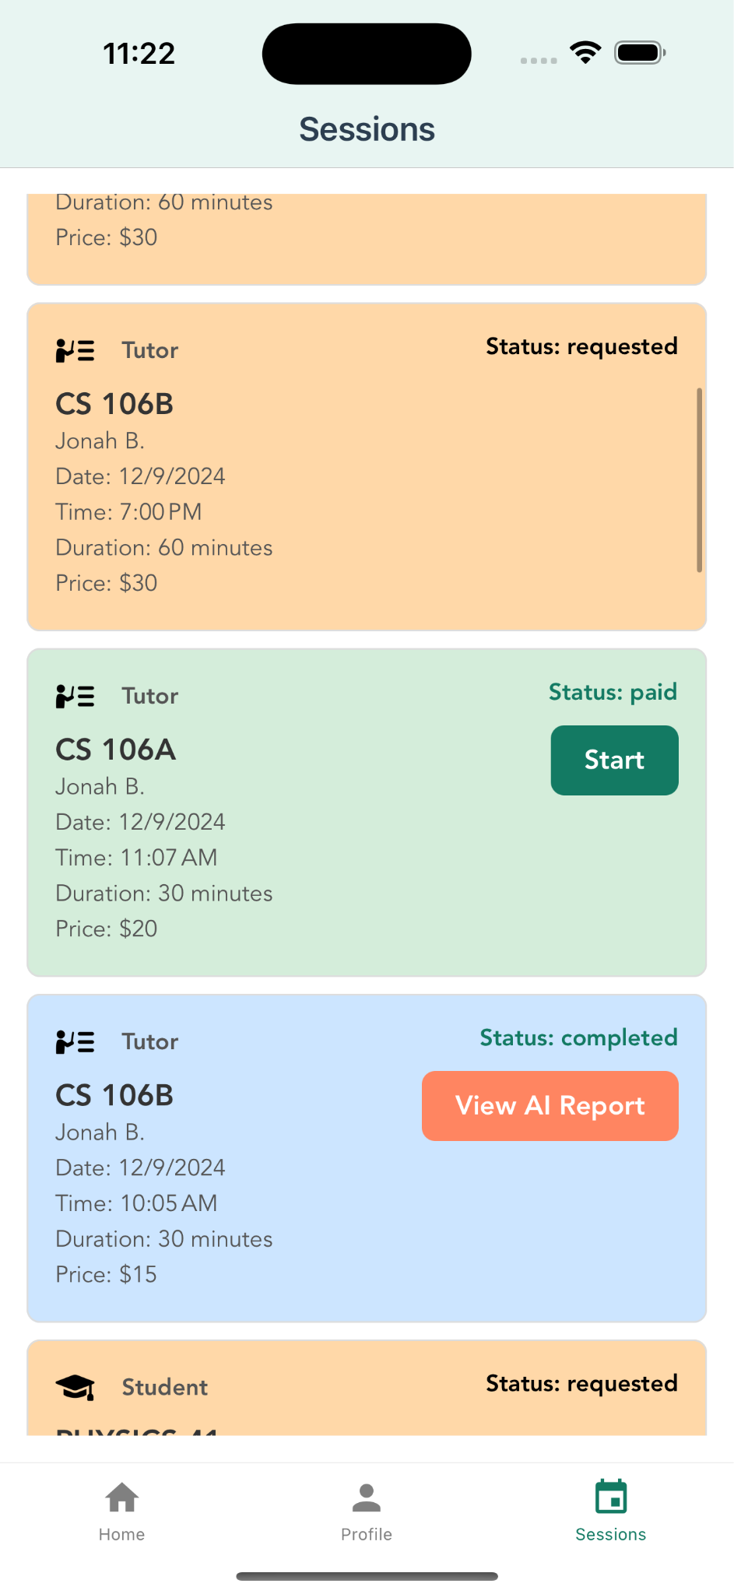
High-fi Implementation- We added a new session management page in the footer to easily access and interact with upcoming and past sessions and their related tasks. In addition, we color coded the sessions based on their status (paid, accepted, requested, etc.)
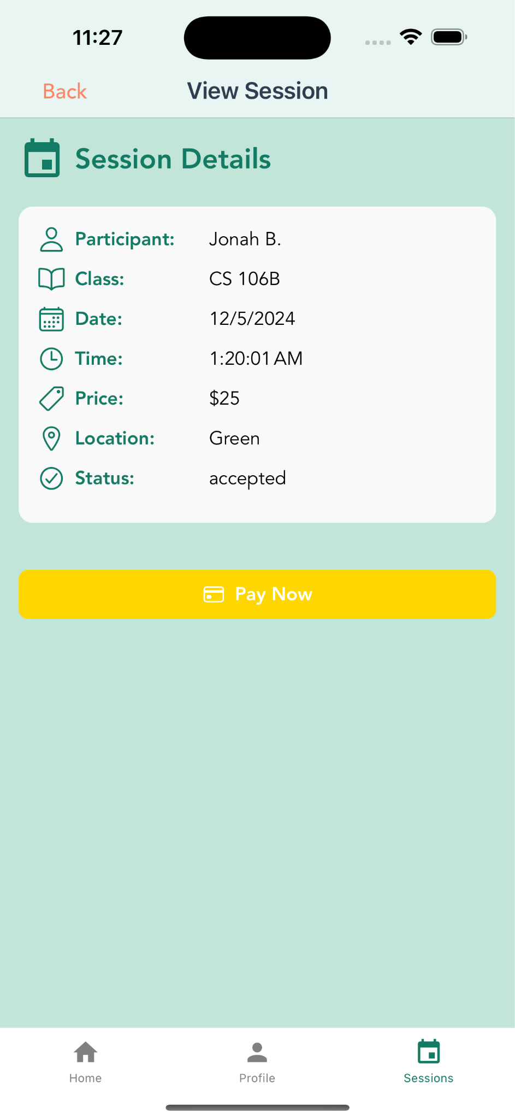
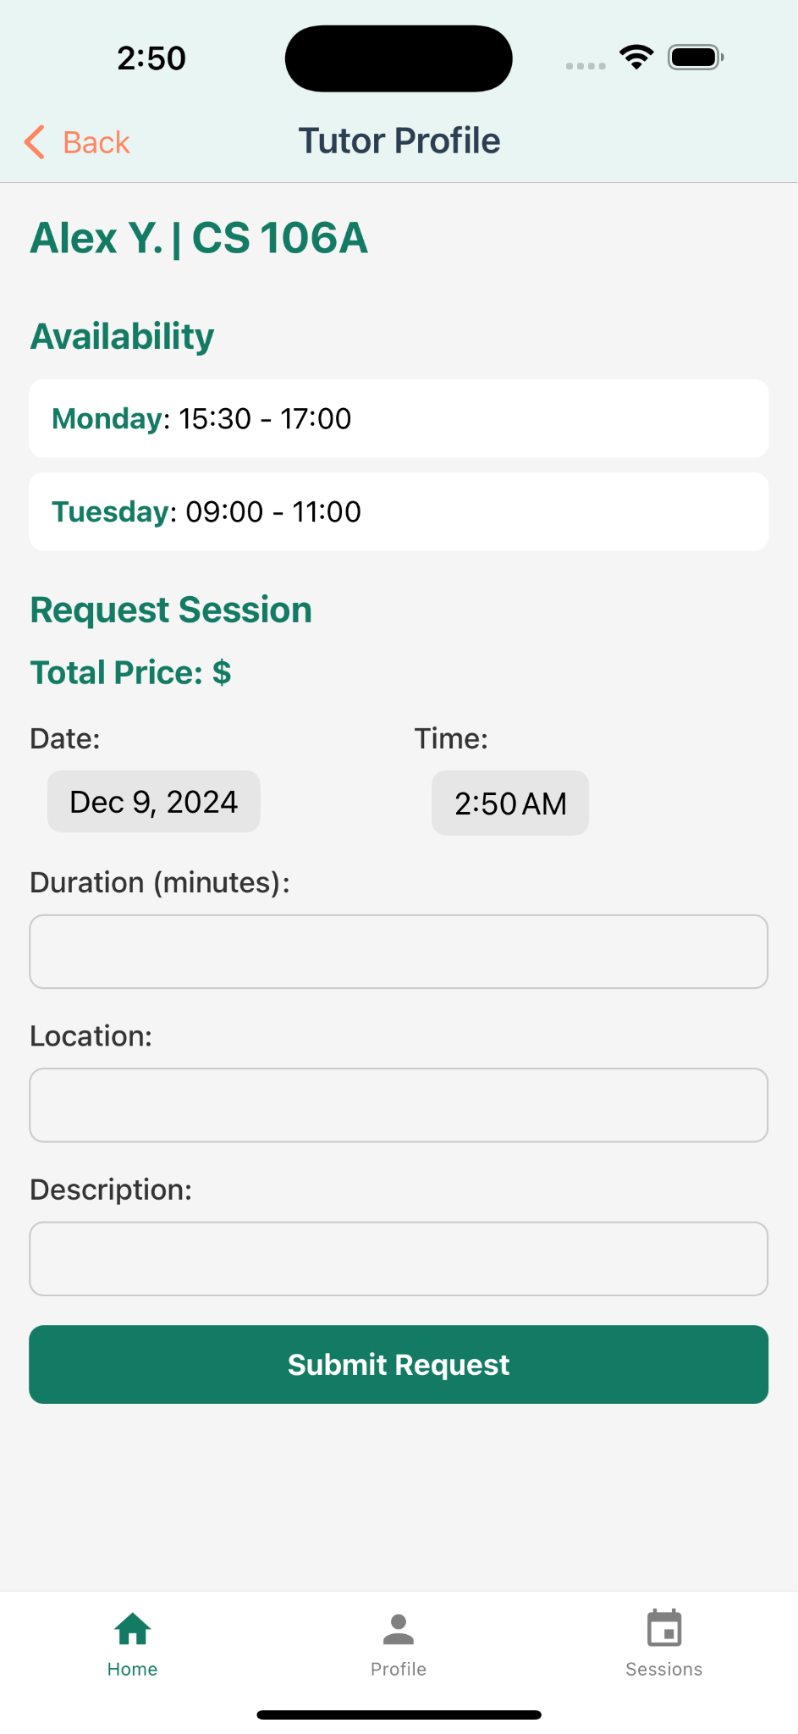
Figure 29. Left to right: Tutor profile, manage session page, and sessions details page

Profile:

Issue | Fix/Rationale
(Severity 4) H1: There isn't a way to check in on your current calendar/change your availability through a calendar POV. | Added display of current availability and button to edit availability in profile

Medi-Fi Revision:
Before the revision, there was no profile page to manage user information including viewing and editing schedule, so we decided to add it for easier management of personal settings.
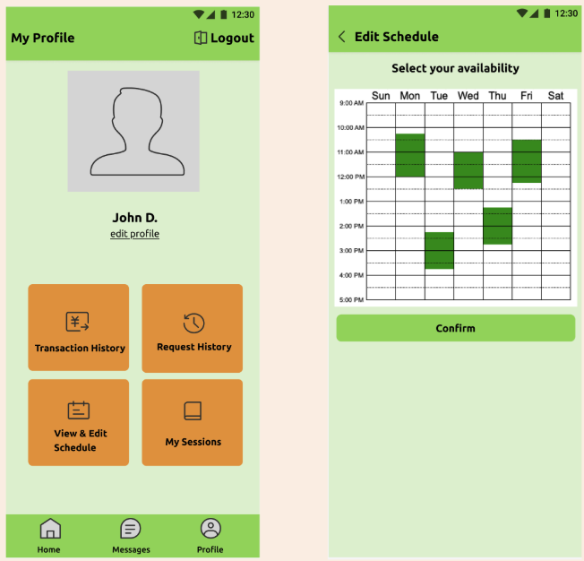
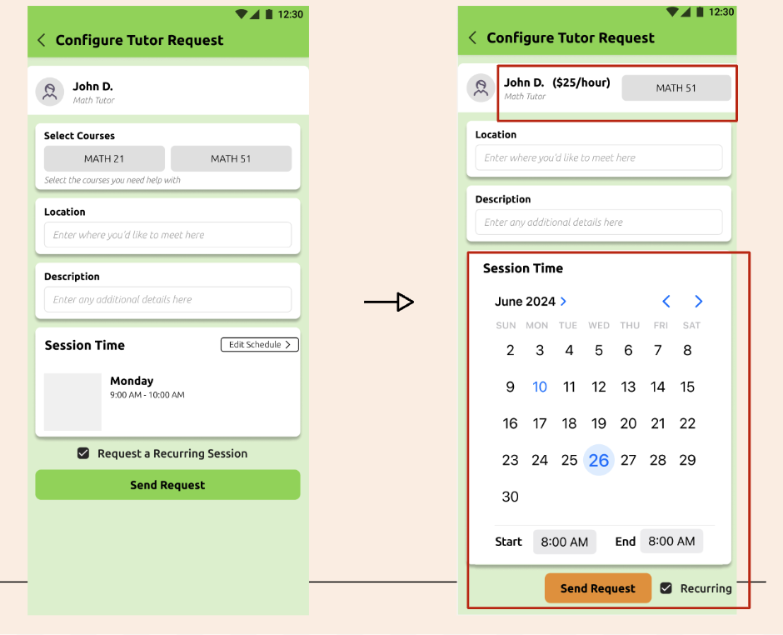

Figure 30. New profile page and configure tutor request schedule selection

We added a more intuitive, user friendly interface to select a session time with a calendar and ensured that tutor rates were readily visible aside each tutor profile.

High-fi Implementation:
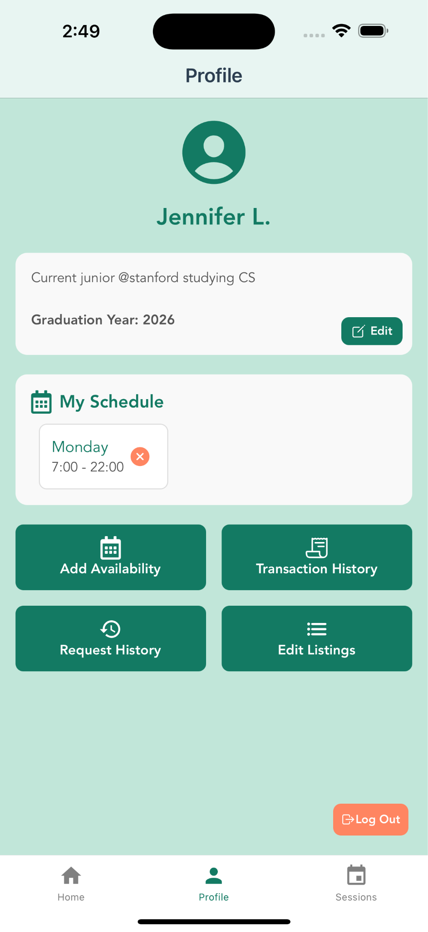
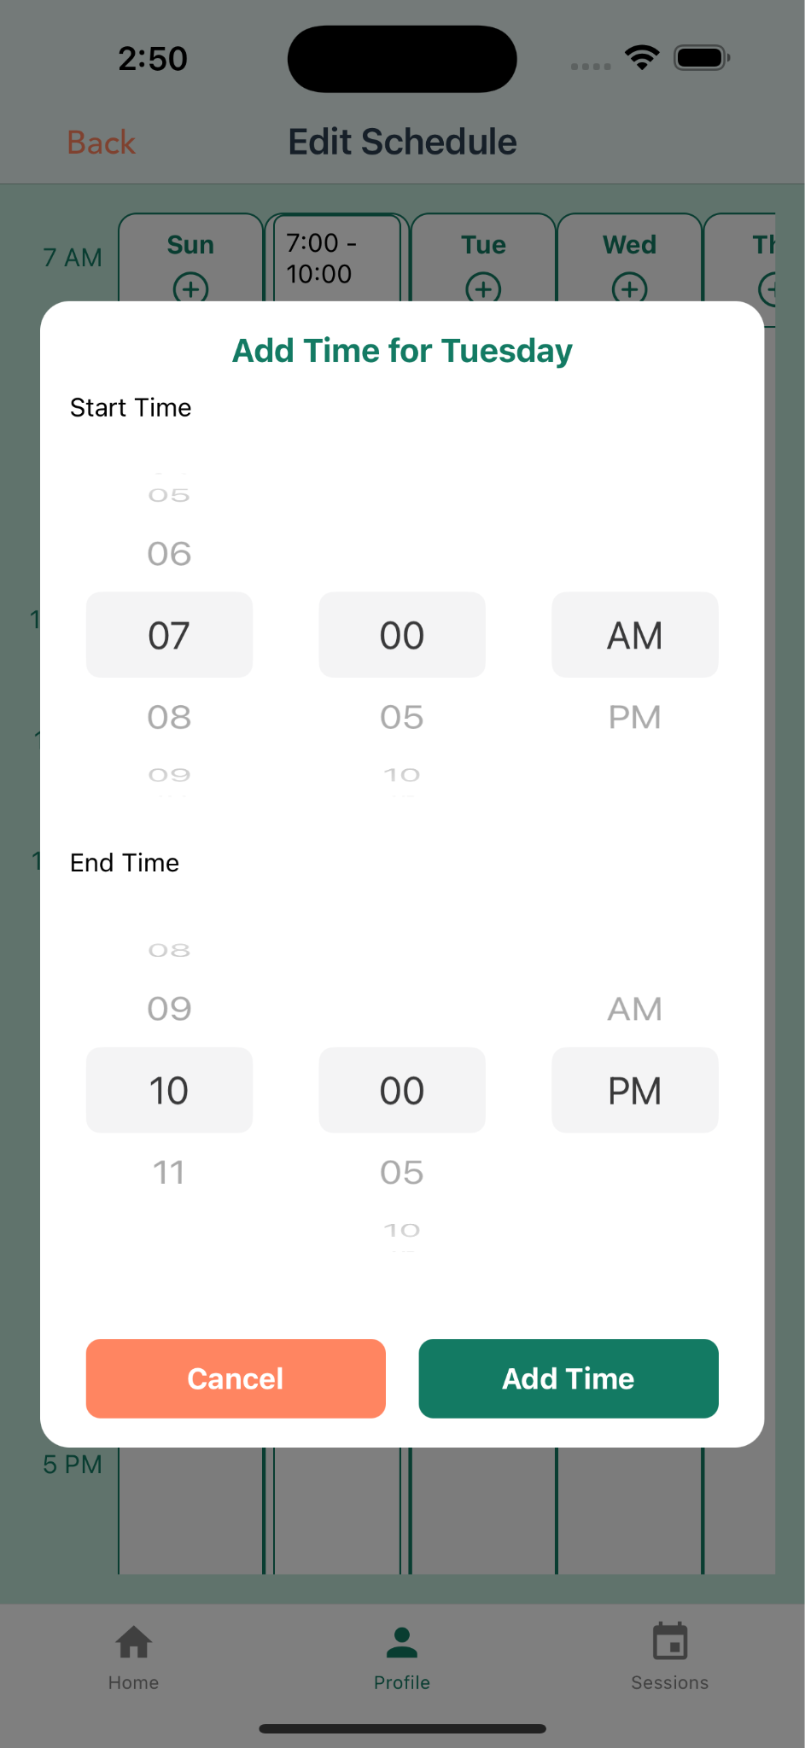
Figure 31. High-fi profile page and edit availability page

Values
As we were developing tutti, we identified four core values we wanted to ensure we prioritized during our design process: Accessibility, Empowerment, Actionable Feedback, and Community and Collaboration.

Identified Values

Accessibility
Through our app, we aimed to lower the barriers to high-quality tutoring by creating a flexible and affordable platform. Students can easily book sessions when they need them, and this makes academic support more accessible than ever. By building a peer-driven network, Tutti strives to reduce the intimidation and judgment often associated with traditional tutoring as it connects students with relatable peers who have successfully navigated the same courses. Ultimately, accessibility is at the heart of creating equitable learning opportunities, and with flexible pricing, efficient processes, and availability to all Stanford students, we are proud to make academic support more inclusive and impactful through tutti.

Empowerment through Peer Learning
Our platform fosters a space where students help one another grow both academically and personally. With a non-judgmental, low-stakes environment, aspiring tutors gain confidence and valuable teaching experience, while tutees receive relatable guidance tailored to their needs. This mutual exchange empowers both sides to take ownership of their learning journeys. It builds self-efficacy for tutors as they refine their teaching skills and reinforces tutees’ ability to actively engage with their academic challenges. Ultimately, both Stanford students leave each session with a stronger sense of confidence and capability.

Actionable Feedback
Through the app, we were able to prioritize these core values by implementing immediate, detailed, and personalized feedback to help users grow after every session. Often during tutoring sessions, both students and tutors are left wondering how to improve. The AI-generated reports provide clear insights into areas for improvement and track progress over time. This allows both tutors and students to refine their approaches and achieve better outcomes. Focused, actionable feedback turns each session into a stepping stone for improvement and offers a clear direction for progress, motivating both sides to continue growing and excelling.

Community and Collaboration
Not just at Stanford, but many college students feel lost in institutions filled with brilliant peers, often hesitating to seek help from professors, alumni, or teaching staff out of fear of judgment or ridicule. In order to address this, we designed our app to encourage a culture of collaboration, connecting students who share similar goals and challenges. By fostering shared learning experiences, the platform builds trust and strengthens academic communities. This sense of connection motivates students and tutors to work together to solve problems. Collaboration forms the foundation of a supportive and effective learning environment, and with the network Tutti creates, students can feel a greater sense of belonging and realize that, in the end, everyone is in the same boat.

Values Embedded in Specific Design Features
In order to create a meaningful and impactful platform, Tutti integrates its core values into each of its key features. First, the AI-generated reports after the recordings embody the value of actionable feedback by providing tutors and tutees with personalized insights immediately at the end of every session. These reports highlight key strengths and areas for improvement, allowing both parties to refine their approaches and track their progress over time. This ensures that each session contributes to measurable academic growth and development. The feature of in-school peer tutoring and searching through different profiles reflects empowerment through peer learning as it connects students within the same school network. This student-to-student tutoring system not only builds accessibility but also fosters a sense of community and collaboration. By providing relatable guidance and shared experiences, it creates a supportive environment where both tutors and tutees grow academically and personally. Default pricing aligns with the value of accessibility, as the set baseline rate of $20 per hour makes tutoring services affordable for all students. Tutors have the flexibility to adjust their rates, balancing their needs with the goal of making academic support widely available while also enabling them to earn income. This aims to ensure that financial barriers do not prevent students from seeking help. Finally, flexible scheduling ensures that users can book sessions at times that work best for them, addressing the challenges of packed schedules, part-time jobs, and limited office hours. This flexibility supports community and collaboration by making it easier for students and tutors to connect and work together despite their individual time constraints. Ultimately, each feature works together to uphold Tutti’s mission of fostering a collaborative, accessible, and growth-oriented learning environment.
Navigating Value Tensions: Challenges and Solution

Privacy vs. Feedback
Balancing personalized feedback with protecting users' privacy was a key challenge. We addressed this by notifying users whenever AI and recording processes were used and informing them upfront about how their data would be handled to maintain transparency and build trust. Additionally, we gave users the option to cancel, pause, or exit during the AI processes, allowing them control over their data and the freedom to make their own decisions.

Empowerment vs. Equity
Setting fair tutoring prices that ensure accessibility while avoiding disparities was another challenge we worked to resolve. We implemented a default tutoring price of $20/hour, providing a fair baseline while giving tutors the flexibility to adjust rates. This approach ensures that tutoring is accessible to students while still allowing tutors to earn a reasonable income. Without this baseline, disparities could arise, with some tutors setting unaffordable prices that only wealthier students could afford.

AI vs. Human Insight
Ensuring that AI-generated reports support, rather than replace, the tutor’s real-time insights required careful consideration. We designed AI to provide structured, actionable feedback after each session while keeping human insight central to the tutoring process. However, one challenge we face is the lack of AI evaluation of body language and tone, which were highlighted in needfinding interviews as crucial for assessing teachers. Addressing this would require balancing the benefits of such features with potential privacy concerns.

Final Prototype Implementation
Tools Used & Pros + Cons
In order to develop the high-fidelity prototype for Tutti, we utilized a comprehensive set of tools to make sure our end result was a polished, functional app. Our development workflow utilized different design, collaboration, and deployment tools to create an accessible and user-friendly interface.
- React Native: The primary framework we used for building our app, and this allowed for cross-platform compatibility for iOS and Android devices.
  - Pros: Allowed the team to build for all platforms/screens simultaneously, reducing development time.
  - Cons: Debugging platform-specific issues was challenging, especially when features behaved differently on iOS and Android.
- Expo: Used for building and testing the app in real-time, allowing rapid iterations during development.
  - Pros: Simplified testing and development with built-in tools, which sped up the entire process of prototyping.
  - Cons: Limited access to some advanced native modules, and this required us to spend extra time to work around these restrictions.
- Visual Studio Code: The IDE used for coding, debugging, and managing app components.
  - Pros: Easy to set up with extensive plugins, which very much improved our group’s productivity.
  - Cons: Debugging React Native-specific issues often required additional setup or external tools, and this slowed down our problem-solving.
- Figma: Utilized for initial design mockups and UI components, making sure visuals were consistent throughout the app.
  - Pros: Allowed the team to easily collaborate on design and iterate quickly on UI changes.
  - Cons: Translating designs into React Native components required adjustments, as some designs did not directly align with development constraints.
- GitHub: Facilitated team collaboration and version control.
  - Pros: Allowed multiple team members to collaborate effectively and track changes.
  - Cons: Merging code changes sometimes caused conflicts that were time-consuming to resolve.
- React Native Documentation: Provided additional resources for addressing technical challenges during implementation.
  - Pros: Comprehensive and helpful for solving common issues.
  - Cons: Some explanations were unclear for advanced/unique circumstances we were running into in our app.
- Supabase: Our backend is supported by a Supabase database that allows people to edit their profiles, add listings and scheduling availability, and send each other requests and ratings.
  - Pros: Provided an easy-to-implement backend solution with built-in authentication and database functionality.
  - Cons: Limited customization options caused challenges when we were implementing advanced features like real-time updates/complex queries.
Hard-Coded Features
Given our backend database, our app runs on real data and real-time interaction from user profiles and settings such as tutor profiles, availability, session requests, etc. However, due to time and technical limitations, some elements of the app are hard-coded features, including user profile pictures and the AI generated report.
Wizard of Oz Techniques
For our Wizard of Oz techniques, we simulated the session recording process by displaying industry-standard recording controls, such as pausing and stopping buttons, along with an audio wave animation to give the appearance of active recording. For the AI-generated reports, we have not yet implemented the actual AI functionality in the app. To simulate this feature, we included a "Generate AI Report" button that leads to a loading page with a progress percentage bar, mimicking the report generation process. Once the loading completes, a hard-coded mock AI-generated report is displayed, allowing us to demonstrate the intended functionality without fully building the feature.
Implemented Features
The following functionalities were successfully developed and integrated:
- User Account Management:
  - Users could sign up, log in, and customize profiles with bios, schedules, and course listings. Each account on our platform is really a separate user on the Supabase database, and to sign up sends a request to the server for a new account with that email address. Supabase then uses an SMTP service called Resend to send a confirmation email via a custom domain, tutti-app.tech, which we were offered for free for the year thanks to having GitHub Education.
- Session Requests:
  - Students could search by class, view tutor availability, and request new sessions to tutors. Tutors will be able to see and accept or decline requests in the notifications page or session management. Once a session is accepted, the app waits for the student to pay and then the tutor will be able to start a session with session recordings. Following the session, users are able to leave reviews and comments on the session.
- Home Page Integration:
  - Displayed upcoming and past sessions, entry to requesting new session
- Calendar Functionality:
  - Users could set and manage their availability, rates, and tutoring subjects.
Challenges and Outcomes
- Challenges:
  - Implementing dynamic features, such as real-time messaging and AI functionalities, was beyond the scope of this prototype.
  - Ensuring accessibility and consistency across platforms required iterative adjustments during development.
- Outcomes:
  - Despite the challenges, the prototype successfully demonstrated Tutti’s core functionalities, addressing major heuristic violations identified earlier and providing a clear direction for future development.

Reflection & Next Steps
Design Thinking Process
Over the past ten weeks, our group has gained several key insights into the Design Thinking Process, all the way from carrying out our initial needfinding interviews to developing our final high-fidelity prototype. One of the most important lessons we learned was the value of empathy and being open-minded during our interviews. Initially, we designed questions that were a little narrowly focused on our studio's goal of uncovering gaps in the education sector. However, as we engaged in open-ended conversations with interviewees, we discovered far more meaningful insights by keeping discussions general and allowing their personal stories and experiences to guide us. Taking the time to truly understand their perspectives and emotions revealed needs we might not have otherwise noticed and laid the foundation for us to confidently take the next steps. Also, toward the beginning of the quarter, our team had preconceived ideas about the gaps in education and which groups might be most affected, based on research we had conducted through reading articles and watching videos. diverse educational backgrounds that our assumptions were truly challenged. However, it was not until we spoke directly with students, teachers, researchers, and tutors from diverse educational backgrounds that our assumptions were truly challenged. Their personal and often vulnerable stories revealed contradictions and exposed us to realities we had not fully considered—it gave us insights and complexities about the education sector we could never have gained from prior research alone.
Another major lesson we learned was the importance of defining our problem clearly and staying flexible throughout the process. During needfinding, we uncovered a wide range of needs and insights. At first, we attempted to address all these issues with a single solution but quickly realized that this approach was neither feasible nor scalable. By narrowing our focus to the specific needs of students, we were able to align our efforts and move forward with a unified purpose. This clarity allowed us to let go of ideas we had initially invested in, and this was necessary to create a more impactful solution. As we moved from low-fidelity sketches to our high-fidelity prototype, we experienced the true value of iteration and user feedback. Although our initial task flows remained consistent, the design itself underwent significant changes as feedback from peers, TAs, and instructors helped us identify areas where our prototype was not intuitive or easy to follow. By bringing our designs into Figma, we could more effectively test and refine our ideas, allowing us to visualize how our improvements addressed the feedback. While it was challenging to let go of certain elements, doing so ultimately allowed us to build a stronger, more user-friendly app.
Finally, we learned that mindset, collaboration, and communication are essential to the design process. The IDEO Deep Dive video on creating a refined shopping cart and the team’s behavior inspired us with its focus on open communication and creative brainstorming, which motivated us to tackle challenges with enthusiasm. Even when we had disagreements, we were able to build a safe space where everyone felt comfortable sharing ideas. This collaborative and enthusiastic spirit helped us move forward in the design process of refining and improving our final product, especially during moments when we were feeling stuck or uncertain.
Studio Theme
All of our group members have experienced both sides of academic support—as tutors and as students seeking help. This gave us firsthand insight into the challenges and rewards of learning in collaborative environments. Also, as computer science majors, we were naturally curious about how these experiences could intersect with technology, particularly in education. Our shared struggles at Stanford, where finding immediate and effective academic help often felt difficult, motivated us to find solutions in the edtech space, and we were very excited to be assigned to AI in the classroom.
In our studio, we learned how AI in the classroom can make education more inclusive and effective, especially when paired with human interaction. One of the key lessons we learned was that AI is most impactful as a support tool rather than a replacement for human connection. Through our studio discussions, we uncovered that while students appreciated AI’s ability to efficiently organize and present information, their most meaningful learning experiences were those that included empathy, excitement, and personalized guidance—qualities unique to human interactions. As a result, when developing our app, we wanted to make it a priority to use AI as a tool to enhance learning through features like session summaries and tailored study plans while making sure that human connection was the main focus.
Over the weeks, our studio also helped us recognize how important flexibility is in educational tools. Students and teachers come from diverse backgrounds (especially socioeconomic conditions) and often face challenges like packed schedules, part-time jobs, or athletic commitments. These obstacles can make traditional academic support systems harder to access. By learning about these accessibility issues in the studio, our group was inspired to focus on creating a solution that promotes both academic and personal success through inclusivity and effectiveness.
Project
This quarter, as we were developing our project Tutti, we learned that relatability and trust is essential to effectively addressing the needs of students and tutors. Tutti is designed to connect students with peers who have successfully navigated the same courses, offering relatable guidance rooted in shared experiences. Through interviews, we discovered that relatability plays a key role in making tutoring sessions more comfortable and productive. Instead of focusing only on expert tutors, Tutti centers on peer-driven support, which makes it easier for students to find relatable and practical help.
We also learned how critical trust is in fostering a strong academic community. Students often hesitate to seek help due to doubts about their qualifications or reliability. To overcome this, we designed Tutti to include features like verified tutor profiles, ratings, and reviews, making sure students feel confident in the quality of support they receive. Beyond building transparency, Tutti focuses on creating a supportive environment where both students and tutors feel valued. These insights shaped Tutti into a platform that not only connects students with the right resources but also builds a sense of community through shared learning experiences void of any judgement.
Next Steps

Due to time constraints, our next steps will focus on fully implementing the speech-to-text and text-to-report features, moving beyond the current hardcoded process. Currently, we simulate these features by manually inputting a recording and specifying a focus area for the AI to generate a predefined report for both the tutors and students. To enhance functionality and make this process dynamic, we plan to integrate OpenAI Whisper for speech-to-text conversion and ChatGPT for natural language processing.

Within the same flow, we plan to take an extra step by adding an image detection feature to help registered tutors receive feedback on their body language during sessions. Initially, we were hesitant about this feature due to potential privacy concerns around video recording. However, during the exposition, we received feedback from judges emphasizing the importance of body language in communication, encouraging us to consider this factor as well. We would implement this feature using AI-based image detection technology, such as computer vision algorithms, to periodically analyze the tutor's presence and posture during the session. This process would not store or share any images, ensuring both transparency and privacy.

Finally, with more time, we would want to implement a chat feature in our app to facilitate better communication between tutors and tutees. This functionality will allow both parties to coordinate session details and address any specific needs in real time. For example, students can inform their tutor if they are running late, request to cover specific materials outside the course description, or clarify expectations about the session. On the other hand, tutors can also use the chat to confirm details, share preparatory materials, or discuss session goals with the student. This feature would be integrated into the app's navigation bar for easy access once a tutoring request is accepted.
Developing Tutti has been an inspiring journey, and we are excited to continue refining our app to empower students to become both better learners and effective teachers within a supportive community. Ultimately, Tutti transforms learning into a collaborative experience, where everyone benefits and grows together.

