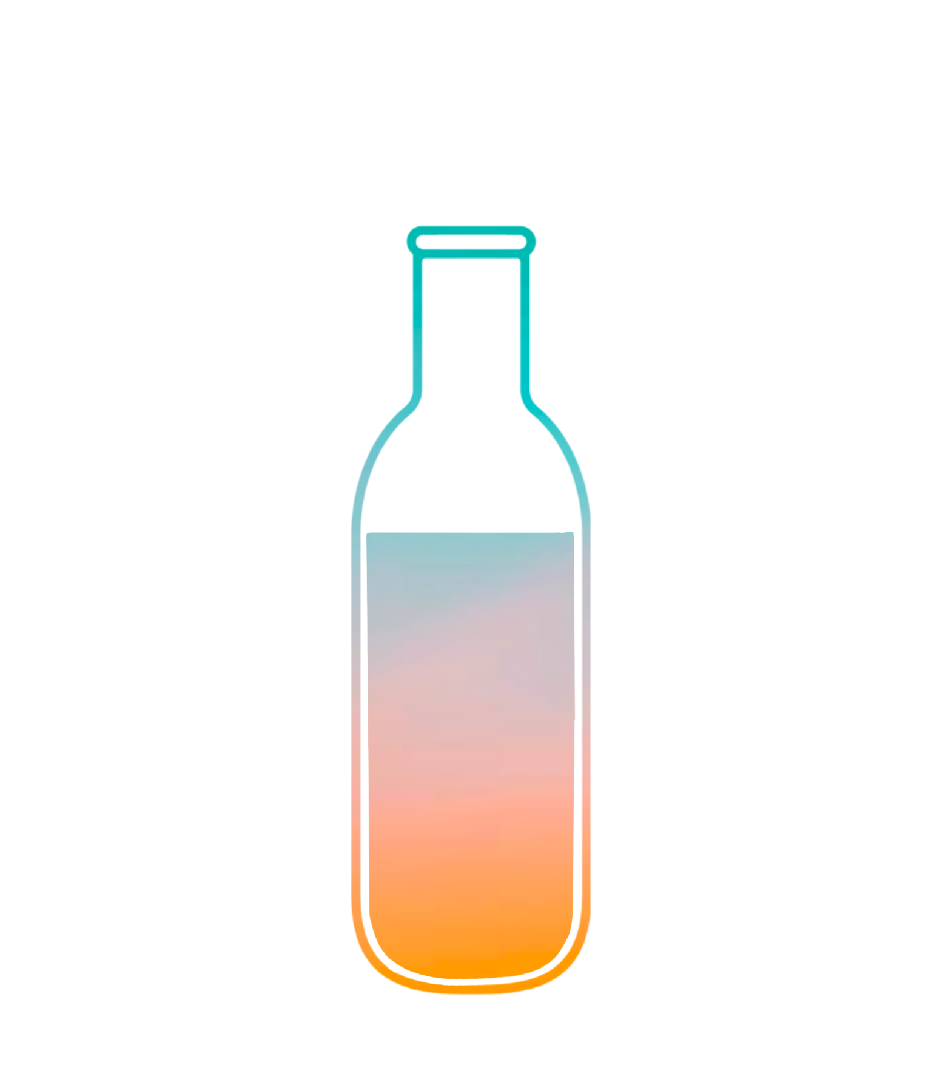
Bottle
Uncap your day with others

Final Report

CS 147 Autumn 2023
Lucia L, Jenny D, Tracy W, Evy S
December 2, 2023

Table of Contents

Project Name and Value Proposition

Team Member Names and Roles

Problem/Solution Overview

Needfinding
- Interviews
- Synthesis

POVs & Experience Prototypes
- POVs
- HMWs
- Experience Prototypes

Design Evolution

Values in Design

Final Prototype Implementation

Reflection and Next Steps

Project Name and Value Proposition

Project Name
Bottle

Value Proposition
Uncap your day with others

Team Member Names and Roles
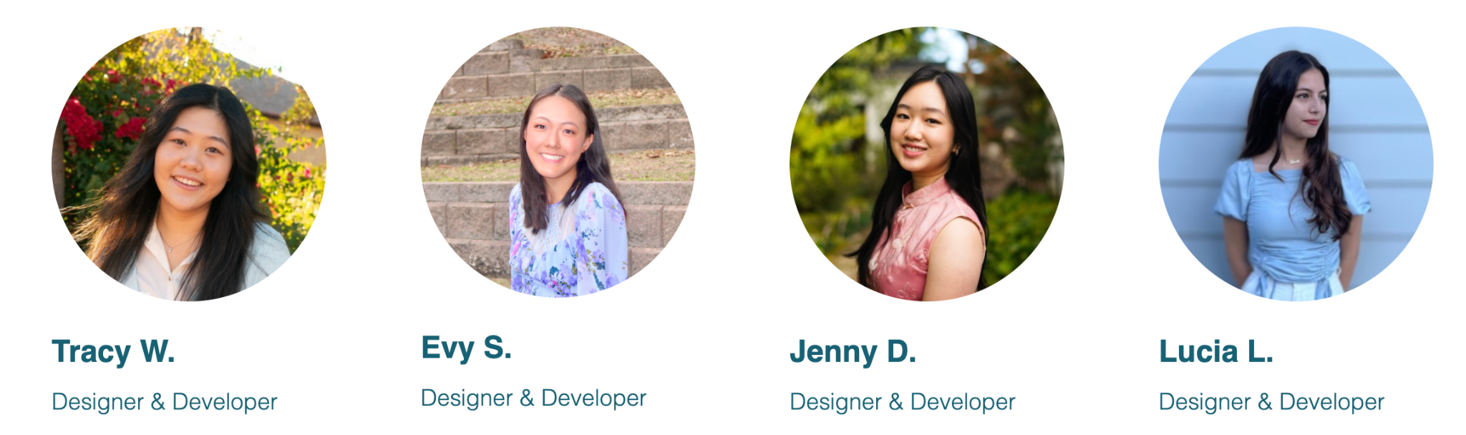

Problem / Solution Overview
Busy lives and time-zone differences make it difficult for long-distance loved ones to share updates in real time. During limited conversations, people have a hard time recounting little moments throughout their day, moments we believe are critical in maintaining emotional intimacy in relationships.

Bottle makes updating easy and fun:

1) Users store “mundane” updates throughout their day (text, images, videos, etc.) in a bottle, in which

2) they exchange with a receiver, to be opened and shared at a set time, enriching conversations. The anticipation before opening enhances engagement between the users.

Needfinding

Interviews
Within the broad studio theme of preserving the past, we brainstormed potential smaller domains. Some compelling options were sharing and tracking life habits and sharing travel spots with friends. After examining our interests as a group, which involved enhancing communication with friends and family, and integrating this interest with one of our group members being in a long-distance relationship, we narrowed down to the domain of long-distance relationships.

To uncover unmet needs in long-distance relationships, we conducted six interviews. Participants were recruited at the Sunday farmer’s market on California Avenue and through friends.

Our interviewees ranged in age, types of long-distance relationships experienced, length of physical distance apart, and gender. Specifically, our interviewees were high school students, university students, hardware store employees, mothers, and grandmothers who've been in romantic, friendship, and familial relationships spanning distances as close as within the same state to across the world.

We also interviewed two extreme users, both being university students. Brian, our first extreme user, was a long-distance boyfriend who moved across the country to his girlfriend’s dorm. Kevin, our second extreme user, was a long-distance boyfriend for two years before breaking up a few months ago.

Synthesis
From these interviews, we gleaned a variety of insights. Frustrations that were common or stood out to us included:

- Reduced variety of engagement: Brian* (extreme user) thought it was hard to find activities to do together to stay engaged with his girlfriend while they were long-distance.
- Exacerbated differences in love language: Kevin (extreme user) found that his girlfriend’s love language of words of affirmation was hard to support digitally. While in person, Kevin could give her hugs, but this support was hard to replicate over distance.
- Difficulty of involvement in children’s growing up: Patty says that her current communication with her long-distance family is sufficient, but wishes they could be more involved in their children’s lives even without in-person interaction.
- Less meaningful conversations: Time zone differences inhibit the feeling of connectedness as couples struggle to catch each other up on big events. Kevin revealed that their conversations were superficial and more centered around updates rather than meaningful.

After uncovering these frustrations, this further solidified our decision to stick with the domain of long-distance relationships to work on resolving these issues. To help us better understand the findings of our interviews, we made empathy maps for Patty, Brian, and Kevin.

Patty’s empathy map: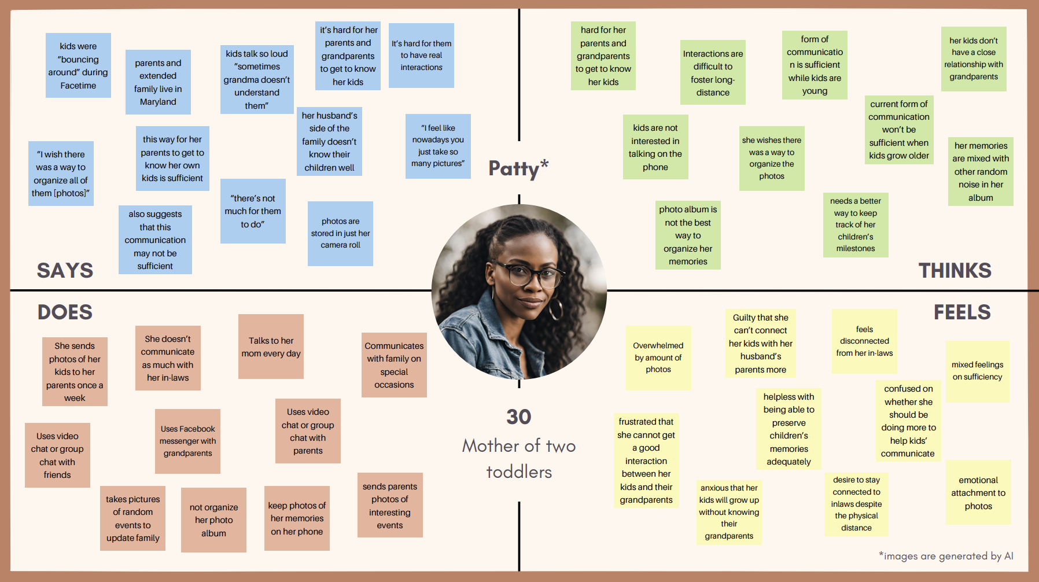
Brian’s empathy map: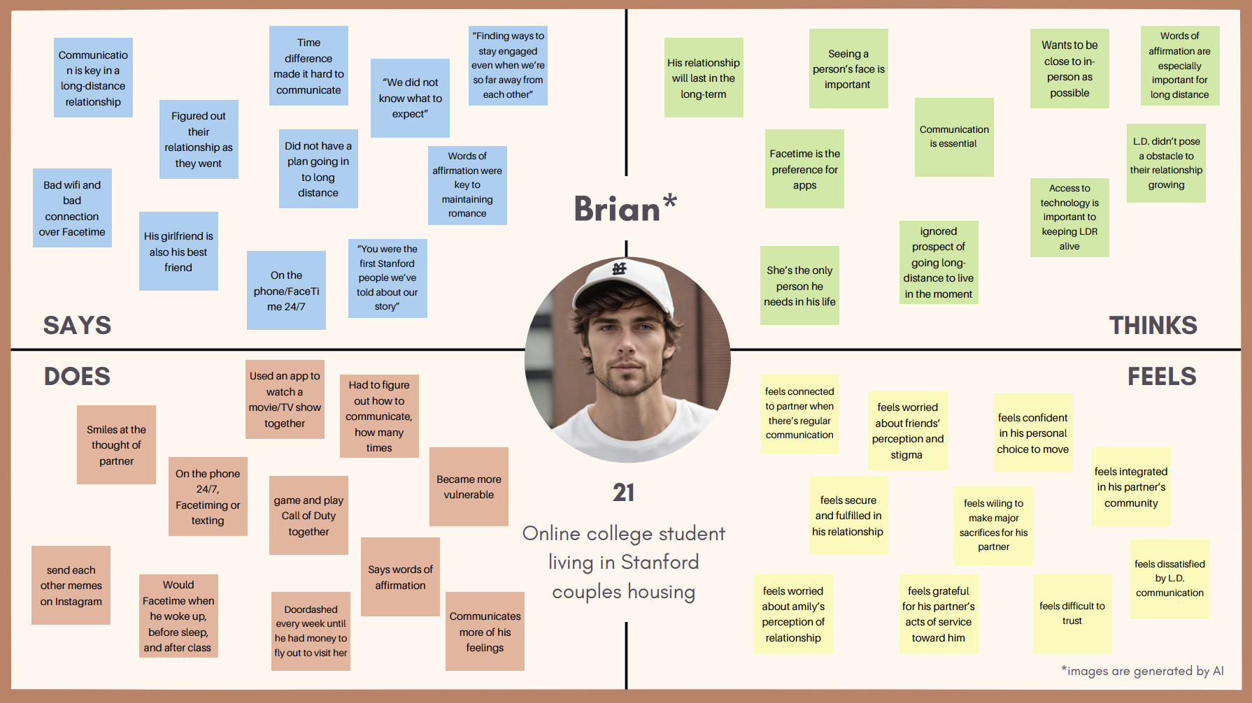

Kevin’s empathy map:
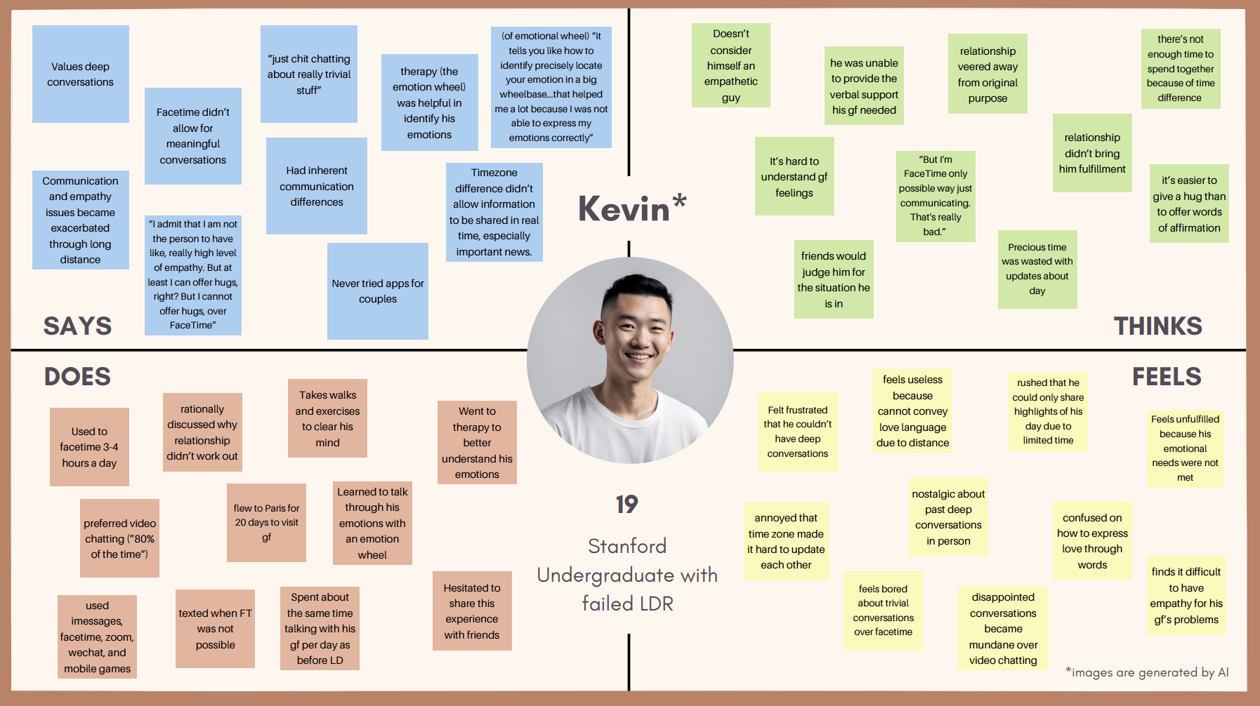

After analyzing the six interviews, we narrowed down our domain of long-distance relationships to facilitating connection over conversations. We found three more interviewees: Dr. Song (father of 2 kids living in the US whose parents and siblings live in South Korea), Chris (North Carolina Student whose grandma lives in Connecticut), and Kayla (Maryland Student whose best friend moved to Alabama).

Through these additional interviews, we gained more interesting insight. Two that stood out to us were:
- Long distance creates cultural distance between long-distance family members. Dr. Song acts as the intermediary between the kids and parents in their conversations, bridging Korean and American culture.
- Seeing snippets of each other's day is a valuable way to connect. Shared Snapchat stories of moments from their everyday lives facilitate connection.

Through this process, we found new, helpful insights that gave us more direction. We discovered that the most important needs voiced by our interviewees were the need for better conversations and ways to be more involved in each other’s lives.

* All names of participants are pseudonyms to preserve their privacy.

POVs and Experience Prototypes

Top 3 POVs
We structured information gained from our interviews into POV statements for our most insightful interviews (Patty, Kevin, and Dr. Song).

Patty’s POV:
We met Patty, a mother living in Palo Alto whose family is on the East Coast.
We were surprised to realize that she feels that her communication with her long-distance family is sufficient but wishes there was more interaction and connection for her kids.
We wondered if this means that she’s anxious her kids will grow up without knowing their long-distance family.
It would be game-changing to facilitate convenient and engaging ways for family members to feel connected to their children.

Kevin’s POV:
We met Kevin, a Stanford undergrad who recently broke up with his long-distance girlfriend of 2 years from overseas.
We were surprised to find that their limited time to talk did not lead to more meaningful and precious conversations but was rather occupied with mundane updates.
We wondered if this meant that Kevin did not have the chance to form a more meaningful relationship because he was unable to give real-time updates and talk about deeper topics.
It would be game-changing to shift their conversation priorities to meaningful topics that preserve their connection instead of trivial updates.

Dr. Song’s POV:
We met Dr. Song, a father of 2 kids who moved to the US from South Korea in 2006 and whose parents and siblings currently live in South Korea.
We were surprised to realize that he acts as an intermediary between his children and his parents and does not urge his children to make conversation with his parents due to cultural and linguistic barriers.
We wondered if this means that he thinks that his children and their grandparents are so different that they can not communicate with them without him as a bridge.
It would be game-changing to remove the cultural barrier between his children and their grandparents.

After we created each POV, we generated HMW statements for Patty, Kevin, and Dr. Song. After brainstorming 20 HMWs per interviewee, we each voted for the 2-3 most interesting.

Top 3 HMWs
- HMW make life updates and trivial topics more exciting?
- HMW create opportunities for parents to support shared storytelling and bonding between children and their grandparents?
- HMW make children interested in connecting with their long-distance relatives?

After HMWs, we brainstormed solutions, about ten solutions per HMW. We voted on the Jamboard for the top three solutions using icons.

Brainstorming solutions for top 3 HMWs
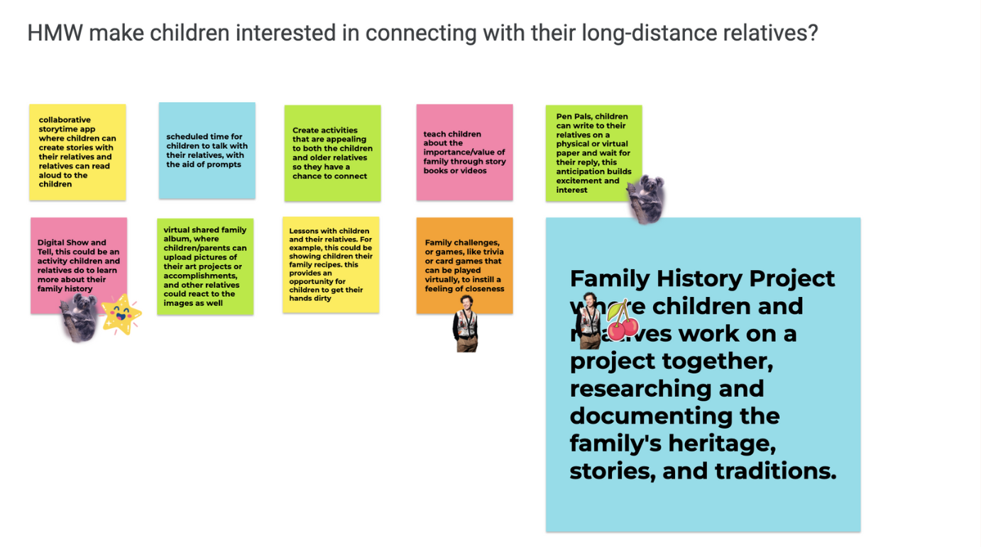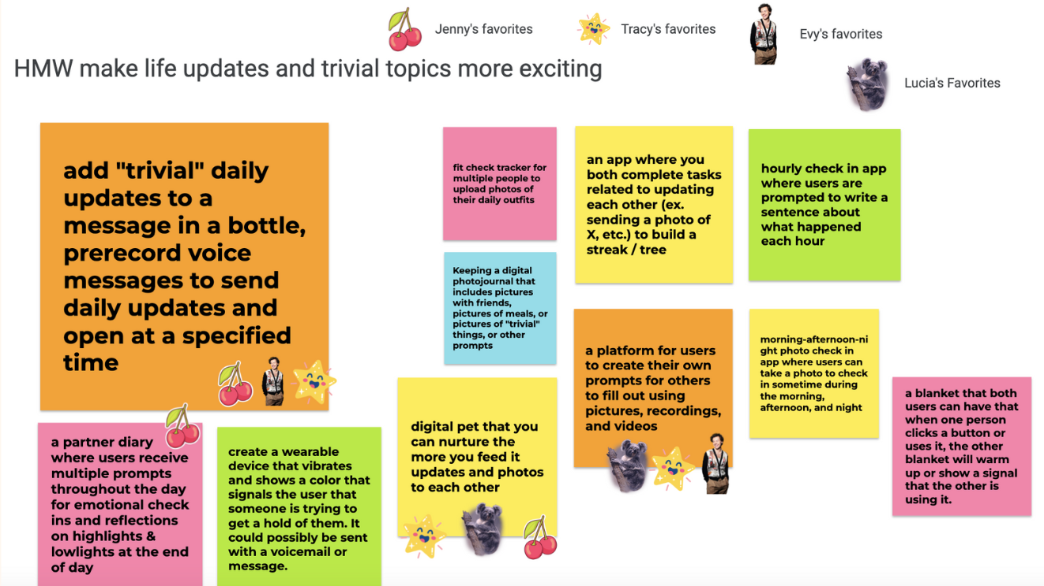
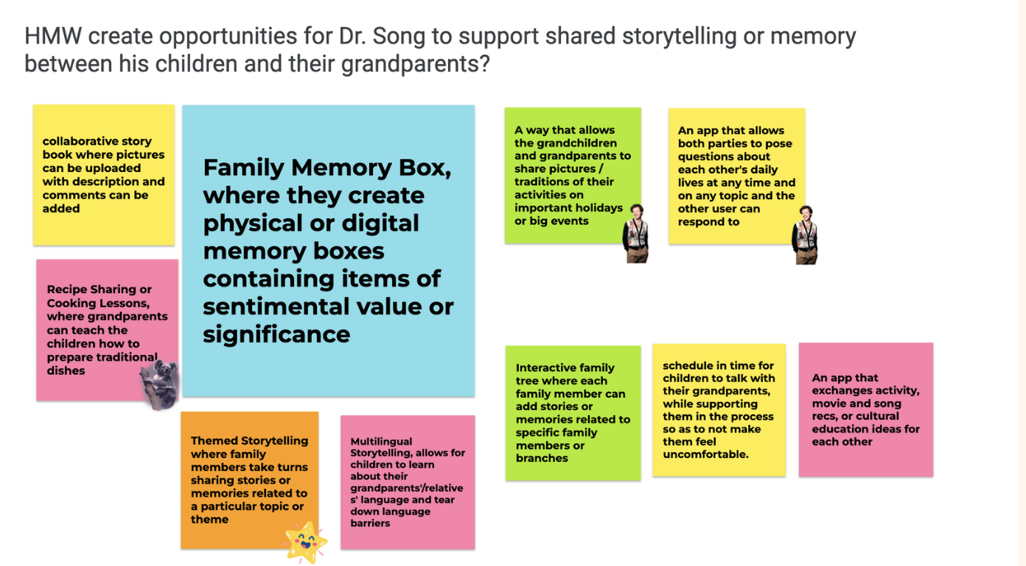

Top 3 Solutions
The top solution for each HMW was:

- Message in a Bottle: Add updates to a message in a bottle, prerecorded voice messages to send daily updates and open at a specified time

- Family Memory Box: Relatives create physical or digital memory boxes containing items of sentimental value or significance and take turns sharing why they entered a certain item.

- Family History Project: Children and relatives work on a project together, researching and documenting the family's heritage, stories, and traditions.

Experience Prototypes
We prototyped and tested each solution to determine which one we should continue with.

- Message in a bottle:

Prototype: For this experience prototype, we wanted to test the process of collecting everyday moments and thoughts into a space that will then be exchanged with each other at a set time. The intention was to provide a fun and efficient way to streamline updating while giving each other a genuine glimpse into their lives, addressing both Kevin’s pain point of the tediousness of giving updates and Kayla’s appreciation for sharing small moments.

To test, we provided a “long-distance” couple Maxine & Cody (gf/bf, both Stanford undergrads) 2 empty water bottles, and had them fill their bottles with updates / random thoughts throughout the day. Throughout the day, they were also asked to restrict any non-necessary communication via texts. At the end of the day, they exchanged their bottles and opened each other’s messages.

We received many positive responses from them both. Both were happy to share things they otherwise would have forgotten. Recording wasn’t inconvenient and both felt excited in the moment to share the moment later. An important response was their enjoyment of the efficient updating as they could ask for clarification on things that piqued their interest while giving less attention to the things.

Assumptions to be tested: Receiving and recording mundane moments brings value to the sender and receiver. It is not a burden to record your mundane moments. Waiting to open messages creates anticipation and excitement

- Family Memory Box:

Prototype: For this experience prototype we wanted to test whether discussing shared memories would bring a child and their family member closer together. To test, we had a child and grandparent talk about what memories are important to their family, putting objects associated with those memories into a box, or other form of compilation as they go through the collection together with another family member.
As the intended audience was long-distance children and family members, we had to test this on Zoom. As such, it was difficult to have a physical box when users. The “box” then became a show-and-tell moment, where the grandpa and child each shared pictures and the stories behind them.
Both were able to come up with meaningful memories to share. Some positive responses include sharing brought up emotions of closeness and that the activity reminded them that they are loved.
Some problems we experienced were connection issues with the older relative. Furthermore, we realized that some significant things do not have physical manifestations. Some only exist in memory. This ultimately deterred us from choosing this for further exploration.
Assumptions to be tested: Having a dedicated space for memories enhances the emotional connection to those memories People have moments of significance tied to objects, pictures, or videos.

- Family History Project
Prototype: We wanted to test whether investigating a shared family history would increase the connection between a child and their older relatives. For this prototype, participants are given a note-taking paper with prompts along with a voice memo app. They went through the prompts on the paper together, took notes, and voice-recorded their answers. Some prompts included interesting parts of their family history, traditions we celebrated as a family, and childhood memories.
Positive responses included that the child (Lisa) heard stories that she had never heard before, such as her grandmother’s childhood during WWII. Lisa felt like she grew closer to her grandmother, and she liked having these notes to look back on.
What didn’t work was that the information-sharing seemed very one-sided, often coming from Lisa’s grandmother. Lisa mainly listened and took notes, so this might not be a two-way connection established.
As we intended to work together on recording family history to deepen bonds between family members both ways, we decided not to move forward with this idea.
Assumptions to be tested: Children and their relatives will have engaging conversations or interactions upon going through the process of documenting their family history.

Deliberations:
When analyzing the implications and looking at avenues of further exploration to continue for each solution, we considered two factors.

First was applicability and reach. We found the most applicability in our Message in a Bottle solution as it facilitates communication amongst not only family, which was the main reach for the Family History Project and Family Memory Box but also friends. For the Family History Project in particular, one of our findings was that communication was primarily one way in which the older relative would share more of their life and history (to be expected, as they have more experience), whereas the younger family member would take on a more passive and learning role. We thought this didn’t foster as much active engagement and connection as we would have liked. This increase in impact along with strong positive responses from our participants Maxine and Cody in their excitement to view each other’s bottle recap increased our motivation to pursue Bottle.

The second factor we considered was the novelty of our idea. We found that the participants in the Family Memory Box already shared pictures regularly, so creating a space for them to reconnect would not add anything new. After our needfinding, in which Kevin expressed the tediousness of recounting updates throughout the day that detracted from more meaningful conversations during his calls with his girlfriend, we compared them with other “update-style” apps in the market, such as Locket, BeReal, Cappuccino, and Agape. We found gaps in each app, as they were either not able to support different forms of media, allow for multiple daily updates, or create daily recap mementos. Furthermore, the explicit excitement and positive response we received from Maxine and Cody in opening their bottles motivated us to create an opportunity for more friends and family to be able to see curated recaps of each other’s days.

Wanting to increase reach as well as fill unmet needs ultimately influenced our decision to continue with our Bottle.

Design Evolution

Final Solution: Bottle

Description: We created a “message in a bottle” type of app that enables users to send daily updates in the form of text, photo, video, and audio moments captured in a digital format. Users open the bottle at a daily specified time, connecting with loved ones from afar.

Rationale: Through insights gleaned from our user interviews, we realized the deep-seated need for a more personal and engaging way to stay connected with loved ones, especially over long distances. Our app is designed to cater to this need by enabling users to share their daily lives through a creative and intimate medium. Users (Kevin and Dr. Song) expressed that time zones pose a significant challenge in their relationships, which this app format addresses through its pre-set time feature. Moreover, interviewees (Patty and Kayla) expressed the significance of mundane, everyday moments in their conversations in maintaining connection. From testing prototypes 2 and 3, we discovered that users wanted ways to connect with different types of relationships in their lives beyond just family. Based on these learnings, we decided to develop a final solution that bridged the gap between distance relationships by elevating and providing a medium to capture one’s daily experiences.

Audience: This solution primarily serves people in long-distance relationships (friends, family, romantic partners)

Who might be left out: People who do not have access to the internet or digital devices would be excluded.

Ethical Implications: People may intend their messages in their bottle to only be seen by the receiver, but it may be leaked if there are problems with data security.

Functionality:
When deciding which tasks we wanted to allow users to do in our product, we drew upon user research and evidence we learned from needfinding.

Speaking with Kayla, who expressed how having a shared Snapchat story with her long-distance best friend allowed them to feel closer, as well as hearing Maxine and Cody’s excitement in reading about each other’s interesting small moments throughout the day from our experience prototypes, we knew that adding in moments into a bottle would be our most commonly used, and thus, core functionality. It became evident that adding in moments into a bottle would be our simple task.

For our medium task, we wanted to broaden the range of the community by allowing for more recipients and different time zones. As needfinding revealed that people had many different types of long-distance relationships (familial, friendship, romantic) that all require communication, we decided to make our app support the ability to send different bottles to different people, which would also consequently require flexibility in different time zones. Thus, the medium task includes changing the recipient of the bottle as well as bottle exchange time.

Our complex task is filtering moments based on emotions. We decided on this task based on our experience talking with Kevin, who voiced how sharing updates was meaningless and unstructured in his and his girlfriend’s conversations. This was due to the difficulty of fully remembering details about one’s day and took away their limited time to have more meaningful conversations. As we wanted to make updating more fun and meaningful, we thought that adding the feature to filter each moment with emotions would add more structure, streamlining, and fun to the recap.

Three Tasks
- Simple: Adding moments into the bottle
  - Adding moments into a bottle to be sent to a receiver is the core functionality of the platform. We believe this task will be the most frequented and as such the easiest to use for users. This task requires users to add pictures, voice memos, and videos into a bottle up until the time set. The bottle will be automatically sent once the time runs out.

- Moderate: Changing the default time for a receiver
  - At the first time of sending the bottle, users are given the chance to set a default time that works for both them and the receiver. The moderate task involves changing the default time for sending the bottle. This may be due to reasons like changing schedules and moving into different time zones. We anticipate this task to be less common than the simple task, which is why we placed this in the moderate task categories.

- Complex: Filtering by emotion
  - With every moment that is added to the bottle, users have the option of tagging an emotion, which can be done by pressing one of the four emojis (happy, angry, sad, funny). On the receiver's end, when the bottle is received, there is the option to select an emotion, which will filter all the moments to only return those of the selected emotion. This will allow for a fun way to view the moments.

Low-fi Prototype / Initial Sketches
In our initial sketching, we considered a few realizations of our idea including augmented reality, virtual reality, and mobile app. In this process, each team member sketched 8 key frames per realization. After reviewing the team’s key frames, the two realizations that excited us the most were mobile applications and augmented reality. We eliminated virtual reality because we believed that it would be difficult to add and collect moments from a real environment. For mobile app and AR, the two realizations we decided to move forward with for further exploration, we deliberated on the pros and cons before making the final decision.

1. Mobile application
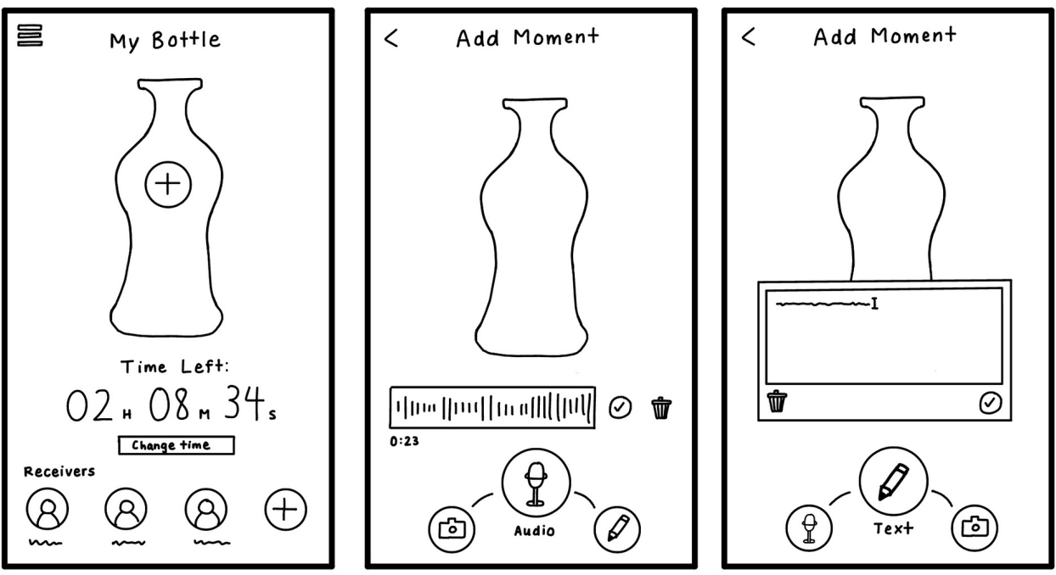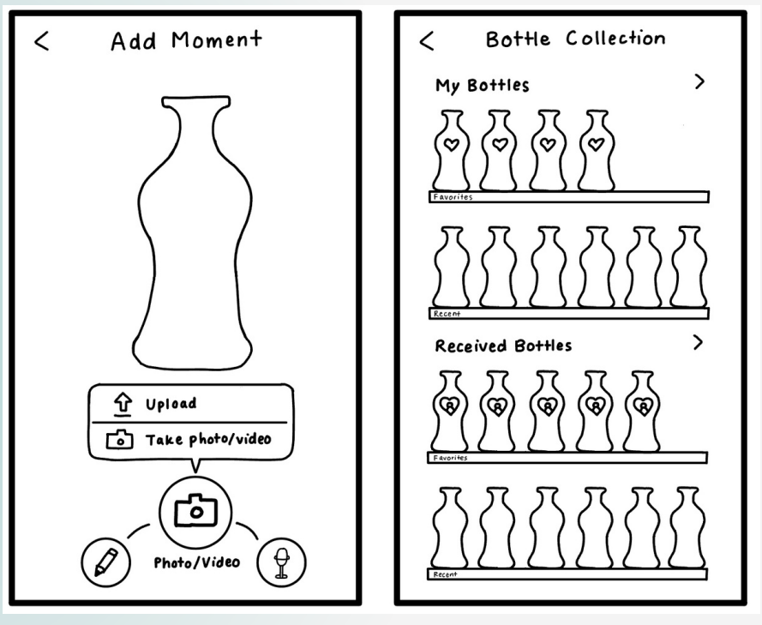

As our collection of moments encompasses a wide range of media, it is convenient and novel for users to consolidate the usage of all of these functions (capturing pics/videos, sending texts, and other media and sending) in one app. A con we thought of was that mobile apps can be difficult to learn for older populations and graphics / interactive components may be hard to use for those visually impaired.

2. Augmented Reality
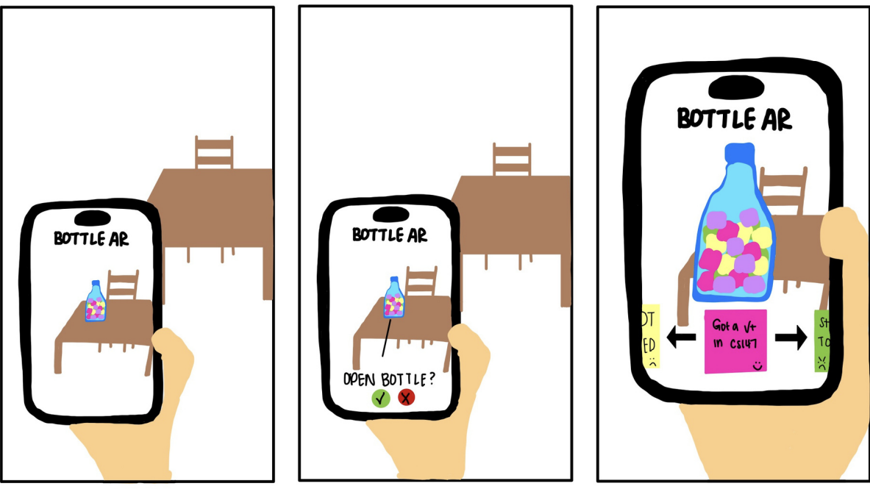

For augmented reality, we were entertained by the thought that users can "see" the bottle appear in their space, pick it up, and "open" it. This mimics the thrill of finding a real message in a bottle, playing to human curiosity and the joy of serendipitous discovery. However, AR technology can be difficult to access for the visually impaired and is less adopted in usage than mobile apps.

After analyzing the pros and cons of both mobile apps and VR, we believe a mobile app best suits our solution idea because it can accommodate a wide range of media (photos, text, videos, voice memos, etc). This allows users to have more flexibility in documenting their everyday moments. It is also more convenient for users as more people own mobile devices compared to AR technology.

Lastly, an AR implementation would not always be practical given the different environments users may find themselves in and it is not inclusive of people who may have visual impairments. We want our solution to have a wide reach, so a mobile app is the superior option for our solution.

Moving onto low-fi prototype sketching, we adopted Notability as our go-to tool for concept sketches and initial prototyping due to its familiar and user-friendly interface. The application offers a pen-on-paper-like experience, effectively replicating the traditional process of sketching on paper, which makes it a preferred choice for many in our team.

Task 1: Adding Moments
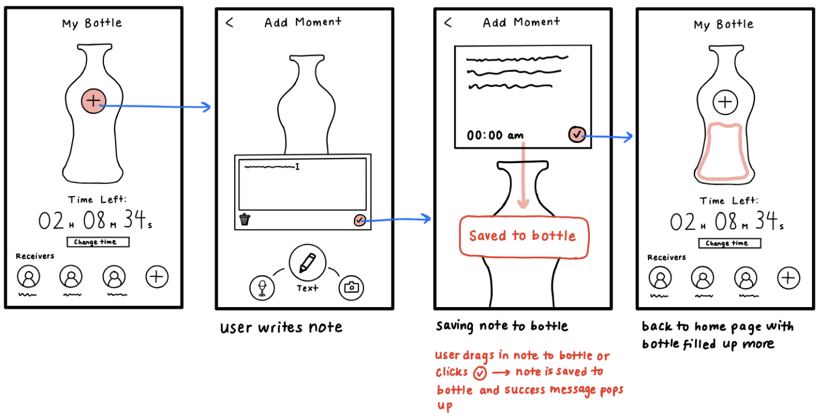

Task 2: Changing the unlock time for a receiver
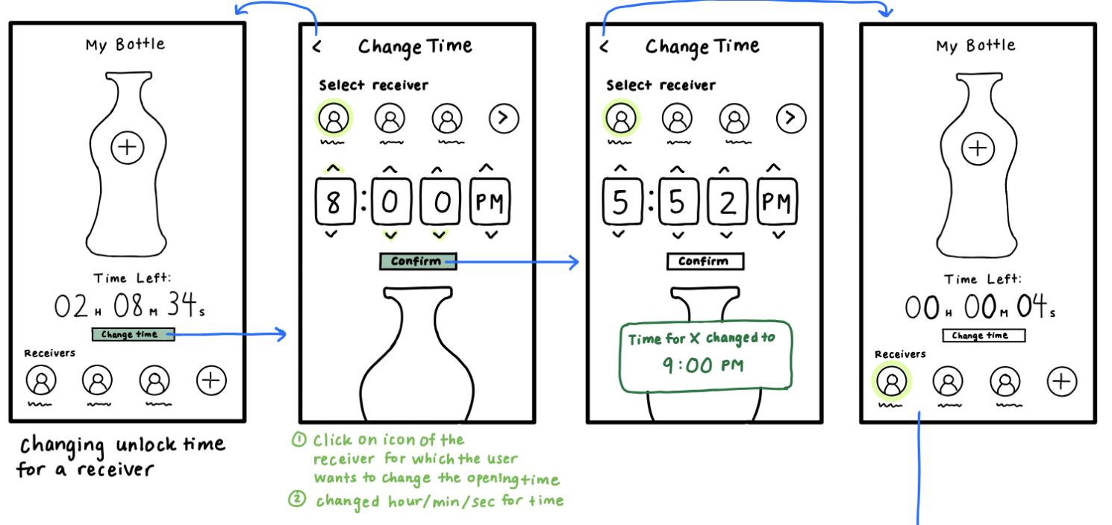

Task 3: Filtering Moments by Emotion

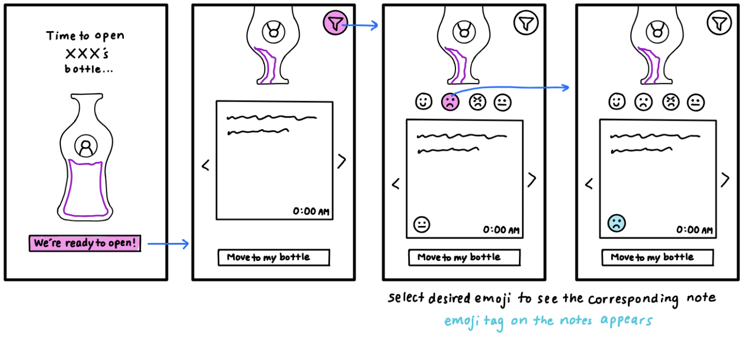

Usability Testing
We created a paper prototype of our app based on our low-fi prototype, with the 3 task flows. For recruitment for participation in our low-fi prototype, we got five total participants interviewed in Peet’s Coffee, compensated with a gift card. Our participants ranged in gender as well as age – from high school students to senior adults.

These paper prototypes were then laid out on a table in front of our participants. After giving them background information on the purpose of our app, each participant was told to perform each task by having them tap on the screens to simulate actions. The computer changed the screens or added pop-ups accordingly. In the end, we asked the participants for feedback about each task, including the aspects they found enjoyable and the parts they found confusing, recording each interview.

Paper Prototype Construction and Testing
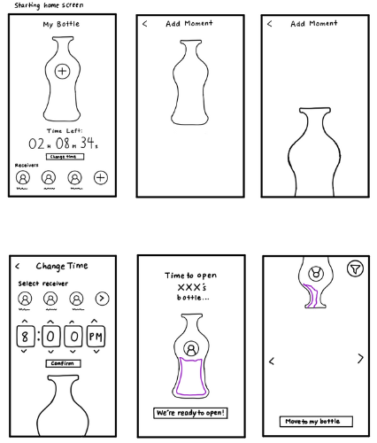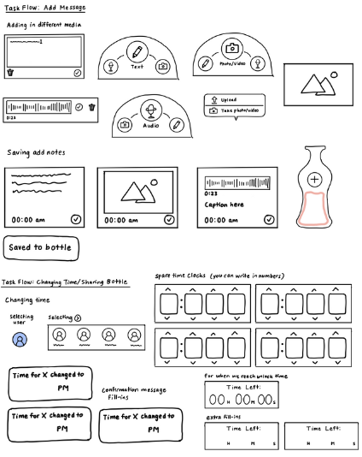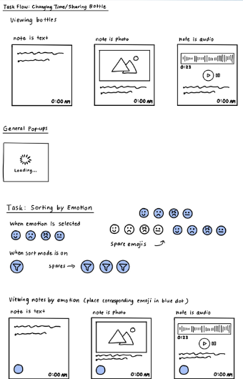

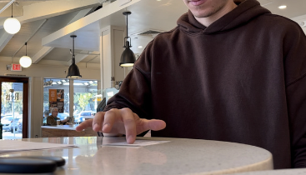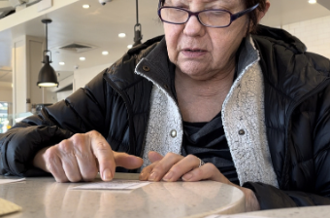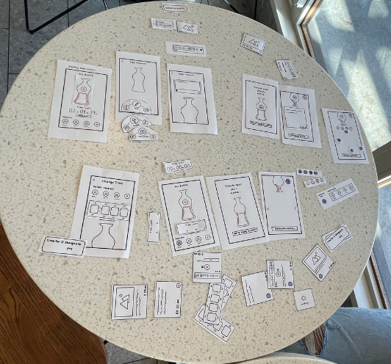

Synthesis of Results:
Our goals for the testing were to identify gaps in our features, test if users are familiar with the icons we chose, and the purpose of each screen. We also wanted to determine if the app is intuitive and easy to navigate, even to the less technologically savvy population. Overall, positive key insights included enthusiasm about the app’s design, aesthetic, and simplicity. Younger users found it more intuitive, whereas the older demographic cited areas of improvement.

Our metrics for overall usability were through soliciting explicit open-ended feedback to gain insight into their experience through the questions “What was confusing?” and “Did you get stuck anywhere where you weren’t sure how to proceed?” We also tracked whether users could complete all three tasks and the number of errors they made for each task.

We were pleased to find a 100% completion rate for the simple and moderate tasks and 80% completion rate for completing the complex task. 100% of users also navigated the camera, text, and voice memo bar.

Errors
Some points of confusion were overall confusion on what is being measured concerning the effectiveness of enhanced long-distance communication and what the time represented on the home screen, namely whether it was time to fill a bottle or time to open. We also observed confusion on the order of tasks being completed. We also noticed that 1 participant added a message in the bottle before selecting the user. Another participant, an older woman, did not complete the task flow of emotion filtering.

Reflecting on the errors led us to contemplate how we wanted to hierarchically and visibly communicate which tasks should be more visible and which features should be more clear. For example, our simple task and the app’s core functionality of adding moments needed to be more apparent from the home screen, so we planned to label the time with a clear indication of the time until the bottle was sent.

We also received feedback on the size of the prototype and the uncertainty of the functionality, which we believed would resolve itself with further refinement in the app’s design and fidelity over time.

Med-Fi Prototype
Taking the feedback we received from the low-fi prototype testing in stride, we immediately began developing our med-fi prototype. For our medium-fidelity design and UX choices, we used Figma, which enhanced our collaborative workflow thanks to its real-time collaboration features. Figma’s vector-based approach allows for pixel precision in design, making it a robust tool for creating detailed and scalable graphics. Its web-based nature ensures cross-platform compatibility, enabling us to work across different operating systems without issue.

Task 1: Adding moments
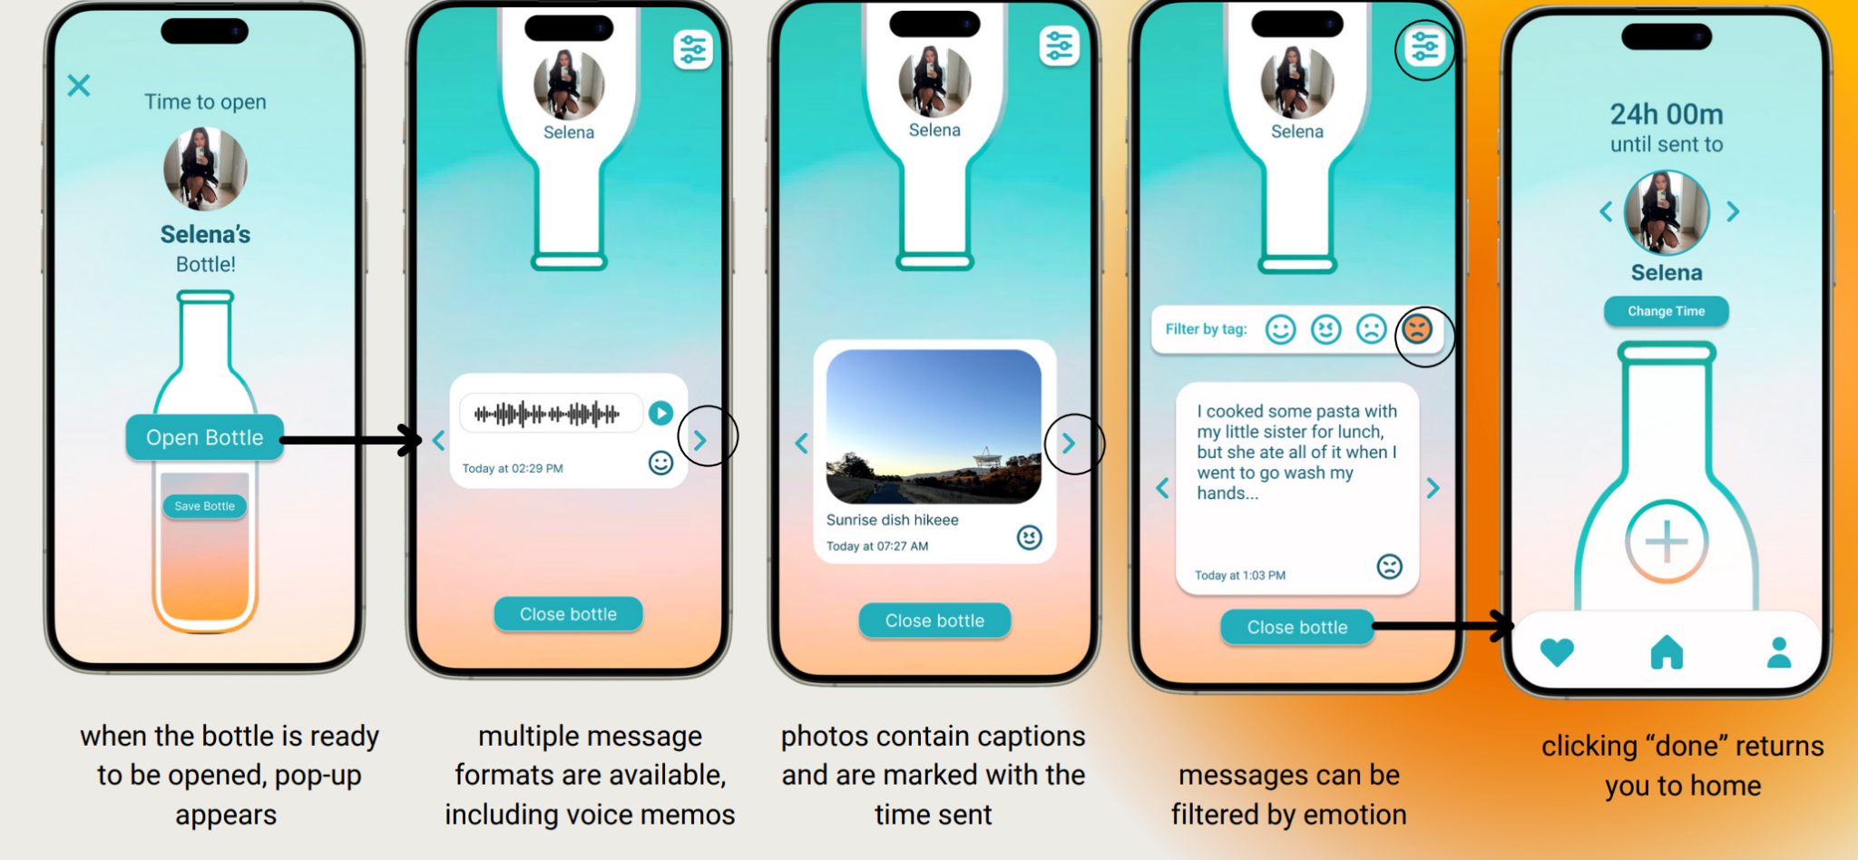
Task 2: Changing time for receiver
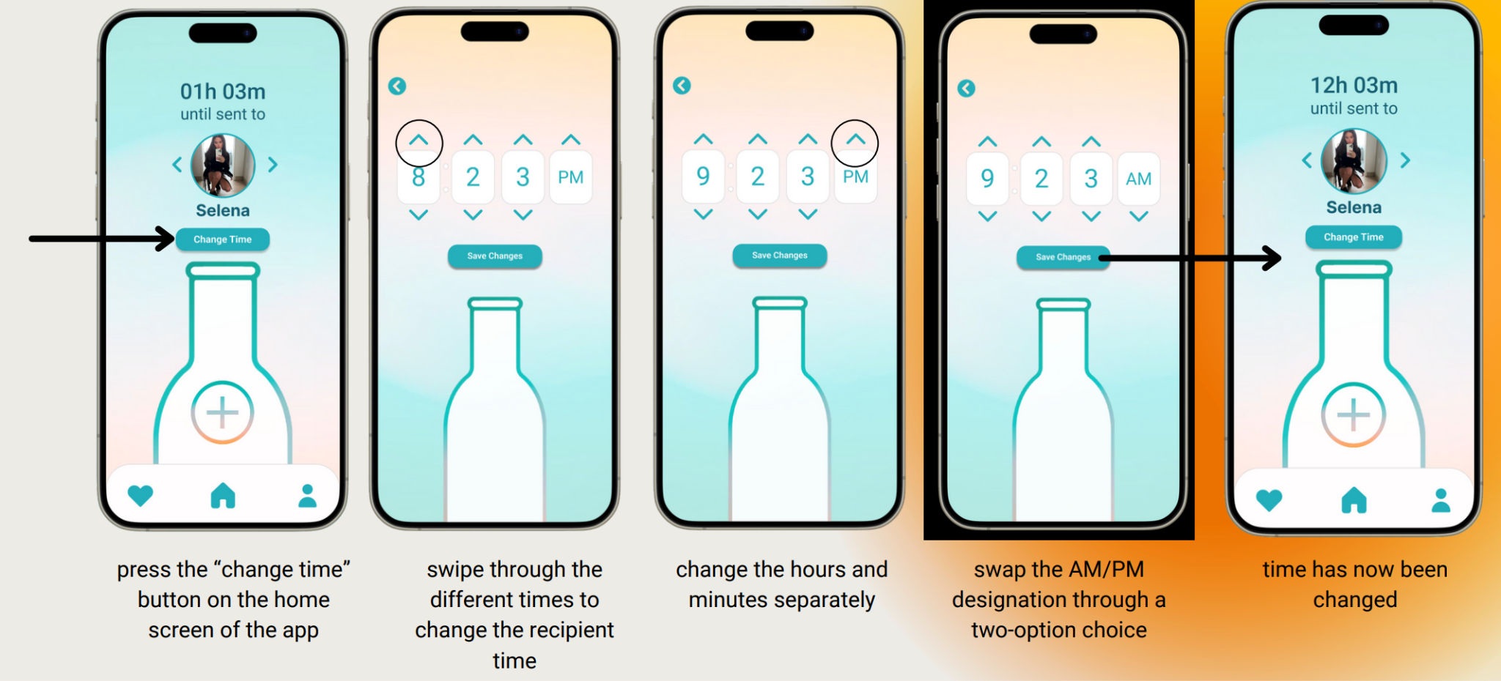

Task 3: Filtering moments by emotions
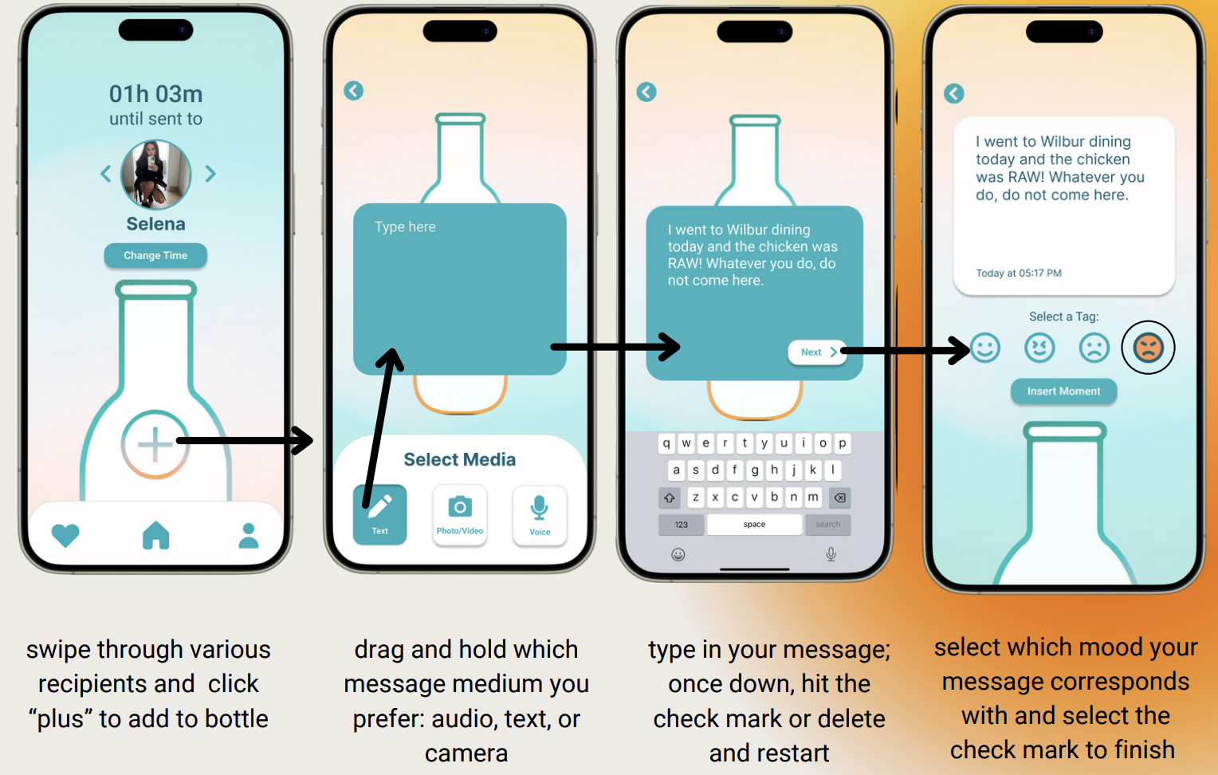

Feedback / Heuristic Evaluations:

With our medium-fi prototype, we received heuristic evaluations and more awareness of room for improvement. In particular, most violations we needed to address were consistency & standards (H4) as well as accessibility (H11).

When it comes to addressing those two heuristics, we needed to:
- Enhance error prevention mechanisms, especially in viewing and managing sent content
- Improve visibility of system status, particularly in indicating active screens and navigation
- Prioritize accessibility concerns, including text legibility and providing alternative input methods
- Enhance the value alignment and inclusion by allowing users to edit their media for authenticity
- Efficiency in features, e.g. time and recipient selection

Revised UI Changes
We built our hi-fi prototype by incorporating design changes from our heuristic evaluation. Here are a few main changes:

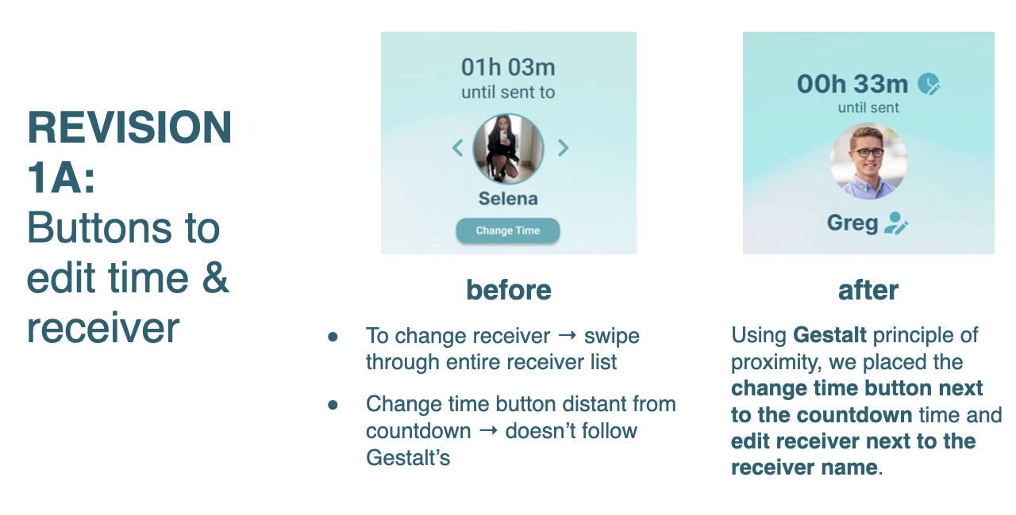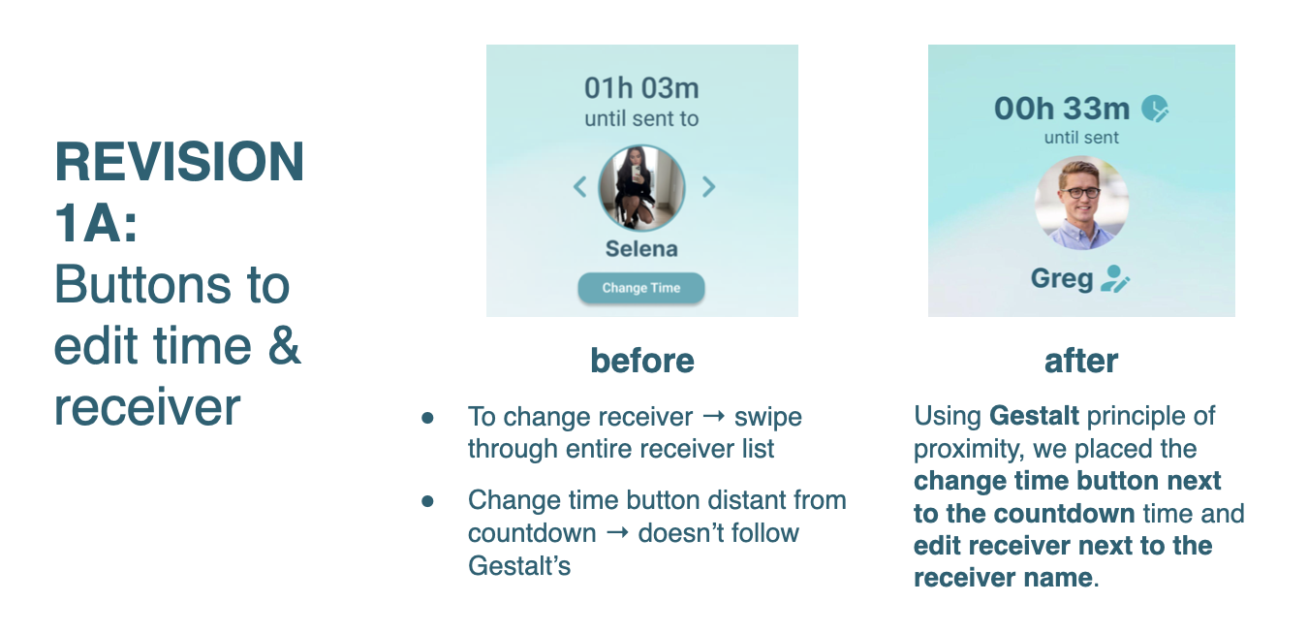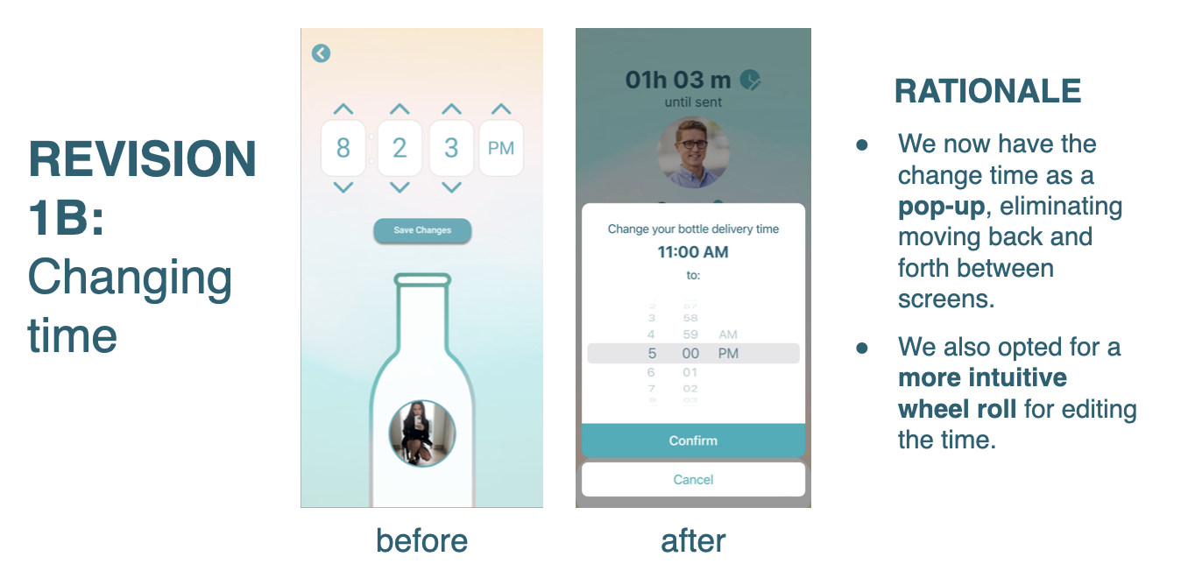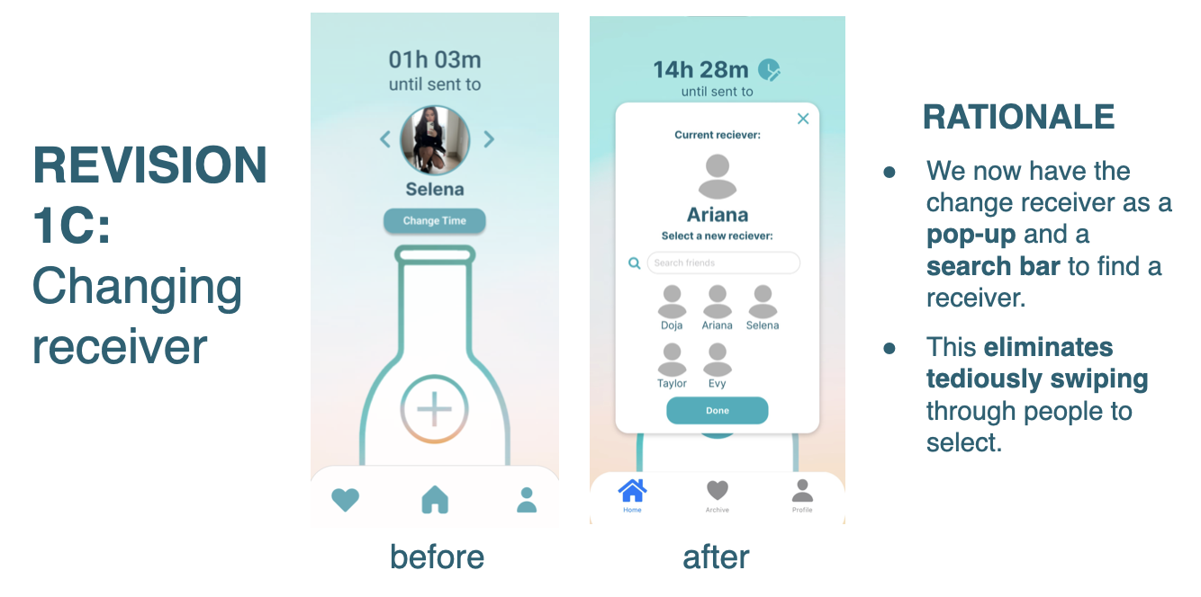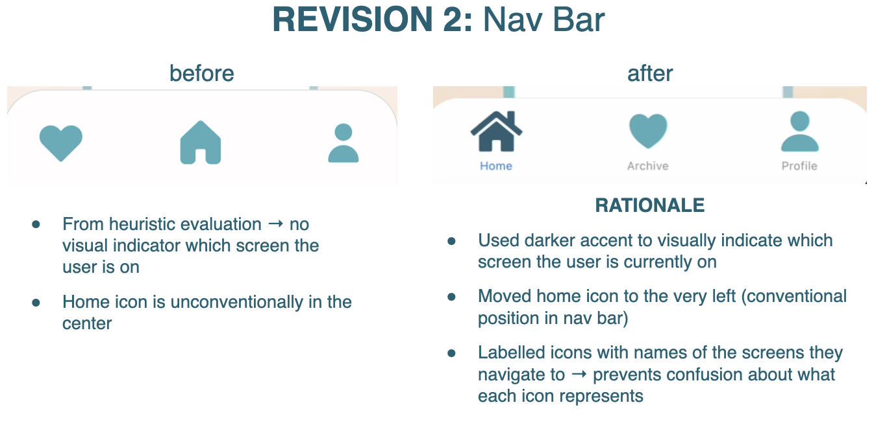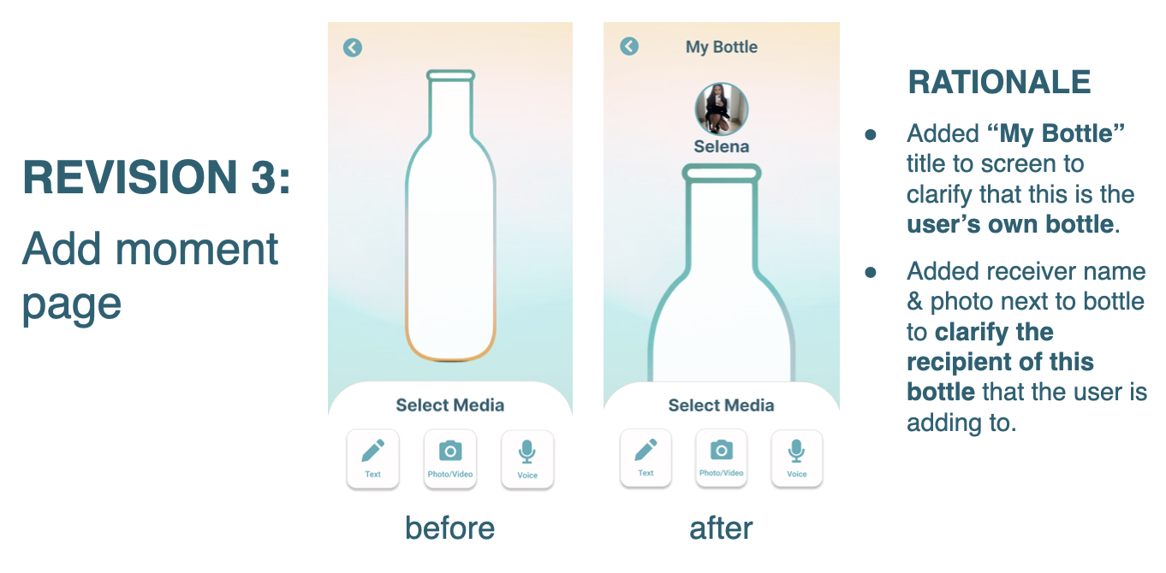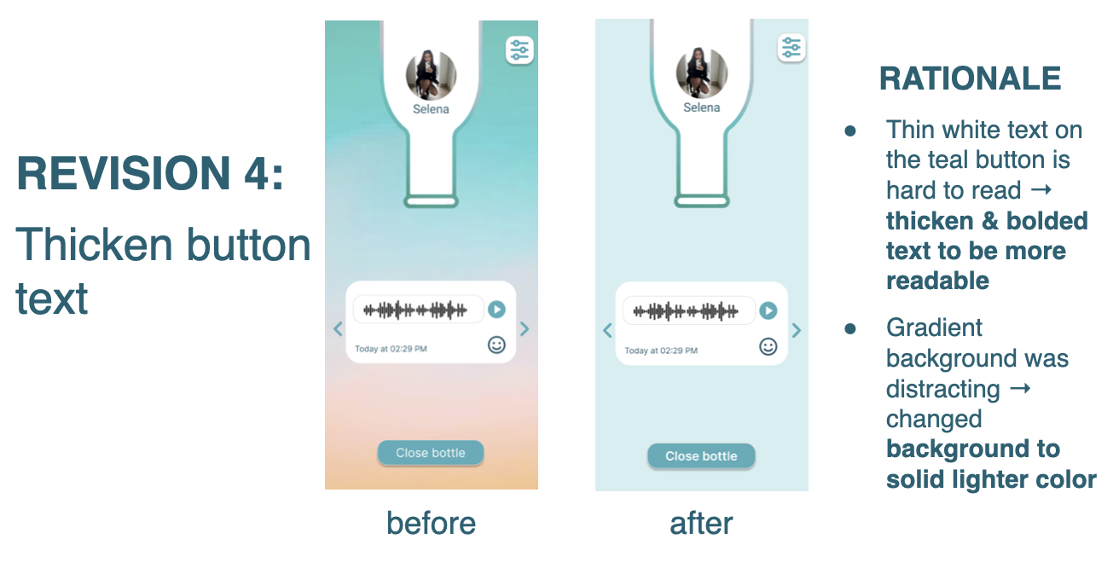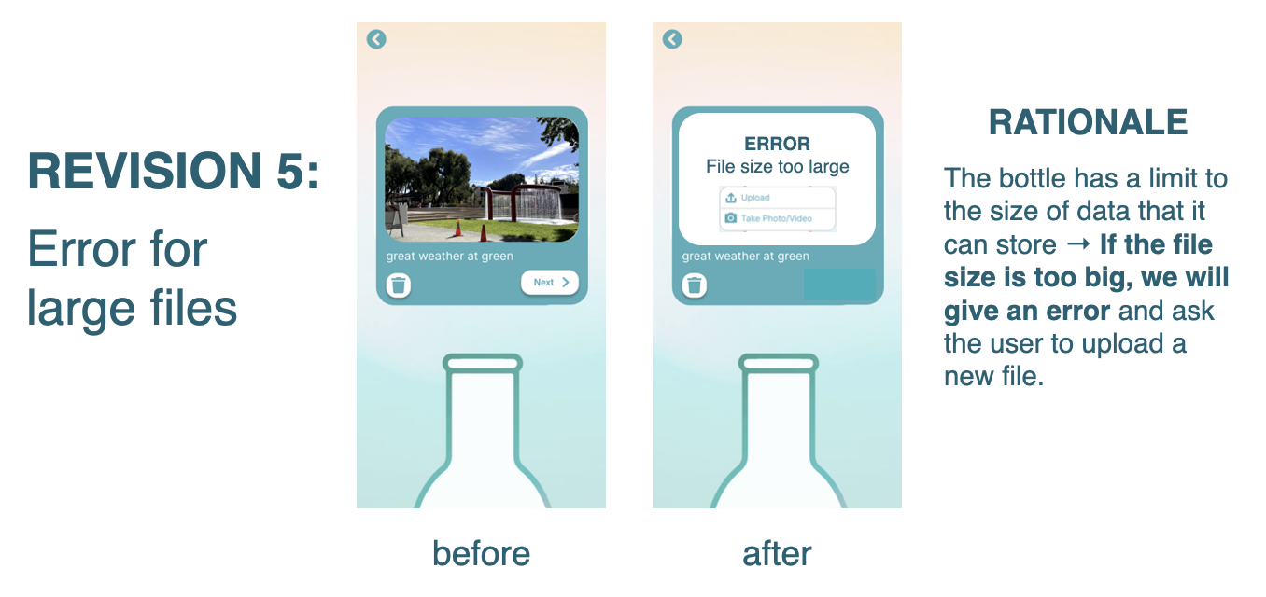

Hi-Fi Prototype
Simple Task: Inserting Moments

Add Text:
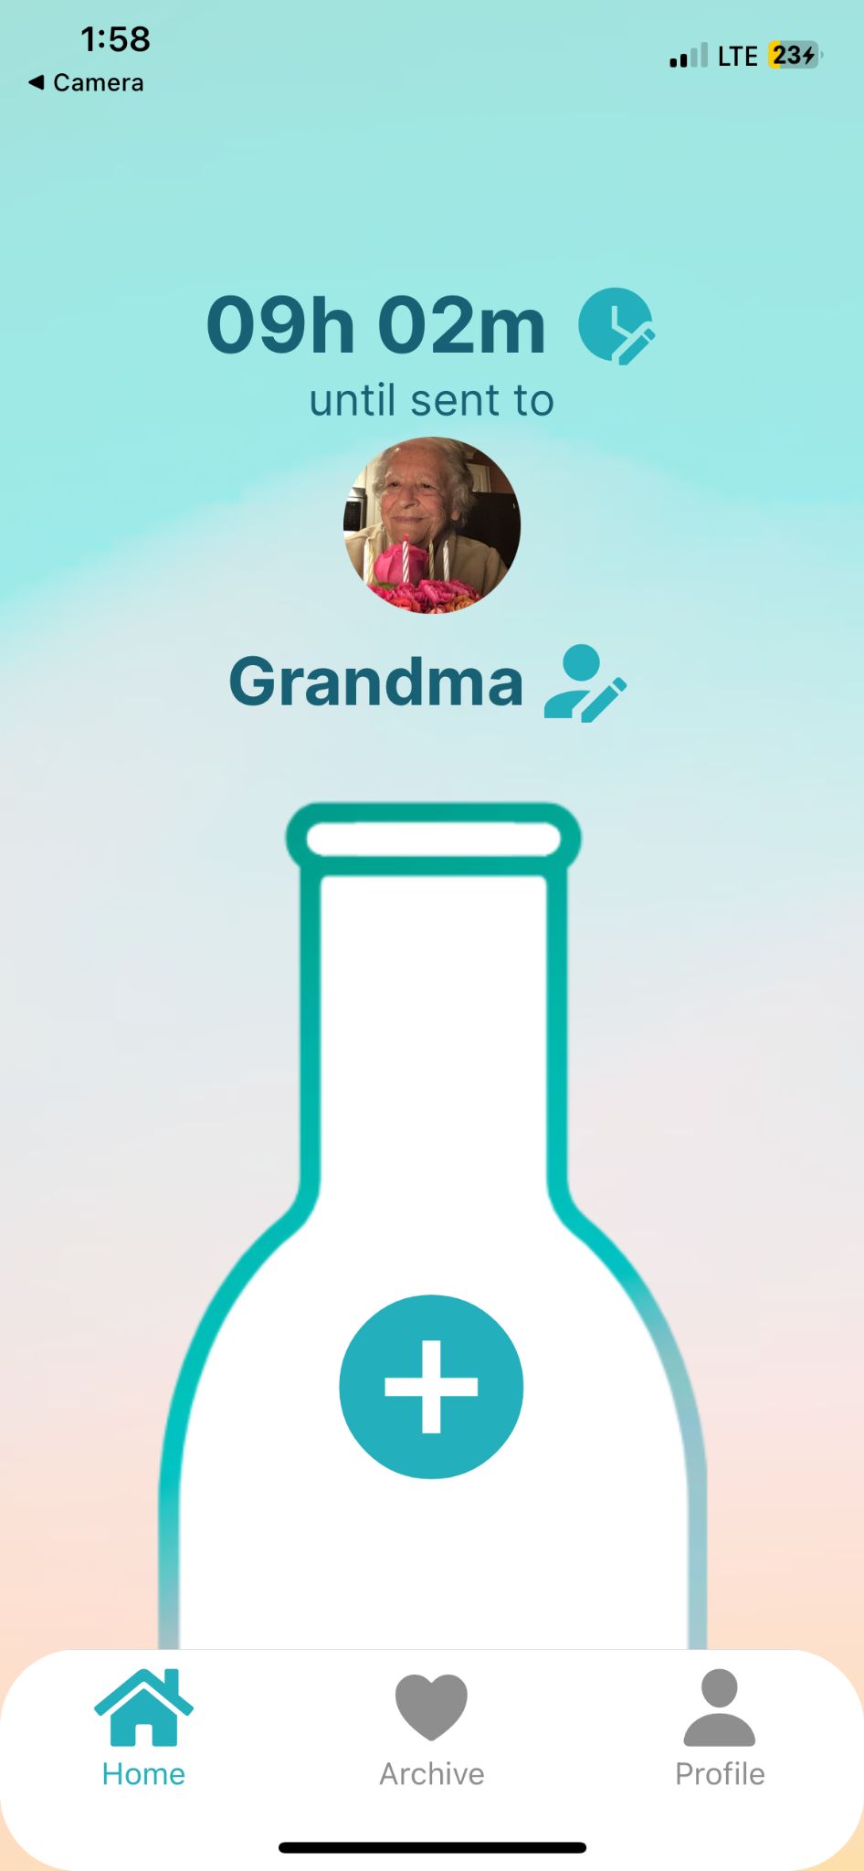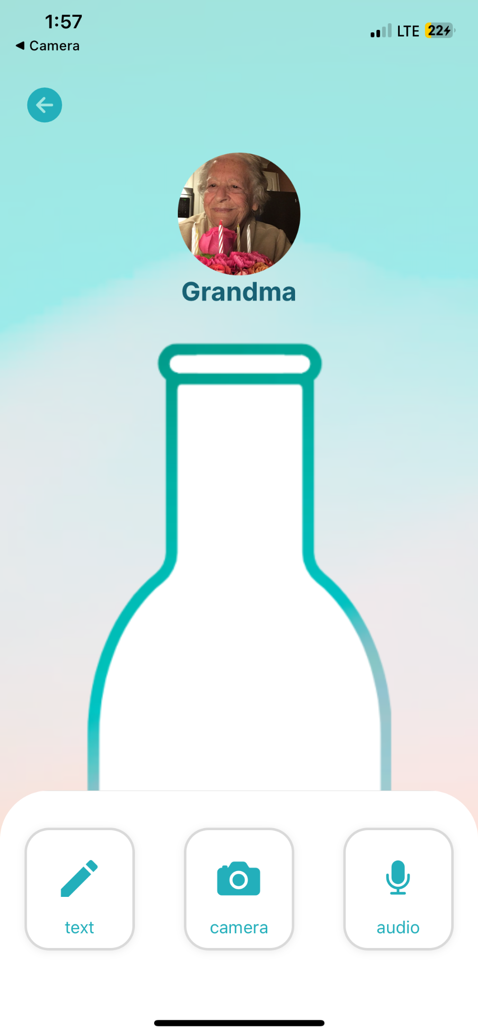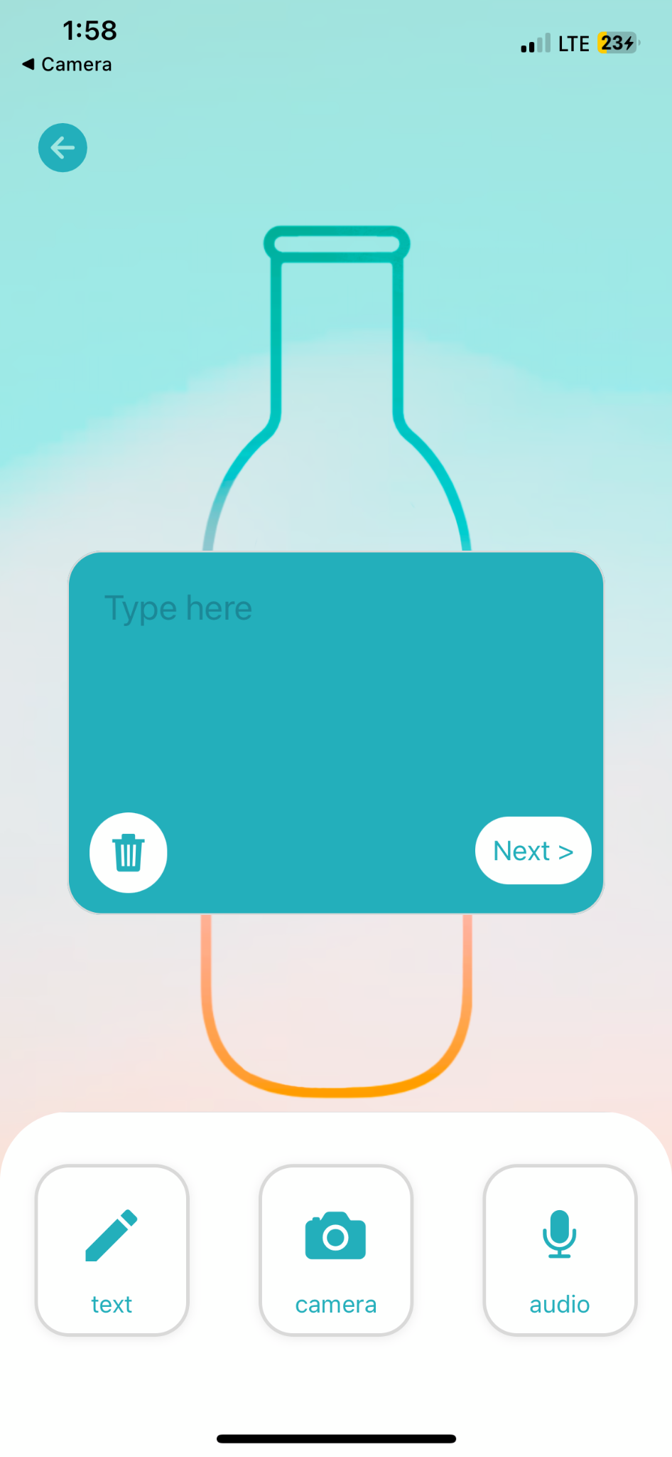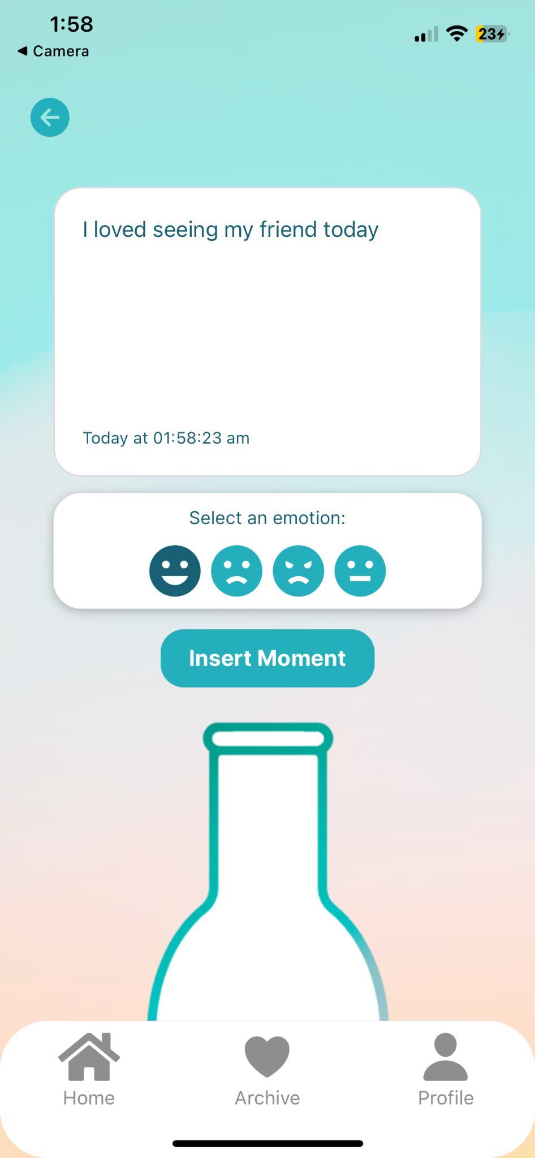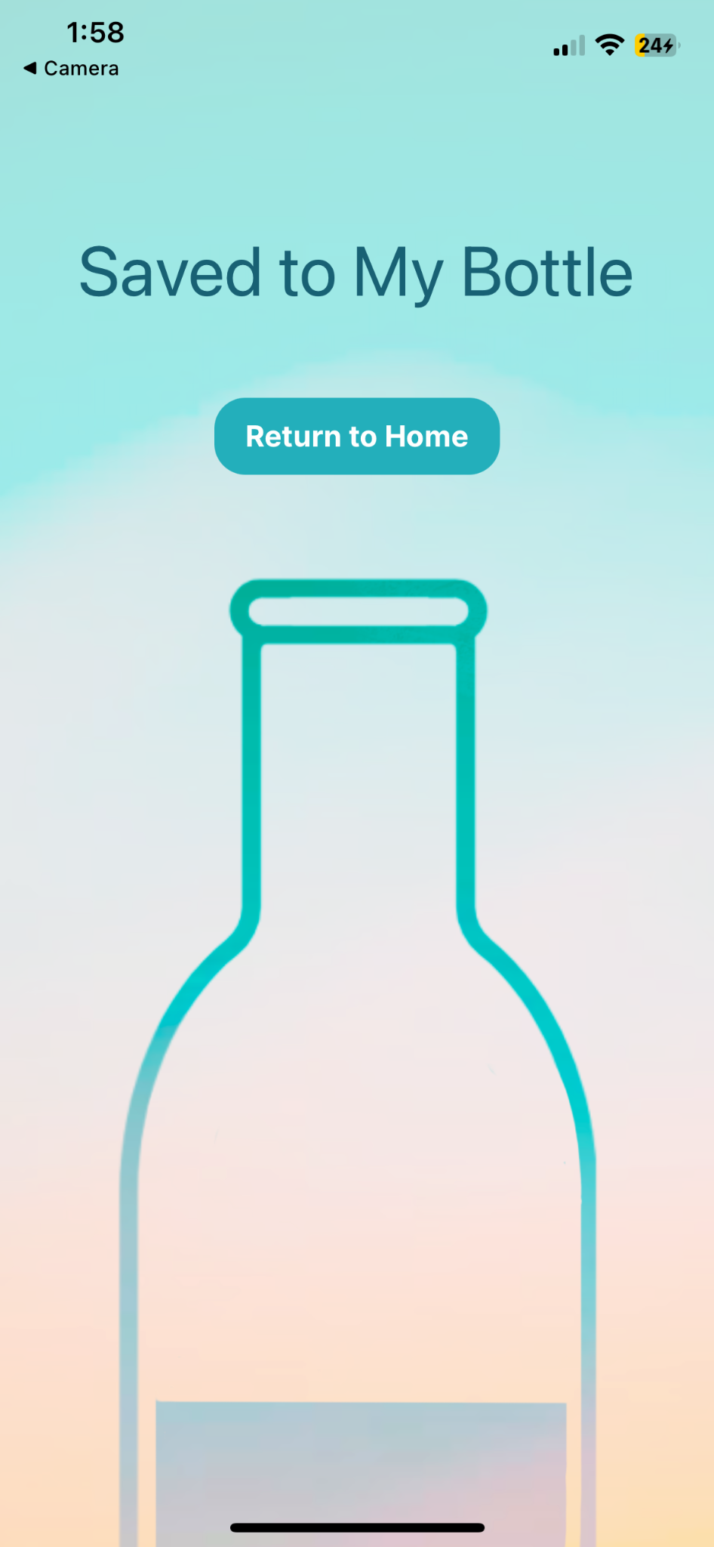
Add Photo/Video:
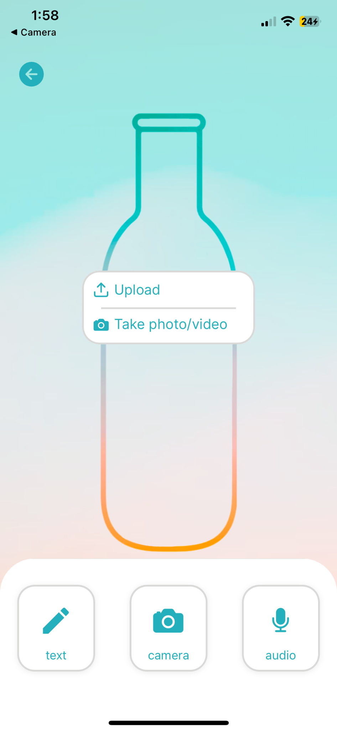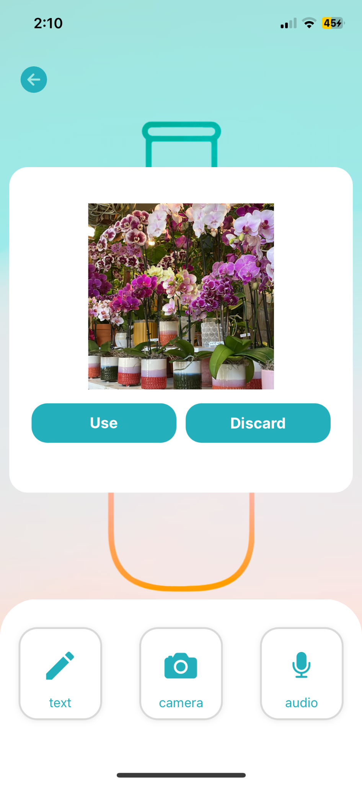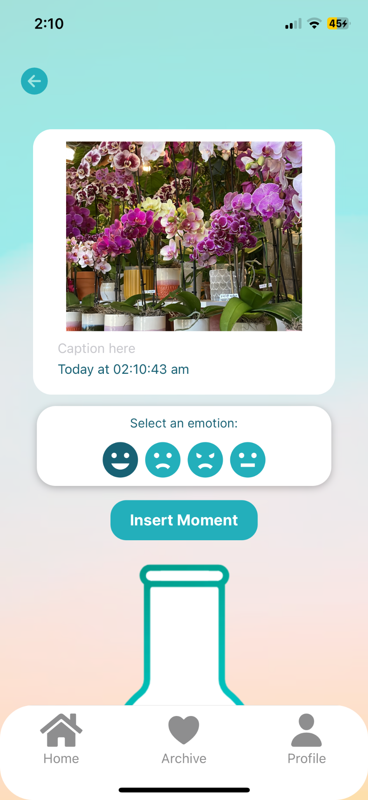

Add Audio:
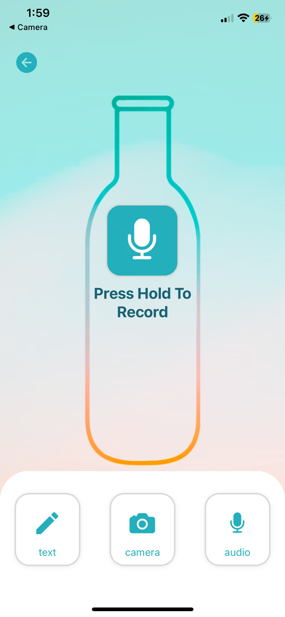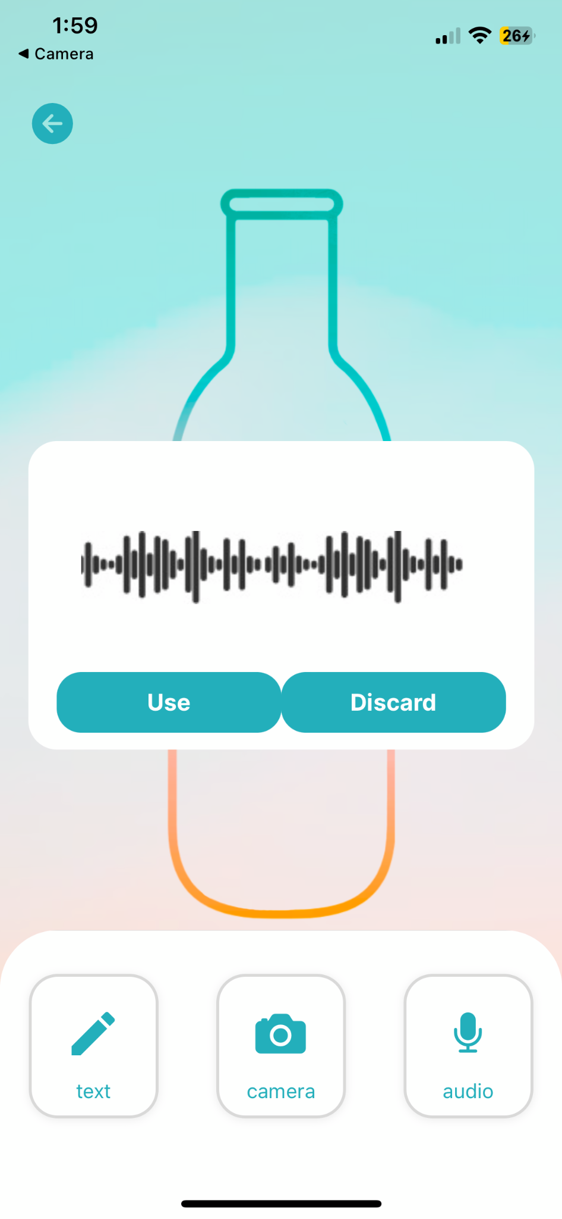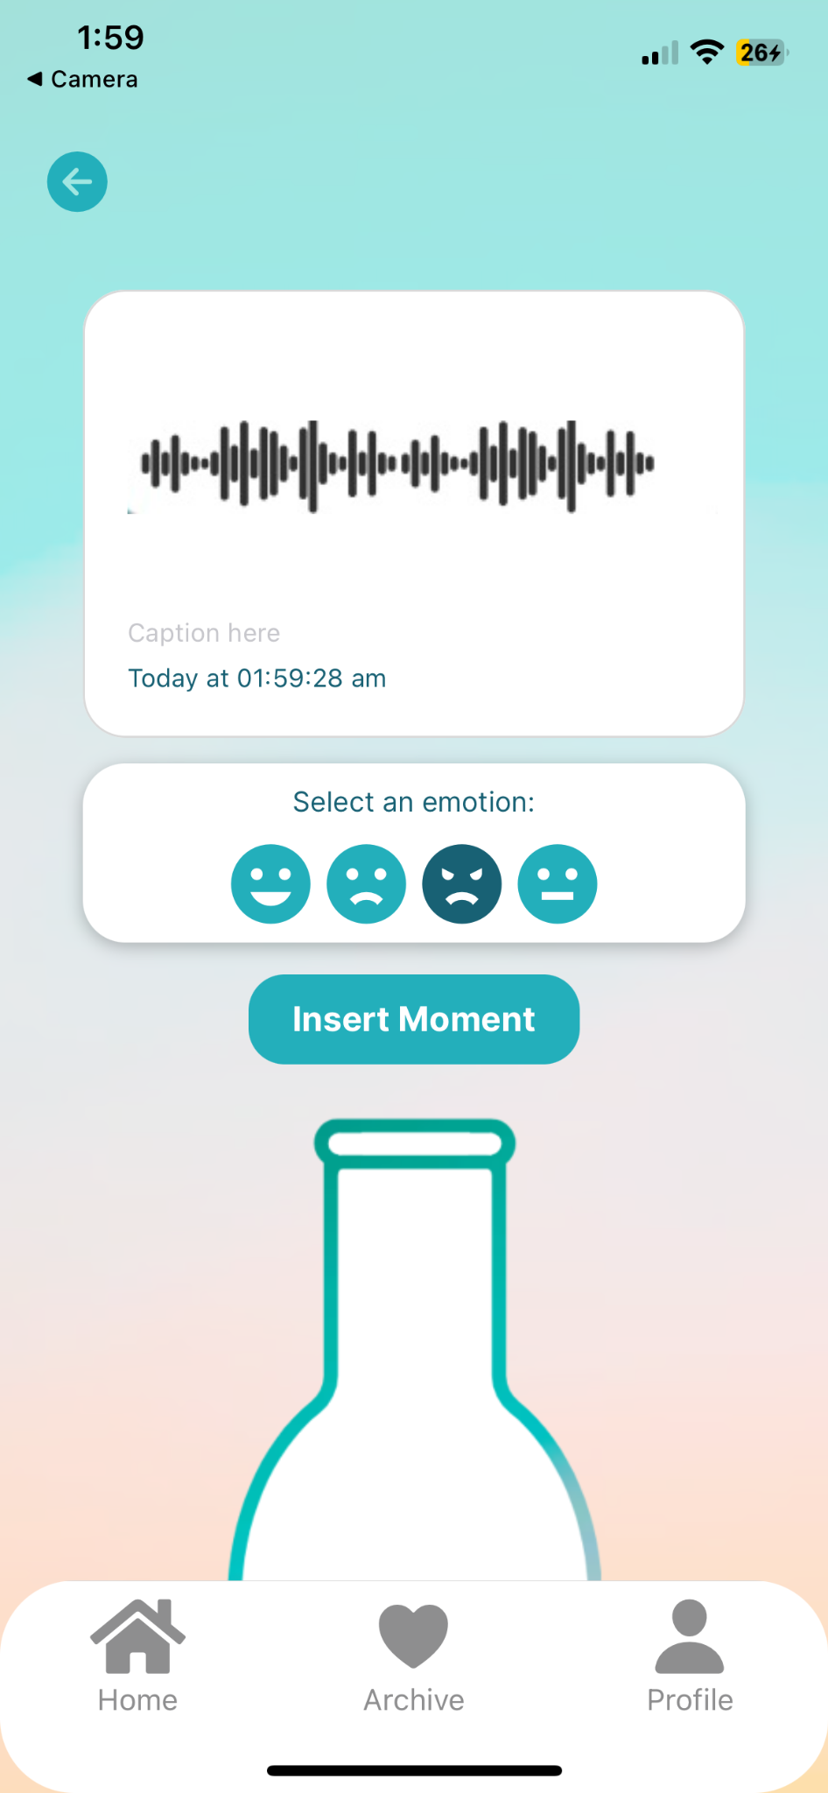

Notes: The trash icon button actively clears inputted text in the text field. We pass user text inputs between screens via React useState features. The time that a message is sent is actively captured via passing through the React moment package. The ability to tag inputs with emojis is developed using a custom handleEmojiSelect function. We have fully implemented a camera feature with custom styling that allows users to import from their camera roll or capture real-time photo/video content.

Medium Task: Changing Recipient and Receiving Time
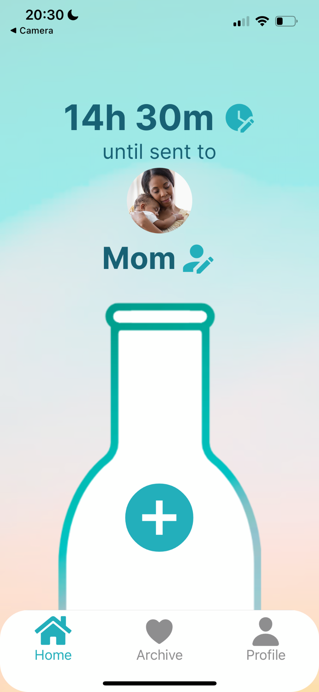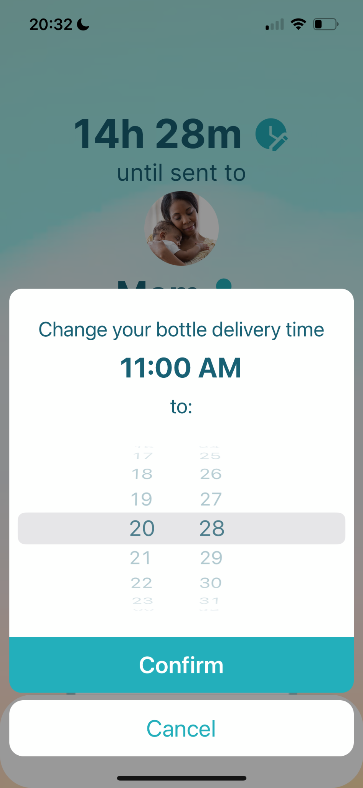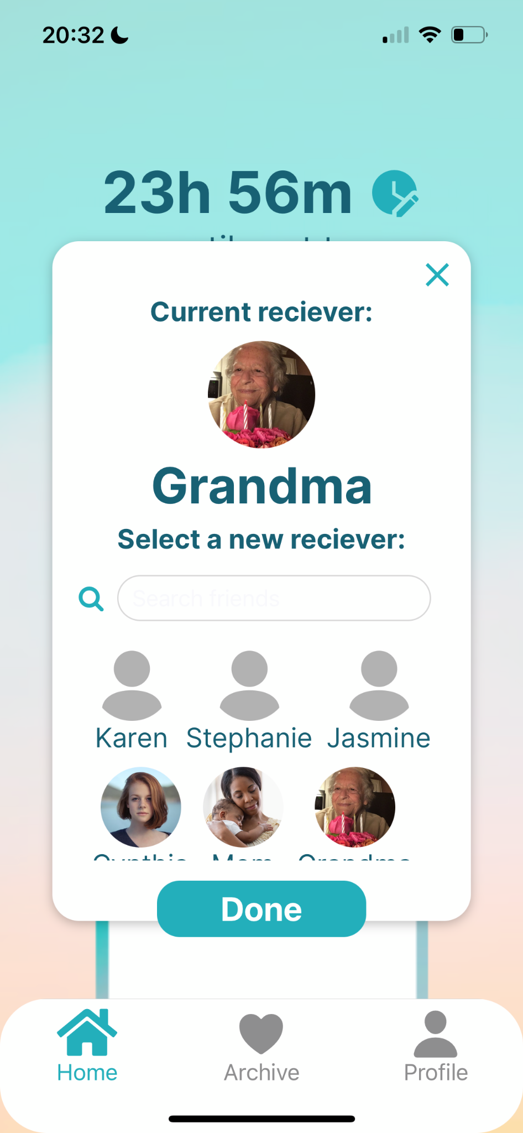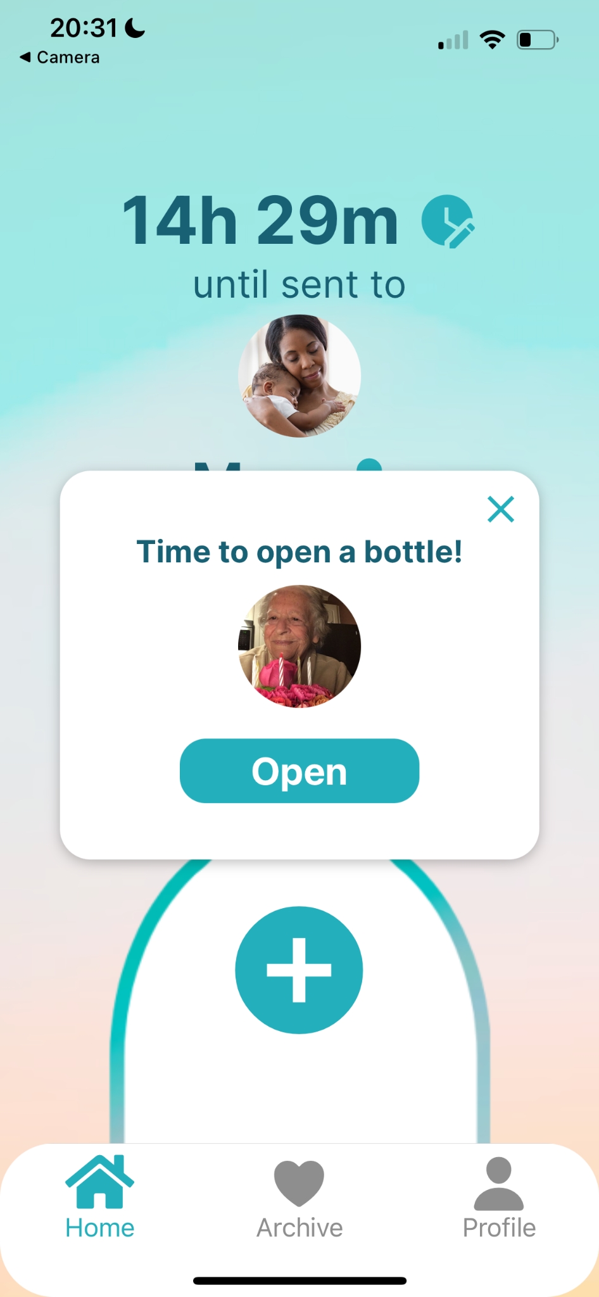
Notes: The potential recipients/receivers are created and accessed via a custom Supabase backend that stores their name and profile photo. Changing the time actively updates the time until sent to display on the home screen. After 40 seconds (for testing/demo purposes) of inactivity on the home screen, a modal pop-up will display, prompting users to open a received bottle.

Complex Task: Filtering Moments By Emotion
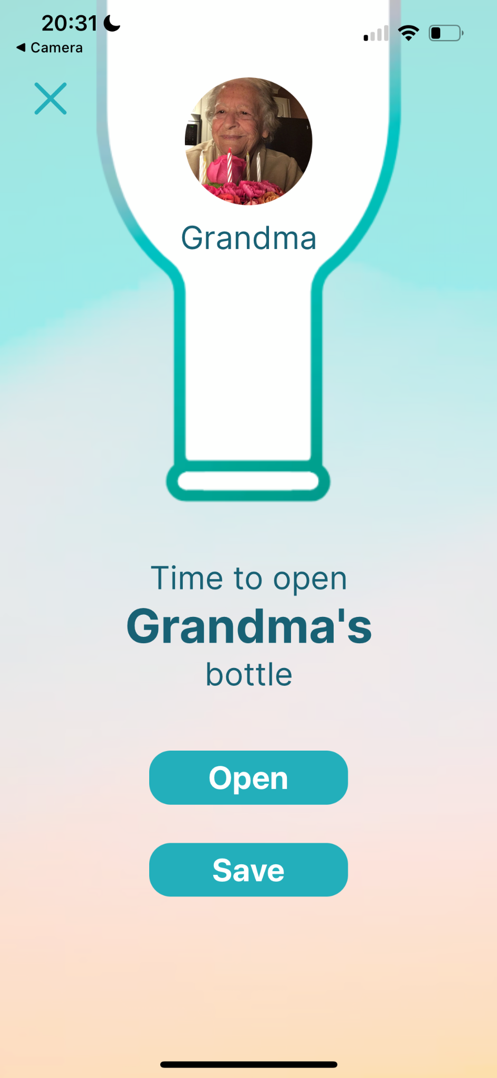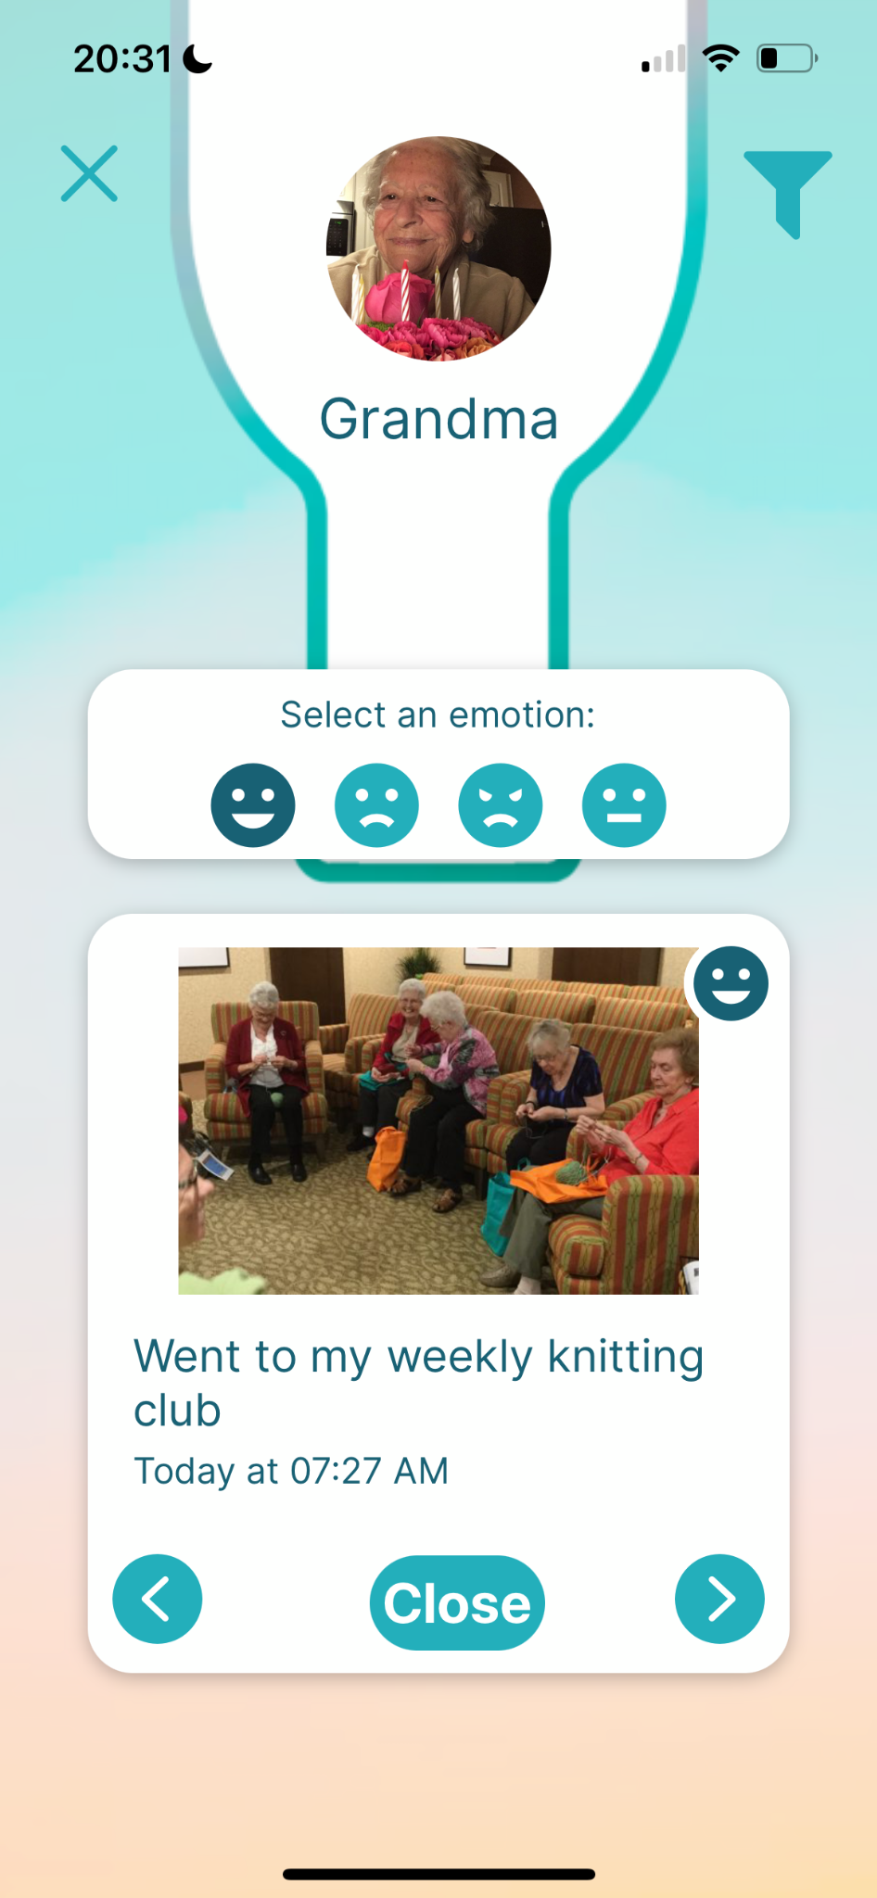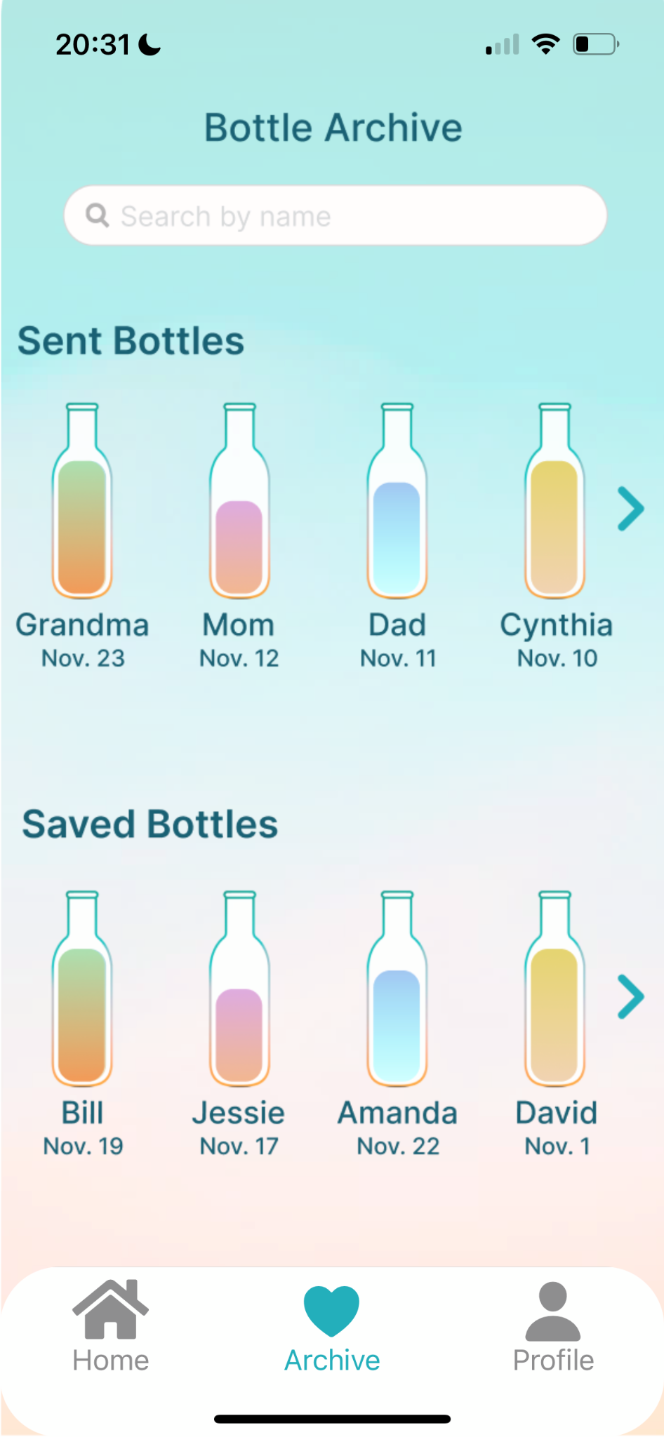
Notes: The emoji filtering is supported by custom-built functions that display only the memories associated with the selected emotion. Users can select one emotion at a time.

Values in Design
From the beginning of needfinding, we kept track of the values we wanted to promote through our app based on the interviewee’s responses. As designers, we wanted to foster healthy communication, and with this broad goal we identified 4 main core values:
- Authenticity: promoting authentic moment collection
  - Filter and pressure-free expression
  - No editing of pictures
- Inclusivity: bringing people closer, involving them into each other’s lives
  - Clear community guidelines that promote respect and support, ensuring a welcoming environment
  - Ability to add new recipients
- Fun: making virtual communication fun
  - Set time encourages participation before the timer runs out. Waiting for the timer to go down builds anticipation and adds excitement and engagement
- Flexibility: accommodating for people of all schedules and lifestyles
  - Users can share memories as text, photo, video, or audio, catering to different preferences and contexts
  - The time until the bottle is sent is easily editable to be accommodation of all time zones
Throughout this process, we also considered potential tensions in our values including:
- Authenticity vs Fun: Users may share deeply personal and potentially serious memories that clash with the app’s value of fun. Ensuring that the platform caters to both fun and serious content without diluting the authenticity of users' experiences can be a delicate balance.
- Flexibility vs Fun: Offering flexibility through extensive customization options could overwhelm some users looking for a simple, fun experience. Striking a balance between these two can be challenging, as too many options can complicate the user experience.

In designing our app, we consciously kept these values and tensions in mind.

Final Prototype Implementation
We utilized a variety of applications and techniques to build our hi-fi prototype: a functioning mobile application. Details of this technical implementation process are below.

Tools Used:

We built our high-fidelity prototype with React Native, Expo, and Supabase. We used Apple’s XCode Simulator and Expo Go to test the app as we developed it.

Pros:
- React Native supports cross-platform app development, meaning that our app could be used on both iOS and Android Devices.
- XCode Simulator includes different phone versions, so we could test out our app on multiple screen sizes to visualize how our UI looked on different devices.
- Expo Go makes it easy to simulate the prototype on a real phone.
- Being able to publish through Expo Go allows more people to view and try out our app.
- Supabase allows us to add users to a backend to allow for informational retrieval and syncing.

Cons:
- We were only able to test our app on iOS devices because XCode Simulator only includes iOS devices, and when we used Expo Go, we used it on our personal devices, which were all iPhones.

Hard-Coded Features

To help capture the experience of a fully functioning app, we hard-coded some of the information and features in our app:
- Hard-coded information:
  - User profile information
  - Multimedia moments in the opened bottle
  - User’s loved ones
- The add bottle screen has been hard-coded to only have Grandma as a receiver. Selecting a different receiver on the home screen still leads to Grandma being on the add bottle screen.
- The audio clips in the moments are images, not real playable audio clips
- The moments (text, image, audio) the user adds are not saved
- The first bottle (Grandma) in the archive is the only bottle that leads to the task of opening the bottle.

Wizard of Oz Features

- The user presses the record button, but the app does not truly record the audio. Rather, we simulate this act of recording an audio clip by providing an image of an audio clip to indicate that the user has recorded something.
- Click the archive button does not truly save the bottle to the archive since we have already included the bottle in the archive.
- The bottle library does not truly hold archived bottles but is rather a screenshot that links to our “open bottle” task flow.
- Time travel: To simulate how the user will receive a pop-up to open a bottle when it reaches its opening time, we signal that it is time to open a bottle after the user is on the home screen for 30 seconds.

Other Limitations

Since this is just a prototype, there are some features that we envision being in our final app that were unable to be fully implemented, including:
- Login and signup not implemented
  - Login directly leads to the home screen
  - Signup directly leads to the home screen
- Adding friends in the profile screen is not implemented
- The pop-up to open a bottle is not implemented to appear when the countdown time reaches 00h 00m. Refer to the last point in the Wizard of Oz Features section.
- Currently, the user can select multiple receivers, but the user should only be able to select a single receiver
- Limitations of React Native’s Modal (nothing outside of the modal is clickable until the close button inside the modal is explicitly clicked)
  - To close the bottle in the opening bottle screen after opening an emoji filter, the user must click the filter button again, then click the close button, and then click the X button.
  - The user must close the open bottle pop-up after clicking the “Open” button in the pop-up to access opening the bottle.
  - The user must click on one of the buttons in the audio pop-up to close the modal when on the “Saved to bottle” screen
  - The back button in the text input screen may not work

Reflection and Next Steps
One of our main learnings was the significance of effective 'needfinding'. We learned to engage with our audience through open-ended, unbiased questions, allowing them to freely express their thoughts. This approach not only provided us with genuine insights but also helped in building a user-centered design ethos.
Turning observations into actionable insights was another critical skill we developed. We focused on identifying tensions, contradictions, and making non-obvious connections. This skill proved invaluable in recognizing unique user needs and opportunities that aren't immediately obvious.
Rapid brainstorming and fostering a "yes and" mindset were central to our ideation process. This approach encouraged inclusivity and diversity in our ideas, enabling us to explore a wide range of potential solutions.
In understanding our studio theme, we realized that preserving the past is not just about history; it's about connecting current experiences with historical contexts in meaningful ways. This insight directly influenced our project 'Bottle'. Our app, with its unique functionality of encapsulating text, audio, and photo/video content in a virtual 'bottle', embodies this theme by allowing users to share and revisit personal moments.
Looking ahead, if given more time, we as a team have identified several areas for improvement and expansion in our app. We aim to enhance the app's functionality with a more sophisticated login flow and authentication system, and the incorporation of in-app messaging. Moreover, we would like to further develop our 'wizard-of-oz' features like the time countdown and audio recording, which would enrich the user experience.
Additionally, we plan to implement a draft system for potential bottles. This feature would allow users to save their ideas and content as drafts, enabling them to revisit and refine their messages before sending them. Furthermore, building out our bottle archive feature is another key aspect we want to focus on. This would allow users to revisit their past bottles, thereby reinforcing our theme of preserving memories.

