SECTION 1 CELL FATE ACQUISITION
PROJECT HANDBOOK FOR THE SUMMER UNDERGRADUATE RESEARCH EXPERIENCE 2007-2012
Cal Poly – SLO
Stanford University
UC-Berkeley
Purpose: Generate Mu transposon-tagged alleles of genes regulating cell fate acquisition and maintenance in pre-meiotic maize anthers.

Index of Tables, Resources, and Checklists in 3 large files (sections)

Section 1
Table 1 | Participating Faculty and Staff
Table 2 | Corn genetics supplies from Stanford
Table 3 | Field preparation supplies at Cal Poly
Table 4 | Irrigation how to
Table 5 | Guide to weeds at the field
Table 6 | Primer on corn development and tiller removal
Section 2
Table 7 | Field screen how to
Table 8 | Generating the tagging population for targeted Mu tagging of a particular locus
Table 9 | Checklist for processing “putons”
Table 10 | Unusual corn plants
Table 11 | Pollinating putons and fertile siblings
Table 12 | Field notes and records
Section 3
Table 13 | Processing leaf samples into DNA or RNA for molecular verification of putons
Table 14 | Harvesting ears
Table 15 | Subsequent genetic analysis
Table 16 | Dissecting staged anthers for transcriptome profiling
Table 17 | Powerpoint presentation on the overall project goals

Table 1. Participating Faculty and Staff
Name | Institution | e-mail | Phone
Virginia Walbot | Stanford | Walbot@stanford.edu | Office 650-723-2227 Mobile 650-218-8699
Alex Bloom | Stanford | abloom@stanford.edu | Office 650-723-0007
Gillian Nan | Stanford | gnan@stanford.edu | Lab 650-723-2609
Darren Morrow | Stanford | djmorrow@stanford.edu | Lab 650-723-2609
Jeff Wong | Cal Poly | jcwong@calpoly.edu
Matt Ritter | Cal Poly | mritter@calpoly.edu

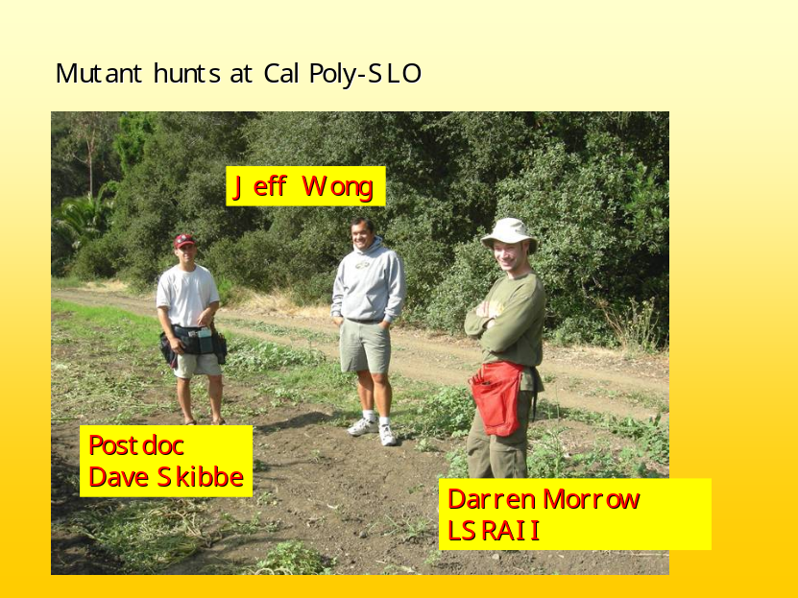
Dave and Darren are wearing the mesh type of apron; the alternative is a like a carpenter’s apron with a bib.
We use high Mu transposon copy number lines to make mutations in genes important in specifying cell fate in developing maize anthers. Mu elements move around in the genome late in organ development throughout the plant. New insertion events that occur in cells whose daughters (or granddaughters or great-granddaughters) participate in meiosis can be transmitted to the next generation.
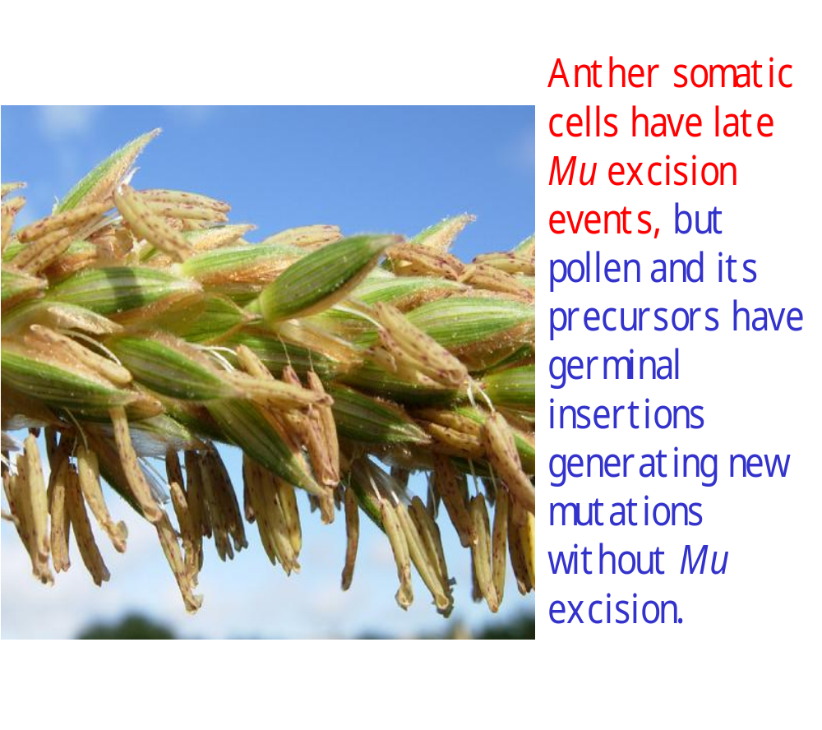

Table 2. Corn genetics supplies from Stanford

What | Source | How Many
Marksalot pens for writing bags and tags | Office supply store | Dozen
Dipel-treated shoot bags | Stanford supply (undergraduates put Dipel into Lawson 217 bags in advance) | 400 for bagging shoots
Untreated shoot bags | Stanford supply of Lawson 217 bags | 1000 for collecting samples, use as labels
Striped 402 pollinating bags with a non-skid paperclip added | Lawson | Case of 1000
“powder” marking paint --- yellow, pink, orange | Hardware store | 4 cans for marking putons and siblings
Forestry tape in bright colors | Hardware store | 4 rolls for marking plants and rows
Pollinating aprons | Stanford | 2 for carrying supplies
Stapler & extra staples | Stanford | 4 (one per person)
Clippers | Stanford | 4 (one per person)
Buckets | Stanford | 2 for holding supplies the field
Cooler & ice packs | Stanford | 1-2 for leaf samples

Photo of Jesse Gay (2007) wearing a pollinating apron with some of the supplies carried in it
Marksalot pen Regular pen Knife (with a shoelace)
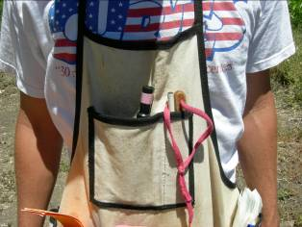 Bright paper card stock Shoot bags
Hidden from view: Stapler & extra staples, Forestry tape, Sunscreen
Paperclips There room for brown pollinating bags and field note cards in the big pocket in the front.
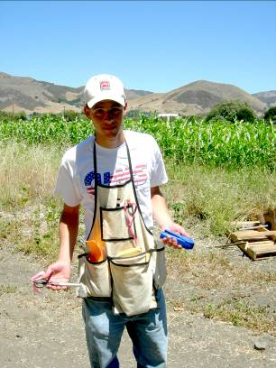

Safety precautions

- wear a hat
- long sleeve shirt
- wear a bandana or something to cover the front and back of your neck
- shoes & socks
- apply sunscreen liberally
- sunglass prevent eye damage
- drink lots of water
- always work with another person in the field
- carry your cell phone
- itchy? Wash up with soap and water quickly – you may have a contact allergy to one of the plants in the field
- cut? blister? Wash up and apply a bandaid. Wear gloves if your hands are tender.


Plan to drink at least this much water in a few hours. Be sure there is “extra” water in the car for washing up and to refill bottles. Your project bottle can be put in the freezer 2/3 full with the cap off. In the morning, fill up with plain water or your favorite drink and put on the cap. You will an ice cold drink all morning.

Table 3. Field preparation supplies at Cal Poly

Tractor and planter

Cultivator

Alabama sweep

Table 4. Irrigation and field maintenance how to

Handy tools to have available

Crescent wrench
Lopers for removing tillers
Drip irrigation supplies (name them)
Repair supplies for drip system (what)

Table 5. Guide to weeds at the field. These are removed by cultivation prior to planting and after germination. Weeding by hoeing or by clipping weeds at ground level is used in bad areas within the field after the plants are tall.

Weed common name | Scientific Name | Comments
Portulaca |  | Low growing, squishy spreads rapidly
Mustard |  | Cut before flowering
Velvet leaf |  | Can grow as rapidly as corn; soft to touch but smells
Chenopod |  | Causes contact dermatitis; grows up to 3 feet tall
Sudan grass |  | Large clumping grass used as silage
Various heading grasses | Avena sativa Setaria X | Not aggressive
Rogue corn | Zea mays | Volunteers from prior year plantings cause confusion; remove any corn not in rows. Silica on the edge of corn leaves causes small cuts
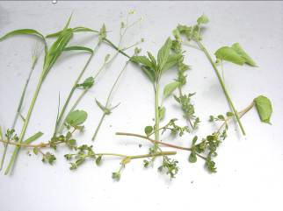Rogues gallery of the worst weeds

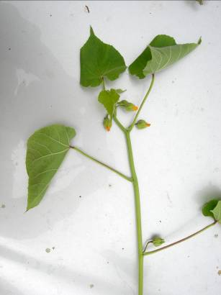Velvetleaf
MUG SHOTS

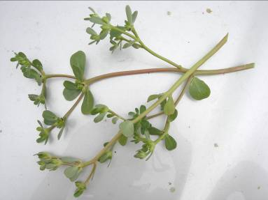Portulaca
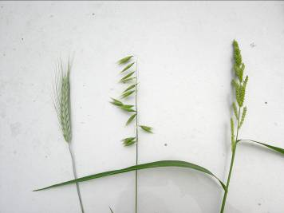3 benign grasses

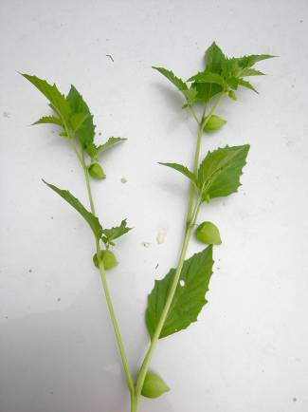Relative of tomatillo

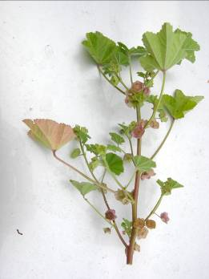sturdy stems – grows along ground and then upward from many points – very hard to get rid of as it has a deep tap root

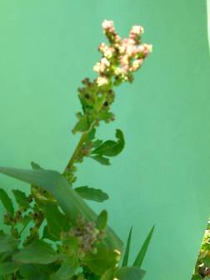the worst – aggressive chenopod that causes contact allergy in some people (swelling, red bumps, very itchy). Sturdy stems with many branches, growing along the ground and up to 3 feet high.

Table 6. Primer on corn development and tiller removal

Growth after germination. The main stem grows in 3 phases: germination in which the 5 preformed leaves in the seed elongate, followed by a phase of little obvious growth for ~1 week, the juvenile phase in which the next 5 or so leaves emerge over a 3 week period, another pause of 7-10 days during ear and tassel formation, and a final rapid growth period in which the final height is reached. Until formation of the ear and tassel, the shoot apex is below ground, and the apparent “stem” of the plant is actually the tightly wrapped leaf sheaths of successive leaves. At the basal nodes, prop roots form to brace against lodging (falling over) in the wind or after watering; tillers can grow from these same lower nodes.

Tillers. Tillers are side shoots emerging from the main stem at the first two nodes of the plant. These nodes are below ground so the connection between the tiller and the main stem can be observed only after removing soil. Tillers emerge at an angle from the main stem and then curve upward (positively geo and phototropism). Tillering is a sign of strong plant growth – plants at the edge of the field or in gaps in the field are more likely to make one or more tillers as these individuals have more room and nutrients to fuel growth. Tillers are a problem in the genetic screen, because the tiller will produce a tassel. This tassel is developmentally delayed (about 7 days) compared to the main stem, but once the main stem is decapitated in the screen, the tiller elongates rapidly and the tassel is visible. This tiller tassel is more immature than what we observe at the emergence of the main stem tassel. The anthers within the tiller tassel will be at the ~2-4 mm stage when the tassel is first visible, and this immature tassel can be easily mistaken for a mutant: pale color, “soft” feel to the tissue, short anthers.

Reproductive Structures. Ears form at nodes 12 – 15 in a typical line; because of very strong apical dominance the topmost ear (the youngest) will actually grow most rapidly and be the first ear shoot observed on the plant in most cases. If this ear is injured – or the plant is very robust – the second ear will also grow and support kernel development after pollination. Above the ear are 3-5 sterile nodes, and then the stem terminates in the tassel. This structure contains ~1000 floral structures, each with 2 spikelets. Each spikelet has 3 anthers. The lower anthers are developmentally delayed about 1-2 days relative to the upper flower anthers. When we dissect anthers for molecular or cytological analysis only the upper flower anthers are utilized. Each anther has about 2000 pollen grains in it, hence, a robust corn plant can produce more than 10⁷ pollen grains. Pollen is shed over a 5-7 day period. Pollen grains are viable for about an hour; by covering tassels with a pollinating bag we can collect a pure pollen sample, provided the bag is left on for at least an hour, to allow any wind borne pollen from other plants to decay. On the day of pollen shed, the 3 anthers in a flower are pushed out of the surrounding glumes by the rapid elongation of the filament, a stem-like structure at the base of each anther. The anthers are initially pointed upward as they emerge, but with further elongation they bend down toward the ground (force of gravity) and the action of wind or other movement (such as tapping the anthers) causes individual pollen grains to drop out of a hole at the tip of each anther much like salt emerging from a salt shaker. The ~2000 pollen grains in one anther are shed in about 20-60 minutes.

Pollen shed initiates in the main spike (central region) of the tassel, with the upper spikelet anthers emerging first in a zone about 6 cm long. The next day, the lower spikelet anthers emerge in this area, and upper spikelet anthers are present throughout the main spike and perhaps in the central region of the major branches. Over successive days, anthers exert towards the tips of all structures; the final emerging anthers are at the base of secondary branches (short branches at the bases of the primary tassel branches). During ear maturation the first silks to emerge are also from the center of the structure (middle of the ear) followed by the base on day 2 and the ear tip on day 3. As you will learn, proper technique in cutting back the ear for pollination is required to pollinate as many silks as possible on one day.

Checklist of structures to find on a corn plant

What | Feature | Your notes
Seedling leaf | One of first 5 leaves
Juvenile leaf | Covered in wax
Adult leaf | Shiny (no wax) but covered in hairs
Prop roots (brace roots) | Actually stem tissue; often bright purple
Ear node | Ear growth distorts the stem, making a curve that is visible in profile
Tassel main spike | Central portion of the tassel and first to shed pollen
Tassel primary branch
Tassel secondary branch
Upper floret, lower floret
Immature anther | Readily dissected 1-3 mm
Mutant anther | Never exceeds 3 mm
Mature fertile anther | ~5-6 mm long
Tiller(s) | Slender stems emerging from side of main stem
Leafy shoots | Elongated husks blades; can be mistaken for tillers but are on upper nodes of the plant
Silks | Sign that the ear is mature and ready for pollination
Ear shoot with silks showing; this ear has been cut through the husks, and the next day the silks grow out as brush.
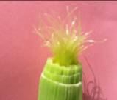
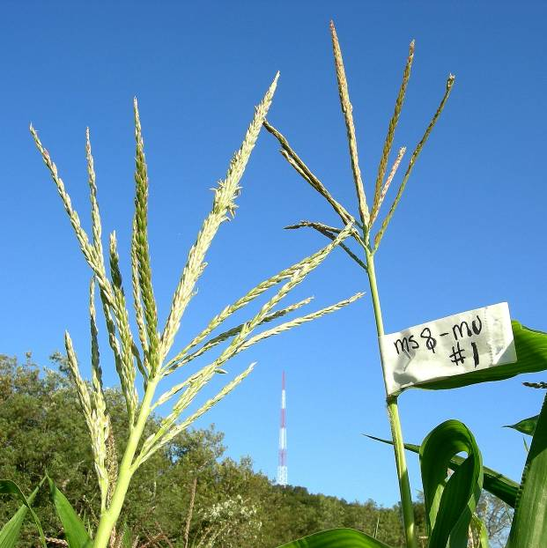
anthers
Main spike
Secondary branch, emerges from a primary

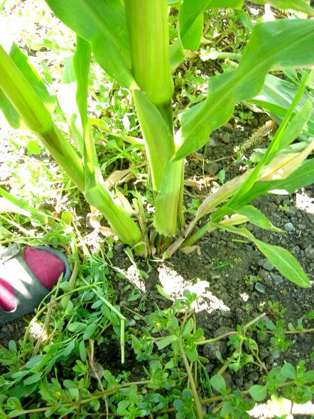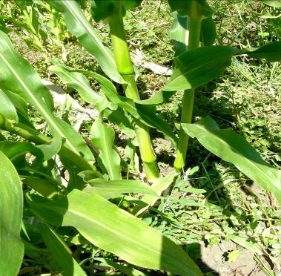Same stem and large tiller as the previous photo, but now viewed from the other side of the plant. The main stem is on the LEFT and the tiller is tilted toward the right. Large tillers are a problem, because they make tassels that can be mistaken for mutants when the tassel is first visible (the tassel is visible while the anthers are still elongating). For an efficient screen, we try to remove ALL tillers from the plants before starting. If there are a lot of weeds, the weeds must be removed first so that you can see that the tiller grows out from the base of a larger main stem. Almost always, the tiller is tilted relative to the main plant.
Main stem - upright

Large tiller – tilted leftward

Small tiller – tilted rightward

This area was cleared of weeds to see the tillers

Prop roots (they are part of the stem and are purple in this genotype)

TILLERS

Before starting the screen, the final field prep is

Label first and last plants in each family with bright colored tags at about eye level | Plants are in paired rows and the field is planted in a serpentine -- make sure the paired rows are obvious | At the edge of the field, make sure that the continuation of a family is indicated (as in 17 con on the first tag of a row that is in the middle of family 17)
Make a final pass to remove tillers | Tillers should be clipped near ground level | Discard into the aisles between the paired planting rows
Remove weeds | Walking aisles should be clear of weeds | Be sure to eliminate weeds that cause rashes
Remove any large rocks or soil clods | Eliminate tripping hazards


Next is Section 2 ….. starting the screen. Get your clippers ready.
SECTION 2 CELL FATE ACQUISITION
PROJECT HANDBOOK FOR THE SUMMER UNDERGRADUATE RESEARCH EXPERIENCE 2007-2012
Cal Poly – SLO
Stanford University
UC-Berkeley
Purpose: Generate Mu transposon-tagged alleles of genes regulating cell fate acquisition and maintenance in pre-meiotic maize anthers.

Index of Tables, Resources, and Checklists in 3 large files (sections)

Section 1
Table 1 | Participating Faculty and Staff
Table 2 | Corn genetics supplies from Stanford
Table 3 | Field preparation supplies at Cal Poly
Table 4 | Irrigation how to
Table 5 | Guide to weeds at the field
Table 6 | Primer on corn development and tiller removal
Section 2
Table 7 | Field screen how to
Table 8 | Generating the tagging population for targeted Mu tagging of a particular locus
Table 9 | Checklist for processing “putons”
Table 10 | Unusual corn plants
Table 11 | Pollinating putons and fertile siblings
Table 12 | RECHECK Field notes and records
Section 3
Table 13 | Processing leaf samples into DNA or RNA for molecular verification of putons
Table 14 | Harvesting ears
Table 15 | Subsequent genetic analysis
Table 16 | Dissecting staged anthers for transcriptome profiling
Table 17 | Powerpoint presentation on the overall project goals
Table 7. Field screen how to

Before starting the screen, some final field preparation

Label first and last plants in each family | Plants are in paired rows and the field is planted in a serpentine | At the edge of the field, make sure that the continuation of a family is indicated (as in 17 continue)
Make a final pass to remove tillers | Tillers should be clipped near ground level | Discard into the aisles between the paired planting rows
Remove weeds | Walking aisles should be clear of weeds | Be sure to eliminate weeds that cause rashes
Remove any large rocks or soil clods | Eliminate tripping hazards

Training on the appearance of a sterile tassel

There will be a plot of hand planted corn near the main screening field. Some families will be segregating 3:1 or 1:1 fertile:sterile and there may be an artificial mixture of 100:1. Start with the segregating family and note key characteristics of sterile tassels
- thin
- no anthers ever exert
- dissection of a spikelet yields anthers of only 2-3 mm long while fertile anthers will be 5-6 mm long near maturity
- flat look to the tassel in profile
- ear silks develop precociously (no competition with developing anthers)
- observe photos in the next sections
This is what you will be doing 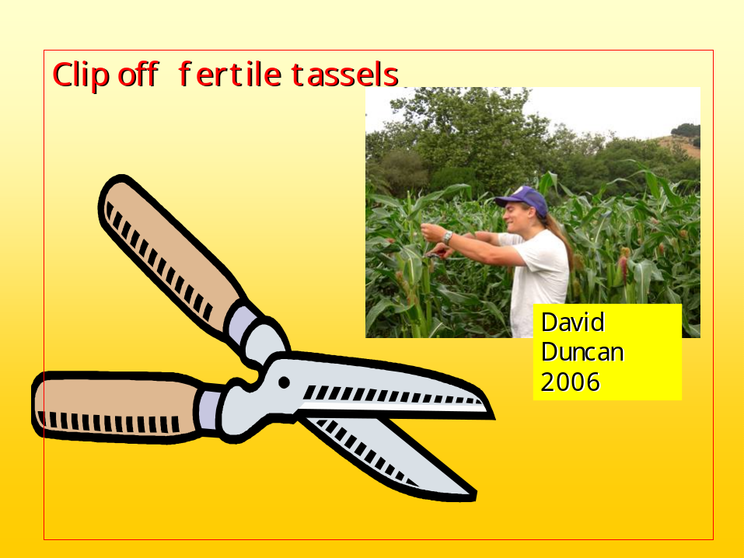

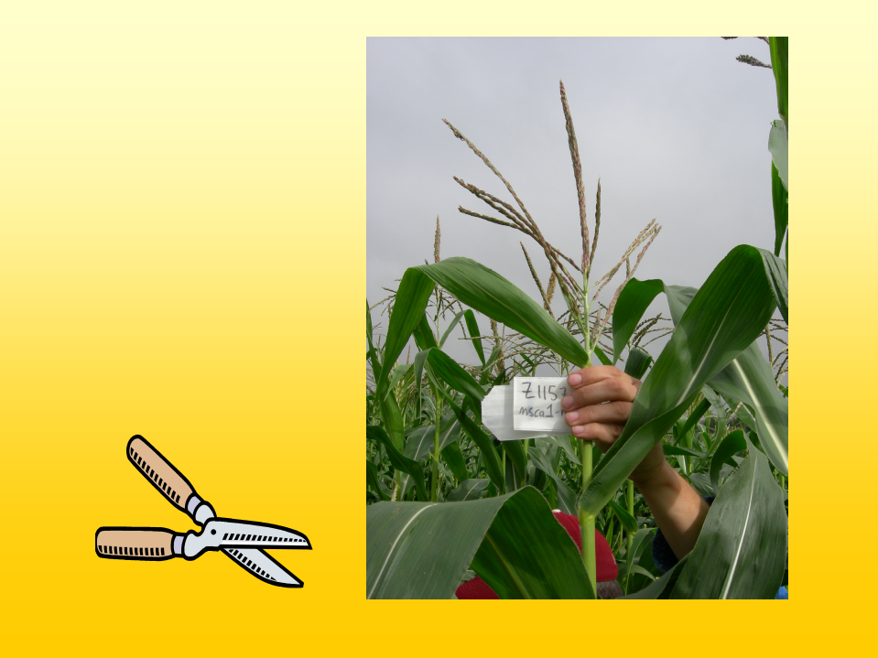
Find a mutant, attach a tag. Note how tall the 2006 plant is (~8 feet).

Basic Procedures

1. Clip off tassels with exerted anthers. Tagging population is planted in paired rows. Walk down the space between the two rows and clip off tassels with emerged anthers to your right and left. Push the clipped tassels into the unused aisles between paired rows. These unused aisles will also have discarded tillers and weeds in them.
2. Identify fully visible tassels lacking anthers. The sterile tassels are thin (flat) compared to fertile siblings. Use the training population planted next to the tagging field to familiarize yourself with the appearance of sterile tassels.
Ryan Bolduan (2007) holds a fertile tassel (black arrow) with exerted anthers next to the puton (white arrow) labeled mac1-mu3 (third puton discovered in the mac1 tagging block). Note that the mutant lacks anthers. Long sleeve shirt protects arms from corn cuts.
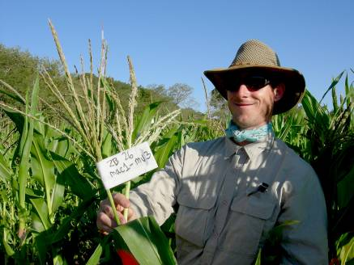
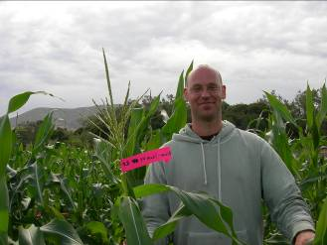

Tim Culbertson (2007) shows off the latest mutant tagged with a bright paper tag. Note that an overcast sky makes the field easier to photograph. Long sleeve shirt protects arms from corn cuts.

- When a sterile puton (putative Mu tagged mutant) is found, verify that
- it is not a tiller
- that it is approximately the same height and girth as neighboring fertile siblings (shorter, slender plants are likely contaminants or possibly haploid plants)
- that the tassel emerged at about the same time as most neighbors
- that the ear is advanced (large, silks may already be showing)

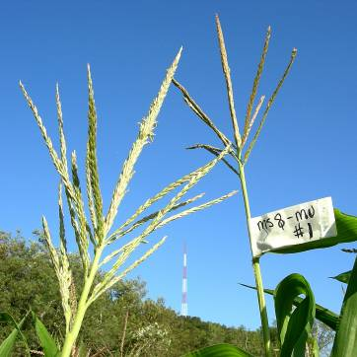
Mid-morning photo of a new puton and a fertile sibling that is just starting to shed pollen in the middle of the main spike (area with anthers just emerging looks “fuzzy”). Also note the pesky radio tower on the hill in the background – try to avoid taking photos with such distracting objects in the picture. By mid-morning the sky is an intense blue and plant leaves are shiny.

4. Find another person to confirm the puton. Make a label indicating the locus (ms8 in this photo) and the order of discovery of the putative Mu-tagged allele (#1 in this case, -mu#1). Staple the tag to the stem below the tassel. Take a photo of the puton and a normal sibling: you can cut the tassel off a normal sibling and hold it next to the puton for a better composition. Push other plants out of the way to make a less cluttered photo. Watch out for the radio tower or other distractions. Take several photos and make sure the tag is visible.

5. Label shoot bags 1 through 10 and put onto ten nearby fertile siblings. Shoot bag the puton. All of these plants will be pollinated by MuKiller. Check again that the “fertile” siblings have normal tassels.

6. Prepare a set of leaf sample collection bags (shoot bags) with the family number; in this case ms8-mu1 was in family 17. The bags would be labeled ZB (summer 2007 field designation) 17-1 leaf, ZB 17-2 leaf, through ZB 17-10 leaf. For the puton, write 3 bags: ZB17-ms8-mu1 sample1, ZB17-ms8-mu1 sample2, and ZB17-ms8-mu1 sample3. To collect leaves, use a scissors to cut about a 4-5 inch (10 - 15 cm) section of an upper leaf, cut off the leaf tip, and then separate the blades from the midrib. Fold the resulting two leaf blade pieces in half to make it easier to stuff them into the labeled shoot bag. Verify that plant 17-1 leaf is in bag 17-1, etc. Put samples in a cooler with frozen packs to maintain low temperature. Transfer samples to the meat cooler of a refrigerator for a few days storage or put into a -80C.

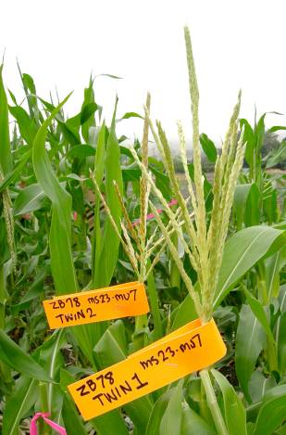
Twins are found in a concerted search through the entire family of a new mutant by peeling back the top leaves. Late emerging twins may be contaminants: the ms x Mutator cross should exhibit hybrid vigor and flower earlier than the ms x sibling contamination cross. This is an early morning photo under the fog with some sunlight coming through the fog; the leaves appear dull but you have a better chance of capturing detail such as the writing on the tags at this time of day. The sky will photograph as light gray or white.

7. With a partner make a concerted search for “twins” of the new puton by more thoroughly screening the family (ZB17 in the example) by examining tassels that have not yet fully emerged and even peeling back the leaves to visualize tassels. Because male sterile plants lack a strong nutrient sink at the top of the plant, the ear develops precociously. It’s important to try to find “twins” before the ear silks have emerged and have been contaminated by random pollen. To date, from 0 to 17 twins per family have been found. About one-third of families will have no twins, and 2/3 will have twins. Label twins, i.e. ms8-mu1 Twin #1, ms8-mu1 Twin #2, etc. in order of discovery. Verify that none of the fertile siblings (numbers 1 – 10 in item #5) are mutants (twins). If you find a “mistake” be sure to write it down!!! You’ll seed some such mistakes in the field excel spreadsheet at the end of this section.

Noon photo of a puton and fertile sibling. By this time of day the main spike is covered with dozens of emerging and shedding anthers. Even after manipulating the photo to reduce “brightness” (this darkens the sky) it is difficult to get enough contrast on white paper to highlight the name of the puton. Also “bright spots” appear on the plants from reflection.

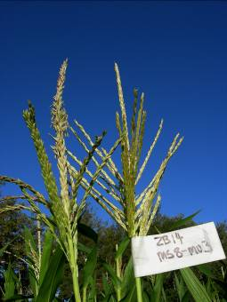

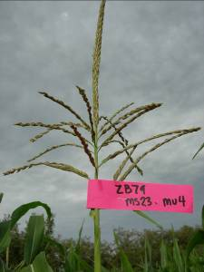
Photo on a very foggy morning – not very bright but the outline of the tassel is often clearer than in full sun.
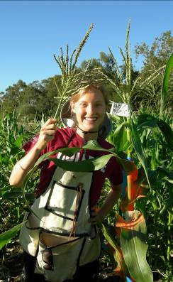
Another noon-time photo: Chelsea Young (2007) holding a fertile sibling near a new puton. Note the orange spray paint on the puton and neighbors, which are also marked with blue forestry tape. Chelsea is wearing one style of pollinating apron; her apron can carry her knife, clippers, tape, pens, and other supplies.

Very Important Lab Tradition: The first person to find a new puton each day chooses the end of day activity (trip for smoothies, frozen yogurt, coffee, lunch), and the project pays the tab.

Daily record of discoveries, 2007. Note that mistakes designating sibs and twins are noted here.
Family | Puton | Twins | DATE | Family Size | Sib Twin Key Notes
17 | ms8-mu1 | 2 | 18-Jul | 800 | #2 late & tall
20 | ms8-mu2 | 0 | 18-Jul | 1450
14 | ms8-mu3 | 0 | 18-Jul | 1150
18 | ms8-mu4 | 0 | 21-Jul | 1000 | Leaf samples labeled 19
16 | ms8-mu5 | 0 | 25-Jul | 1600
25 | mac1-mu1 | 1 | 19-Jul | 109
55 | mac1-mu2 | 9 | 19-Jul | 1451 | 55-8=twin7 -6=twin8 -4=twin10 late
26 | mac1-mu3 | 0 | 19-Jul | 260
51 | mac1-mu4 | 1 | 20-Jul | 754 | Sib 51-9 = Twin#1
40 | mac1-mu5 | 5 | 20-Jul | 216 | Sib 40-1 = Twin#4
50 | mac1-mu6 | 6 | 22-Jul | 584 | Twins 2,3,6 v. short
53 | mac1-mu7 | 9 | 23-Jul | 2942 | Sib 53-8 = Twin7
56 | mac1-mu8 | 5 | 23-Jul | 716 | Twins 2,3 contamin? Twins 4 & 5 7/29
41 | mac1-mu9 | 1 | 24-Jul | 216 | Twin 2 + 3 pur on tassel
37 | mac1-mu10 | 1 | 24-Jul | 1188 | Most twins found 7/27 in late field
23 | mac1-mu11 | 0 | 24-Jul | 40
39 | mac1-mu12 | 17 | 25-Jul | 1272
65 | ms23-mu1 | 10 | 20-Jul | 517 | Sib 65-3 = Twin 9
64 | ms23-mu2 | 7 | 21-Jul | 492 | Sib 64-5 = Twin 6
69 | ms23-mu3 | >10 | 21-Jul | 567
79 | ms23-mu4 | 0 | 22-Jul | 1174
58 | ms23-mu5 | 15 | 22-Jul | 1854 | Twin 5 = fertile Twin 14 & 15 7/29
61 | ms23-mu6 | 3 | 22-Jul | 3043
78 | ms23-mu7 | 5 | 25-Jul | 673 | Twins 1,2,3 contam?
73 | ms23-mu8 | 9 | 25-Jul | 701 | Twins 2,3,4,6 contam?
62 | ms23-mu9 | 0 | 29-Jul

Table 8. Generating the tagging population for targeted Mu tagging of a locus. Playing the odds to find desirable mutants. Expect about 1/5000 plants to have a new ms-mu allele in a targeted mutagenesis screen. Read the Wong et al. 2007 manuscript for more information on the genetics of the tagging populations.

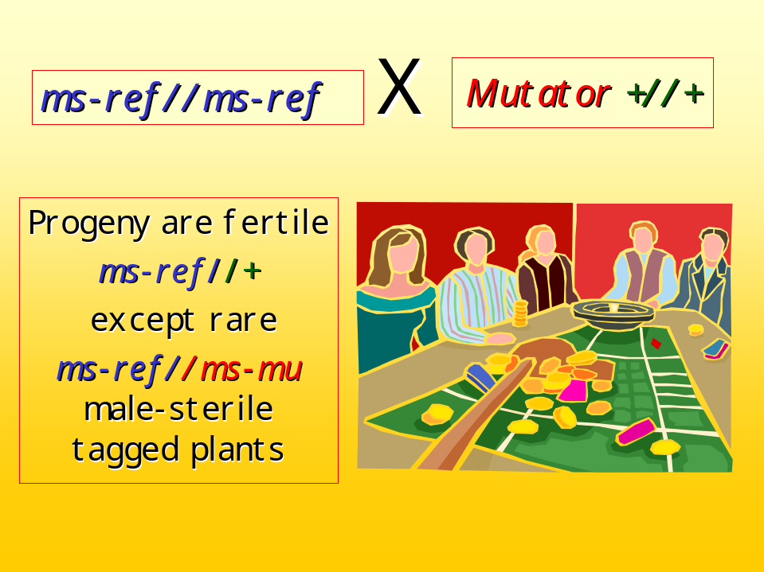

After reading that manuscript,

- Can you explain why spotted kernels are so important in evaluating Mutator activity status?
- How are ears pooled from the tagging crosses to make a single family for planting in the screening field at Cal Poly?
- What is a MuKiller line? Why is it useful in this experiment?
- What color kernels are produced by crossing a new mutant by MuKiller in the tagging field? Why? How does the color differ for an open (contaminating) pollination in the tagging field?
- If you have questions, please discuss them with the faculty as soon as possible. We expect you to understand the manuscript fully.

Table 9. Reminder Checklist for processing “putons”

Find a friend to verify the puton with you.
Label the puton with a sequential mu number at the base of the tassel.
String forestry tape for ten plants on either side.
Designate 10 fertile siblings for crosses by MuKiller by shoot bagging them with numbered bags.
If the ear shoots have not yet emerged, turn the numbered shoot bag side ways and “park it” in the notch between a leaf and the stem.
Spray paint the area to find it easily.
Collect leaf samples from the puton (3 replicas) and the 10 labeled siblings that day or the next morning, depending on how busy you are.
Photograph the puton and a normal sibling.
Check the ears daily and cut back the silks when ready.
Write a pollinating bag DATE Plant Number x MuK after cutting back. If the ear has had silks showing before bagging, write x open + MuK.
Put the pollinating bag up the next morning; collect fresh pollen and pollinate the cut back ear.

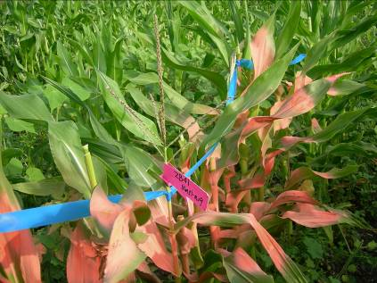
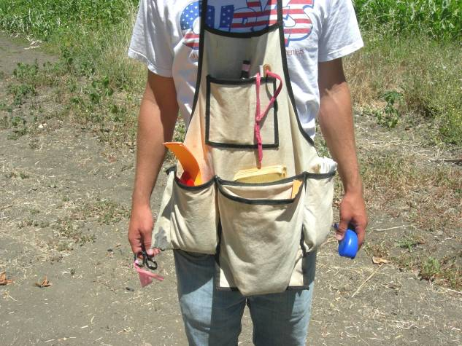
Head into the field well-prepared to take care of labeling, writing bags, and doing your crosses. Extra supplies are stored the trunk of the car, as shown on the next page.
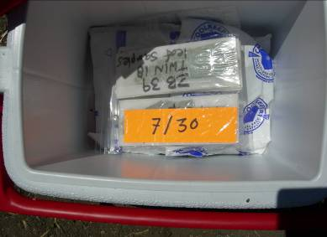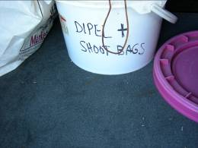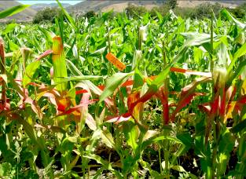
Family ZB2 puton (ms8-mu6) found 7/30/2007. Leaf samples will be collected 7/31/07. The ear shoots will be ready a few days later.
Pollinating supplies, labels, snacks, water, sunscreen, etc. stored in boxes in the trunk of the car. Small cooler with fronze “ice packs” is used to store leaf samples, organized by family. Misc. twins from 7/30 are in a common bag.

Table 10. Unusual corn plants. Part of the fun of screening a very large population is that some unusual plants are observed.

Oil yellow is a dominant visible phenotype caused by misdifferentiation of chloroplasts. Instead of green, the plastids are bright yellow. Oy sectors are readily visible, and they are often observed in Mutator tagging populations from “gain of function” (over expression of Oy). This is positive evidence of high Mutator activity.

1/2 plant: wild type on one side of the midrib and Oil yellow on the other side in all of the leaves. This phenotype results from an early mutation in the apical meristem, i.e. when the apex contains only a few cells. The new Oy allele is likely to be transmitted through the ear (which develops from a few cells on either side of the midrib) and the tassel (which develops from 2-4 cells at the top of the shoot apex).
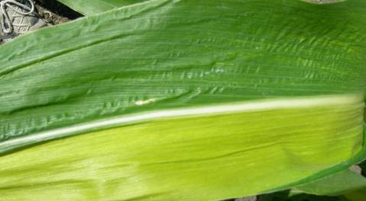

Streaks of Oy phenotype are more commonly observed, resulting from mutations in one or a few cells of the mature (200 – 300 cell) shoot apex. These new alleles are unlikely to be transmitted to the next generation unless they are next to the midrib in the leaf subtending the ear or the tassel.

Barren stalk – no spikelets from early failure in tassel differentiation. Tassel lacks all floral structures.
Tassel seed: maize flowers are initially perfect, but selective abortion of female structures in the tassel results in male-only (staminate) flowers. Mutations that delay or prevent female flower abortion result in kernels in the tassel. Often, tiller tassels are terminated by a partial ear. This structure echoes the structure of inflorescences in teosinte, the wild species from which modern corn was domesticated. Teosintes have separate staminate (male) and pistillate (female) flowers in the same inflorescence.

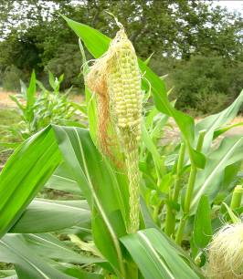

Table 11. Pollinating putons and fertile siblings

Step | When | Why
Cut back ear shoot | Day before pollination | 2-3 cm brush of silks shortens path of pollen tube growth; more silks represented (each silk goes to a different kernel
Label pollinating brown striped bag | Day before pollination = Same time as cutting back silks | Careful labeling and dating is essential. OK to keep a list and copy onto bags later.
Choose MuKiller male parent that will shed pollen that day | Day of pollination | Use a tassel with some anthers emerged (likely left from the day before) but with areas of the tassel not yet finished
Leave pollen bags up for at least one hour | Day of pollination | Sterilize any random pollen on tassel before bagging.l
With a partner take bags down and carry to the plant indicated on the label. | Day of pollination, after 10 am to as late as 1 pm | Pollen is viable for about one hour. Collect copious pollen by tapping the bag. Partner can staple bags to the stem after pollination and “proofread” bags and plant tags.
Rebag the best MuKiller males. | Day of pollination, visual inspection of bag contents or listening for lots of pollen as you tap the bag. | Just in case you have a few bags with poor pollen shed, it’s an insurance policy to have your best plants rebagged as back-up pollen sources.

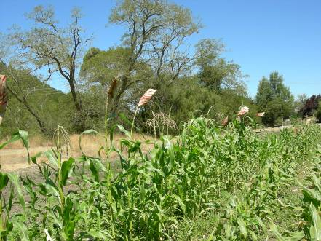
Pollen collection bags set up early in the morning (as soon as the tassels are dry if it’s foggy) and left up until about 10 am (one full hour of sunshine). The male plants are .MuKiller.

Carrying pollinating bags from the MuKiller rows (hand planted area next to the main field) to recipient ears. Note the “high weeds” surrounding the field. Bags are set-up on tassels first thing in the morning (provided the tassels are dry), and collected after one hour after bright sun starts until noon for controlled crosses. Striped bags are easy to spot in the field during harvesting.
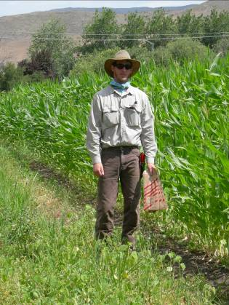

Day before pollination ears to be crossed are “cutback” to permit more silks to show the next day. The ear is about 1/3 of the way up from the node and 1/3 of the way down from the ligule/blade junction… approximately as drawn here.
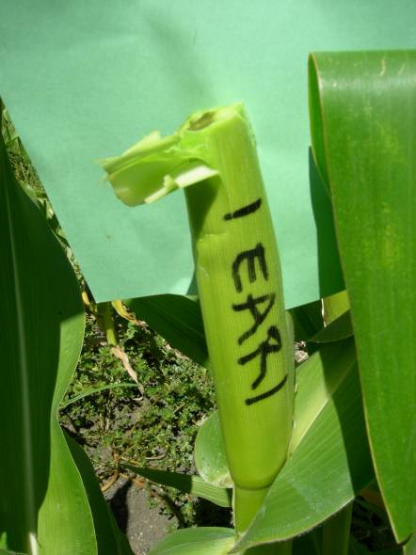
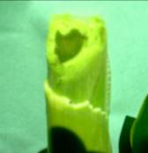
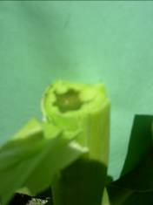
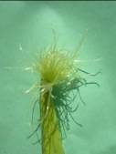
Cut back the silks to 1-2 cm above where you think the ear will start. If you get to the tip of the ear, you’ll see a white dot (arrow below).

What silks look like 2 days after cutting back – a group of about 50 silks are 4 cm long and about 150 are 2 cm long. All along each silk are receptive “hairs” where pollen can germinate. Each silk leads to a single kernel.
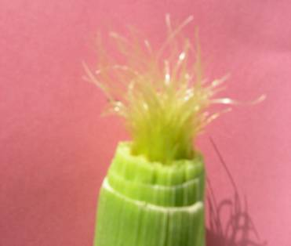

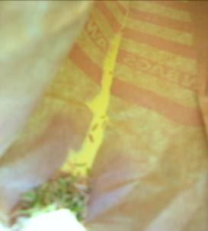
View inside a brown pollen collection bag. By making a crease done the center of the bag when you put it onto the tassel in the morning, you can easily collect the pollen and anthers that drop into the bag into the crease. The empty anthers are light weight and drift towards the opening of the bag when you tilt the bag slightly downwards. There are tens of thousands of pollen grains – all pale yellow – behind the pile of anthers. You deliver the pollen to a receptive, cutback ear by tapping the pollen onto the silks.
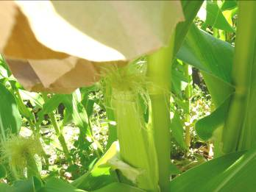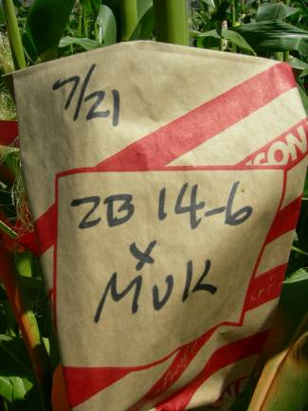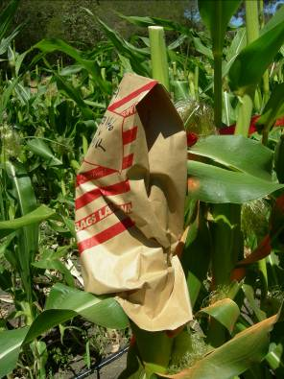
Deliver the pollen to the ear – avoiding contamination with pollen from other plants by being quick – by tapping the pollen from the brown bag onto the ear. Then push the brown bag over the ear, and pull the back “flaps” around the stem and staple into place. The front section is “free” to allow substantial ear growth.
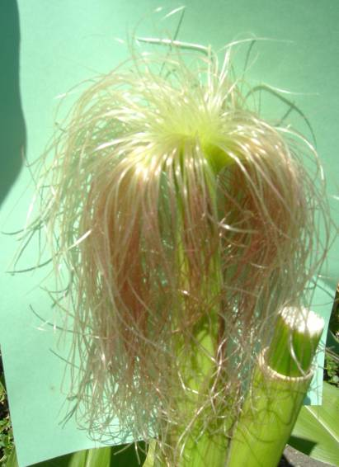Ear with 4-5 days of silk growth. Note that the silks come about pale yellow and turn “pink” in sunlight (salmon silk gene). In a normal field with lots of pollen, the silks would not be this long, because once pollen reaches the embryo sac and causes fertilization, the silks stop growing. This takes about 24 hours in a cutback ear (pollen tubes grows 10 cm or so in 24 hours). These silks continue to grow because we are removing all the tassels shedding pollen every day and there is virtually no pollen available in the field.

Table 12. RECHECK Field notes and records. Note which twins or putons have phenotypes that are expected and which are short, slender, and/or late. The latter group are more likely to be contaminants. Note this on both the cards you carry around in the field and make sure that your notes are transferred to the spreadsheet summary.

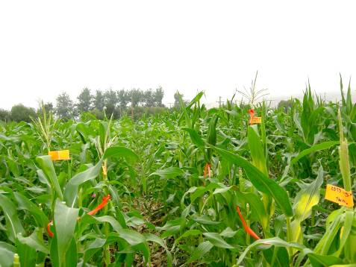
After most tassels are clipped, the only tall plants left are putons and their twins. Note the yellow spray paint and red forewstry tape marking the area. This photo is during a foggy morning.

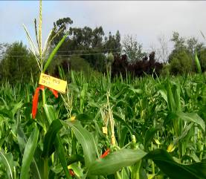
Note that 3 “twins” are very short, relative to clipped neighboring siblings. Such short plants are likely to be contaminating ms-reference//ms-ref homozygotes and not new ms-Mu//ms-ref plants. The lack of hybrid vigor shows up as shortness. The numbers of these twins should be recorded with the notation “short plants.” Molecular analysis will likely confirm that they are contaminants, but write this in your notes!
Photo taken as the fog is clearing (sky mixed gray and blue).

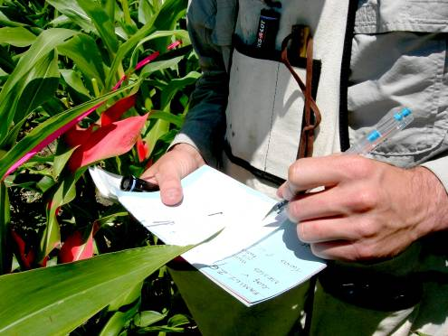
Take careful notes in the field and transfer them to the permanent records. Don’t rely on your “memory” – always write your observations down. If it’s important TAKE A PICTURE.
You’re ready for Section 3.

CELL FATE ACQUISIT
ION PROJECT HANDBOOK FOR THE SUMMER UNDERGRADUATE RESEARCH EXPERIENCE 2007-2012
Cal Poly – SLO
Stanford University
UC-Berkeley
Purpose: Generate Mu transposon-tagged alleles of genes regulating cell fate acquisition and maintenance in pre-meiotic maize anthers.

Index of Tables, Resources, and Checklists in 3 large files (sections)

Section 1
Table 1 | Participating Faculty and Staff
Table 2 | Corn genetics supplies from Stanford
Table 3 | Field preparation supplies at Cal Poly
Table 4 | Irrigation how to
Table 5 | Guide to weeds at the field
Table 6 | Primer on corn development and tiller removal
Section 2
Table 7 | Field screen how to
Table 8 | Generating the tagging population for targeted Mu tagging of a particular locus
Table 9 | Checklist for processing “putons”
Table 10 | Unusual corn plants
Table 11 | Pollinating putons and fertile siblings
Table 12 | Field notes and records
Section 3
Table 13 | Processing leaf samples into DNA or RNA for molecular verification of putons
Table 14 | Harvesting ears
Table 15 | Subsequent genetic analysis
Table 16 | Dissecting staged anthers for transcriptome profiling
Table 17 | Powerpoint presentation on the overall project goals
Table 13. Processing leaf samples into DNA or RNA for molecular
verification of putons

Puton leaf samples should be kept cold in the field and in the meat compartment of a standard refrigerator if they will be used within a few days. If not, freeze at -80C until use.

Part of a leaf sample usually suffices for the DNA prep – about 3 x 6 cm is powdered by mechanical action (glass rod and a vortex mixer with liquid nitrogen) or in a grinding machine. This powdered leaf sample can then be aliquoted by weight for DNA or RNA extraction.

The Walbot lab will supply the latest DNA and RNA extraction protocols each year. The protocols change from time to time. You will need ~10 ug of DNA or RNA to start the validation procedures. More is better.

A. Methods for validating that a puton is a Mu-induced mutant

Method | Accuracy | Time | Comments
PCR of DNA to find bz2-mu | Can only validate 1/2 of the mutants because only 1/2 inherit the reporter allele | Few days
HinfI digest & DNA blot hybridization | Assesses Mu1 and Mu2 copy number: high in Mutator lines | week
RT-PCR to measure mudrA transposase RNA | Mutator lines should have high transcript levels; nonMutator lines have low level of homology MuDR transcripts | Few days | Requires high quality tissue to get RNA

1. Tracking the bz2-mu reporter gene

Recall how the tagging population was established

Step 1 bz2//bz2 ms//ms X Mutator bz2//bz-bz2-mu +//+

Step 2 Progeny in the tagging field ms//+ bz2//bz2 or ms//+ bz2//bz2-mu

bz2-mu is the mutable reporter gene used to evaluate how active the Mutator plant is: 50% of the progeny of a cross to bz2 tester should be spotted kernels

Similarly, 1/2 of the plants in the tagging population (the ms//ms females) should inherit the bz2-mu allele. Consequently, when a puton is identified, there is a 50:50 chance that that particular plant will be a bz2-mu carrier. After DNA is prepared, one PCR primer in the bz2 coding region and a Mu transposon primer are tested with the DNA sample. A positive result (an amplified product) proves that the puton has the mutable bronze2 reporter allele, and therefore, the puton is an authentic Mu-induced mutant because you have proven that the puton had a Mutator parent.
bronze2 allele
Mu

If a puton is negative (no product) but has 3 or more twins (sibling plants in the same family in the screening field with the ms//ms phenotype), the test can be done with the twins. The twins are from events before meiosis, and there should be independent segregation of the new ms-Mu allele and bz2-mu during meiosis. Therefore, half of the twins should have the bz2-mu reporter allele. If a twin is positively shown to be a bz2-mu carrier, then you have proof that at least some of the new putons in that family carry an authentic new Mu-induced ms allele (and are not contaminants during population constructions). If you have 10 twins, you expect 5 to have bz2-mu; 95% probability bracket means you accept from 3:7 to 7:3 as 1:1 ratios.

For future propagation of stocks, obviously you will concentrate on individuals with the bz2-mu reporter allele because they are unambiguously Mutator plants. For completeness, you may also want to find out if the puton and/or twins without this allele are actually Mutator derivatives. That will require one of the other two tests.

2. HinfI digest & DNA blot hybridization with a Mu1/Mu2 probe

The active Mutator lines in our tagging stocks have 50-100 copies of Mu elements in the genome. In contrast, nonMutator lines
have 1-5 “dead” copies of Mu elements. These dead copies are usually highly methylated (5-methyl cytosine in the DNA). HinfI is a
methylation-sensitive restriction enzyme: it readily digests unmethylated DNA but cannot digest methylated restriction sites. Both terminal inverted repeat ends of Mu1 and Mu2 contain HinfI sites near the end of the element. The 1.4
kb Mu1 element yields a 1.3 kb * fragment after HinfI digestion; the 1.7 kb Mu2 element yields a 1.6 kb + fragment. Lanes 1 and 2 to the left illustrate what an active, high copy Mu line will look like on a Southern blot. Lane 3 is what you would see from a non-Mutator line.
1 2 3
+
*

Putons and twins with a highly active Mutator parent should look like lanes 1 and 2. If a high copy line loses activity (epigenetic silencing, as will happen after crossing with MuKiller), the many Mu elements become methylated and a gray smear is visualized from about 2.0 – 8.0 kb on the gel blot. Thus this DNA blot hybridization assay can distinguish active Mutator, formerly active (just silenced) Mutator, and nonMutator lines. All of the authentic putons and twins should be active Mutator, with possibly a few epigenetically silenced, high copy number individuals.

3. RT-PCR to measure mudrA transposase RNA

MuDR elements encode the transposase(s) required to excise and insert mobile Mu elements in the maize genome. In an active tagging line there will be 5 – 10 copies of MuDR, and these copies encode substantial amounts of mudrA and mudrB transcripts. Standard (nonMutator) and epigenetically silenced Mutator elements have very low levels of transcripts similar to mudrA and mudrB encoded by homologs of MuDR (hMuDR elements). hMuDR has copies that have acquired mutations such that their products are no longer functional in mobilizing Mu elements.

To measure mRNA levels, a reverse transcription (RT) reaction is conducted with the mRNA (or total RNA) to convert it into cDNA (complementary DNA). Then a PCR reaction is conducted to measure the amount of product with primers specific to mudrA or mudrB. There should be a 10-100 fold difference in transcript levels between an active Mutator plant and a standard line. For this experiment a control RNA sample from a nonMutator line (such as an inbred line) should be included in the test, because the assay is a comparison of the levels of mRNA between lines.

All putons and twins with high levels of MuDR-encoded transcripts are authentic Mutator individuals and therefore are not contaminants in the tagging population.

What is the yield of MUTANTS from the initial group of PUTONS?

What factors make bad news contaminating PUTONS more likely?

How would you calculate when Mu insertions occur prior to meiosis based on the number of twins per family?

Don Robertson, the Iowa State corn geneticist who first worked with Mutator, estimated that 20% of the new insertion events occurred prior to meiosis (3 or more progeny with the same mutation), 60% could occur just before or during meiosis (2 or 1 progeny with the mutation), and 20% occurred in the pollen, after the mitosis that separates the two sperm (the embryo and endosperm of a single fertilization had different genotypes = non-concordance). Based on the data from the CELL FATE ACQUISITION PROJECT, should Dr. Robertson’s estimates be revised? For which of the 2 stages do we have data? How does our data differ from Dr. Robertson’s? Why do you think we have found a much higher level than he did at one of the stages?

Table 14. Harvesting ears.

When to harvest? Kernels mature in about 40 days, so it is safe to remove all of the puton, sibling and twin X MuKiller bagged ears 40 days after the last pollination in the field. Before harvesting in a family, make sure that all of the bags are labeled with the FAMILY NUMBER (not just plant #2 or twin #3).

Supplies you will need with you in the field
Small mesh bags (15 x 20 inches) with drawstring. Each bag will hold the ears from one family.
Large onion sacks – will hold ~6-10 mesh bags.
Pen, for writing any additional info on the bags during harvesting.
Water bottle.
Harvesting buddy or cell phone for emergencies.

Step 1 | Step 2
Check writing on the bag | Last chance to correct errors | Record
Pop open the staple at back of the bag and lift the bag off | Tuck the bag under your arm, grab the ear and break if off the plant | Get the ear
Remove the husks from the ear, and most of the silks | Put the cleaned ear into its bag, roll or fold the back, and then put the bagged ear into a mesh bag | Clean the ear and put back in it’s bag

Drying the ear to increase seed longevity. After harvesting the bagged ears should be dried at about 100 – 105 F in a dehumidified room (there’s one at Stanford, at the field) for 3-5 days. Drying proceeds more rapidly if the small mesh bags are not too full; the small bags can be laid out on the baker’s racks in the dryer to allow more air circulation. Air drying takes the % moisture in the kernels down to 8-12%, a level that insures long survival in cold storage. The high temperature will kill some insect pests, if present, but can foster fungal growth.

Treating ears with fungus. CAUTION – BLEACH CAN CAUSE SERIOUS EYE DAMAGE. Wear glasses or goggles when pouring or handling bleach. The 10% solution is safe for your hands but not for your clothes. To avoid the “tie dyed” look, where a lab coat around bleach solutions. Obvious fungal growth on a harvested “wet” ear in the field. Put the ear back in its bag, and set aside in a special box or bag for treatment. At the end of the harvesting session make a solution of 10% bleach (Stanford uses cutlery sorting trays for this as they are about ear length and about 2 inches deep). Immerse the ear in the bleach solution for 10-15 minutes, rotating the ear once or twice to insure good killing. Then, rinse the ear thorough in cool water and pat dry with towels. Write a clean brown bag for the ear (the old bag is probably heavily contaminated) copying all of the data on the old bag onto the new bag. Dry the ear as in the preceding paragraph. It’s safe to put this ear in the same small mesh bag as the rest of its family.

Labeling dried ears. When the ears are fully dried, they must be labeled for storage. There are a number of methods for doing this. One is to print out harvest tags on the computer and then use a sturdy rubber band to attach the tag (date, cross performed, notes) onto each ear. A second method is to write a label Date Cross Performed Notes on colored “time tape” and wrap this around the ear, overlapping the ends to prevent unwinding of the tape. Some people shell the ears into envelopes after drying. With Mutator materials, we typically want to do some kernel counts, bronze:spotted, bronze:purple, etc. and look for regional differences on the ear. Recall that an open pollinated ear in the field will have bronze or spotted bronze kernels (and is likely to be found in the middle of the ear) whereas a cross by MuKiller a1 Bz2 stock onto the ms//ms bz2 A1 puton will generate purple kernels (likely at both ends of the ear if there was some open pollination). The information on “regional” distribution is lost if the ear is shelled immediated. Typically the Walbot lab shells ears about 2-3 years later, after all such data are collected and rechecked.

Table 15. Subsequent genetic analysis

Progeny of putons and twins are of two genotypes afer crossing with MuKiller – 50% of each

ms-reference//+ MuKiller//- Bz2//bz2 A1//a1
ms-Mu//+ MuKiller//- Bz2//bz2 A1//a1

seed phenotype: PURPLE plant phenotype: FERTILE

The fertile plants are self-pollinated. Half of the resulting progeny ears will have 1/4 homozygous ms-ref//ms-ref kernels => sterile plants. The other half of the progeny ears will have 1/4 homozygous ms-Mu//ms-Mu individuals. By the time you get to this step, we should have this particular ms gene cloned, and a molecular test will indicate which families are homozygous for the newly tagged allele.

bronze seed on the ms//ms x MuKiller ear would be from contamination in the field with pollen from a ms-reference//+ fertile sibling

ms-ref//ms-Mu bz2//bz2 or bz2-mu A1 x ms-ref//+ bz2 A1

seed phenotype: BRONZE or SPOTTED (bz2-mu)
plant phenotypes: 50% fertile, 50% sterile

Self pollination of the FERTILE individuals will, just like the first example, yield half families homozygous for the mu-ref allele and half families homozygous for the new ms-Mu allele. Try drawing out the cross to prove this.

Map of the sequenced gene. The most valuable map will be based on the DNA sequence of the ms gene. The Mu-tagged alleles provide a rapid method for cloning a gene – even with 50-100 Mu elements in a line, that’s a huge improvement over the 50,000 genes in the genome. We PCR amplify then clone and sequence all of the Mu insertion sites: independent Mu mutants will be insertions into the same gene but at different sites. Two maize lines (ms23-mu1 and ms23-mu2 from the tagging field) will have few insertion sites in common, but will definitely both have a Mu insertion into the ms23 gene. By comparing 3 independent new mutants, we should be able to pick out the “target” gene easily.
Once the “target” gene is defined, then we will sequence the functional allele, using PCR to amplify this normal allele in sections (0.5 yo 1.5 kb) suitable for DNA sequencing. We will check databases of maize Expressed Sequence Tags and the Full Length cDNA collection of maize to determine what types of transcripts (mRNAs) are produced by the gene. By comparing the DNA sequence with the RNA transcript sequences, we can place the exons and introns of the gene.

Typically the sequence of the normal allele (fertile plant) is given, and then the defects in each mutant listed. It’s possible that the reference allele has a stop codon, a missense mutation (wrong amino acid), or contains a deletion or insertion that disrupts function. Each of the Mu-induced mutations should have a Mu element inserted in the gene: upstream in the promoter, in the transcription unit (5’ leader, exons, introns or 3’ untranslated region). The insertion locations are found by sequencing the “joint” between the Mu element and the gene, and the sites are illustrated as triangles on a diagram of the sequence or a schematic drawing of the gene.

Schematic key

line = transcribed region
box = exon
ine between boxes = intron
inverted triangle = transposon insertion site; the type of transposon is indicated

Mu3
MuDR
Mu1
GAA -> TAA stop codon

Table 16. Dissecting staged anthers for transcriptome profiling, cytological staining, or Laser Capture Microdissection (LCM).

Anthers are dissected by removing a portion of a developing tassel at a stage when we cannot distinguish a fertile from a sterile tassel. Therefore, the plant must continue development until tassel emergence so that we can score fertility. To insure collection of at least 4 sterile and 4 fertile samples of each mutant, 12 distinct biological replicates are prepared. The number of anthers in a replicate is a requirement to have enough material for preparation of RNA for a microarray experiment or for proteomics. For laser Microdissection individual anthers are fixed so that sections can be prepared for microscopy.
Line | Stage | Replicas | # Anthers/  Replicate
ms8 | 1.0 mm | 12 | 100
 | 1.5 mm | 12 | 60
 | 2.0 mm | 12 | 40
ms32 | 1.0 mm | 12 | 100
 | 1.5 mm | 12 | 60
 | 2.0 mm | 12 | 40

17. Powerpoint presentation that provides an overview of the project.

