Apples and Oranges MP3 Players
Compare and Buy the Best MP3 Players

http://applesandoranges.squarespace.com/

Business Abstract

- Co-founders:
- Emerson Andrade, MBA Candidate 2007
- Michael Klemann, MS&E M.S. Candidate 2007
- Gaurav Singh, MS&E M.S. Candidate 2007
- Caleb Tolman, MS&E PhD Candidate 2010

- Context: This Internet startup is a project as part of Professor Ashish Goel’s class on Internet Commerce, MS&E 235.

- Business Idea: We offer a convenient (comfortable, uncomplicated and time-saving) online platform to compare and buy only the top MP3 players through Amazon. The MP3 player market is dynamic and “unclear” enough for us to create valuable information for the consumer: New players and generations are released frequently and consumers are often not aware of alternatives offered by companies holding a lower market share than the leader Apple. Also, it allows employing a very targeted advertising campaign.

Web Site and Content

Concept Explanation

- Strategy: Our goal is to create value for consumers. In order to achieve that, we put ourselves in the consumers’ shoes: “Imagine you wanted to buy an MP3 player. What would you like to know the most, and why would our site be helpful?” As a result, we felt that providing an overview of the most popular MP3 players of multiple brands, listing the most essential information (an executive summary), would maximize that value. We have noticed that on Amazon, a consumer can be overwhelmed by the volume of products and information provided. By providing concise and relevant information, we enable customers to make comparisons at a brand-to-brand as well as a product-to-product level. Our “competitive advantage” should be to be simple (not too much information), clear (no complicated details) and useful (important information).

- As a consequence, we will enhance the chance of a consumer arriving on an Amazon product page through our site will buy that product on the spot, as opposed to browsing other (Amazon) pages. The information we provide is minimalist but high quality, if a consumer has the need for information, he will click our link to arrive at the Amazon product page – our site acts as a seamless interface with vendors (not only Amazon, but also third-party sites)

Informational Content

- To remain simple, we have a limited amount of MP3 players per brand. We choose the players according to popularity of sales and quality according to professional technical reviews.

- The specific information we provide for each player is:
  - Amazon ratings and number of reviews
  - Amazon (Electronics) sales rank
  - Product price range
  - Essential comments/reviews (see below)
  - Hyperlink to Amazon product page

- Information relevance: We list the chosen players daily according to their rank in Amazon’s consumer electronics sales to account for consumer popularity and also to increase our conversion rate.

Customer Reviews

- Sources of reviews: We do research on Amazon, verify the information with the actual product specifications, and also consult Yahoo!Answers. Yahoo!Answers is virtually financially non-exploitable and thus is a great source of truthful public opinions. We then assemble the opinions that seem most relevant by focusing on reviews that received high "helpful"-ratings, and by looking for facts (e.g. features that the players have).

- Ensuring trustworthy and reputable reviews: Because reputation systems on the Internet are gamed, we hand-select which comments are used, i.e. we dictatorially select them. In the future, we might let the customers (anyone who has bought a product) vote, and a small reward will be given to those who vote most truthfully.

          - As you will see shortly, we built our profit model around our content structure to prevent bias. We put clean content before high purchasing rates, and will explain later how we compensated for costs.

Advertisements

- Links to third-party sites: Several profit-generating links to other vendors, provided by Google AdSense, are also on the page. By using AdSense and making sure that our brand pages contain a sufficient amount of relevant keyword for AdSense, we assure that we only host ads that add value to our customers. This creates an atmosphere where the user is able to freely navigate toward his purchase. The user has several explorative and purchasing options, and is not distracted or persuaded on our site.

Website Design

- Usability and end-user testing: Editing and improving the design and content of our site was an iterative process based on constantly looking for user feedback on our look and feel and every aspect of our content (products, reviews, etc.). We felt that design is an important issue for an Internet startup, since trust (which is relevant to our conversion rate) is also based on visual impression.

- Screenshots:

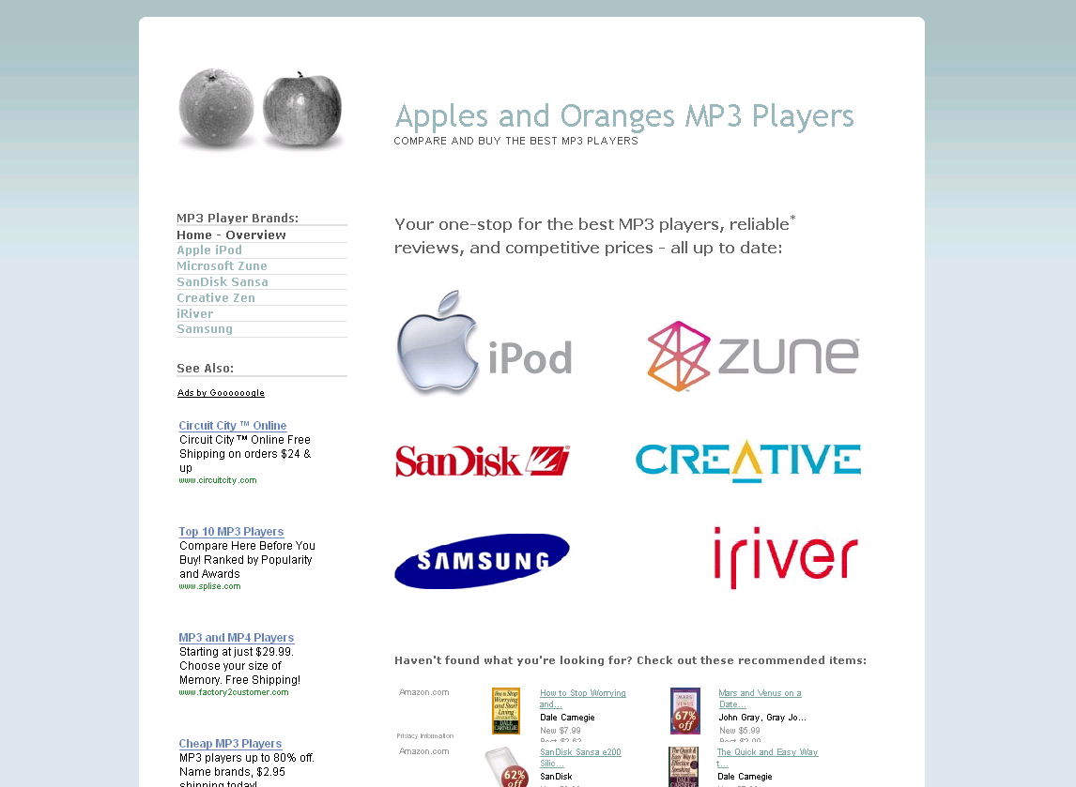
Figure 1: Our home page with all brands

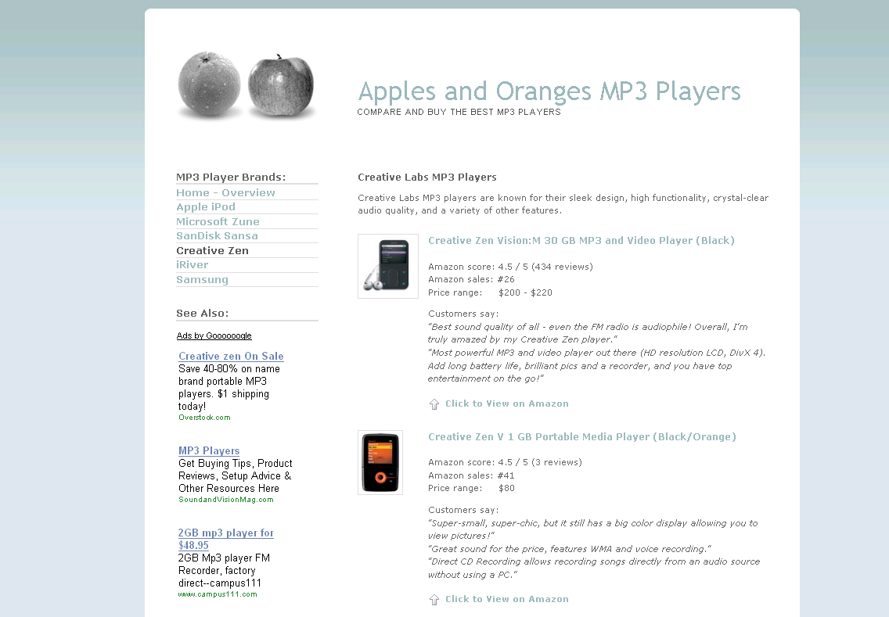
Figure 2: One of our specific brand pages

MP3 Market as Part of our Strategy

- Need for up-to-date information: The dynamic MP3 market is subject to rapidly changing digital media (sound, picture, and video) and technology (file formats, WiFi-capability, connectivity standards). As a consequence, consumers are generally uninformed about current options available, leading to a need for our information services. New exciting products, such as the recently released Microsoft’s Zune MP3 player are released frequently.

- Brand dominance: Since Apple dominates the brand marketing in this market, there is an unusual imbalance of information and hence a demand for comparison and explanation. As a consequence, we expect more visitors.

- Popularity despite high price: MP3 players are top-sold items on Amazon in consumer electronics even though they are relatively expensive.

- Targeted advertising: The MP3 player market is small and well-defined. On the one hand, this makes it easy for us to target potential customers by using AdWords. On the other hand, it ensures that very relevant AdSense ads (scanning specific brand and model names) are displayed on our site (as opposed to when selling books).

Monetizing the Business: Revenue and Cost Analysis

Our Profit Model

- Daily costs: To obtain interested visitors, we bid on Google AdWords to be a sponsored link on Google’s search hit page. We pay about $5/day for about 50 clicks, or $0.10 per click. This model scales, since more costs imply more clicks and thus more visitors, i.e. higher potential revenue.
- Monthly costs: To have a web domain and use Squarespace’s web framework for quick initial development, we pay $7/month.
- Source of frequent, low revenue: We have Google AdSense advertisements on our site, which directs traffic to other third-party sites. We get about $0.17 if someone clicks on the ads per click. The current probability (observed by tracking) for that is about 10% - i.e. one in ten visitors does it. We get about $5/day.
- Source of less frequent, high revenue: We are an Amazon Associate, which means we allow visitors to buy from Amazon directly from our site. Amazon pays us 4-8% commission of the price reflecting the total amount in the buyer’s shopping cart (i.e. MP3 player plus other items). This is about $6 if somebody clicks on Amazon Link and also buys the product. The current probability (Amazon conversion rate, observed by tracking) for this is about 2%
    - We emphasize Adsense revenues over Amazon revenues because doing so enables us to put content quality first. Having well organized pages helps Google identify more relevant Adsense listings; being more relevant, they cease to be annoying and users click on these ads; we also resist putting any other ad or distraction on the page. We have successfully matched our average Adsense revenue rate to our average Adwords cost rate: that is to say, for every visitor coming onto our page we pay 10-11 cents to Google, but for every five visitors, three will click on an Adsense link, and Google will then give us 17 cents for each one, and the margins neutralize out. Thus we have “virtual zero costs”. This is important because it allows us to focus on the product: keep the page free of distractions or be tempted to deviate from the most sincere content in hopes of improving Amazon purchase rates. We feel that in the long run, this strategy will be more successful, and we also know that any winning strategy when scaled properly can scale to infinity.

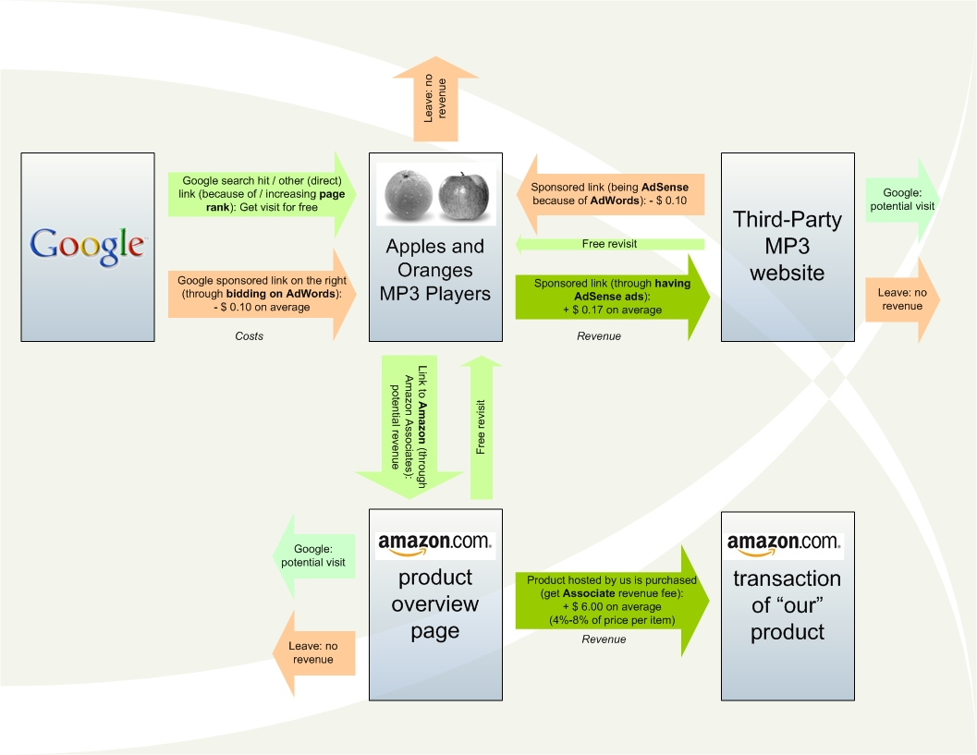
Figure 3: Overview of our Profit Model

Summary of Revenues and Costs

- Single figures: In the short time period from November 14th through December 4th, we have spent $113.63 ($118.63 till December 5th, but $5/day less until 4th) on advertising with Google AdWords (costs) but we have recovered $83.74 with Google AdSense (revenue). Over this time we have generated $175.78 in referral revenue as an Amazon Associate (revenue, given that a 4% bonus for specific links applies on December 31st). Our only other costs to date are $7 for the Squarespace website framework and $7 for a detailed keyword analysis to improve AdWords performance.

- Bottom line: This sums up to a total revenue of $259.52 and a total profit of $131.89 (without $100 AdWords voucher). In actuality, since Google subsidized $100 of our advertising budget, our profit is $231.89 in less than three weeks with no initial out of pocket expenses.

Detailed Evidence of Revenues and Costs

- Amazon Associates

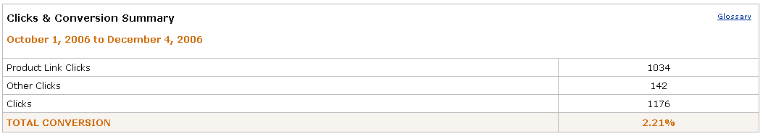
Figure 4: Shows how many Amazon Associate product link clicks we had from November 14th to December 4th. The conversion rate of 2.21% is the number of items ordered through our site (26) divided by the total number of product link clicks

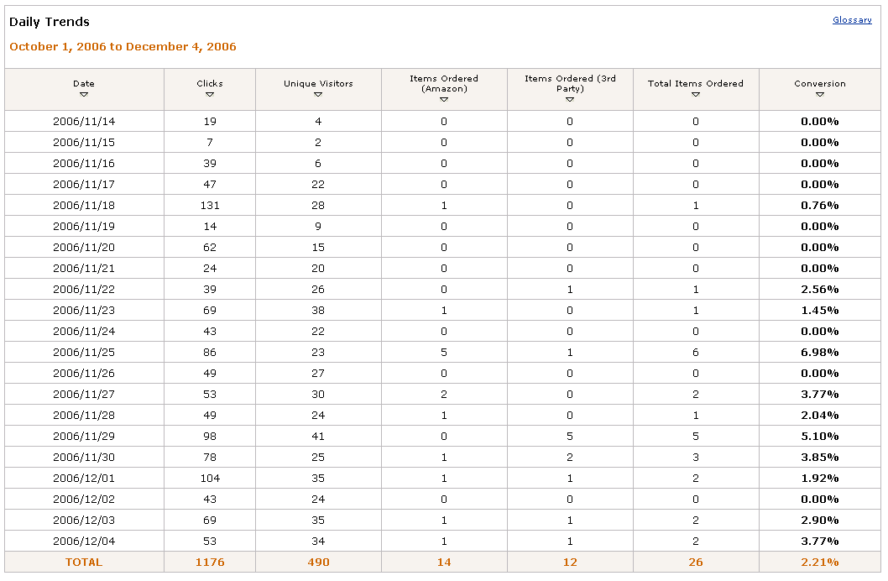
Figure 5: Shows the daily trends associated with the number of Amazon Associate product link clicks and items ordered. Due to editing the content of our site to meet customer needs, the numbers of clicks and items ordered have generally increased since our inception.

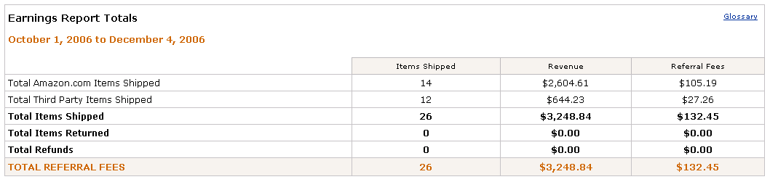
Figure 6: Shows our Amazon Associates earnings report. From November 14th until December 4th we have $132.45 in revenue from Amazon Associate referral fees without the 4%-bonus for the so-called Omakase-Links on our homepage which will be applied at the end of this year.

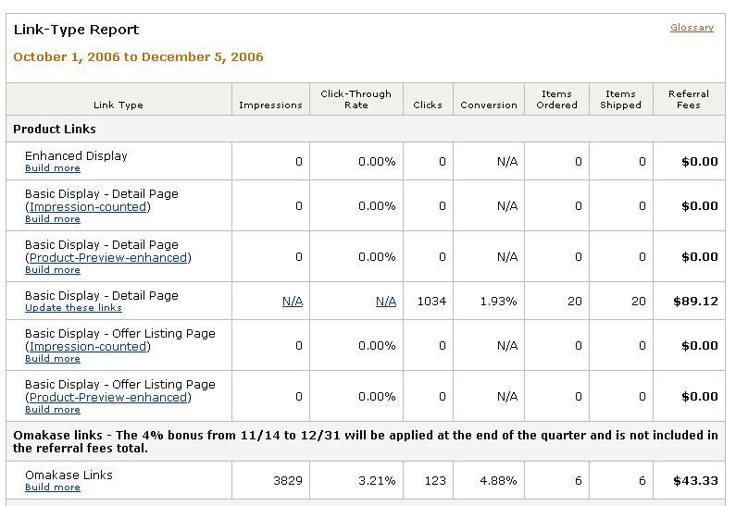
Figure 7: With the 4%-bonus for the Omakase-Links (which will then earn 8% instead of 4%), we will get an extra $43.33, as this figure shows.

In short, our total revenue through Amazon for purchases till December 4th will be $175.78 ($132.45 + $43.33 Bonus).

- Google AdWords

Figure 8: Shows our MP3 campaign for which our daily budget was about $5.00. It shows that our total number of clicks generated by the AdWords campaign was 1,104 and that we had over 1 million total impressions. The overall click through rate was 0.10%, the average cost per click was $0.11 and our average position on the paid advertisement list was 4.5.

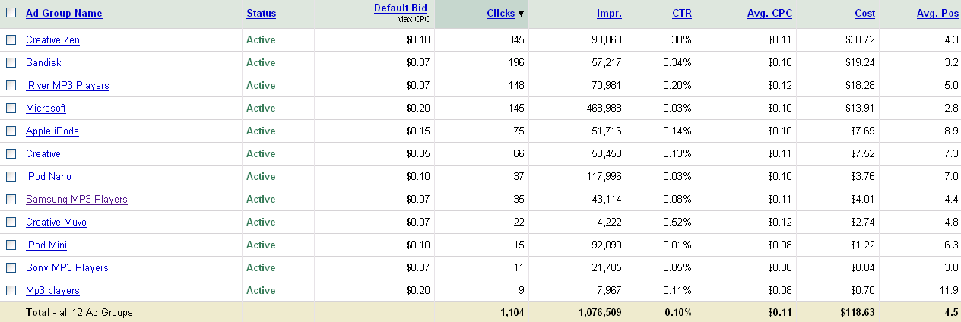
Figure 9: Shows the different ad groups within our MP3 campaign. Each group has from less than 10 to more than 40 keywords associated with it, which were chosen using the keyword effectiveness index and bid on accordingly.

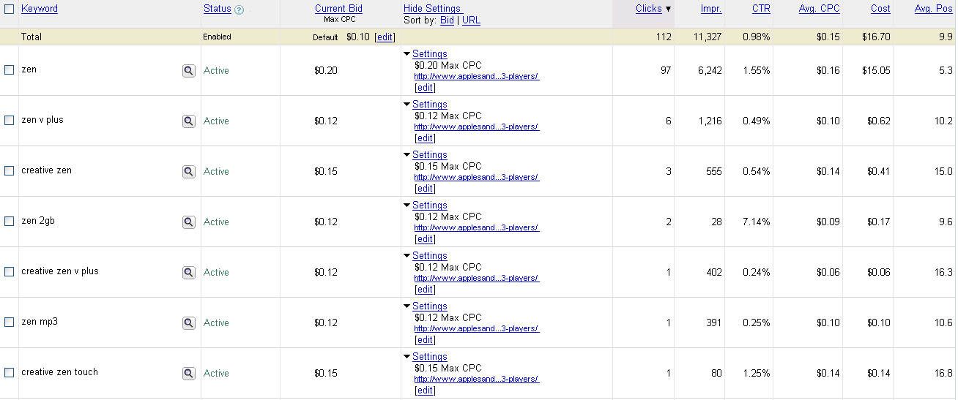
Figure 10: Displays the keywords and statistics for the Creative Zen ad group in our MP3 campaign.

- Google AdSense

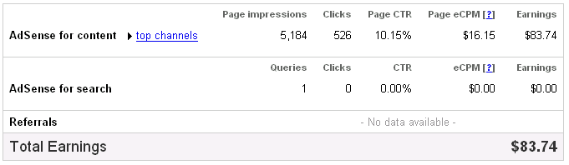
Figure 11: Shows our total page impressions, clicks, click through rate and earnings from AdSense.

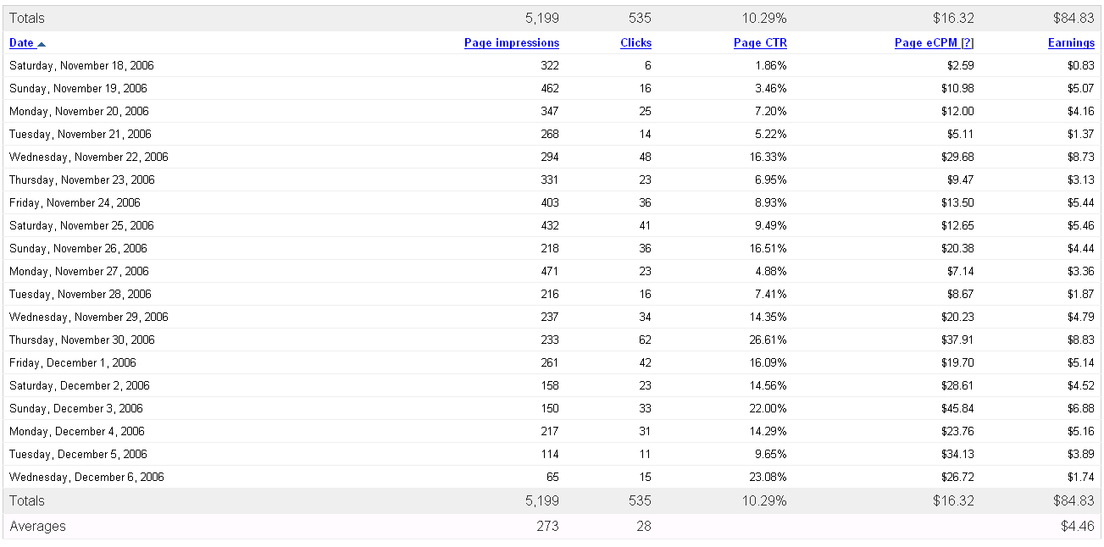
Figure 12: Daily breakdown of total AdSense statistics.

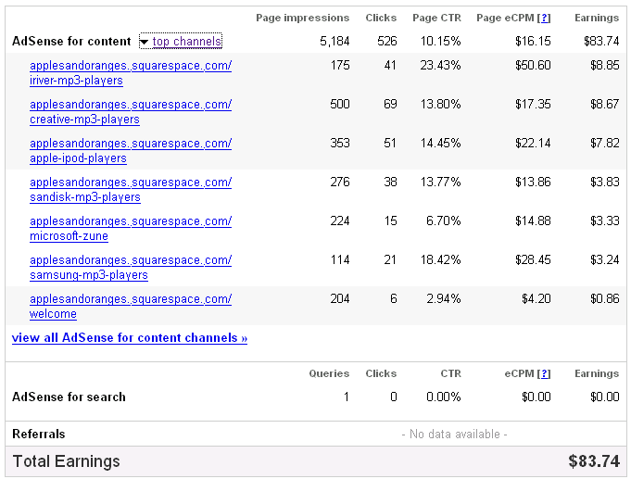
Figure 13: Channel location breakdown of our AdSense statistics (we set up custom URL channels to track the performance of specific MP3 brands).

Advertising Campaign Management

Using Exploration as a General Strategy

- Dynamic Strategy: A general approach that we use for keyword bidding, placement of AdSense ads and even choosing the brands of the players to put on our site is exploration: Whenever we add new content, we experiment using various strategies at the beginning, since we have no data/information to work with. Then, we refine our strategy according to where we got the best performance in terms of costs per click for AdWords, revenues per click for AdSense, and Amazon conversion rate. We also use the tools provided by Google and Amazon, e.g. channel tracking and analytic reports about visitors’ preferences.

AdWords Campaign Optimization

- Keyword Optimization: Our first step was to obtain the “best” keywords. Our metric on keyword value is KEI (Keyword Effectiveness Index). It compares the 'count' result, i.e. the relative number of times people have entered this keyword as search query, to the number of competing web pages for the keyword. Even before we bid on any keyword, we had an ordered list in terms of KEI of about 200 queries/keywords on Google at the cost of $7.

- Optimizing CPC: Since we have no problem getting enough clicks (CTR is not an issue), we initially tried to get the most clicks for a fixed daily budget (i.e. minimize CPC), but we observed that there is no clear correlation between our maximum bid specification and the actual average CPC charged by AdWords. We bid on brand and product names and tried different combinations of words yielding lower CPCs.

Other Means of Publicizing

- Viral Marketing: We have been telling friends and family to check out the site and spread the work by mouth and email.
- Other websites: We lured free visitors to our site by adding links to websites such as Facebook and LinkedIn. Links from particularly reputable sites are likely to increase our PageRank.

Site Traffic Optimization

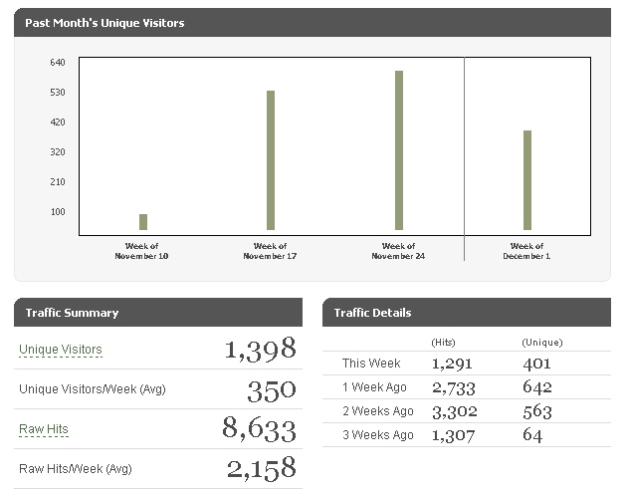
Figure 14: Shows a steady increase of unique visitors to our site. The data for the last week does not reflect the entire week. [Squarespace Report]

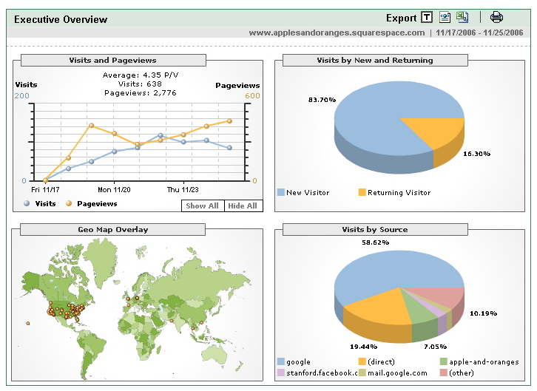
Figure 15: Shows where our visitors come from [Google AdWords Report]

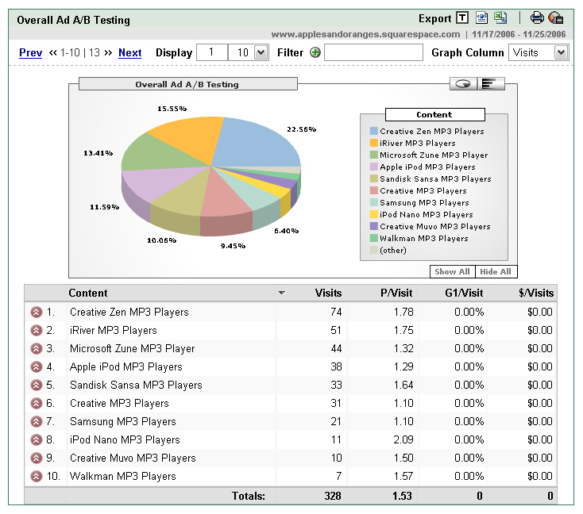
Figure 16: Shows where our visitors go to. You can clearly see that as a result of targeted Google AdWords, Creative MP3 players (and not Apple iPods) are the most popular items on our web page. [Google AdWords Report]

Outlook: High-Priority Next Steps for Improvement

Website Content

- Implement user-interactive feature: We can have a form on our homepage where users can specify their preferences including price range, storage space and certain features. We will use this information as a filter to show them the players that fit their criteria the most. In case they are not familiar with certain technical terms, we can ask intuitive questions to evaluate their preferences, such as
- How many songs do you want on your MP3 player?
- What is your budget?
- Do you want your player to be able to play videos?

- Broaden our product base and enter new markets: Once we have created a sustainable model for MP3 players, we can replicate the model for other consumer electronics, i.e. digital cameras, gaming systems, cell phones, High Definition flat-screen television (LCD vs. Plasma), DVD players (HD-DVD vs. Blue-Ray).

- Add customer content: We can empower visitors to post comments about products (like Yahoo!Answers). They could also decide on which comments are to be posted for the product, and a small reward will be given. Management Scientists have found mathematical formulas that can be used to disproportionately reward votes in such a way as to promote truthful voting [please refer to research by Rajat Bhattacharjee]. This would remove a scaling cost - our time to update product reviews.

- Automatize content management: We can use Amazon’s web services to automatically have the most current information on our site.

Obtain High-Quality Domain

- Increases traffic, since visitors are more likely to like and remember our URL.
- Is search-engine- and crawler-friendlier, since clear keywords can be scanned.
- Leads to a better AdWords performance, since the new URL would look more appealing.
- Would result in us having a more serious image, which is better for marketing.

Advertising Campaign Management

- Further Optimization: We feel that with more analysis on keyword bidding on AdWords, adding several less popular search engines with sponsored links at 5 cents per click, and by adding AdSense banners to the right side of the page, we can get even better results.

