Photographing Dahlias for Lab #1 – the good, the bad, the ugly

Hypothesis: Visible light will stimulate anthocyanin pigmentation in stems of varieties with tan-purple or even dark purple stems. Light could be an absolute requirement, that is, if very young stems are covered with foil, there will be no pigment. Alternatively, light could “enhance” a light-independent synthesis of anthocyanin, just increasing the pigmentation. In either case, if light affects pigment we should see a green or lighter purple patch under the foil.

How long to leave the foil on? When to check it and photograph “the patch”? What part of the stem to cover?

CAMERA CONFESSIONS I confess … I’m used to taking pictures with a Nikon D70 with great lenses for scientific photography. I use my small digital Nikon for vacation photos – mainly landscape where I don’t have to focus close-up. So my primary problem is getting small object in focus with my personal digital camera. Also I take nearly all my photographs outdoors in natural light or in indirect (shade) light. Greenhouse lighting (which favors the red part of the spectrum) makes plants look yellow-green in photos, especially with a flash. This photo was taken on a dark day (little or no natural sunlight).
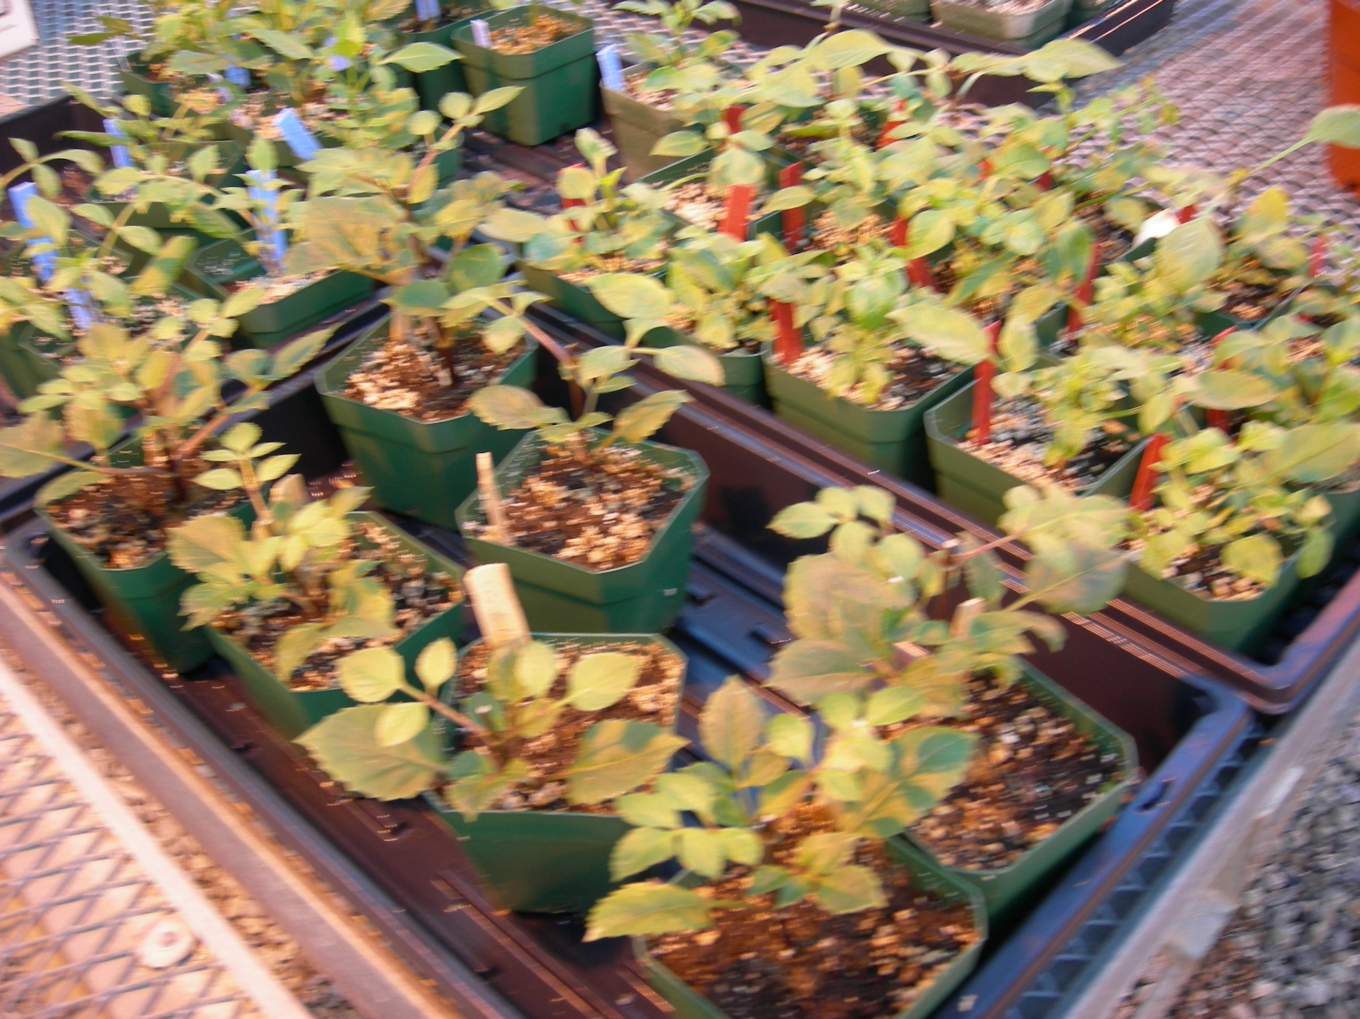
EXPERIMENTAL DESIGN
To begin to explore the experimental design parameters, I covered 3 to 5 internodes of several plants. The youngest internodes were typically green, and the oldest were already purple. This means that age alone could explain pigmentation: gradual accumulation, for example, after the period of cell expansion. If age alone is important then even covering the internodes with foil should not disrupt pigment accumulation. Light could be important earlier as a stimulus causing pigmentation that develops later (days or weeks later). Perhaps I should also try covering the apex with foil, depending on the outcome of my initial experiments?

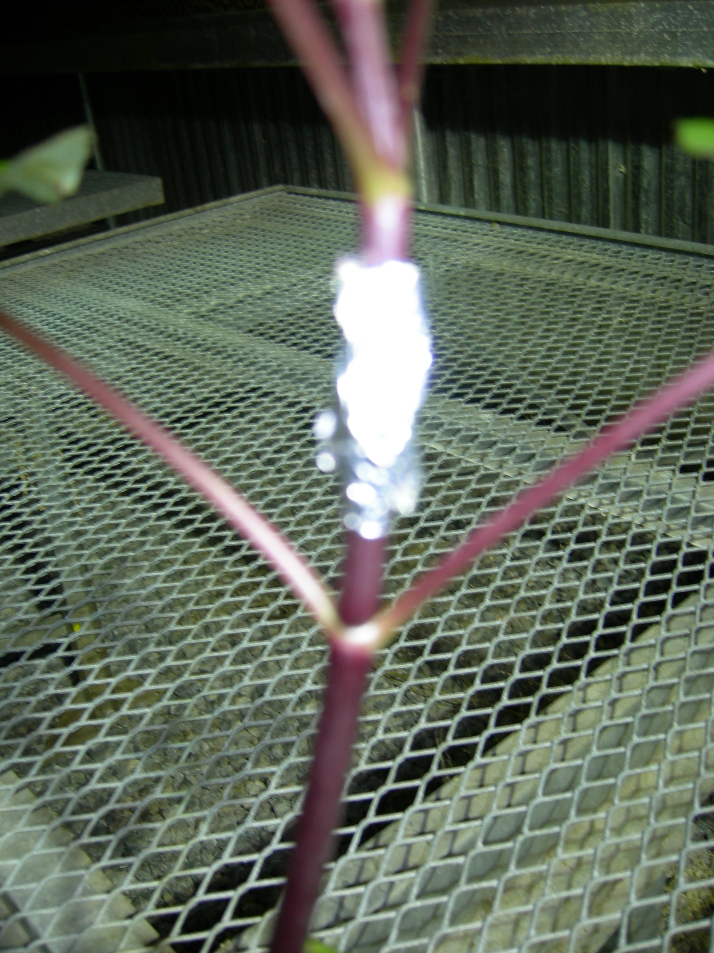
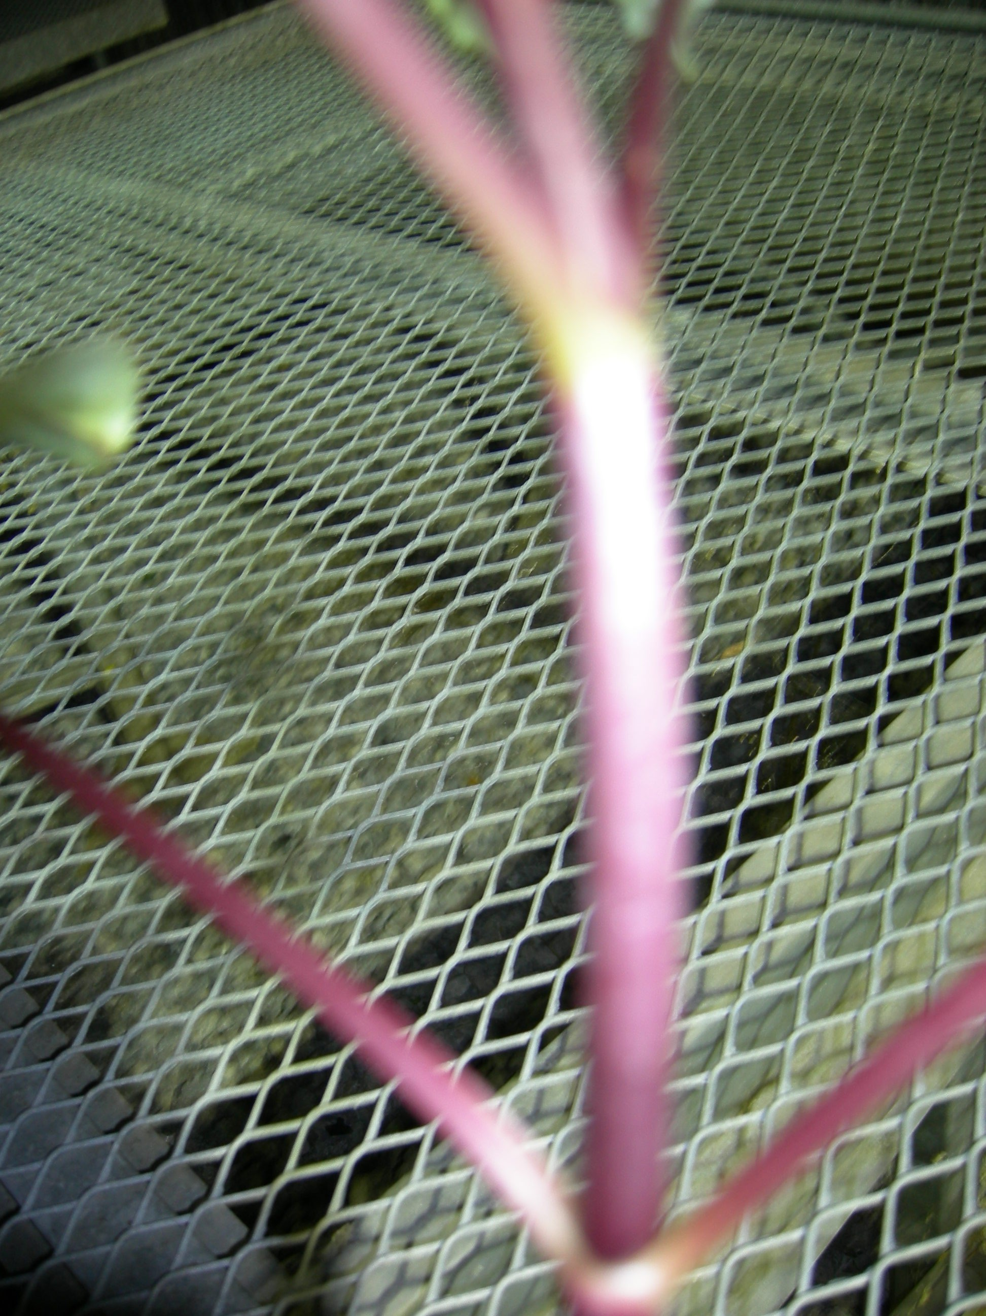
Pinot Noir (relatively dark stem at the start of the experiment, left). Yet, the foil covered area is paler (yellow arrow) after 7 days. There are paler areas on the upper surface of the side branches facing the main stem (right and left photos). Big problem here is that the camera focused on the greenhouse table and not on the stems!

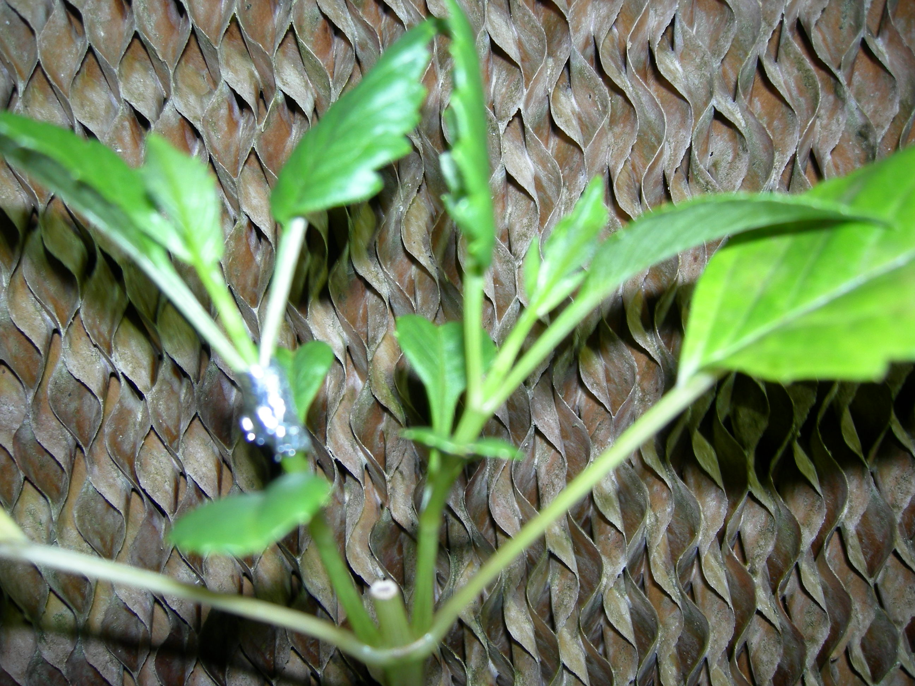
What happens if I photograph plants against the cooling pads of the greenhouse? The plant color is much, much better against the brown background. The wavy lines of the pads are “interesting” but they detract from the plant. Having a background really close to the plant more or less solves the focus problem with a small digital camera.

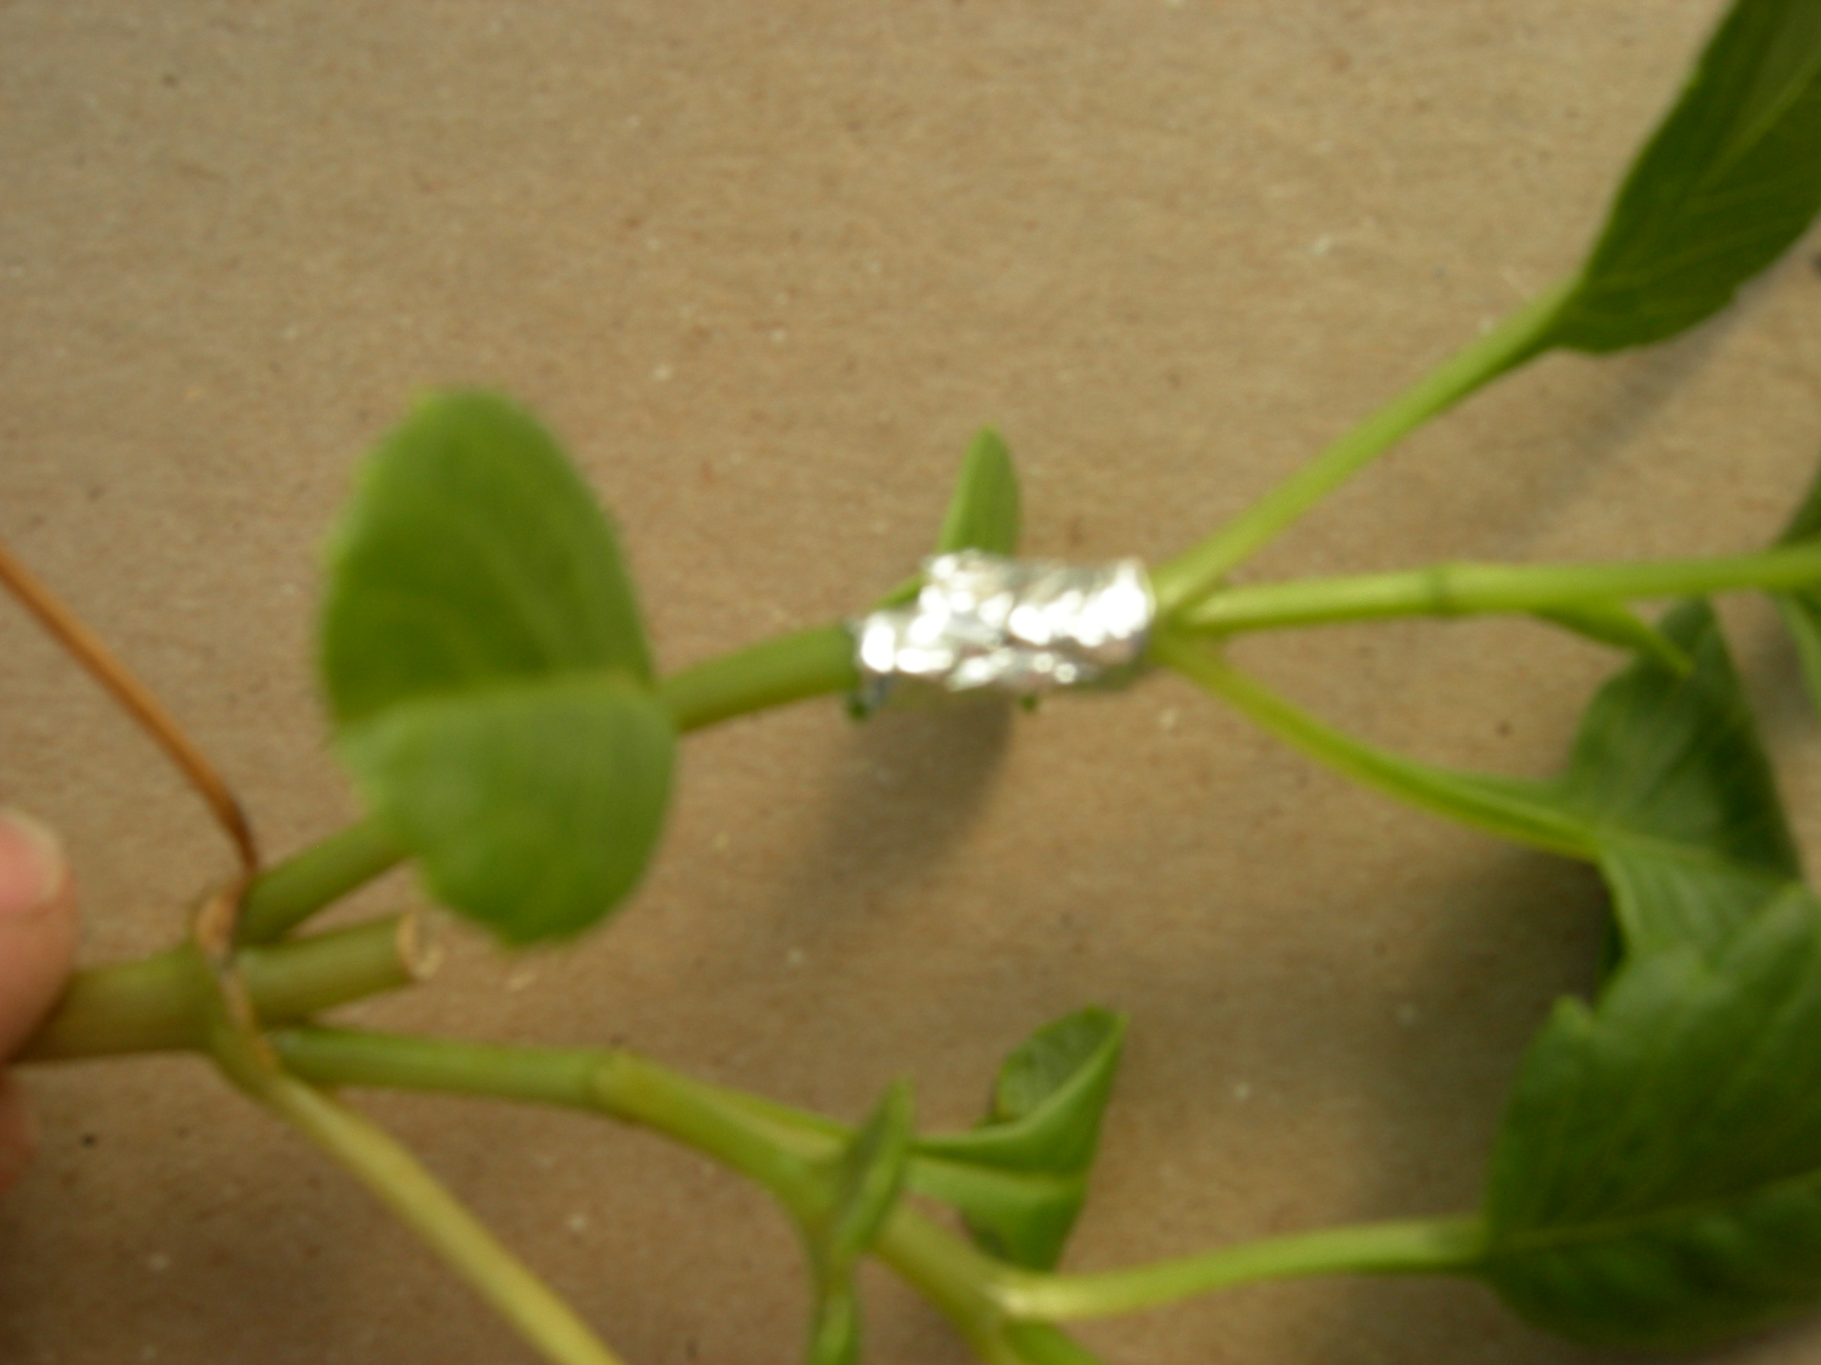
Photograph was against a cardboard box. Right side is in better focus than the left. Thumb was not visible in the viewfinder when I composed the shot, but this is not a problem. This is a control plant with green stems to find out if being covered with foil does “anything.”

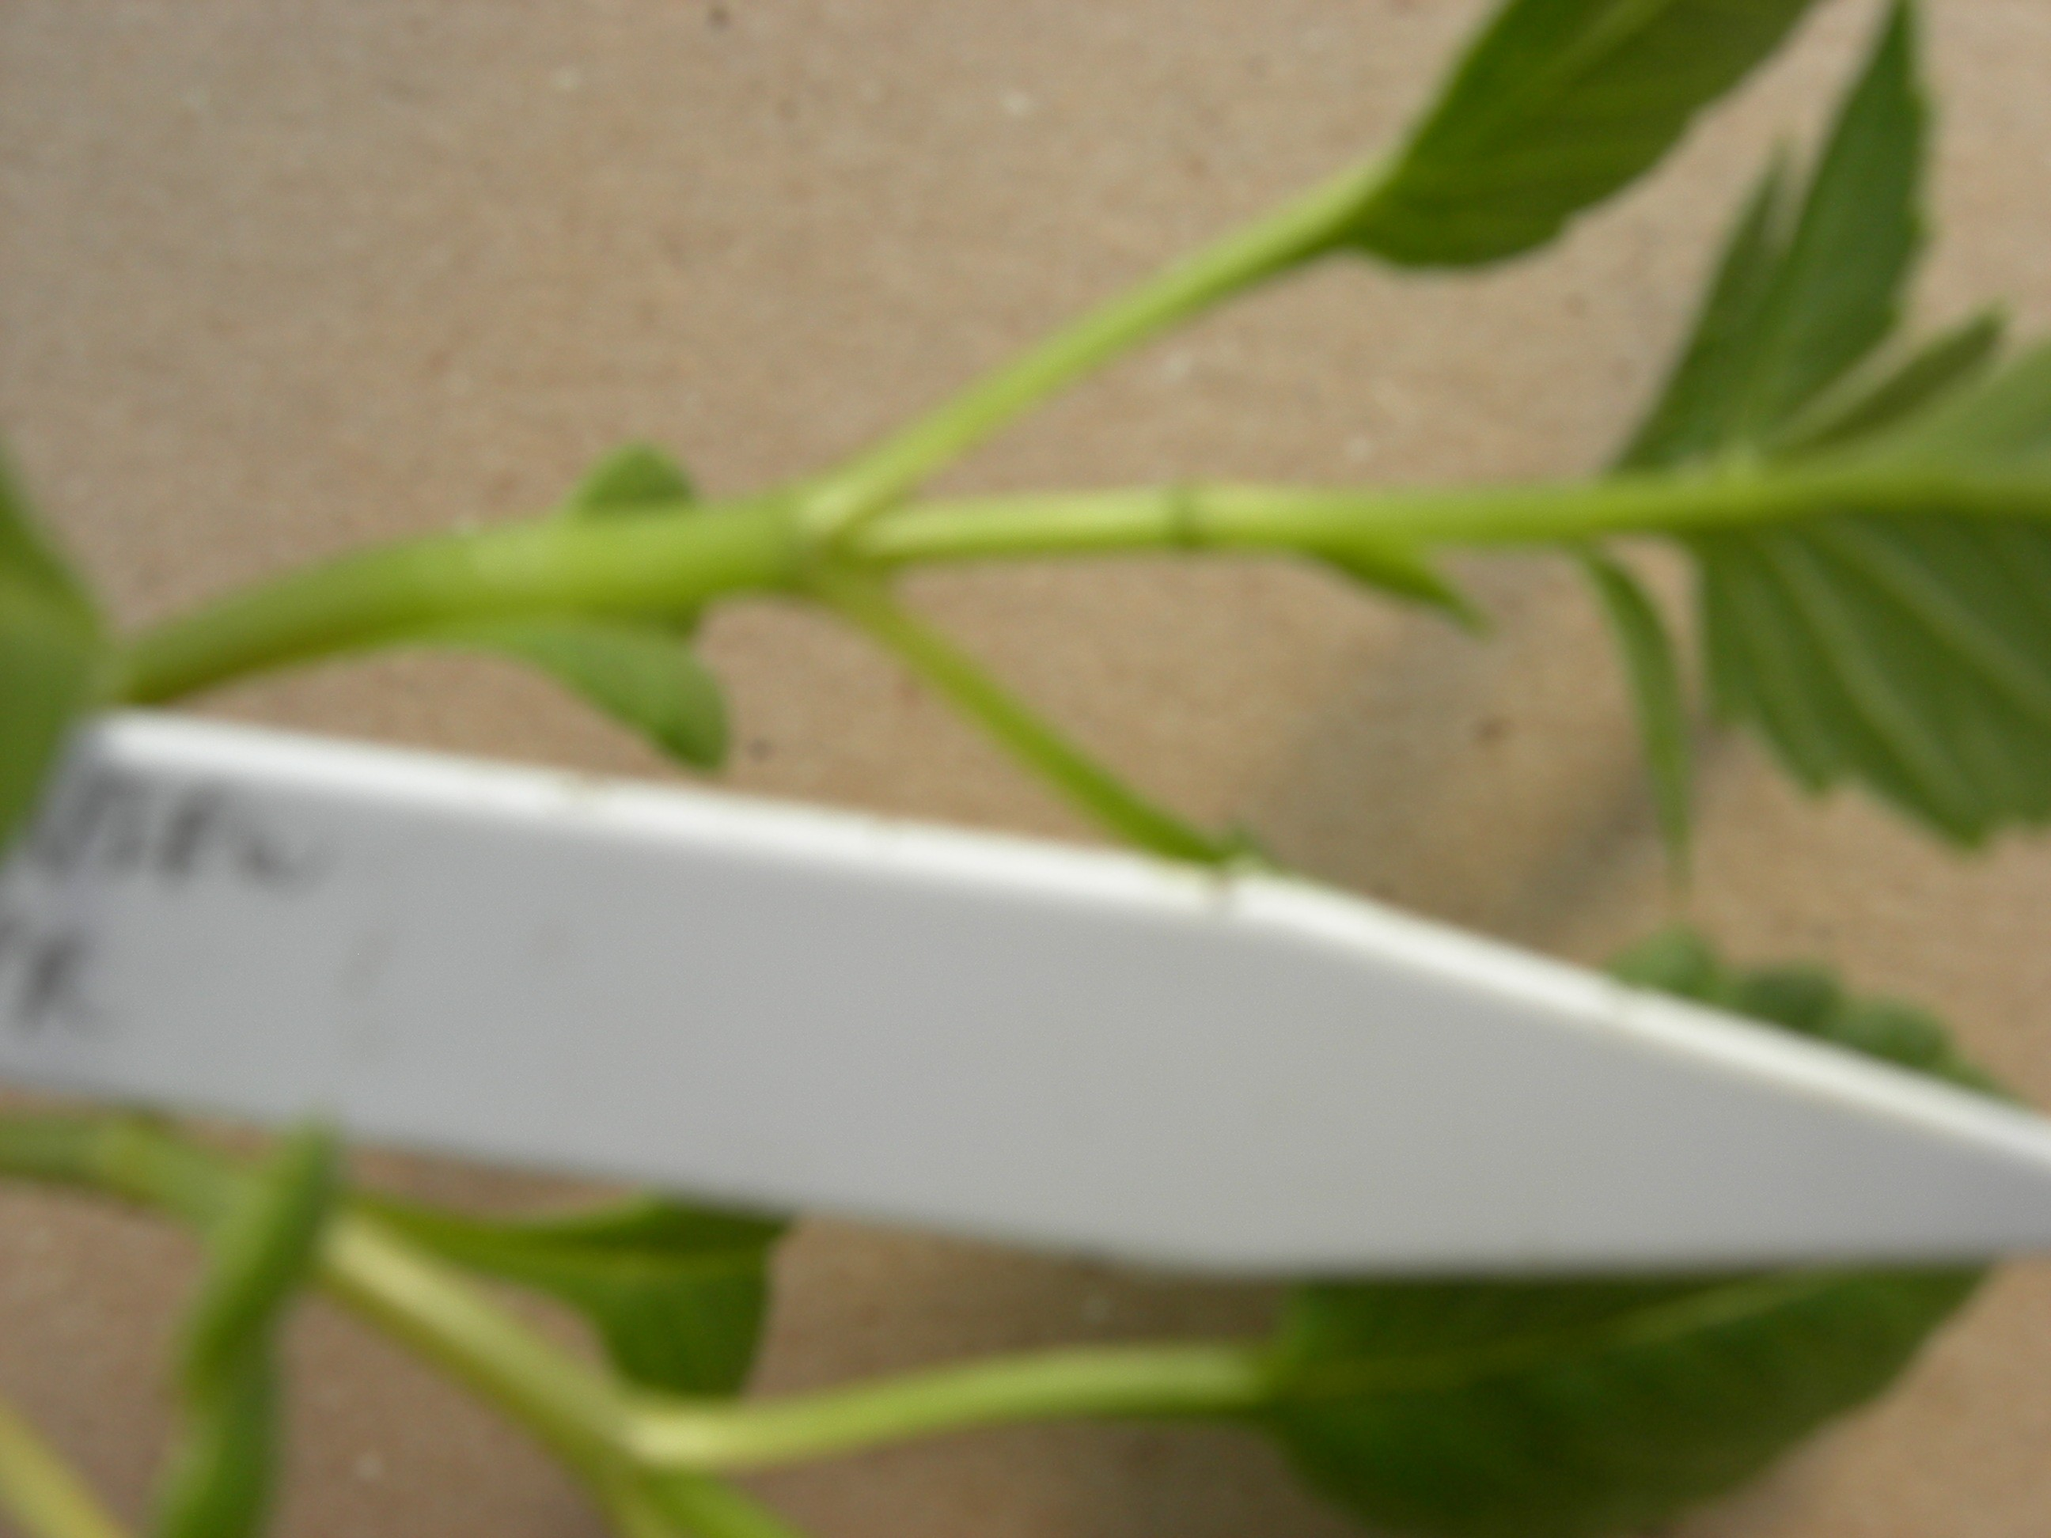
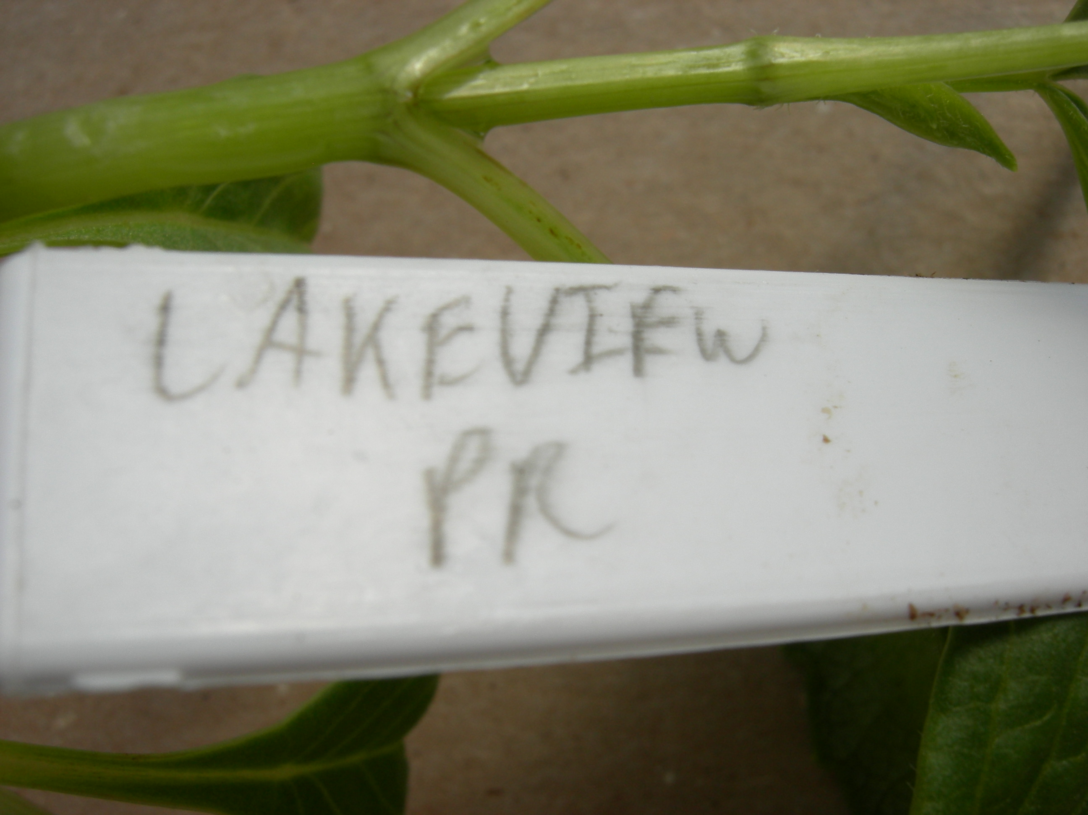
Not a profound discovery, but yes light is required for maintaining greening. There’s clearly a line in the middle of the internode marking the boundary between light and foil covered. Too bad I didn’t get the important part of the plastic label in this photo. The variety is Lakeview Premier. Second photo, below, gets the sign but “oops” I can’t see the boundary anymore.

I should move the tag directly under the part of the internode I want in my picture!

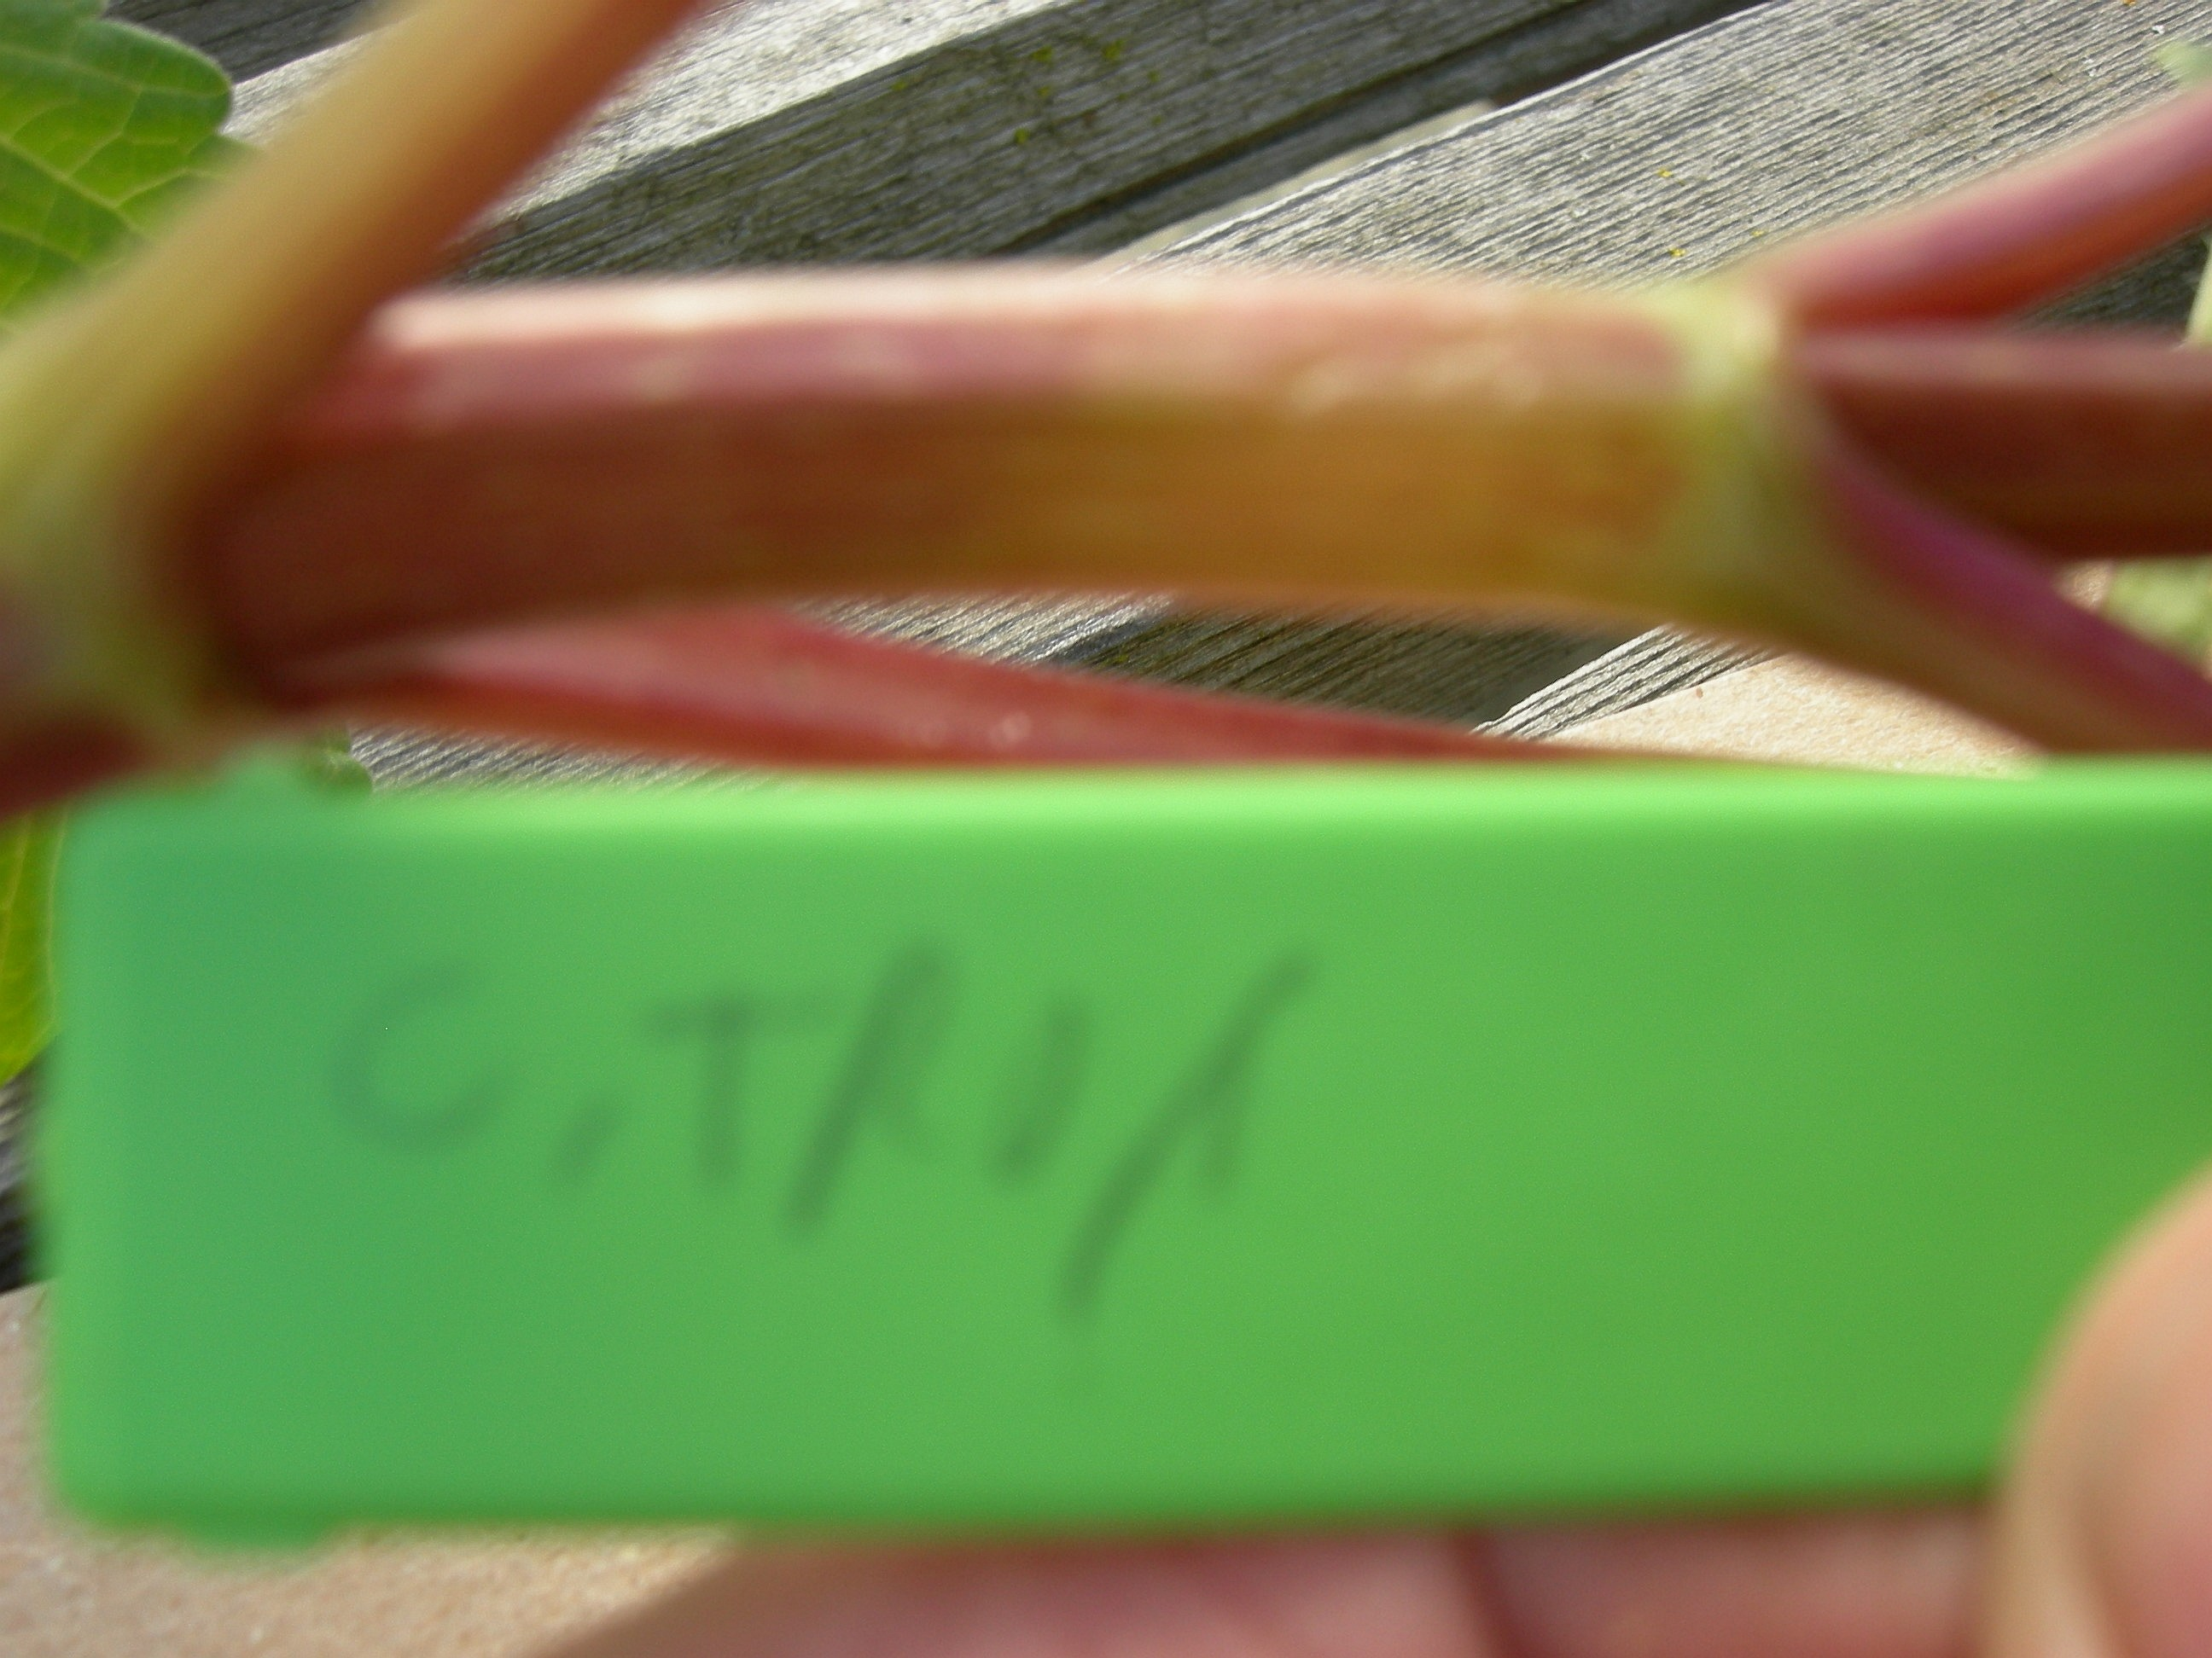
Chimacum Troy is a variety with reddish stems. And foil definitely caused the area to be lighter!!! This photo is outdoors in the light, on a greenhouse bench. The label is out of focus (pesky camera focused on the bench!). There’s just mottled purple left – perhaps this is light-independent pigmentation or some cells got the “light” signal before I put the foil on. Looking at the plant more critically, I also see that the lower sides of the branches are green, not red. I wonder if this is a natural demonstration that light is required for anthocyanin pigmentation. Perhaps red light? The longer the wavelength the less light reflects off surfaces such as the rock floor of the greenhouse. Also the plant canopy is pretty dense with 15 plants per tray, and most red light would be absorbed by the plants; the black trays under the plants are not very reflective. Should I try hanging a plant upside down to test this idea? Are the abaxial and adaxial surfaces of stems equally competent to make pigment? Could I test this by lighting the plant from below? What if I put the plant on it’s side so that ½ ab and ½ adaxial sides receive light?
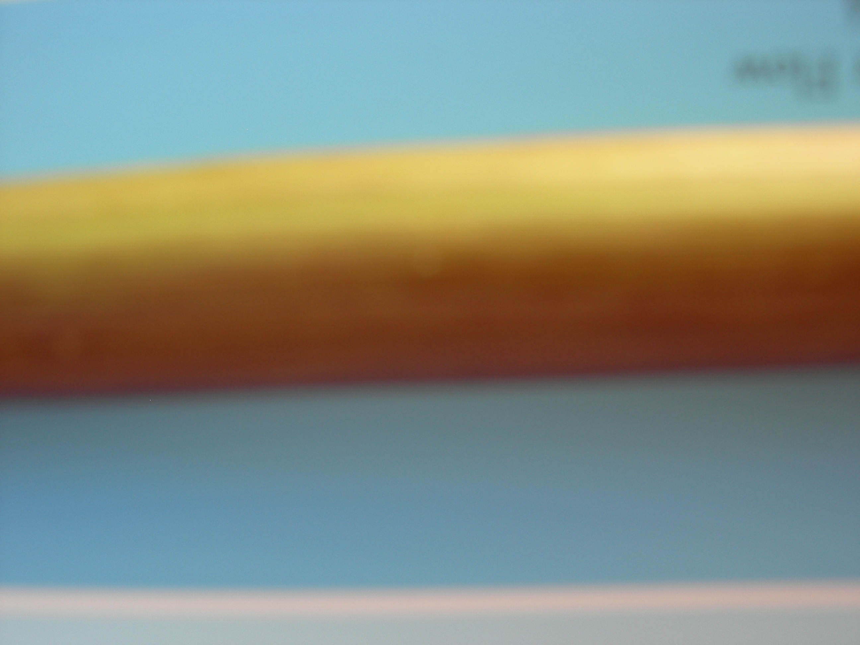
I didn’t actually do those experiments, but you could. Instead I found a plant at the edge of a tray that had ½ of it’s stem in full light and the other half well-shaded by dense vegetation. Check it out. It’s a really crummy out of focus picture, but you can see that there is a green and a red side. Also, I like the blue background (from a paint chip), and I took this picture outside, in the shade with a flash.

Let’s see what else looks good with the blue background

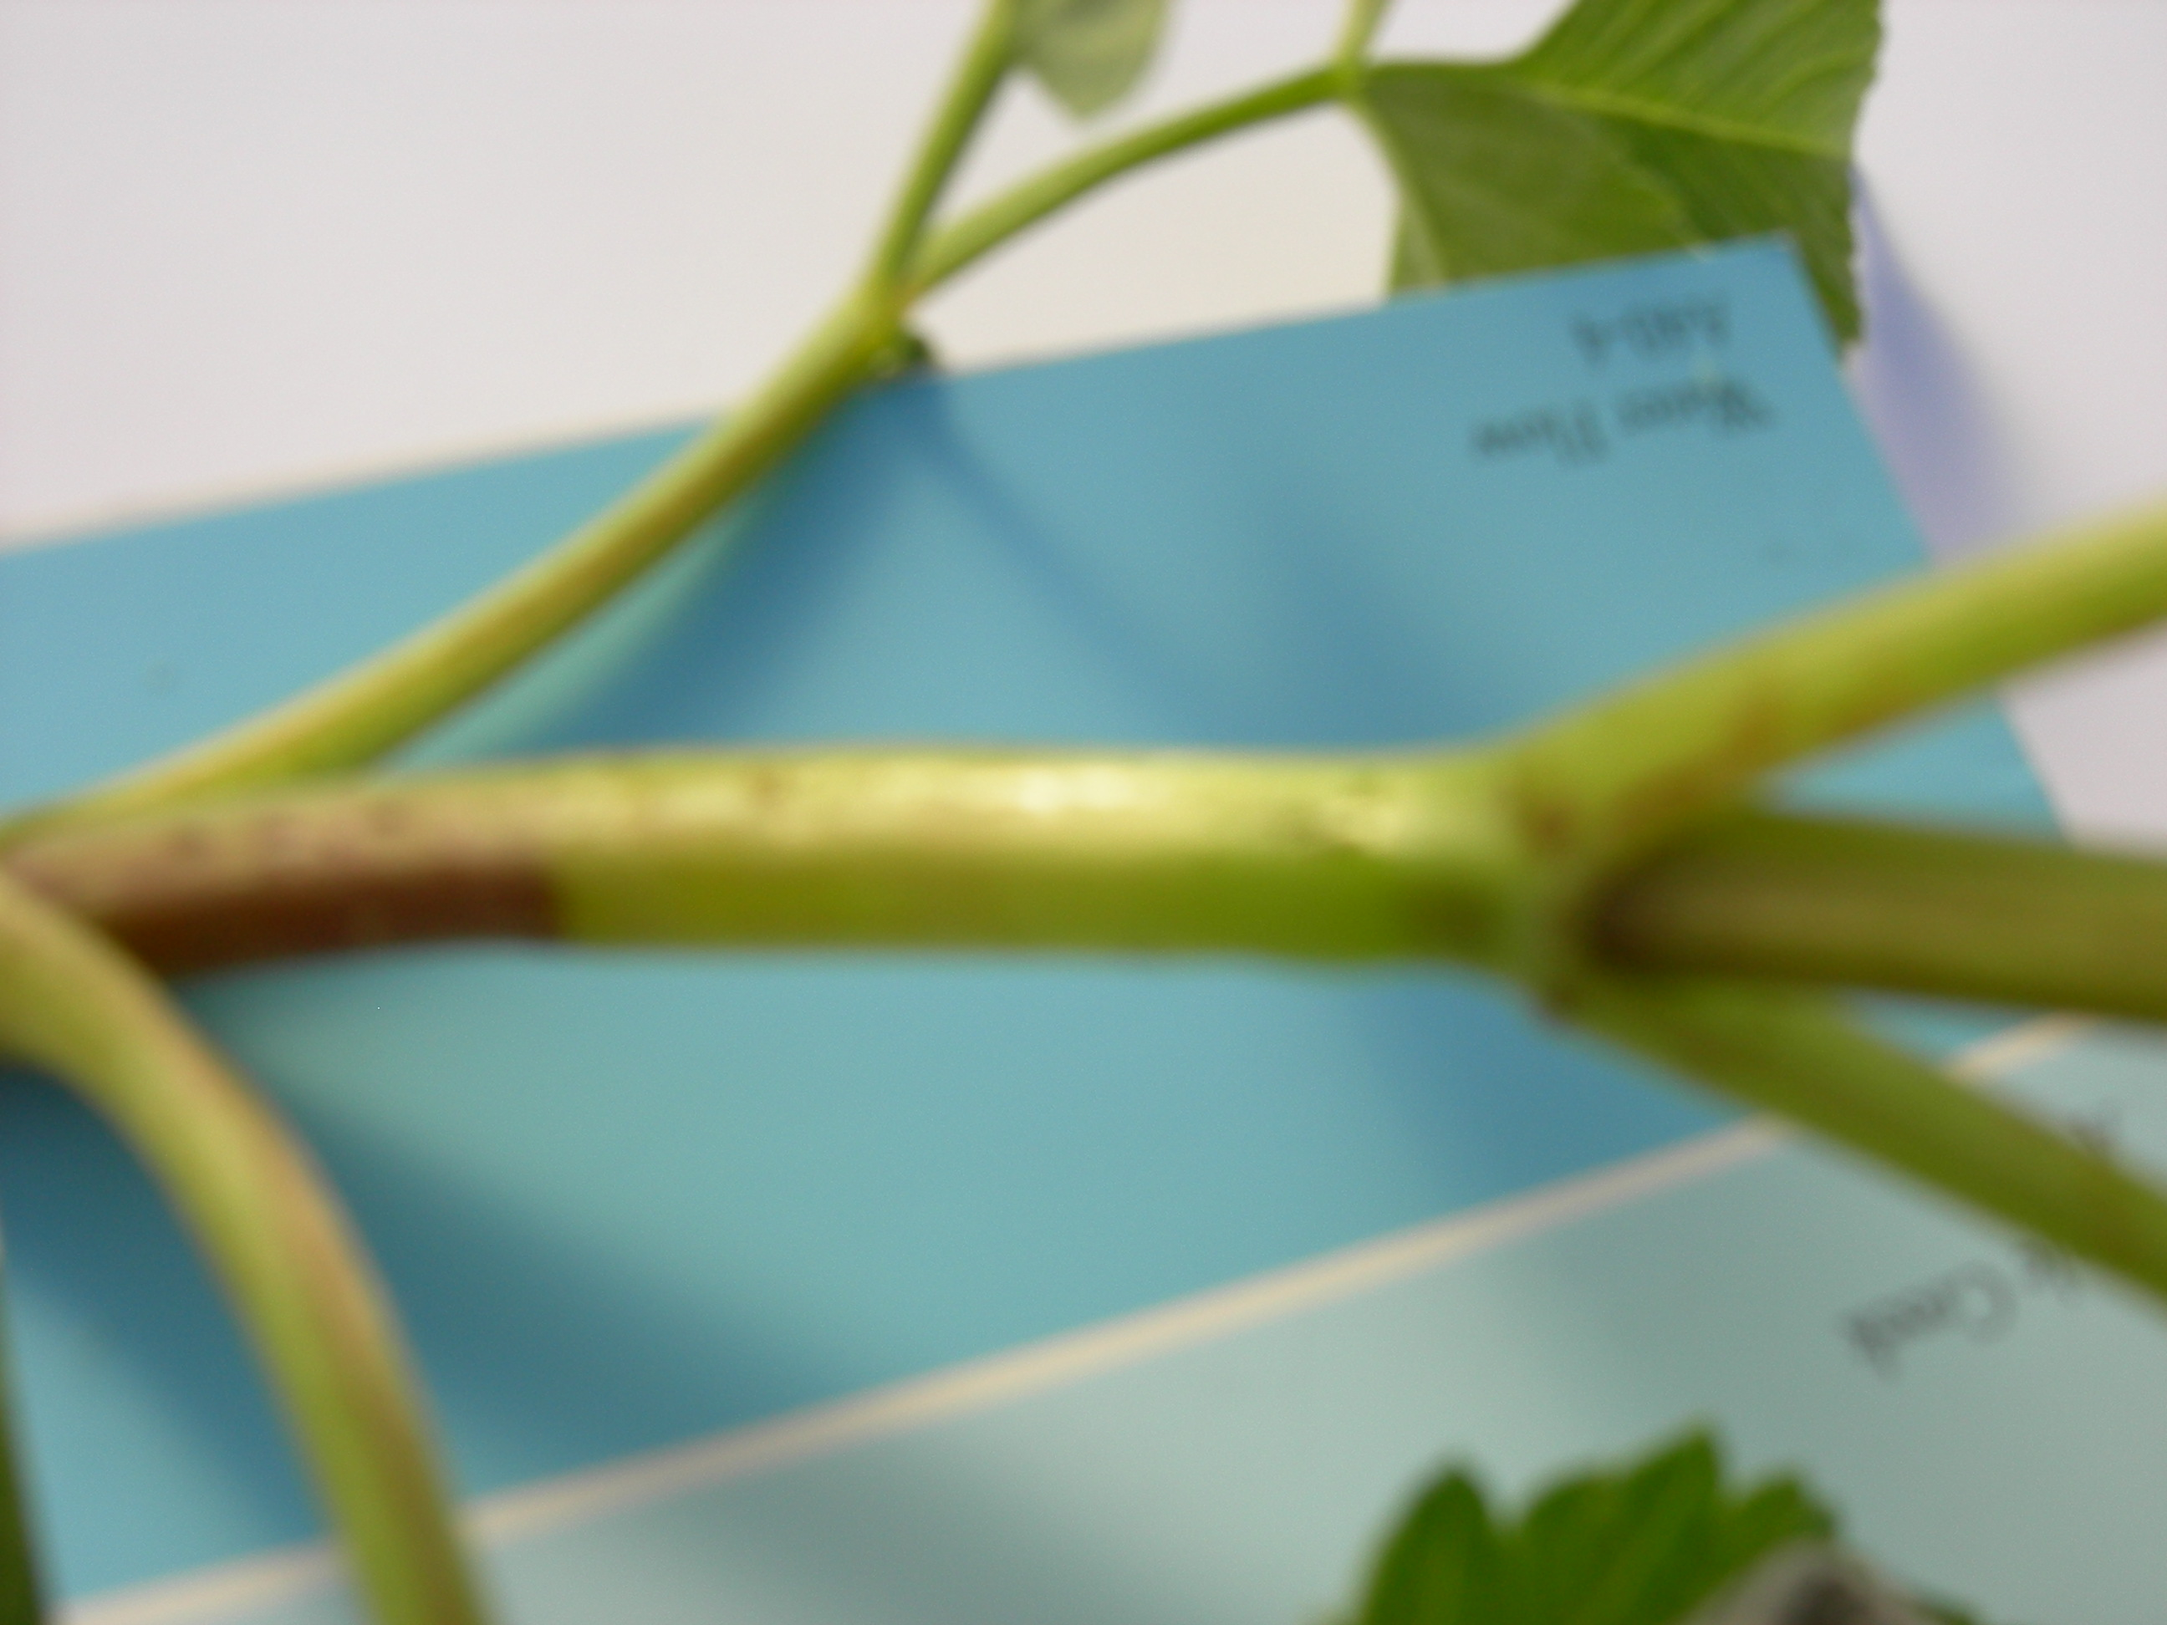
Outdoors in light shade with white paper on the bench so it will be easier to focus on the plant; automatic flash from the camera. The blue paint chip wasn’t “big enough” or I didn’t get close enough … but I could crop this picture and have a pretty good illustration, albeit slightly out of focus.

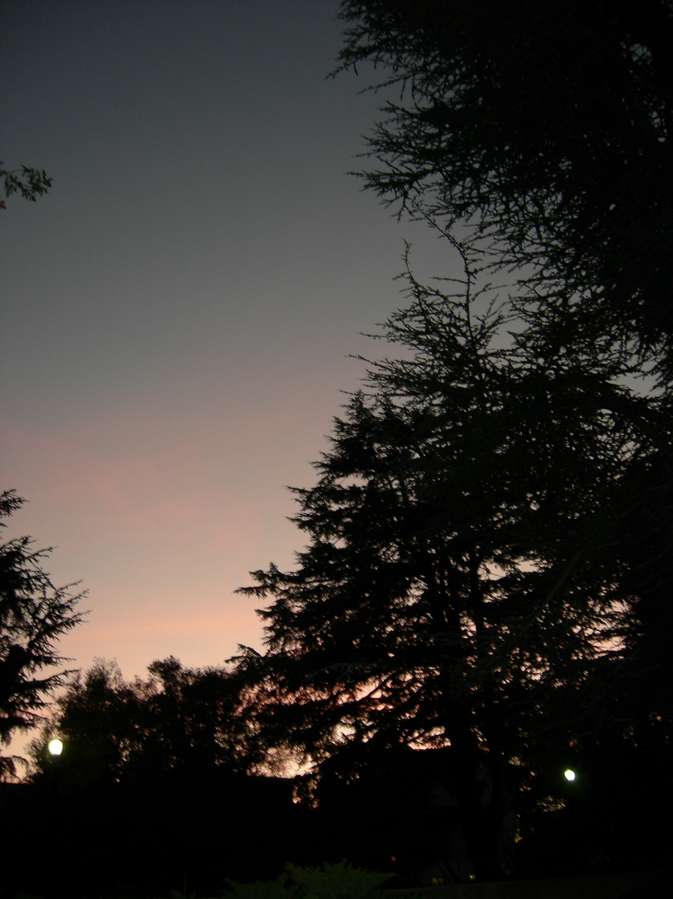

End of the day

