Continuing Studies CS 21 · Stanford University

Exercise 7

Part A: The HTML file (inclass.html)
<!doctype html>
<html>
<head>
<title>STUDENT'S Home Page</title>
<link rel="stylesheet" type="text/css" href="style.css">
</head>

<body>
<h1>
<span class="firstname">FIRST NAME</span>
<span class="lastname">LAST NAME</span>
</h1>

<p>
Welcome to my in-class home page! As is the case with many webpages, mine is still <em>under construction</em>!
</p>

<p>
I created this page in a
<a href="http://continuingstudies.stanford.edu">
<img src="http://www.stanford.edu/group/csp/cs21/images/cs.gif"
alt="Continuing Studies image" width="179" height="56" />
Continuing Studies
</a>

class at

<a href="http://www.stanford.edu">
<img src="http://www.stanford.edu/group/csp/cs21/images/su.gif"
alt="Stanford University image" height="50" width="38" />
Stanford University
</a>.
</p>

<p>
The website for my class is <a href="http://www.stanford.edu/group/csp/cs21"> http://www.stanford.edu/group/csp/cs21/</a>.
</p>

<address>
Last Updated: TODAY'S DATE
<br />Copyright &#169; 2011, <a href="mailto:youremail@yourisp.com">STUDENT</a>
</address>

</body>
</html>

Part B: The CSS file (style.css)

body {font-family: Verdana; color: #000000;
background: green url(http://www.stanford.edu/group/csp/cs21/images/bg.gif); }
address {font-family: Times; font-size: 9px; }
.firstname {font-family: Arial; color: red; }
.lastname {font-family: Courier; color: #fff; }

EXERCISE EIGHT – PART 1
Download "cs.gif", "su.gif", and "bg.gif" from http://www.stanford.edu/group/csp/cs21/images to a folder called images on your folder on your Desktop, then copy them to the your webs account.

1) Launch Internet Explorer.

2) Go to http://www.stanford.edu/group/csp/cs21/images

3) Right-click the link bg.gif and choose Save Target As
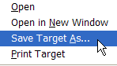

4) In the Save in field, click Desktop. Click your CS 21 folder, and then click Open.
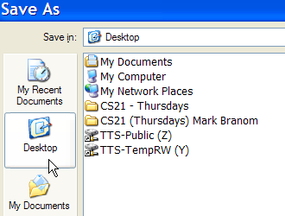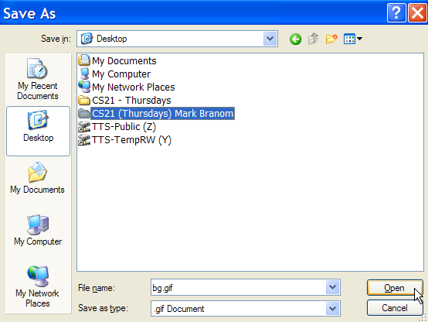

5) Click the Create New Folder icon.


6) Enter images (NOT Images)


7) Double-click the images folder, then click Save.


8) Right-click cs.gif and choose Save Target As

9) Make sure the Save in field says images, then click Save.

10) Right-click su.gif and choose Save Target As

11) Make sure the Save in field says images, then click Save.

12) On your webs.com account, create a folder called images.

13) Upload to the images folder the files su.gif, cs.gif, and bg.gif.
EXERCISE EIGHT – PART 2
Change the URLs for the images in your HTML file to reflect their new locations (no longer on http://www.stanford.edu/group/csp/cs21/images/ )

Part A: The HTML file (inclass.html)
<!doctype html>
<html>
<head>
<title>STUDENT'S Home Page</title>
<link rel="stylesheet" type="text/css" href="style.css">
</head>

<body>
<h1>
<span class="firstname">FIRST NAME</span>
<span class="lastname">LAST NAME</span>
</h1>

<p>
Welcome to my in-class home page! As is the case with many webpages, mine is still <em>under construction</em>!
</p>

<p>
I created this page in a
<a href="http://continuingstudies.stanford.edu">
<img src="images/cs.gif"
alt="Continuing Studies image" width="179" height="56" />
Continuing Studies
</a>

class at

<a href="http://www.stanford.edu">
<img src="images/su.gif"
alt="Stanford University image" height="50" width="38" />
Stanford University
</a>.
</p>

<p>
The website for my class is <a href="http://www.stanford.edu/group/csp/cs21"> http://www.stanford.edu/group/csp/cs21/</a>.
</p>

<address>
Last Updated: TODAY'S DATE
<br />Copyright &#169; 2011, <a href="mailto:youremail@yourisp.com">STUDENT</a>
</address>

</body>
</html>

Part B: The CSS file (style.css)

body {font-family: Verdana; color: #000000;
background: green url(images/bg.gif); }
address {font-family: Times; font-size: 9px; }
.firstname {font-family: Arial; color: red; }
.lastname {font-family: Courier; color: #fff; }

