Continuing Studies CS 21 · Stanford University

Exercise 10 – Adding Lists

<!doctype html>
<html>
<head>
<title>STUDENT'S Home Page</title>
<link rel="stylesheet" type="text/css" href="style.css">
</head>
<body>
<header>
<nav>
<ul>
<li>About Me</li>
<li>About This Site</li>
<li>Footer Stuff</li>
</ul>
</nav>
<h1>STUDENT</h1>
<h2>About Me</h2>
<p> Lorem ipsum dolor sit amet, consectetur adipiscing elit. Integer vehicula tincidunt nunc eget varius. Sed consectetur dolor ligula. </p>
<h2>About This Site</h2>
<p>Welcome to my in-class home page! As is the case with many webpages, mine is still <em>under construction</em>!</p>
<p>I created this page in a <a href="http://csp.stanford.edu/" target="_blank"> <img src="images/cs.gif" alt="Continuing Studies image" width="179" height="56"> Continuing Studies</a> class at <a href="http://www.stanford.edu/">Stanford University</a>.</p>
<div class="promote"> <img src="images/su.gif" alt="Stanford University image" height="50" width="38" /> </div>
</header>
<main>
<p>The website for my class is <a href="http://web.stanford.edu/group/csp/cs21/">http://web.stanford.edu/group/csp/cs21/</a>.</p>
<p>Here is a list of things I have to do for this class:</p>
<ol>
<li>Write a description of my audience and goals</li>
<li>Create a flowchart of my website</li>
<li>Create a site organization chart for my website</li>
<li>Create a color chart for my website</li>
<li>Get some graphics for my website</li>
<li>Create a website (one home page with three linked subsequent pages with content, links,
and graphics on each page -- four pages in all) </li>
<ul>
<li>The website is due Friday, March 25th</li>
</ul>
</ol>
<p> <img src="http://web.stanford.edu/group/csp/cs21/images/schools.gif" usemap="#schools" border="0">
<map name="schools">
<area shape="rect" coords="6,6,85,35" href="http://www.stanford.edu" target="_blank"
alt="Stanford University" title="Stanford University" />
<area shape="rect" coords="6,40,85,70" href="http://www.berkeley.edu" target="_blank"
alt="UC Berkeley" title="UC Berkeley" />
<area shape="rect" coords="6,75,85,105" href="http://www.harvard.edu" target="_blank"
alt="Harvard University" title="Harvard University" />
<area shape="rect" coords="6,110,85,140" href="http://www.yale.edu" target="_blank"
alt="Yale University" title="Yale University" />
</map>
</p>
</main>
<footer>
<address>
Last Updated: TODAY'S DATE <br>
Copyright &copy; 2016, STUDENT
</address>
</footer>
</body>
</html>

Exercise 11 – Email Newsletters

To create an email newsletter, use tables to control page layout and only use inline styles or font tags to control character formatting.

A sample email newsletter is set up for you on the CS 21 exercises site:
http://www.stanford.edu/group/csp/cs21/exercises/11.html

To send an email newsletter:
- Mac Users
  - Open the email newsletter in Safari (use File > Open File if it’s on your computer)
  - On the File menu, select Mail Contents of This Page (Safari 5 and earlier) or
File > Share > Email this Page (Safari 6 and newer)
  - Apple Mail should open with the email newsletter in the body of the message. Enter the email headers (to, subject, cc, bcc, etc.), and send!

- Windows Users
  - Open the email newsletter in Internet Explorer (use CTRL-O to locate it if it’s on your computer).
  - Right-click the window and select Command Bar.
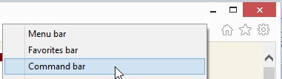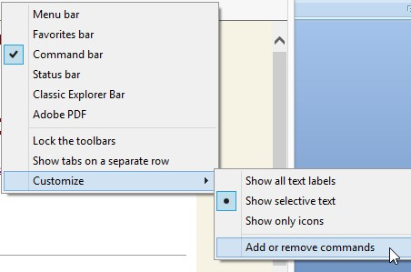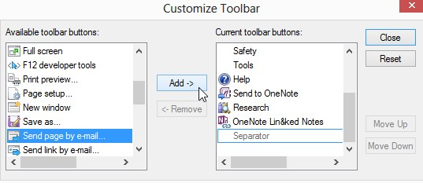

3.

Right-click the
Command bar
and select
Add or remove commands
.

4.

In
Customize Toolbar
, locate
Send page by e-mail
, then click
Add
, and then click
Close.

  - Click Send page by e-mail.
  - Outlook should open with the email newsletter in the body of the message. Enter the email headers (to, subject, cc, bcc, etc.), and send!

