Syllabus for

Gödel, Escher, Bach

Symbolic Systems 11si
a literary approach to minds and machines via DRH’s GEB:EGB

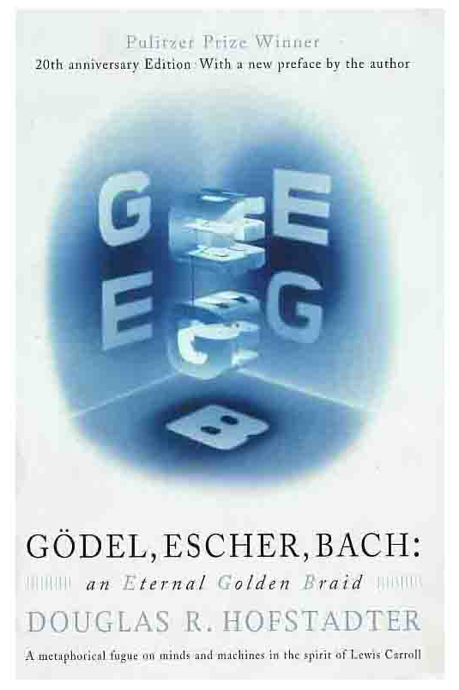
Student Instructor: Brendan O’Connor, brendano@stanford.edu
Faculty Advisor: Maggie Johnson, Computer Science Department

Student-Initiated Course, Spring 2005
Fridays, 11:00 – 11:50 am, 60-62C, P/NC
http://ssp11si.stanford.edu

The Text:
Douglas Hofstadter. Gödel, Escher, Bach: an Eternal Golden Braid. A metaphorical fugue on minds and machines in the spirit of Lewis Carroll.
$20 in the bookstore.

Course Summary:
What creates intelligence and meaning? Does computer science have anything to do with art, music, or philosophy? Douglas Hofstadter's Pulitzer-winning Gödel, Escher, Bach freely integrates poetry, fugues, Zen, Platonic dialogues and metaphorical puns, all to pursue thorny questions about artificial intelligence and the human mind. This class will take a playful approach in understanding these ideas through discussion, analysis, and performance.

Will cover concepts in computational theory, mathematical logic, and philosophy of the mind. Can be said to include topics from the disciplines of math, philosophy, computer science, psychology, logic, cognitive science, music, art and more. Students from all disciplines encouraged to join!

Class Format and Requirements:
The bulk of this course will consist of reading through the admittedly long GEB and discussing its ideas, techniques, and concepts. Apart from a few speakers, on most weeks we will have a reading followed by in-class discussion. During class we will (1) review the often complex concepts and arguments put forth in the book, (2) critically discuss and analyze those ideas, and (3) just see what everyone thought. Students should come prepared with questions about or inspired by the reading and be prepared to critically think about the issues raised. All sorts of approaches to the text are welcome; performance of dialogues, drawing our own pictures, bringing in music…

This course is only offered Pass / No Credit. Since reading is already heavy for a 1-unit course, grading will be primarily attendance- and participation- based. Attendance Requirement: students may miss up to one class session for the quarter. Being forced to miss others will entail make-up assignments. Presentation Requirement: All students will sign up (in groups if wanted) to present and summarize one particular week’s reading. Students experienced in a particular subject – logic, philosophy of the mind, computer science – may want to help out the class in understanding a certain week’s material on that topic. Less experienced students may want to jointly present with others. Students are expected to keep up with the reading and be prepared to discuss every week.

Final decisions on grading will be made by the faculty advisor.

Since everyone’s here because they want to be, we should enjoy the book and have fun!

Note on Student-Initiated Courses:
This course was developed with the tremendous assistance of SIC, a program for students trying to help initiate new courses. There is a huge range of SIC’s being offered, from courses on nutrition to community service to film criticism. The SIC website is http://assu.stanford.edu/sic.

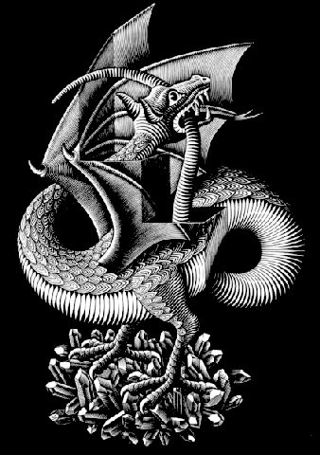
Schedule:
Whenever a chapter is assigned, that includes the dialogue immediately preceding it. So the reading for Ch. 4, which begins on page 82, actually includes the dialogue starting before that on page 75.

The schedule is intentionally top-heavy, so the bulk of the technical readings are hopefully finished before midterms start in full swing. Please read ahead if this is a concern for you.

The most up-to-date schedule will always be on the front page of the website, http://ssp11si.stanford.edu

Week 1 (4/1): Course introduction

Week 2 (4/8): Formal Systems & Intro to Meaning
Readings:
- Preface (only in 20th anniversary edition) – just the first ~4 pages
- Introduction – A Musico-Logical Offering
- Chapter 1 – MU puzzle
- Chapter 2 – Meaning and Form
- Chapter 3 – Figure and Ground (metaphor from the visual arts, for mathematical knowledge)
- Chapter 4 – Consistency, Completeness, and Geometry
  - Highlight: Contracrostipunctus

Key reading: the dialogue for Chapter 4, Contracrostipunctus. It illustrates some very important concepts for later in the book; also, it’s pretty nifty. [hint: there’s at least one hidden message]

Week 3 (4/15): Recursion, Meaning, and Music
Readings:
- Chapter 5 – Recursive Structures
- Chapter 6 – Location of Meaning.
Speaker: Maggie Johnson, on Bach’s music.

Week 4 (4/22): Logic & Number Theory
Readings:
- Chapter 7 – The Propositional Calculus (introduction to propositional logic)
- Chapter 8 – Typographical Number Theory (Hofstadter’s formal system)
- Chapter 9 – Mumon and Gödel (a delightful almost-tangent on Buddhism and DNA)
- Can read ahead: Prelude… Ant Fugue, the joint dialogue for Chapters 10, 11

Week 5 (4/29): Holism, Reductionism, and Mind
Readings:
- Chapter 10 – Levels of Description, and Computer Systems
- Chapter 11 – Brains and Thoughts
- Chapter 12 – Minds and Thoughts

Read the first picture for Ant Fugue several times over, it might take a few tries to get what’s going on.

Week 6 (5/6): Finally, Gödel’s Incompleteness Theorem
Readings:
- Chapter 13 – BlooP, FlooP, GlooP (overview of computability)
- Chapter 14 – On Formerly Undecidable Propositions (the theorem, finally explained)
Speaker: Maggie Johnson, über formal untscheidbare Sätze der Principia Mathematica

Week 7 (5/13): GT’s Implications
Readings:
- Chapter 15 – Jumping Out of the System
- Chapter 16 – Self-Ref and Self-Rep
- Chapter 17 – Church, Turing, Tarski, and Others

Week 8: (5/20): Artificial Intelligence
Readings:
- Chapter 18 – AI: Retrospects
- Chapter 19 – AI: Prospects
Speaker: Terry Winograd, Professor of Computer Science

Week 9 (5/27): Final discussion
Reading:
- Chapter 20 – Strange Loops, or Tangled Hierarchies

