Katrina A. Redfern

December 6, 2004

Final Paper

War and Propaganda:

A Look at How the Two Have Been Inseparable Though Time

There have been many wars that the Unites States has been a part of. Some were fought on American soil, others fought abroad. But through it all, there has always been a need for the public’s support. And what better way to get that support than by putting information out there for the public. Now of course this is biased information that it put forth in front of the general public; just enough to get people caring and thinking about the war, but not enough to keep them fully educated on the subject. Once people start knowing too much and researching, it becomes something that they either feel has too much support, or they take stands that the government does not want. The different media that is out there is geared towards the general public knowing the truth. But I pose the question that “what is the truth?” especially back in the old days? Who, but those who put the information out, knew what was really going on when it came to wars and the enemies? This is why I thought it might be interesting to look at the way the citizens were swayed towards believing certain things during the war. Why was there such a scare about the Japanese being in the United States during WWII? The propaganda that was out at the time was highly against the Japanese, even the Japanese Americans, calling them the enemy. While it is sad to know that these sentiments are true, it is important to remember the past and to learn from it.

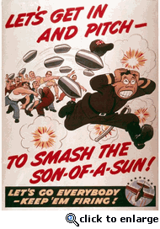

History of Propaganda
Propaganda has been a human activity as far back as reliable recorded evidence exists. The writings of Romans like Livy are considered masterpieces of pro-Roman statist propaganda. The term itself originates with the Roman Catholic Sacred Congregation for the Propagation of the Faith, the department of the pontifical administration charged with the spread of Catholicism and with the regulation of ecclesiastical affairs in non-Catholic countries (mission territory). The actual Latin stem propagand- conveys a sense of "that which ought to be spread".
Propaganda techniques were first codified and applied in a scientific manner by journalist Walter Lippman and psychologist Edward Bernays (nephew of Sigmund Freud) early in the 20th century. During World War I, Lippman and Bernays were hired by the United States president Woodrow Wilson to sway popular opinion to enter the war on the side of Britain. The war propaganda campaign of Lippman and Bernays produced within six months so intense an anti-German hysteria as to permanently impress American business (and Adolf Hitler, among others) with the potential of large-scale propaganda to control public opinion. Bernays coined the terms "group mind" and "engineering consent", important concepts in practical propaganda work. The current public relations industry is a direct outgrowth of Lippman and Bernays' work and is still used extensively by the United States government. For the first half of the 20th century Bernays and Lippman themselves ran a very successful public relations firm.

Revolutionary War Propaganda
Under the leadership of Samuel Adams, patriot propagandists deliberately and conscientiously kept the issue of slavery off the agenda as goals for freedom were set for the American Revolution. The Boston Gazette, the most important newspaper of the Revolution, was chief among the periodicals that dodged or excluded abolition. The Gazette misled its readers about the notable Somerset decision that led to abolition in Great Britain. The Gazette also manipulated the racial identity of Crispus Attucks, the first casualty in the Revolution. When using the word slavery, The Gazette took care to focus it not upon abolition but upon Great Britain's enslavement of its American colonies.
By the time the Revolution began, white attitudes toward blacks were firmly fixed, and these persisted long after American independence had been achieved. In Boston, notions of virtue and vigilance were shown to be negatively embodied in black colonists. These devil's imps were long represented in blackface in Boston's annual Pope Day parade.
Although the leaders of the Revolution did not articulate a national vision on abolition, the colonial antislavery movement was able to achieve a degree of success but only in drives through the individual colonies.

Civil War Propaganda
Both the Union and Confederate forces used propaganda during the Civil War to help recruit soldiers and sway public opinion in their favor. By putting the information out there, there would be more of the population that would know about the war and feel compelled to at least pick one side and support that side.
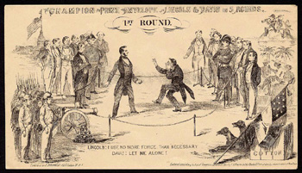
Types of Civil War propaganda included posters, documents, pamphlets, poetry, newspapers, clothing, envelopes, stamps, and other forms. Both sides held rallies where representatives would speak in front of enormous crowds. One of the best known Propaganda clubs of the North was the Union League.
The Union League was started in Philadelphia, Pennsylvania in November of 1862. The Union League advertised the Union cause in many ways. The movement quickly spread from Philadelphia into other major cities including New York City, Boston, Baltimore, Washington, and San Francisco.
The group successfully distributed massive amounts of literature across the country. They also recruited soldiers and helped to raise money for soldier supplies.
The Union also benefited from the work of the Loyal Publication Society of New York courtesy of Charles King and Francis Lieber. The Loyal Publication Society of New York raised tens of thousands of dollars and published astronomical amounts of literature.
In late 1861 Abraham Lincoln sent Archbishop Hughes, Bishop McIlvaine, and Thurlow Weed on an international propaganda assignment hoping to dissuade France, Spain and England from aiding and abetting the Southern Confederacy.
The task of Archbishop Hughes was to win the support of the Papacy, of Napoleon, and of other Catholic rulers. Bishop McIlvaine had an objective to make an appeal for support to the clergy of England.
Thurlow Weed's duty was to interact with journalists and public figures in an effort to counteract Confederate journalistic enterprise abroad.
The Confederates hired English writers to assist in the creation of anti-Union Propaganda. Henry Hotze was a major asset in the propaganda war for the south. He created the Index, a Confederate newspaper.

World War I Propaganda

"Lead this people into war, and they'll forget there was ever such a
thing as tolerance. To fight, you must be brutal and ruthless, and
the spirit of ruthless brutality will enter into the very fiber of
national life, infecting the Congress, the courts, the policeman on
the beat, the man in the street." -Woodrow Wilson

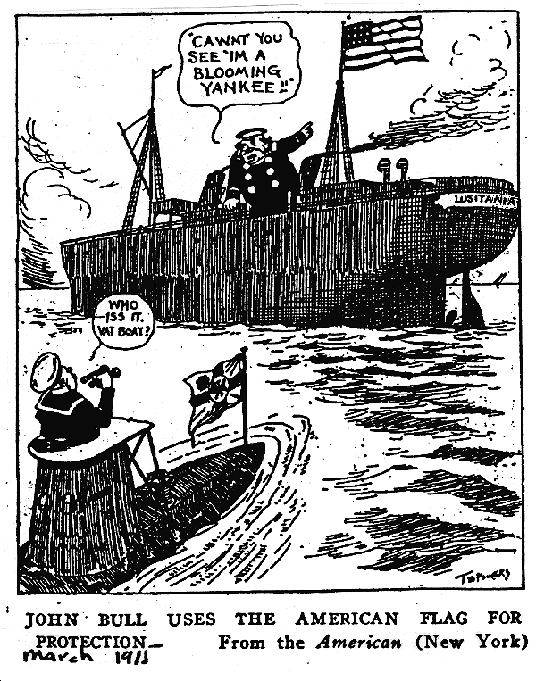

It is one of history's great ironies that Woodrow Wilson, who was re- elected as a peace candidate in 1916, led America into the first world war. With the help of a propaganda apparatus that was unparalleled in world history, Wilson forged a nation of immigrants into a fighting whole. An examination of public opinion before the war, propaganda efforts during the war, and the endurance of propaganda in peacetime raise significant questions about the viability of democracy as a governing principle.

In the above picture, it says, the cartoon refers to the practice taken up by the British of flying a neutral flag (especially American) when in the declared war zone. The artist chose to depict one of the most well known British merchant ships, the Lusitania, to represent the entire merchant navy. Ironically, the Lusitania would end up being torpedoed two months later. After the war it was divulged that the Lusitania was carrying an extensive shipment of munitions in the hold.

World War II Propaganda
World War II saw continued use of propaganda as a weapon of war, both by Hitler's propagandist Joseph Goebbels and the British Political Warfare Executive. Some historians claim that the use of gas chambers in the Holocaust is an instance of an effective Allied propaganda campaign that could not be reined in after the war, much like the now discredited claim made during the Gulf War that Iraqi soldiers were ripping newborn babies out of incubators and throwing them to the ground.
In this piece of propaganda from WWII, the title of the picture is “Hurricane’s in action: thank you, Tanganyika!” it is a picture of Hurricane fighter planes at an airfield and attacking over land to assist Great Britain’s war effort. 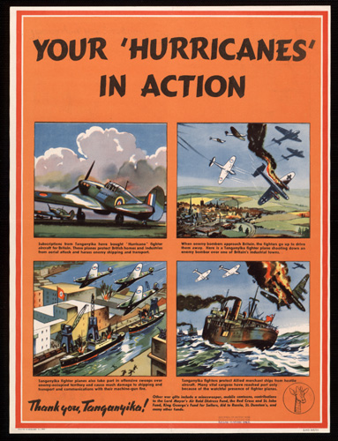

*Nazi Germany
Most propaganda in Germany was produced by the Ministry for Public Enlightenment and Propaganda. Joseph Goebbels was placed in charge of this ministry shortly after Hitler took power in 1933. All journalists, writers, and artists were required to register with one of the Ministry's subordinate chambers for the press, fine arts, music, theater, film, literature, or radio.
The Nazis believed in propaganda as a vital tool in achieving their goals. Adolf Hitler, Germany's Führer, was impressed by the power of Allied propaganda during World War I and believed that it had been a primary cause of the collapse of morale and revolts in the German home front and Navy in 1918. Hitler would meet nearly every day with Goebbels to discuss the news and Goebbels would obtain Hitler's thoughts on the subject; Goebbels would then meet with senior Ministry officials and pass down the official Party line on world events. Broadcasters and journalists required prior approval before their works were disseminated. In addition the Nazis had no moral qualms about spreading propaganda which they themselves knew to the false and indeed spreading deliberately false information was part of a doctrine known as the Big Lie.
Nazi propaganda before the start of World War II had several distinct audiences:
- German audiences were continually reminded of the struggle of the Nazi Party and Germany against foreign enemies and internal enemies, especially Jews.
- Ethnic Germans in countries such as Czechoslovakia, Poland, the Soviet Union, and the Baltic states were told that blood ties to Germany were stronger than their allegiance to their new countries.
- Potential enemies, such as France and Great Britain, were told that Germany had no quarrel with the people of the country, but that their governments were trying to start a war with Germany.
- All audiences were reminded of the greatness of German cultural, scientific, and military achievements.
Until the Battle of Stalingrad's conclusion on February 4, 1943, German propaganda emphasized the prowess of German arms and the humanity German soldiers had shown to the peoples of occupied territories. In contrast, British and Allied fliers were depicted as cowardly murderers and Americans in particular as gangsters in the style of Al Capone. At the same time, German propaganda sought to alienate Americans and British from each other, and both these Western belligerents from the Soviets.
After Stalingrad, the main theme changed to Germany as the sole defender of Western European culture against the "Bolshevist hordes." The introduction of the V-1 and V-2 "vengeance weapons" was emphasized to convince Britons of the hopelessness of defeating Germany.
Goebbels committed suicide shortly after Hitler on April 30, 1945. In his stead, Hans Fritzsche, who had been head of the Radio Chamber, was tried and acquitted by the Nuremberg war crimes tribunal.

Korean War Propaganda
Although the North Koreans and Chinese lacked the resources to emulate the leaflet disseminations of the United Nations, they attached great importance to every form of propaganda, and in many cases used this weapon most effectively.
Here we list some examples of this circa 1950 Korean War Propaganda.

The Korean People’s Army and the Chinese People’s volunteers dropped Christmas cards for the British troops showing an old-world coaching scene on the front, in four colours. Inside were greetings and the following text:

British Officers and Soldiers,
It is nearly 28 months since the Yanks dragged Britain into this war. Nearly 10,000 British lads have been killed or wounded in this period (actual number of casualties to September 1952--- 9393).
The Gloster Regiment has suffered particularly heavy losses as a result of American selfishness. Now British soldiers have also been rushed into Koje Island, where the Yanks have been committing the most terrible crimes against Prisoners of War.
They want you to share their responsibility. Though, all over Britain, the people are longing for peace, yet the so-called United Nations delegation -- which is run entirely by the U.S. without a single Britisher on it -- has been sabotaging the truce talks. They are forcing you to face another grim winter in Korea.
Is it not true that almost every letter you get from home mentions how prices are going up -- food, clothing, fares and nearly everything else?
The Ministry of Labour has reported there are now 517,000 unemployed in Britain.
Where is Britain getting to as a result of tailing behind the Yanks, the American Big Business millionaires who want to grab the whole world for their profits?
Is it not quite plain
That only peace will put a stop to further,
unnecessary casualties for all you lads;
that only peace will save your folks from
the growing burden of armaments expenditure;
and peace will give you the chance of spending
Christmas along with your dear ones.
Even U.S. airmen have lately been refusing to fly in the Korean War. Friends! Don't fight for the Yanks any more! Without you, they cannot keep up this war!

My GI Buddy
I am a prisoner of war under the care of the People's Army. I make an appeal to you. Stop this useless fighting and lay down your arms as I did. Don't believe what you were told about being killed or tortured! You will be treated kindly. I have been well-fed and housed since the first day of my capture. I, too, was afraid to surrender, but believe me, buddy, it is the best bet. Use your head! Don't die on foreign soil for nothing.

AMERICAN G.I.s
Have you ever stopped to think what you are fighting for? Stop! Just stop! And think it over. I say we shouldn't be fighting these people.
I say we have no reason to fight, no reason to fight these people whatsoever! We are fighting the people who are fighting for the freedom of their country. This is their country and not ours. We should withdraw from Korea. We're Americans. Let the Korean people settle their internal problems just as we settled ours.

There is so much that we as citizens have to worry about when it comes to knowing about our surroundings and wars that go on around us. Sometime the propaganda that we see helps us, and sometimes it is important not to take them all for face value.

Works Cited
Doob, Leonard. Propaganda: Its Psychology and Technique. New York: Henry Holt and Company, 1935.

Ellul, Jacques. Propaganda: The Formation of Men’s Attitudes. New York: Vintage Books, 1965.

Hummel, William and Huntress, Keith. The Analysis of Propaganda. New York: William Sloane Associates, 1949.

Institute for Propaganda Analysis. Propaganda Analysis. New York: Columbia University Press, 1938.

Lee, Alfred McClung. How to Understand Propaganda. New York: Rinehart and Company, 1952.

Miller, Clyde. The Process of Persuasion. New York: Crown Publishers, 1946.

Pratkanis, Anthony and Aronson, Elliot. Age of Propaganda: The Everyday Use and Abuse of Persuasion. New York: W.H. Freeman and Company, 1991.

