War Propaganda
Past, Present and Future

Tami Ransom
Engineering 297a

Outline:

Part 1:
An In-depth Look at War Propaganda

Part 2:
Propaganda of the Past
Discussion of Propaganda from WWI, WWII, the Vietnam War, the Cold War, and the Gulf War

Part 3:
The Transition of Propaganda throughout the Years
An analysis of propaganda from the past to the present

Part 4:
War Propaganda Today
A closer look at the War on Iraq

Part 1: An In-depth Look at War Propaganda

Propaganda consists of the planned use of any form of public of mass-produced communication designed to affect the minds and emotions of a given group for a specific purpose, whether military, economic, or political.
-Linebarger, Paul Myron Anthony

In every aspect of life, there tends to be a desire to have others see things the way we see them. In theory, if we all share the same views and opinions, we can unite for common goals. Propaganda consists of a communicators objective to impose or manipulate a person, or group of people into adopting his ideals. Perhaps the most common place that Propaganda is used is during times of war. Given the choice, most people would most likely not express a love for war. Some are passionately against it, others, though not in love with the idea, support it when it’s necessary. Due to the raw nature of war and people’s reactions to it, there seems to be some force working to mask the negative feelings towards war and unite people in support of it.
With regard to war, the purpose of propaganda is to make a particular group of people forget that another group is human. By focusing on a few, simple target ideas that reinforce the notion that another group of people are harmful and inhumane, propaganda is able to unite people in an unrealistic mindset. Understandably, however, governments have a priority to nurture the morale of its people and the armed forces that represent it by intimidating the enemy with the force of natural will. The question of whether or not we choose to accept this harsh reality remains ambiguous, as there will always be two sides to the argument.
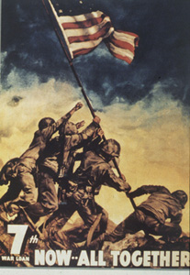
So as it stands, it is well known that “In war, truth is a relative commodity and propaganda a staple of battle.” It is clear that, despite the negative connotation that propaganda entails, prestigious world leaders admit to its necessity. “In wartime, truth is so precious that she should always be attended by a bodyguard of lies. (Winston Churchill) Though leaders will often admit to their use of propaganda, the tendency is to denounce it as such, reverting to euphemisms when discussing their own political agenda. For example, the American government will admit to the use of propaganda only when it is referred to as “public information”. When speaking of the enemy, however, it is essential that their tactics be deemed war propaganda.

Propaganda in totalitarian regimes is easy to recognize for its blatant and crude methods. In democratic societies, on the other hand, propaganda is often disguised. In a nation where the public is required to think and act according to the collective good of society, the use of blatant propaganda would most likely not be questioned. If it were questioned, it’s generally not within anyone’s right to express their dissatisfaction or concern of the nature of the government’s actions. In a nation with free will and thought, however, things aren’t so simple. The use of propaganda must be sneaky and disguised. If blatant propaganda were used in such a country, there would be such a reaction from the public that the government would suffer. Given this, it is imperative that propaganda in a democratic nation be of a different nature.
Propaganda agents generally attempt to relay their message with as few sources as possible, as to avoid confusion and contradiction. The propagandist also tends to separate himself from the audience as he assumes a position of superiority. With this in mind, it is important to distinguish between the three different types of propaganda; white, grey, and black. White propaganda, associated with overt psychological operations, is issued from a credible source. Propaganda of the grey sort does not specifically name a reference. Black propaganda, the most evil kind, pretends to be from a source other than the true one, a tactic used for covert psychological operations.
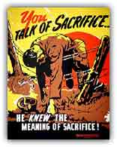
The main objective for propaganda is to unite behind the belief that what is being done is in the best interest of everyone. To achieve this, the enemy must be demonized by certain principles, which at the same token, are not used to judge the self. This, inevitably, leads to questions regarding the double standard and hypocrisy of their methods. “The most effective propaganda relies on framing rather than on falsehood. By bending the truth rather than breaking it, using emphasis and other auxiliary embellishments, communicators can create a desired impression without resorting to explicit advocacy and without departing too far from the appearance of objectivity.” (Michael Parenti, political scientist)

Information is the currency of victory
–US Army Field Manual 1996

There are essentially four levels or strategies of war propaganda. The first is that of the “Big Lie”, which was personalized by Hitler and Stalin. The second level maintains that any sort of information is capable of being presented, so long as it’s feasible. The third strategy consists of telling the truth, but in doing so, making sure to withhold the other side’s point of view. The last strategy insists on telling the whole truth, including all sides and presenting both the good and the bad. In Western societies, the last three levels are adopted, as people will generally not fall for the big lie.
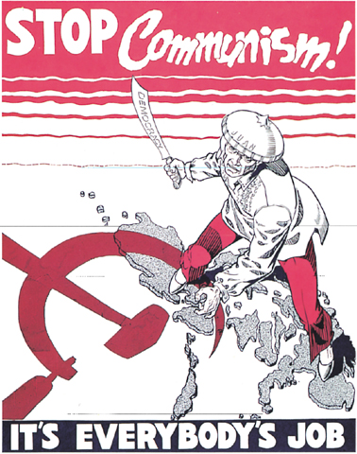
In preparing for a war, there are a few steps that are usually always taken to ensure its success. First, the media must report on the crisis situation. This often involves message to the pubic that the negotiations between “us and them” are irresolvable. Second, the media must find a target symbol for people to direct their anger and hatred. It is difficult to sit back and say that Germany as a whole is evil, but sitting back and pointing the blame at Hitler makes the hatred more tangible. Demonization of the enemy’s leader is a key to evoking war spirit in people. Next, the demonization must be gradually applied to the collective enemy and each individual there within. This gradual manipulation of mindset will eventually lead to people being able to justify killing a group of people who they ordinarily would not have had any serious problems with. The last step for the media upon preparing a country for war involves continual reporting of atrocities. Fabricating and or embellishing stories will serve to stir up and strengthen emotional reactions, which will eventually lead to a sudden urge to go to war.
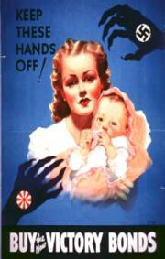
The focus of propaganda during wartimes is often on children. In World War I, stories were published detailing how Germans would throw babies into the air and spear them onto their bayonets during their marches. Besides targeting children in war propaganda, race is another popular topic. Children’s books in France portray Japanese as gibbering monkeys. Posters in Italy illustrate black U.S. bomber pilots as wild killer apes. Even in America, Japanese people were depicted as having slanted eyes and buck teeth.
Propaganda must be targeted at the public mass, and catered towards being comprehended by the lowest of intellects. In order to encompass the broad range of citizens, it is generally the case that the simpler the message, the better. To accomplish this, there are a few tricks that reporters use to draw us in, regardless of our background. The first is word games, which consists of name calling, group labeling (both positive and negative), and euphemisms. Second is the use of false connections, which includes transfer, positive symbols, testimonial, and claims by unqualified individuals. Lastly, propaganda makes use of special appeal. This includes use of plain folks, images of “ordinary” leaders, band wagon, and exploitation of fear. Propaganda seems to be quite successful, and here’s why:
- People want to believe the best about themselves and their country
- People are fear mongering, especially about threats to cherished values such as freedom and justice
- Presentation of fear seem logical and factual
- Narrowed ranges of debate keep devious thoughts in check

“All propaganda must be so popular and on such an intellectual level, that even the most stupid of those towards who it is directed will understand it…Through clever and constant application of propaganda, people can be made to see paradise as hell, and also the other way around, to consider the most wretched sort of life as paradise.” (Adolph Hitler)
Contrary to what one might believe, however, propaganda is often more effective on the educated, rather than the uneducated population. This is mainly due to the fact that educated people tend to read more often, exposing them to more of the media that is pushing the propaganda. On another level, educated people frequently have jobs in academia, management, and media, which in some form make them agents of the propaganda system. With social, financial, and intellectual background aside, there seems to be a logical reason why we don’t whole heartedly pursue the truth in times of war: “If one’s privilege is based on maintaining the empire, it’s not surprising that some people won’t want to know about what the empire really does.”

Part 2: Propaganda of the Past

“It was, of course, the astounding success of propaganda
during the war that opened the eyes of the intelligent few in all
departments of life to the possibilities of regimenting the public mind.”
-Edward Bernays (Sigmund Freud’s nephew)

In August of 1914, soon after WWI broke out, the British government discovered that the Germans had a Propaganda Agency. But it wasn’t until 1935 that the activities of the Bureau became known to the public. It’s a well known fact that the Germans were responsible for starting the war, and we now can partly understand how the public came to trust and believe such a vicious leader such as Hitler- through propaganda. With the publishing of Mein Kampf, Hitler was able to captivate the German people and awe them into submission. His message to the public: “The aim for which we were fighting the War was the loftiest, the most overpowering, that man can conceive: it was the freedom and independence of our nation, the security of our future food supply, and our national honor.” On the other hand, this was his message to his government:

Its [propaganda] effect for the most part must be aimed at the emotions and only to a very limited degree at the so-called intellect. All propaganda must be popular and its intellectual level must be adjusted to the most limited intelligence among those it is addressed to. The art of propaganda lies in understanding the emotional ideas of the great masses and finding, through a psychologically correct form, the way to the attention and thence to the heart of the broad masses. A slogan must be presented from different angels, but the end of all remarks must always and immutably be the slogan itself. Only in this way can the propaganda have a unified and complete effect.

Hitler had stumbled upon something so powerful that not even he could comprehend the effects it would have on the world in the future.
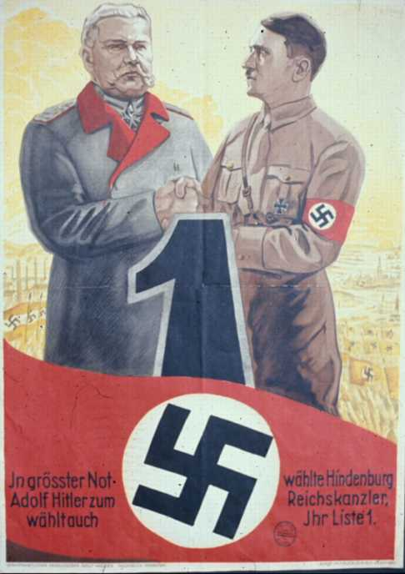
Hitler’s actions throughout World War I were brutal and vicious, yet despite the outrage that his actions produced throughout the world, it still was not nearly enough to justify joining the war. The forces which united to put and end to the Nazi Regime would not have been able to do so without concentrated and consistent efforts from their governments to gain public support through the use of war propaganda. It is doubtful that Hitler ever imagined that the brilliance he discovered which helped him to mesmerize and brainwash the Germans would be the very thing that ultimately led to his demise.
The United States of America felt obliged to assist in the war efforts, but struggled to gain the support of the Americans for the cause.

Democratic theory, as interpreted by Jefferson and Paine, was rooted in the Enlightenment belief that free citizens could form respectable opinions about issues of the day and use these opinions to guide their own destiny. Communication between citizens was assumed to be a necessary element of the democratic process. During the First World War, America’s leaders felt that citizens were not making the correct decisions quickly enough, so they flooded the channels of communication with dishonest messages that were designed to stir up emotions and provoke hatred of Germany.

The American public fell into the same trap that the Germans had with Hitler’s propaganda, as they began to believe everything the media was showing them and soon became fully devoted to the war effort. In World War I, Americans spread stories of Germans spearing babies on the end of bayonets during their marches. The focus of WWI propaganda was the conflict between civilization and barbarism.
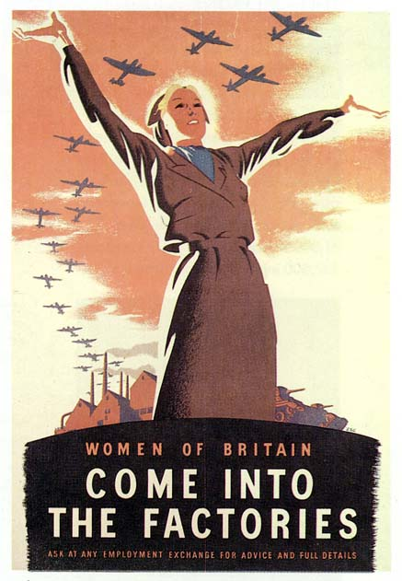
Britain also relied heavily on war propaganda to spark emotional upheaval within the country. Their control of the media was quite drastic, especially on the battlefront. Only two photographers, both of whom were British army officers, were allowed to take pictures of the Western Front. There was strict regulation on what the photographers could take pictures of as well. “I am not allowed to put dead men into my pictures because apparently they don’t exist. I am no longer an artist. I am a messenger who will bring back word from the men who are fighting to those who want the war to go on forever. Feeble, inarticulate will be my message, but it will have a bitter truth and may it burn their lousy souls.” (Paul Nash)
After World War I, it seemed that the American government had fallen in love with the powerful capabilities that the use of war propaganda could bring. World War II saw an excessive amount of American propaganda, which was continually fueled by the discovery of the Axis Power propaganda. In WWII, the conflict had been re-named, making the theme of the propaganda the fight between democracy and dictatorship. A key component in this batch of propaganda was the element of fear. For example, in 1942 America published an anti-Japanese poster featuring a Japanese soldier with a dagger in hand, peering into a baby’s room with rattles and teddy bears. The caption read, “Keep Jap Terror from Your Home.” During the Second World War, Washington not only censored dissident voices and produced its own propaganda programs, but also created a master schedule, dubbed the National Allocation Plan, for advancing its messages in radio comedies, soap operas, and other series. The American government, however, did not go unchecked on their propaganda techniques. The National Recovery Administration, which produced massive amounts of radio programming early on, was eventually ruled unconstitutional. Without this large player in the propaganda war, the US came up with subsequent innovations such as Franklin Roosevelt’s famous fireside chats.
During the War, advertising firms in the United States struggled. The constant bombardment with political ads left little room or money for other advertisements. The government was so hooked on war propaganda that it was willing to manipulate the economy to gain more access to the public. In the second phase of the New Deal, advertisers still faced opposition from the government. With the aid of the war, the 1942 tax code was adopted, which stipulated that companies could write off up to 80% of their advertising costs under the condition that the ads promoted the war. It seems rather drastic that a country would go to no ends to find ways to manipulate the public into believing what the government wanted it to.
Though the US was busy at work with the production of propaganda, Germany was doing exactly the same. In fact, theirs might just have been a little more ruthless. During WWII, German propagandists bombarded the French army with films of captured African colonial soldiers clumsily dancing barefoot. At the same time, they targeted British and American blacks with propaganda that mocked the fact that they would fight for countries where they were barely third-class citizens. Yet again, Germany had discovered another, more vicious way to manipulate people into blindly following the Nazi’s. In fact, at that point just about every country was fully wrapped up in the concept of war propaganda using it for just about anything, and not feeling ashamed of it in the least bit. Churchill admitted that “there are a lot of lies going around and half of them are true”.
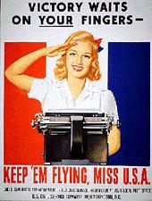
War propaganda is extremely powerful, and despite the moral dilemmas it may present, countries across the world were unable to resist the temptation. It was just too easy to let go. Both the UK and US governments believed that the key to winning the Suez (1956) and the Vietnam wars was the media control and propaganda. If there was one failure with these, however, it was that the information was void of pictures. This mistake was not made again during the 1991 Gulf War. After each war, the governments would sit back and analyze what worked and what didn’t so that the next time around they could get it right, making their propaganda tactics even more convincing and effective.
It’s funny how at the time, people get swept up in the moment and can’t tell which was is up. Looking back on all the things that have happened in the past, it’s easy to see how much people were manipulated. It is clear now, looking back, that a good majority of the things claimed during the war did not actually happen. For instance, during WWI the Germans did not boil corpses for glycerin for munitions. The German reports of the French gouging out the eyes of German soldiers or chopping their fingers off to obtain their rings were false. The Iraqi soldiers did not, as America claimed, throw babies out of incubators. Sadly, it’s difficult to critique those of the past from the vantage point we sit at today. For, given the same circumstances, it seems almost given that we would have fallen for it just as everyone else did.
Truth is the first casualty of war.

Part 3: The Transition in Media

During the First World War, propaganda was largely radio based. Posters, pamphlets, and flyers were common as well. With the invention of the television, the emphasis was shifted toward network nightly news. For a long time the government relied on television to distribute its messages. Recently, however, there has been yet another shift in media use throughout the United States and the rest of the world. America’s use of news media has been drifting away from network TV and newspapers, with the introduction and popularization of cable television and the internet. The immediacy of these new media forms have conditioned their audiences to expect instant news, delivered live or within moments of the event. How has this changed the face of media? In the past, there was time to fully develop all of the information coming in. It was possible to throw out useless information through cross referencing and organize it in a logical and coherent manner before presenting it to the public. With the shift to more immediate forms of media, however, there has been an increase in deadline pressures, which has led to a trend of presenting raw and undeveloped information.
Specifically, a survey conducted this year found that thirty eight percent of people get their news from cable TV. Thirty four percent listed the nightly news as a source. In total, seventy two percent of those surveyed reported using television as their main media source. This was significantly higher than in 1994, where only sixty percent had listed that the network nightly news was their media of choice. In just ten years, there has been a dramatic shift in media use in America. The most significant finding from the study was the dramatic rise in cable television use over network nightly news. The basic philosophical goal behind government regulation of broadcasting has always been to ensure a wide variety of competing points of view. Deregulation is changing that concept. Cable television is significantly more capable of only presenting one side of the story, which generally happens to be the side that the government wishes to present.
On top of this, when people between the ages of eighteen and twenty-nine were asked about particular cable television shows they chose to watch for news and politics, TV comedy shows such as Saturday Night Live and the Daily Show ranked higher than newspapers. With all due respect to the entertainment value of those shows, it seems that entertainment is about all those programs offer. As far as accuracy is concerned, the newspapers would be an extremely more reliable source of information. It’s important to be cautious of newspapers as well, especially the New York Times, as it is the newspaper most responsible for promoting war than any other newspaper in the country. With concern of the internet, in 1996, only two percent of those surveyed had mentioned that they use the internet as a news source. Today, however, that number has risen to nearly thirty percent. It seems as if immediacy has stolen the show these days.
When looking specifically at network television, there seems to be numerous similarities among the large networks. It is a common trend among the three major news networks (ABC, CBS, and NBC) to hire former government beaurcrats, military officials and politicians. This seems an extremely brilliant way for the government to maintain control of the media behind the scenes. Further, Ben Bagdikian, the author of Media Monopoly, has estimated that the media in the United States is dominated by the same six inter-related corporations. In fact, NBC is owned by the military contractor General Electric. Strangely enough, the media themselves, which consist of huge corporations, share the same economic and political interests with the small elite that runs the American government. This being said, it seems logical that all of them should work hand in hand, as each benefits from the others goals and accomplishments.
Along with the transition in media forms, there has been a transition on the battlefield as well. “We don’t go up against traditional armies and native and air forces as much as we used to. But the kinds of adversaries we face, whether you’re talking al-Qaida and Taliban, or the Iraqi regime, use disinformation with great skill. They’re very good at it. So we’ve reorganized. We’ve re-equipped. We’ve changed the way we do things to meet and overcome those challenges.” Given the interconnectedness of the government and the media, it seems logical that a change in one would cause a shift in another.
Though many new forms of media and propaganda have been implemented in the United States and throughout the world, we still rely heavily on the old tactics as well. For instance, Just last year the state department created a new division dedicated to promoting war propaganda. The messages abroad consisted of images of American Muslims who spoke of their happiness of freedom and life in the US. This new office is strangely similar to the Office of War Information from World War II, which used to commission Hollywood to produce films that infuriated the public against Japan and Germany.

Part 4: Propaganda Today

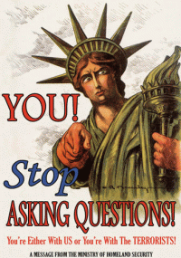
Though there have been significant shifts in media use throughout the world, propaganda has remained as strong, if not gotten stronger. As people have wised up to the actions of the media and government, the messages of propaganda have had to become more sly and deceitful. Old techniques for propaganda have been re-vamped to fit the needs for persuasion today. For example, to stir up feelings of hatred of Iraq after September 11, the Foreign Office issued a dossier of human rights abuses by Saddam, all of which we have known for years, but which have been released at this moment to make it appear that the war, when it comes, is motivated by a humane desire to lift the burden of fear from the people of Iraq by killing even more of them in a series of murderous air attacks. Latching on to the simple expression, “Right time, Right place”, the American government has discovered that there is much to be gained by presenting information to the public at the opportune time.
They have also figured out the concept of wrong information, wrong time as well. Just this February, in fact, MSNBC pulled Phil Donohue’s show from it’s programming, saying that it “presented a difficult public face for NBC in a time of war.” In fact, the media has actually gotten itself to the point where it doesn’t necessarily need to be regulated anymore. They are rather keen on deciphering which information should and should not be reported. For instance, Dan Rather was interviewed in Britain in May of 2002:

What we are talking about here—whether one wants to recognize it or not, or call it by its proper name or not---is a form of self-censorship. It starts with a feeling of patriotism within oneself. It carries through with a certain knowledge that the country as a whole…felt and continues to feel this surge of patriotism within themselves.

Due to the nature of his comments, Dan Rather’s interview never made it into American news reports. Similarly, no one had to restrict the media from informing the public that the British had discovered the Bush administration spying on the United Nations Security Council members during a debate on a new resolution to authorize war on Iraq. The cold hard truth is the media will undoubtedly support this war, or any war for that matter, regardless of government restrictions and manipulation of media information. It seems as if the government has taken advice from Adam Smith and adopted a Laissez Faire approach to war propaganda, whether by choice or by mistake it is unclear.
These days, it’s gotten increasingly more important for countries to not only spread propaganda within their own country, but within others as well. The difficulty is determining which forms of propaganda would be most effective in each region. Reaching the people in Iraq is just one of the fronts in the information war. Reaching the American audience is another, and it’s seeing the war from the perspective of the American Soldier, supplied by journalists embedded with coalition troops, many of them broadcasting reports in real time from their small patch of the desert. Besides revolutionizing the war coverage, it has also revolutionized war. The way we present information to others tends to be different than the way we present it to others. Oftentimes information presented to others is frighteningly realistic. On the other hand, that same tactic in the US would not be acceptable. As General Douglas McArthur said, “To show reality has become unpatriotic”.
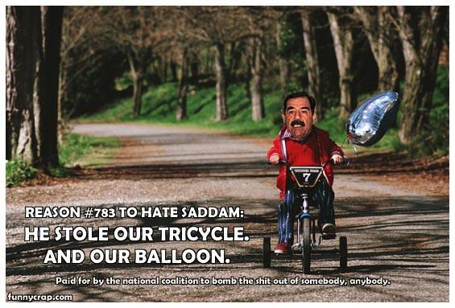
When looking at other countries and their propaganda, the same thing is true. Reality is generally not accepted. While the press in the free world intervenes and corrects the misinformation and exaggerations made by the representatives of the armies in that part of the world, the press in Iraq or in the rest of the Arab world does nothing to reveal the lying and deception systematically practiced by Saddam and his followers…The only realistic element of the Iraqi and Arab war propaganda is the image of the civilian war victims. However, the same propaganda makes no reference to the civilian victims of the acts of repression committed by the Iraqi regime in times of peace. Strangely, however, Saddam manages to score propaganda points just by surviving. “Every day he succeeds in juxtaposing images of American cruise missiles blowing up in Baghdad with pictures of Iraqi farmers shooting down Apache helicopters, he wins the battle foe the hearts and minds of 250million Arabs. (Joseph Wilson, former US official in Baghdad)
When Saddam was finally captured, we most certainly used that as a slap in the face-or did we. The most famous image of the war on Iraq, the US soldier scaling a statue of Saddam Hussein in Baghdad, draping the Stars and Strips over the black metal is claimed by some to have been a photo-op created specifically for Bush’s re-election campaign. It could possibly have been an image planned to ease the minds of Americans who felt discomfort and anger at the war. Similarly, the US government has been dropping food into Afghanistan to help the citizens, while at the same time continuing to bomb the country. This is thought to be propaganda directed specifically toward appeasing the American people, not helping the citizens. To add to this, few American reporters, of 8000 stationed in Quatar and Kuwait, were actually allowed to remain in Baghdad to get the full and complete truth of the war on Iraq. When the reporters arrived in Baghdad, nearly ninety five percent of them were sent home before the war had even started.
Despite all of this, a recent survey found that most Americans are actually quite happy with the war coverage in Iraq. If they had the choice, however, they would decrease the reports of anti-war activism and the number of TV appearances by former military officers.
Though the face of media throughout the world has been experiencing dramatic changes, it is clear that propaganda has, and will continue to have a significant effect on people and their thoughts regarding war. Old propaganda techniques, rather than being discarded, have rather been given a makeover to fit the existing demands today. Likewise, propaganda in the future is likely going to be based on the same principles and ideals that Hitler created during World War I, yet they will be revamped to coincide with the changing times.

Works Cited:
- Benn, Tony. Bush’s War on the UN. Morning Star. December 13, 2002.
- Boztas, Senay. Dumb TV, War Propaganda and the Queens of Kiss and sell. The Sunday Herald. August 29, 2004.
- Garvin, Glenn. Exhibit Showcases the Truths and Lies of War Propaganda. The Miami Herald, November 4, 2003.
- Ghebre-ab, Rahwa. Professor Criticizes US War Propaganda. University Wire (Michigan). March 5, 2003.
- Hitler, Adolph. Mein Kampf- Chapter 1.
- Jones, Clarence. Winning the News Media. News Media Trends. 2005 Edition.
- Kroft, Steve. The Information War; Propaganda War Being Waged by the Iraqis and the American Leadership. CBS News Transcripts. April 13, 2003.
- Lambrecht, Bill. The Battle for Minds and Emotions in War; Propaganda and Persuasion Aim at Enemy and Home Alike
- McFeatters. US Plays Catch-Up in Mind War. Pittsburgh Post-Gazette. April 1, 2003.
- Pavel, Dan. Romanian Report Contrasts War Propaganda. Global News Wire. April 7, 2003.
- Starick, Paul. Iraq War Propaganda; War of Words- the Battle for Hearts and Minds. The Advertiser. March 29, 2003.
- http://www.disinfopedia.org Propaganda Versus Democracy
- www.globalissues.org Shah, Anup. War, Propaganda and the Media. August 2004.
- www.independent.org Horten, Gerd. Radio Goes to War: The Politics of Propaganda World War II.
- www.medialens.org Miller, David. Eliminating Truth: The Development of War Propaganda
- www.onlinejournal.com
- www.propagandacritic.com
- www.socialistworker.org Pro-war Propaganda Machine. March 2003.
- www.stentorian.com/propagan.html Levinson, William A. An Introduction to Propaganda. 1999.
- www.truthout.org Morgan, David. Critic Accuses Media of Aiding US War Propaganda. May 2, 2003.
- www.spartacus.schoolnet.co.uk

http://www.disinfopedia.org
Garvin, Glenn. Exhibit Showcases the Truths and Lies of War Propaganda
www.globalissues.org
Lambrecht, Bill. The Battle for Minds and Emotions in War; Propaganda and Persuasion Aim at Enemy and Home alike
Lambrecht, Bill. The Battle for Minds and Emotions in War; Propaganda and Persuasion Aim at Enemy and Home alike
www.globalissues.org
http://www.disinfopedia.org
www.stentorian.com/propagan.html
www.globalissues.org
www.globalissues.org
www.globalissues.org
Lambrecht, Bill. The Battle for Minds and Emotions in War; Propaganda and Persuasion Aim at Enemy and Home alike
Garvin, Glenn. Exhibit Showcases the Truths and Lies of War Propaganda
www.globalissues.org
www.globalissues.org
www.globalissues.org
www.onlinejournal.com
www.spartacus.schoolnet.co.uk
Hitler, Adolph. Mein Kampf
Hitler, Adolph. Mein Kampf
www.propagandacritic.com
Lambrecht, Bill. The Battle for Minds and Emotions in War; Propaganda and Persuasion Aim at Enemy and Home Alike.
www.spartacus.schoolnet.co.uk
Lambrecht, Bill. The Battle for Minds and Emotions in War; Propaganda and Persuasion Aim at Enemy and Home Alike
Garvin, Glenn. Exhibit Showcases the Truths and Lies of War Propaganda
www.independent.org
www.independent.org
www.independent.org
Garvin, Glenn. Exhibit Showcases the Truths and Lies of War Propaganda
www.medialens.org
www.globalissues.org
www.medialens.org
Jones, Clarence. News Media Trends
Jones, Clarence. News Media Trends
Jones, Clarence. News Media Trends
Jones, Clarence. News Media Trends
www.truthout.org
Jones, Clarence. News Media Trends
www.socialistworker.org
www.socialistworker.org
www.socialistworker.org
Kroft, Steve. The Information War’ Propaganda War being Waged by the Iraqis and the American Leadership
McFeathers. Us Plays Catch-Up in Mind War.
Benn, Tony. Bush’s War on the UN
www.socialistworker.org
www.socialistworker.org
www.socialistworker.org
Kroft, Steve. The Information War; Propaganda War Being Waged by the Iraqis and the American Leadership.
Pavel, Dan. Romanian Report Contrasts War Propaganda
Starick, Paul. Iraq War Propaganda; War of Words- the Battle for Hearts and Minds
www.truthout.org
Ghebre-ab, Rahwa. Professor Criticizes US War Propaganda.
Boztas, Senay. Dumb TV, War Propaganda and the Queens of Kiss and sell.
www.truthout.org

