The News: International “Objective” Informant
An essay that analyzes the media and its coverage of conflict periods through various theories and past wars.

Tiffany Hawthorne
EDGE
Winter Quarter 2003
Professor Bruce Lusignan
March 12, 2004
War is rarely an event looked forward to by many people. It involves death, abandonment, guilt, money, deceit, and an ultimate loss of too many elements to list them all. However there is rarely a time when there is not a war going on in some part of the country. For wars to happen there has to be people willing to fight in them. With so much at stake and so mush to lose it is often a wonder how governments, which are seldom trusted anyway, convince their citizens to support their various war efforts. With closer speculation it becomes quite clear how this is accomplished: the media. Whether print, radio, or television the media gives the public a sense of getting the real story. With this in mind it is much easier to persuade citizens that wars are necessary. Medias role in the politics of war is an often debated topic by those who believe the role is minimal and those who believe that media plays the utmost importance. Although there is no universal opinion, looking at different theories proposed and the wars of the past it is difficult to question how influential media is when dealing with any type of governmental action especially war.
Although under constant scrutiny, the media plays a very significant role in the politics of warfare. Many believe that “governments seek cooperation, if not outright support, from the media to legitimize military action” (Thussu and Freedman 128). Media of Conflict argues that the media serves several purposes in the continuance of conflict. First it claims, “national media coverage has had the effect of exacerbating conflict as a result of conscious political strategies by political activists”(Allen 3). This has often been the case when politicians have the support of journalists, and they work in conjunction to present a certain image full of sensationalism and less insight. The second claim is that “wars are what the media makes of them”(Allen 3). This does apply to the shaping of military strategies but more importantly deals with representation of violence. The media has the ability to make certain forms of killing acceptable while making others appear inhumane and unnecessary. Media of Conflict’s most important point about the purpose of media is found in the declaration that “how wars are made, how participants strategize their interests, how and if the international community reacts, how the audiences in other more comfortable places comprehend what is happening and how responsibility is structured and action are all, in the modern war, in part, a media story”(Allen 4); which comments on the ability of the media to provide the only information on the actions of the government as well as the apparent motivation of their actions.
Before one discusses the media and its role in public opinion on warfare or on government image, the term media must be defined. Popular use of the term would imply that media is singular and refers to only one type of communication. However ‘media’ is the plural form of the term ‘medium’. It includes any type of information giving whether it is print (articles and photos), audio (radio), or audio-visual (internet, television and movies). All of these media are used to provide information to the masses in a relatively quick fashion. Nowadays certain media proves to be more efficient than others. In this new age of communications, the audiovisual media has more impact than the others; especially the Internet, which is proving to me more popular due to its easy accessibility and wide amount of information. Audiovisual media may reach more of the masses and provide the most information in the shortest amount of time, however when dealing with public preference, photographs are the medium of choice. Oftentimes there is a race to get the most personal, real life photo to mirror what is occurring on the war front. Photos are popular because it is believed that there is more difficulty manipulating a photo than a verbal account of an event. Photos also take less energy to process and do not take time to analyze. As people become lazier and want information quickly to match the fast speed of their lives, it is no surprise that wartime photos are in high demand.
The debate on public opinion and the masses is a large one that has two extreme sides proposed by Maxwell McCombs and Donald Shaw. One theory is known as media agenda. Media agenda proposes that media content heavily influences public opinion. The media thus “sets” the agenda for the public, telling them what issues are of importance and what to think of those issues. In the media agenda corporate heads, investors, and news editors determine which stories are of importance and those are the ones covered. The alternate opposing theory is known as the public agenda. The public agenda proposes that it is the public that determines the important issues. The media adjusts itself to the information about which the people want to know. Those who are strong advocates of the public agenda theory deflate the influence of the media and feel that it does not affect how people think about war. In their War and Media, Miles Hudson and John Stainer comment on the public agenda. They argue that although it has some good points it seems against common sense to argue that such is the case with foreign affairs because the majority of the public cannot bring their own experiences with international affairs in order to have their own opinion (304). Whether advocates of the public agenda agree with this way of thinking, there are some historical accounts that would prove that it is fairly accurate.
The type of influence that media has had in the past can be seen through the example of the Third Reich and World War II. Under circumstances so drastic, the media in Germany provides one of many explanations why a whole country blindly believed in the ideals of one radical man. During the wartime the German press offered very little variety in its articles and story topics. Every piece of written work could somehow be traced to Nazis and Nazi belief. In fact the German newspaper was described as being, “… a means of propaganda, not exclusively an organ of information, it has to serve the movement and without it, it loses its justification”(Herzstein 170). Newspapers had no obligation to the people but rather were allied with the government. The means of regulation were “in accordance with the National Socialism as a philosophy of life and as a conception of government”(Herzstein 171). Through the Reich Press Chamber, the Nazis monitored topics covered and what was said, although there were times when Hitler himself dictated the outline for the paper and its stories. The Third Reich claimed that by censoring the news they were helping the papers escape unreasonable expectations of capitalist special interest groups. Through fines and closings the threat of upsetting the government was high and compliance to their regulations took little effort.
The Reich Press Chamber however closed most paper publications whether they complied with the given regulations or not. For the majority of the war, there were only two main papers, or illustrated weeklies, remaining: Berliner Illustriate and Illustrierter Beobachter. During the war the circulation of these illustrated weeklies rose drastically due to the increased popularity in occupied areas. Between the years of 1939 and 1944 both publications gained over nine million readers and had about 82.5% of the total German readership (Herzstein 171). Although there were a large number of papers being bought the German public was not unaware of government censorship. This added skepticism to much of the reading but the reading continued because oftentimes this was the only information the public was given access to and tainted information was considered better than ignorance and no information at all.
The newspaper was not the only form of media that was censored by the government of Nazi Germany. The radio also was heavily controlled. During this period, one journalist in particular held great control over both the radio and print journalism. His name was Joseph Goebbels. It was said that this propaganda minister held direct control over the radio industry and felt that “the new medium could serve a great role”(Herzstein 176). He thought so highly of the radio’s influence on the cause he opened the tenth German radio exhibition on August 18,1933 with these words, “(the radio is ) the first and most influential intermediary between… movement and nation, between idea and man…We want a radio that marches with the nation, a radio that works for the people..”(Herzstein 176). Oftentimes it was stated that without Goebbels’ influence, the radio would not have been as important to the spread of propaganda in Germany.
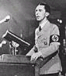
Figure 1 Joseph Goebbels www.zone-mondiale.org/.../ pages/comm11.htm

Just as the Reich Press Chamber controlled the press, the Reich Radio Society was in charge of monitoring the German radio network. It controlled and coordinated all broadcasts and arranged the exchanges between the twenty-six stations that made up German radio (Herzstein 177). Goebbels attempted to appoint Alfred Ingemar- Berndt to run the Reich Press Chamber but his incompetency soon became very apparent and a new officer was needed. This new officer would become notorious for his control and “skill” in using propaganda. His name was Hans Fritzsche and his ambitions to gain rank in the Reich overrode any skill that he might have in the radio industry. He went from being the editor of the Prussian Yearbook to the head of the ministry’s radio division and Goebbels’ commissioner for the political structuring of the Greater German radio. The job of regulating radio broadcast was one that required much attentiveness and restriction. Those that worked under Hans were required to “monitor and transcribe foreign broadcasts”(Herzstein 178). From this monitoring confidential information was received and shared among the various high ranking officers of his choice. Then German radio was responsible to respond to whatever was transmitted and undermine any unapproved rumors that might have been started as a result.
Fritzsche’s presence demanded respect behind scenes of German radio and on air. Herzstein describes him as “the most important broadcaster during the war”(182). He is said to have spoken over a thousand times and each time his voice and character would get the attention of the masses. Weekly he could be heard giving updates on the war and the progress of the Germans. The wit and ridicule combined with the sarcastic, ironic, supercilious tones in his voice attracted many listeners. He had a clever way of seizing information from Allied camps and developing theory around them, making the listeners feel as though they were getting an inside scoop. He also tended to refer to the conquered in such a manner that uplifted the confidence of the Germans and convince even the doubters of German superiority. An even greater part of Fritzsche’s appeal to the public was his seeming honesty that would come through non-victorious periods (Herzstein 186). The German people often claimed to hear the nervousness in his voice and as time progressed became less skeptical of government censorship at least while he was on the air. Towards the end of the war, Fritzsche was also depended upon to provide the German public with inspiration and motivation. He once claimed that, “Bombing will not break our will” (Herzstein 185). He is also credited with telling the German public that secret weapons were being developed that would guarantee the success of the Third Reich. He held the German public in the palm of his hand. Radio was his strings and the public was his puppets.
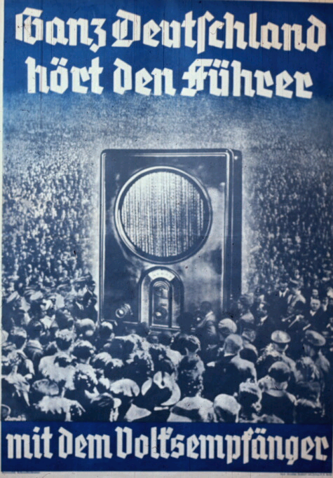
Figure 2 German Advertisement for the radio www.calvin.edu/academic/cas/ gpa/posters/radio.jpg
During the wartime, German radio typically consisted of two nationwide daily broadcasts. Radio personnel reworked materials so that they were broadcast ‘friendly’ but they were not permitted to advance their personal viewpoints or release any private information. To reinforce that everything must be done with his approval, Goebbels required radio commentators and news editors to attend his ministerial conferences (Herzstein 179). The broadcasts were not strictly news and information on the progress of the war. Goebbels was aware that people listened to the radio for relaxation and music. In response to this desire he required that there be light music played on a somewhat regular basis. Passed off as music for relaxation, German radio played military music. The German marches are said to have stirred even the most apathetic of citizens during times of victory and new occupation. German radio’s use of music “demonstrated its hold that party ideologues and fanatics had over the medium”(Herzstein 180). Stations were even encouraged to play Austrian and Prussian war songs to demonstrate the close alliance between the three nations. German poetry and classical music was used to keep pious Germans out of church and stuck next to their radios.
As seen through the above example, media affects war by providing an informative basis for the public to know the wars progress and helping build citizen morale and support. However there is a flip effect as well. Wars often are important to the media by providing it with a topic that increases ratings and establishes a system for determining public credibility. In their War and the Media Daya Thussu Thussu and Des Freedman discuss how the media operates and what motivates news selection especially television news. Television is the most global of the media for its ability to transcend language and geographical barriers through its use of images, which often carry a higher impact than any words (118). One of their claims is that international television politics have become increasingly political, economic, and technological (117). A new genre of news 24/7 has emerged from the demand that international news be available at all times of day. A global audience expects quick, accurate, and live accounts of events worldwide. Daya Thussu Thussu argues that this demand is leading to “sensationalism and trivialization of complex stories and the temptation to highlight the entertainment value of the news”(117). With this new entertainment thrust of newscasts the coverage conflict has proven to be a high ratings catcher and has the most entertainment value. War coverage has become what Daya terms as ‘infotainment’.
The term ‘infotainment’ was coined in the 1980s as a neologism that refers to an explicit genre-mixture of information and entertainment in news and current affair programming (Thussu 122). Whether infotainment gains journalistic merit or not, it seems as though it’s the most efficient way to attract younger audiences to the news. These younger viewers have been reared in a time that appreciates postmodern visual aesthetics, which include fast paced eye catching visuals, computer animated logos and rhetorical headlines. Infotainment is also heavily affected by online news and its multi-media interactive approach. Many critics warn against the popularity of infotainment arguing that it is likely to “contribute to a structural erosion of the public sphere in Habermasian sense, where the viewer, bombarded with visuals may not be able to differentiate between public information and propaganda from a powerful military-industrial-entertainment complex”(Thussu and Freedman 123).
Different international news stations such as CNN and BBC gain their respect and high regard from their claims to provide impartial news in addition to having a large a knowledgeable staff of people supporting them. CNN alone boasts of 150 correspondents in 42 international bureaux and 23 satellites that was said to have broadcast in over 150 million homes in more than 212 countries and territories worldwide (CNN website). CNN is the dominant international newscast in the states while BBC has precedence in Great Britain. Although the dependence on news footage has been typically associated with US style broadcasting, more and more newscasts around the world are also becoming dependent on news footage because of the two main suppliers of such, news agencies Reuters Television and Associated Press Television News. Reuters Television boasts of a 77 bureaux worldwide and a team of 2500 journalists and photographers operating in more than 150 countries able to provide “…fast, reliable, high quality video coverage in ‘near real time’” and APTN boasts of being the crucial supplier of footage to broadcasters around the globe (Thussu and Freedman 120). Both agencies also provide entertainment footage, which serves as great story fillers.

Figure 3 CNN Emblem www.discreet.com/.../flint/ flint_cnnhn_logo.gif

In a survey done in 2002, US citizens reported preferring live reports from global spots of conflict to any other type of international story, including interviews with world leaders and background reports (Thussu and Freedman 120). This preference puts an unyielding amount of pressure on newscasters to not come with late breaking news but to also have a dramatic story and footage to go along with it. Television journalists are under tremendous pressure of minutely deadlines, leaving little time for investigation or reflection. During times of war, the sifting gets incredibly difficult due to the mass amount of disinformation and misinformation that is circulated. Journalists have to have the ability to sift through myths and half-truths or find the most accurate story possible. With a limited amount of exciting real time footage and dramatic stories, most news stations resort to speculation and supposition as well as the misconstruing some footage as ‘live’ that is not (Thussu and Freedman 121). Although this does contradict the assertion that news is always as honest as possible and unbiased, the great deal of pressure for newscasts to increase their audience in a period where interests in the news is declining and wartime coverage gets old quickly and when advertisers become less and less thrilled about spots during the news; most executives believe that such truth twisting on some issues is necessary in order to keep the news going so that those who really care and the stories that need to be told can do so.
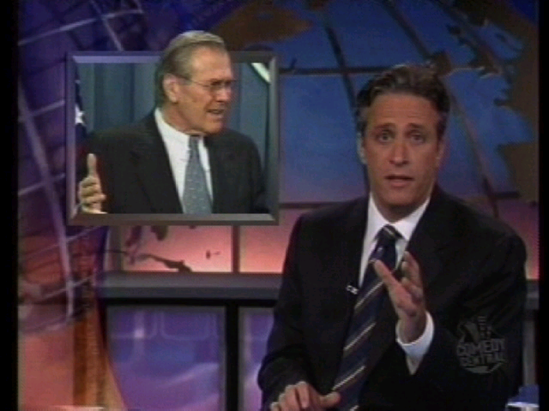
Figure 4 Newscasters www.skapunkandotherjunk.com/ Portfolio/digital...

News nowadays is based on an entertainment format. There are “..video/computer game style images of surgical strikes by ‘intelligent’ weaponry, arresting graphics and satellite pictures and a ‘chat-show’ use of ‘experts’”(Thussu and Freedman 124) The more modern type of news casting is said to have begun with the 1991 US attack against Iraq. For the time military conflict was brought into American homes. There were high tech virtual representations of war, which included cockpit videos of precision bombings that caused mass destruction of lives and property to appear as harmless as a videogame, desensitizing much of America. In addition to these advanced video clips are the complicated maps, graphics, and studio models that illustrate the progress of war. These graphics, the mimicry of warfare, miniature war tanks and airplanes, combined with enthusiastic male correspondents and experts commenting on strategy give news depiction of war a ‘game for boys’ type of feel (Thussu and Freedman 126). Such journalism however is criticized heavily for its affect on the public. Critics argue that viewers are not exposed to the realities of war. Rather they see war in terms of the bloodless strategic bombing escapade that it is depicted as. Many argue that this type of coverage is intentional on the part of the government because if the real images of bomb casualties, famine, poverty, drought, oppression, and brutality were shown, the United States’ public support would erode domestically and internationally (Thussu and Freedman 126).

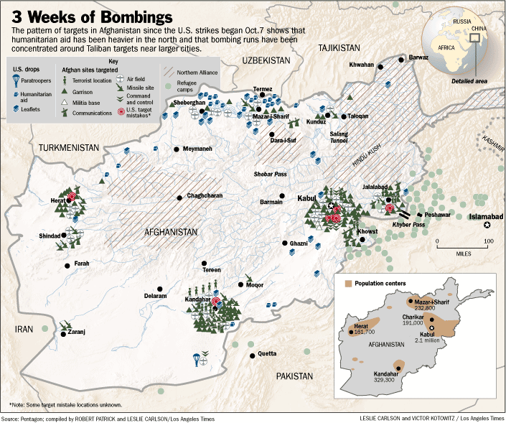
Figure 5 Example of video game depiction of bombing http://www.information-products.de/maps/AFG-war-11-01.gif

Many other problems have been discussed with the infotainment of today’s news. One reason why United States coverage of war is and issue is because of the large influence that the US has over other countries in the world. There also is the tendency for this bloodless war coverage to foster feel good feelings among Westerners who only see war as their humanitarian effort to aid the hotspots of the world, which oftentimes is not the case. Infotainment also “..fails to provide the economic or political context to help explain why there are conflicts in the world” (Thussu and Freedman 129). With no context, the public tends to lose interest in the topic of war. In recent studies done in the US international news is of little interest to the public due to the lack of background information in the area (Pew Center, 2002; Utley 1997). The lack of educating and substantial informing in today’s age, saddens and worries many of the journalists of the past who believe that continuing on this track will lead to greater mass ignorance and no development of new solutions to war.

Bibliography

Allen, Tim, and John Seaton(ed). The Media of Conflict: War Reporting and
Representations of Ethnic Violence. London: Zed Books, 1999.

Herzstein, Robert Edwin. The War That Hitler Won: The Most Infamous Propaganda
Campaign in History. New York: G.P. Putnam’s Sons, 1978.

Hudson, Mike, and John Stainer. War and the Media: A Random Searchlight. Great
Britain: Sutton Publishing, 1997.

Thussu, Daya Kishan, and Des Freedman(ed). War and the Media: Reporting Conflict
24/7. London: SAGE Publications, 2003.

