The Middle East Media Manipulation
Media Manipulation, Imbalanced Economic Support, and the U.S Favoritism of Israel in the Israel-Palestine Conflict.

Gustav Rydstedt

I’m a frequent traveler over the Atlantic Ocean as I shuttle between my home in Stockholm, Sweden and school in Stanford, California. When doing regular traveling one gets to compare and contrast different cultures on regular basis. Most of these comparisons include foods, clothes or simple social attributes. Lately however I have to come to realize a sharp and quite disturbing difference in US media. Whenever I have the chance to compare news coverage in the middle-east I find myself confused and parted. I often find American news coverage, TV and newspapers alike, being bias, especially those covering problems in the Israeli/Palestine conflict. It seems as if I am watching two different wars. In America I am watching a stronghold power, Israel, fighting the endless terrorism brought by Palestinians. In Europe I see a war between two nations in despair thoroughly trying to fight terror from both sides of the conflict. I consistently find myself questioning American newspapers, as they use overly strong terminology and definitions on top of puzzling omission of essential facts. This paper was made to research and analyze the cause of my questioning while comparing these causes to Europe in order to see if my questioning is justified. I found that because of small groups with pro-Israeli interests dictating this country, U.S government has a need to manipulate and slant media in order to get accord for their action. The questionable U.S actions include extremely imbalanced aid to the Middle/East conflict, favoring Israel. However, before I could draw any conclusion of a U.S bias I had to analyze whether my accusations for U.S media bias was justified. The manipulation becomes quite evident if one analyzes seven common violations of objective journalism: selective omission, misleading definitions and terminology, imbalanced reporting, opinions disguised as news, lack of context, using true facts to draw false conclusions, and distortion of facts.

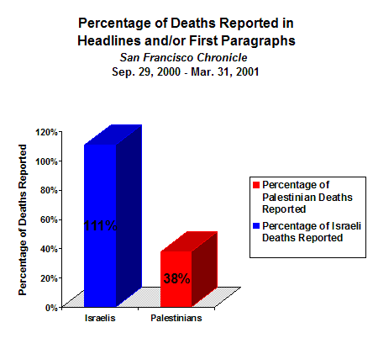
Media Manipulation
The newspaper I frequently devour over breakfast is the San Francisco Chronicle. In examination of this chronicle one will find evidence of misinterpretation and misreport mainly from the Middle East. The Bay Area paper was subject to analysis of IfAmericansKnew.com, a media pro-Palestine activism site, which found that the SF Chronicle reported 111% of Israeli deaths versus only a stunning 38% of Palestinian deaths. Out of these deaths the analysis separated deaths of children, which illustrates frightening statistics: only four Israeli children were killed during the analyzed periods, which were reported on at six different times, whilst out of the 88 dead Palestinian children only five were covered in news reports. That is a 150% reporting of Israeli children versus 5% reporting of Palestinian children (IAK-Statistics).
The violation exampled in the San Francisco Chronicle is often called selective omission. “[Selective omission is] choosing to report certain events over others, the media controls access to information and manipulates public sentiment” (Bias). This form of manipulation is evident nationwide although the Ethics Code of Professional Journalism (Ethics Code) clearly states that journalists are to “seek truth and report it [while being] honest, fair and courageous in gathering, reporting and interpreting information” (Ethics Code).
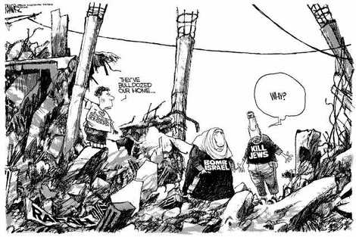
Another commonly discussed breach in the Ethics Code is the use of misleading definitions and terminology. This “technique” is “using terminology and definitions in a way that implies accepted fact, the media injects bias under the guise of objectivity” (Bias). Although “more than 80% of Palestinians killed are civilians who had nothing to do with terrorism” these people are often linked and referred to as terrorists. In an analysis of the Washington Post this trend is clearly visible. In a 17-month time period analyzed the word “terrorist” was predominantly used to describe Palestinians or their actions. In an even closer look at the use of this definition it became clear that “terror” or “terrorist” were often utilized without any quotation marks, suggesting the conscious slanting of the Post. The same conclusion can be drawn when analyzing the use of vigilante: “member of a volunteer committee organized to suppress and punish crime summarily (as when the processes of law appear inadequate); broadly: a self-appointed doer of justice" (Merriam-Webster's online dictionary). During the subject time period seven uses of “vigilante” was found; principally suggesting pro-Israeli groups as “crime punishers”. One of the articles was found to be suggesting a Palestinian as vigilante; this group however was described to fight other Palestinians (Vigilante). In September, 2002, CNN launched two galleries from the Israeli/Palestine conflict depicting casualties. The gallery portraying the dead Israelis was intentionally titled “Victims of Terror” picturing the killings of innocent civilians. However, in the gallery portraying the dead Palestinians, the title was set to “Palestinian Fatalities” describing these killings as somehow necessary. This deliberate skewing of definitions suggests CNN’s double-standard concerning the conflict. Another way of violating objectivity is the imbalanced reporting where “media reports…skew the picture by presenting only one side of the story” (Bias). In March, 2002 PMWatch, a pro-Palestinian media watch organization, reported this violation nationwide. During the examined time-period of six months 713 Palestinians were killed, compared to the 256 total killed Israelis. Despite this alarming ratio newspapers primarily reported on the Israeli deaths, carelessly ignoring a lot of the Palestinian casualties. In an analysis of front-page pictures in the Philadelphia Inquirer this slanting becomes severely evident, with close to 90% of the images “depicting Israeli suffering” during the time period. In 78% of the instances where the Palestinians were depicted they were identified as suicide bombers and militants, leaving only 22% of the pictures to portray Palestinian suffering (Front Page). The next common journalist fault is disguising opinions as news, often consciously serving to defy objectivity. Crushing a famous cliché one can say that a cartoon is worth more than a thousand words. The comic columns of major newspapers have gradually developed into a political newsstand. Although the cartoons all are supposed to be in good humor the cartoonists are often found to be slanted, revealing scary bias. This cartoon by Micheal Ramirez was published in May 2004 in the LA Times and awoke strong emotions among pro-Palestinian media activists. The cartoon portrays three Palestinians standing in the rubble of their bulldozed home. Their dialogue follows: “They’ve bulldozed our home” answered by “Why?” (LA Times). The cartoonist is making a blunt joke with the text on their t-shirt saying; “I love Suicide Bombers”, “Bomb Israel”, and “Kill Jews”. Several activist organizations reacted to this article claiming the cartoonist was openly showing “support for collective punishment of civilians” (War Crime). Ramirez shows clear skewed support for the Israeli’s and commends bulldozing homes, a crime of war. Several cartoonists are subject to debate among the organizations of media neutralization. Tony Auth, a cartoonist for The Philadelphia Inquirer, has been accused of including his slanted opinion in his cartoons, as it became evident that 80% of his cartoons were blaming Palestine for the violence in the conflict. 57% of his cartoons debating the conflict blamed Jassir Arafat or the Palestinians exclusively for the violence while 23% blamed them partially.
Journalists are also found failing to include correct information, making articles lack in context: “failing to provide proper context and full background information…, dramatically distort[ing] the true picture” (Bias). In January 2003 a story by the Jason Keyser for the AP clearly illustrates “how the US media sees the conflict between the Palestinians and the Israelis from the point of view of the Israelis” (Calm). Keyser reports on bombing incident inside Israel:

“The bombings also ended a period of relative calm. Previously
the last bombing inside Israel was Nov. 21, when 11 bus passengers
were killed in Jerusalem” (Calm).
This imaginary ‘calm’ is hard to recognize if one has all the facts, as Keyser failed to mention the dozens of Palestinian civilians that had been killed by Israelis since the last suicide bombing that occurred in November, 2003. Kersey also failed to mention that “over 70% of victims have been… women, and the elderly… and that over 80% of Palestinians killed for “curfew violations” have been children” (Calm).
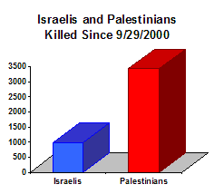
The final tool used by biased newspapers is to use true facts to draw false conclusions. Many journalists in American media conclude that the killings of the Israel-Palestine conflict are tragic and reaching enormous amounts. Yet, these numbers are often presented without a realistic ratio comparing Israeli losses to Palestinian, suggesting a conclusion that causalities are equally divided. This is of course blunt fallacy as the ratio is heavily leans towards to the Palestinian losses. These false conclusions are most of the time conscious slanting, but can however also be badly drawn assumption made by mistake. The latter is often combined with another violation of objectivity, the distortion of facts. “Reporters frequently do not have the time, inclination or resources to properly verify information before submitting a story for publication” (Bias). In an article in the Seattle PI, Mark Smilowitz writes that “Israeli checkpoints protect lives” and condemns several activists whom criticize the Israeli checkpoints. Smilowitz says “There's a new trend among some human rights activists: Find people risking their necks to save the lives of innocents and harass them“(Seattle PI). In fact, Israeli checkpoints are notoriously known to suppress and contain Arabs. Shlomo Lahat, a major general in the IDF (Israeli Defence Force) and a mayor of Tel Aviv, admits the checkpoints to be the “breeding grounds for hatred” as he exclaims:
"I am convinced that the checkpoints constitute a breeding ground for hatred for Israel, and harm an innocent population in an inhumane manner. [For] the sake of the Palestinians, but mainly for our own sake, the faster we end the occupation and leave the territories, the better for us” (Checkpoints).
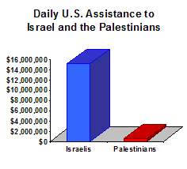
Economic Support
As it seems clear that American media is biased and uses deliberate techniques in order to promote pro-Israeli ideas, the same favoritism can be found in analysis of financial aid given to the Israel/Palestine issue. Examination of U.S assistance to Israel-Palestine conflict confirms that the U.S. gives $15,139,178 per day to the Israeli government and military compared to $568,744 per day to Palestinian NGO’s (Statistics). As this insane imbalance of 2600% supports the notion of American favoritism, the money given to the Israelis does not start to justify what tax payers really give to Israel. Richard Curtiss, former U.S Foreign Service Officer, concluded this in the Washington Report on Middle East Affair:

“Generous as it is, what Israel actually got in U.S. aid is considerably less than what it has cost U.S. taxpayers to provide it. The principal difference is that so long as the U.S. runs an annual budget deficit, every dollar of aid the U.S. gives Israel has to be raised through U.S. government borrowing.” (Taxpayers)
Americans often hear that US aid supports Israel with around $3 billion a year. This however is only calculated from the financial aid, excluding $500 million from the federal budget and $2 billion in guaranteed federal loans to Israel. The real amount given to support Israeli government and military then reaches a total of $5.5 billion. If Americans were aware of the real amounts there might be counteractions in the budget. The absence of required action is closely connected to the media manipulation already discussed. Curtiss exclaims: “One can truthfully blame the mainstream media for never digging out these figures for themselves, because none ever have” (Taxpayers). U.S favoritism becomes bluntly evident in comparison of U.S aid to third-world countries. “The per capita U.S. foreign aid to Israel’s 5.8 million people is $10,775.48.” For every dollar spent on a much less fortunate African, “[the U.S] spent $250.65 on an Israeli, and for every dollar it spent on someone from the Western Hemisphere outside the United States, it spent $214 on an Israeli” (Taxpayers). Furthermore, there is an irony in the tens of billions of U.S. tax dollars and transfers of American military technology to Israel, experts say. The support helped create and nurture Israel’s industry, and in effect subsidized a foreign competitor. The close to $3 billion given in financial support to the Jews has brought their weapons industry much further than “Lockheed or Boeing or Hughes would have liked” (Subside). The Israelis, now controlling 7% of funds in the world-wide weapons market, produces top-tier missiles, radar, and fighter jets which all compete strongly with the American companies. Another unwanted repercussion of the aid is Israeli trade with China, whom America has long considered an off-limit strategic competitor. The Chinese recently paraded a new J-10 fighter jet, which was modeled from the Israeli Lavi, a fighter jet built from $1.3 billion in Washington aid.
The constant American aid can be contrasted to European countries condemning Israeli terrorism and their efforts to conduct economic blockages and sanctions on Israel. In 2002, EU suspended parts of the Association Agreement, which was founded to support EU-Israeli trades, in order to express disapproval of the war crimes conducted by the Israeli regime. In October 2004, the EU launched a new international campaign in order organize sanctions against the Israeli government. The given factors for the campaign were “Continued Israeli occupation and endless attacks”, “Israel’s development of an Apartheid system”, “Sharon’s deliberate destruction of the ‘peace process’” and “Israeli intervention in Palestinian elections” (Campaign). Actions included total suspension of the Association Agreement, ending all military cooperation with Israel, divestment from Israeli companies and governmental non-cooperation with Israel (Campaign). Europe, contrary to the U.S, supported Palestine with notable financial aid. In May 2003, the Quartet, a coalition of the US, EU, UN and Russia, released a “roadmap” which was designed to regulate Palestine violence and Israeli occupation. In order to support the roadmap the EU has since supported the Palestine NGO financially; reportedly 250 million euro should have been put into the Palestine reform. However, Pro-Arab activists find the map being “a roadmap to nowhere” because of the pro-Israel imbalance:

Although the roadmap is the joint product of the Quartet, the United States essentially controls its content and timing and will be the final arbiter, in cooperation with a very reluctant Israel, of its implementation. This would seem to be the kiss of death. Israel has made it known that it has one hundred proposed changes to the roadmap and is already interpreting the plan according to its own lights, particularly on whether it calls for parallel or sequential implementation of its demands on each side. (Campaign)

Why?
The U.S support for Israel serves an opposing purpose as many officials and military experts “have long held that U.S. support of Israel is often contrary to and, in fact, extremely damaging to U.S. interests” (Subside). When looking back at history one can find that the current Israeli support hurts U.S oil companies and heavily deteriorates the Muslim customer base, representing close to 1.2 billion people worldwide. Additionally, we already saw proof of how Americans are paying immense taxes that could be spent in dealing with domestic issues rather than supporting one of the richest countries in the world. In fact, it is hard to define any national reasons for the Israeli interest. What is it that America sees in Israel that Europe doesn’t, or vice versa? It is evident that US media slants and manipulate reports of the Israeli-Palestine conflict in favor of the Jewish community. Also supporting the notion of favoritism is the imbalance in the economic support given to the conflict by the U.S. Then why this Israeli support? The two groups identified as sources for the Jewish support are identified as neoconservatives and special-interest Israeli lobby-groups.
The term neoconservative does not pertain to the traditional notion of being a conservative, and does not suggest a new conservatism. The neoconservative does not root itself in the traditional political ideas of decentralization and small government. Rather an “easy way to summarize a neo-conservatism is: a big state at home, empire abroad” (Weird men). Even though a neoconservative would never identify ‘an empire abroad’ as his agenda, that is what roots the definition of this idealistic ‘regime’. These people, who can be found throughout high positions in the Pentagon and the Bush Administration, all derive from similar backgrounds and organizations. Among the neo-cons are Paul Wolfowitz (deputy secretary of defense), Douglas Feith (the number three at Pentagon), Lewis Libby (Cheney’s chief of staff), Elliot Abrams (appointed to head Middle East policy at the National Security council), as well as James Woosley, former CIA director. This group of consensus has created the narrow-minded persona of the Bush administration which we have seen through the last four years. The group’s interest and idealistic ideas pertaining to the Middle-east are so similar that the group is not willing to entertain an alternative viewpoint (mainly from other parts of the Pentagon or government). The neo-cons’ stronghold on the U.S administration is achieved by utilizing George Bush’s ignorance to invoke the group’s policies. George W is considered “a thinly educated playboy who had failed repeatedly in business before becoming the governor of Texas, a largely ceremonial position” (Weird men). The neo-cons are running America through narrow-minded approach, which is manifestly pro-Israeli based on their personal Israeli ties.

[Neoconservatives] are products of the largely Jewish-American Trotskyist movement of the 1930s and 1940s, which morphed into anti- communist liberalism between the 1950s and 1970s and finally into a kind of militaristic and imperial right with no precedents in American culture or political history. Their admiration for the Israeli Likud party’s tactics, including preventive warfare such Israel’s 1981 raid on Iraq’s Osirak nuclear reactor, is mixed with odd bursts of ideological enthusiasm for “democracy”. (Weird men)
The neo-cons loathe for Arabs and Muslims dominates their decision making in American government policies. They tend to be pro-Israel zealots who believe “that American and Israeli interests are inseparable” (much to the alarm of liberal, pro-peace Jews, whether in America, Europe or Israel itself). “Friends of Ariel Sharon‘s Likud, they tend to detest Arabs and Muslim” (Costly friendship). In order to redirect attention and hide their anti-Arab agenda’s the neo-conservatives manipulate media and makes sure journalists portray Israeli as vigilantes and freedom fighters.
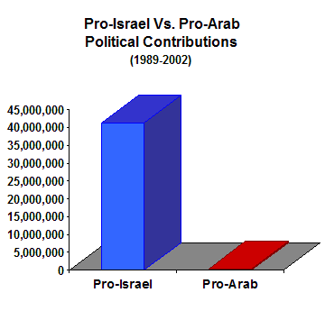
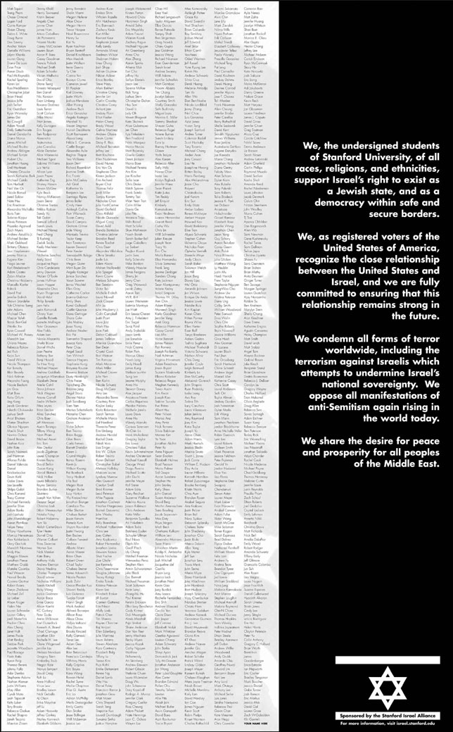
The neo-cons also tend to be closely related to special-interest lobby groups active in Washington. The pro-Israel lobby include all the top lobby groups in the U.S. American Israel Public Affairs Committee (AIPAC) was ranked the top individual lobby group in the U.S, as AIPAC alone contributed $1.1 million in their lobbying in 2001 (Statistics). In comparison, the pro-Israel groups gave $43.1 million to federal candidates and party committees, while pro-Arab lobbyist spent a diminutive $297,000. In fact there are only two groups lobbying pro-Arab causes; the National Association of Arab Americans and the American Muslim Council. The imbalance of pro-Israel and pro-Arab funding of course goes hand in hand with their influence in the U.S. government and will try to enforce and practice pro-Israel agendas in the Bush administration. The Israeli interest groups also understand the importance of reaching out to the educated U.S, predominantly appearing in U.S academic universities. AIPAC’s Political Leadership Development Program has affiliated over 5,000 students on 350 campuses in all 50 states. “[Pro-Israeli student groups] are systematically monitoring and comprehensively responding to anti-Israeli groups on campus. They are involved in pro-Israel legislative efforts, in electoral campaign politics as well” (Campus). On Stanford campus the AIPAC correspondent is the “Stanford Israel Alliance”, whom for example circulated a 1500 name petition to turn Stanford pro-Israeli. The Alliance is consistently active in making sure any anti-Israeli commentary is held to a minimum on campus. The group has at many times condemned Pro-Palestine articles in the Stanford Daily, and calls the campus magazine predominantly “anti-Israeli”. This “constant pressure on campus” (Campus) should supply Stanford students with microcosms of what is happening on a broader scale in manipulation of the US media and government.
SIA pro-Israeli Petition collected 1500 names at Stanford

In contrast to the U.S government’s skewed pro-Israeli interest, Europe’s interests work towards a more neutral and pStanford pro-Israeli Petitioneace-keeping perspective of the Middle-east issues. With the number of Muslims in Europe exponentially climbing (currently 20 million) European countries wants to be sure not to lose their Arab and Muslim customers in trading. Even though America holds similar interest, considering the 1.2 billion Muslims world-wide, Europe’s proximity to the Middle-east makes peace-keeping more vital. Consequently, more important than the actual peace-keeping is perhaps NOT to be pro-Israeli; which would awaken strong discontent towards Europe in the Muslim world, much like what is happening to the U.S., although this discontent would be more damaging to Europe than it is for the U.S considering the immediacy. In addition to the foreign trade of European countries they must also be aware of their domestic issues. France, with 10% of its population being Muslim, would see fatal effects internally if they were to support the Israeli community. Secondly, Europe’s geo-proximity makes hostilities in the Middle-east critical for the well-being of the individual European countries because of migration. Increased immigration becomes an important factor whenever hostilities are in close propinquity. This has European countries on high alert recollecting troublesome immigration issues for Western-Europe in the nineties.
Conclusion
Conclusively, it is evident that Europe and America serve different interest in the Israel/Palestine conflict. The European Muslim customer platform and geophysical proximity support interests in peace keeping or pro-Palestine (if slanted). The U.S seems to have no direct national interest in supporting Jews; neoconservatives and dominant lobby groups dictate the American government towards a pro-Israeli bias. My discoveries of slanted media are justified as actions for these different interests. As they are distinctively different one whom travels through both continents will see remarkable dissimilarity between national policies. An American device to enforce these policies is manipulation of the media and thus the American people. Even though national newspapers assert to the Ethic’s Code the media bias can be identified through seven violations: misleading definitions and terminology, Imbalanced reporting, opinions disguised as news, lack of context, selective omission, using true facts to draw false conclusions, and distortion of facts; all of which are easily identified in a pro-Israeli favor in major newspapers and news programs in America. Supporting this notion of U.S favoritism is close analysis of the financial aid given to the conflict by taxpayers, as there is a 2600% difference in funds to Israel and Palestine. Israeli government and military are given $15,139,178 per day compared to $568,744 per day to Palestinian NGO’s. This in comparison to European aid to the conflict, which is supporting Israeli economic blockage, supports the notion of U.S bias even further. Personally, I don’t believe that America foreign affair policies towards the Middle-East conflict represent ideals of a majority in the U.S society. In order for these strong but small forces to dictate U.S government policies and financial funding they need to manipulate the American people. If only Americans knew the true side of the Israeli/Palestine conflict the oppositional forces against neo-cons and AICAD would be principally stronger and more successful.

Americans… are empowering the worst elements of Israeli society, and undermining those working for a just, peaceful, and nondiscriminatory nation.
We are driving the violence in this region.
We can stop it.
– IfAmericansKnew.com

Works cited

“Statistics” If Americans Knew. 2004.
IfAmericansKnew. 1 Nov. 2003.
<http://www.ifamericansknew.org>
“What is Bias?” Honest Reporting. 2004.
Honest Reporting. 20 Jul. 2002.
< http://www.honestreporting.com/a/What_is_Bias.asp>
“Code of Ethics”. Society of Professional Journalism. 2004.
Society of Proffesional Journalism. 2004
< http://www.spj.org/ethics_code.asp>
“’Vigilantes’ vs. ‘Terrorists’: Enough of Double Standards...”. PMWatch. 2002.
Palestine Media Watch. 12 March, 2002.
<http://www.pmwatch.org/pmw/cast/vigilante.asp>
“Mideast Realities According to…Front Page Photographs“. PMWatch Report, 2002.
Palestine Media Watch Report. June 20. 2002.
< http://www.pmwatch.org/pmw/reports/wp/WP_FRONTPAGE.html>
“LA Times cartoonist justifies war crimes”. PMWatch. 2004.
Palestine Media Watch. 28 May. 2004.
<http://www.pmwatch.org/pmw/mediocrity/displayCall.asp?essayID=242>
Cartoon, Micheal Ramirez. 2004.
LA Times. 27 May. 2004
<www.latimes.com/news/opinion/commentary/la-include-ramirez,1,4857056.ssipage?coll=la-util-op-ed>
“AP still talks about ‘period of relative calm’”. PMWatch. 2003.
Palestine Media Watch Report. 6 January. 2003.
< http://www.pmwatch.org/pmw/mediocrity/displayCall.asp?essayID=45>
“Israeli Checkpoints Protect Lives.” Mark Smilowitz. 2003.
Seattle PI. 14 February. 2003.
<http://seattlepi.nwsrouce.com/opinion/108570_place14.shtml>
“Israeli Checkpoints: Breeding Grounds for Hatred”. Shlomo Lahat.
Haaretz.com. 5 Jan. 2004.
<http://educate-yourself.org/cn/checkpointbreedinghatred05jan04.shtml>
“The Cost of Israel to US Taxpayers”. Richard H. Curtiss. 2004.
Washington Report on Middle East Affairs. 2004.
<http://www.washington-report.org/us_aid_to_israel/index.htm>
“U.S. Aid to Israel Subsidizes a Potent Weapons Exporter.” Jim Krane. 2002.
Associated Press. 20 June, 2002.
<http://www.ifamericansknew.org/us_ints/p-krane.html>
“The Launching of New International Campain…” Dr. Mustafa Barghouthi. 2004.
EU Social Forum. 20 Oct. 2004.
<http://www.palestinagrupperna.a.se/sanktioner041020.pdf>
“The Weird Men Behind George W. Bush’s War”. Michael Lind. 2003
New Statesman. 7 April. 2003.
<http://www.ifamericansknew.org/us_ints/nc-lind.html>

”A Costly Friendship”. Patrick Seale. 2003
The Nation. 21 July, 2003.
<http://www.ifamericansknew.org/us_ints/nc-seale.html>
“Pressure on Campus”. Paul Findley. 2004.
They Dare to Speak Up. 2004.
< http://www.ifamericansknew.org/us_ints/pg-campus.html>

