Michael Taylor
Edge- Religion, War and Politics
Professor Bruce Lusignan
December 3, 2004

The Media and Its Influence on Politics
"Freedom of the press is guaranteed only to those who own one." This quote by A.J. Liebling illustrates the reality of where the media stands in today’s society. Over the past twenty years there has been an increase in power throughout the media with regard to politics. The media’s original purpose was to inform the public of the relevant events that occurred around the world. The job of the media is to search out the truth and relay that news to the people. The media has the power to inform the people but often times the stories given to the public are distorted for one reason or another. Using slant and sensationalism, the media has begun to shape our views in society and the process by which we choose our leaders. There was once a time when the government used the media as a medium to influence voters, committees, communities etc. Recently, it has been the presidents of major media outlets that have not only exercised power over the public but also made their presences felt in government and in the halls of congress. When the word democracy is thrown about it usually has to do with the rights or original intentions for a group or organization. The first group intended to be influenced by the media was the informed voter. Political parties along with the government used a variety of media resources to persuade the voter or in effect receive a vote for their cause. Returning to the thought of “democracy” the question is, what was the original intention of the media with relation to the theme of democracy and the informed voter? To analyze this thought thoroughly one must first grasp an understanding of the basic definition of democracy.
According to our Founding Fathers, a democracy is a government by, for and of the people. This definition implies that the people are the main political force, demonstrated by their ability to vote officials into and out of office, engage in frequent and meaningful debates about relevant issues, and participate in "public life" – engaging in activities related to their community and possibly their country (Acfnews). So what are the ramifications of this definition on the media? Well the answer to that question is in the phrases “the people are the main political force” and “engage in frequent and meaningful debates about relevant issues.” The relationship between these two statements is where the media enters the equation because it is the media that provides the public with the relevant issues. Under the Federal Communications Act of 1934 and subsequent legislation and court decisions’ broadcasting was to serve the "public interest, convenience, and necessity, ascribing certain democratic functions to the media” (Gseis.ucla.edu). The press and then the broadcast media were thus to provide information, ideas, and debate concerning issues of public significance in order to promote a democratic public sphere. Broadcasting was conceived as a public utility, with the airwaves established as part of the public domain, subject to regulation by the government to assure that broadcasting would meet its democratic responsibilities. Today the relationship between the media, politics and society has changed significantly. Even though they are all interconnected they have specific interactions which each other that should be highlighted.
The relationship between media and politics is a mysterious malady in the American electoral democratic process. Media companies are among the highest donors to political campaigns, while rarely covering their own role in campaign financing. Advertising — money paid to media outlets — is the single highest campaign expense, while, the United States is the only "major democracy" that doesn't mandate free air time for political candidates and parties (Media Channel). Media industries make up some of the most powerful lobbying interests in the capitol, leveraging their power as opinion-shapers and successfully advocating for legislation they barely report to the public. Meanwhile, the press and politicians go on blaming each other for voter disaffection. The simple fact of the matter is that any dissatisfaction that the voter or society has must be blamed on the system that the media and the politicians have concocted. The system that the media and politics have set up is meant, not to benefit the public at all but to be either mutually beneficial to the government and the various media outlets or exclusively beneficial to one side. For the most part media and the government, when I use the term government I am referring to all political parties, or organizations that have any interest or stake in political outcomes decided by the public, are meant to lie in bed together and be mutually beneficial. 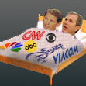 But there are occasions when one side creates a situation where one is guided by the other.
Recently, the media has gained more control over what political information is presented to the public. The world of mass media has been shrinking ever since the 1970’s and a handful of companies today have a controlling interest in what news is reported on and how that news is represented. Several media analysts point to the Telecommunications Act of 1996 as one of the primary reasons behind the ever strengthening influence the media has over politics and subsequently the public. The act removed long-standing limits on the number of media outlets that any one company could own in any single market. Currently the cap stands at 35% of national television station ownership (PBS.org). The original intention of the Telecommunications Act was to make it easier to gain access into the telecommunications business by lifting ownership restrictions. The problem with the easing of the sixty-two year long restrictions is that the new guidelines didn’t set out any boundaries for major media corporations. Without limits they were able to purchase and control a larger share of the market thus having the opposite affect of what the act intended. Technically the Telecommunications Act was meant to be a means to enhance the idea of what media and democracy should be but in actuality without rules the rich just continued to get richer. Under the present conditions in today’s political and social climate it would be very difficult to present a balanced display of the issues through the media. There are a few reasons why this is true. First, the nature of the media doesn’t allow all sides to be represented because that would be detrimental to the business aspect of production. Next, the idea of the “informed” voter has vastly changed over the past twenty-five years. In the past the majority of political coverage was done by accredited stations and this is where the public looked for their information if they were interested.
In today’s society, the expansion of media options makes it hard for anyone individual to claim they are informed. In a nationwide survey about one-third of the country received its political news from the internet in this past election. This includes “credible” sites like CNN and sites that only preach the personal agenda’s of their webmasters.
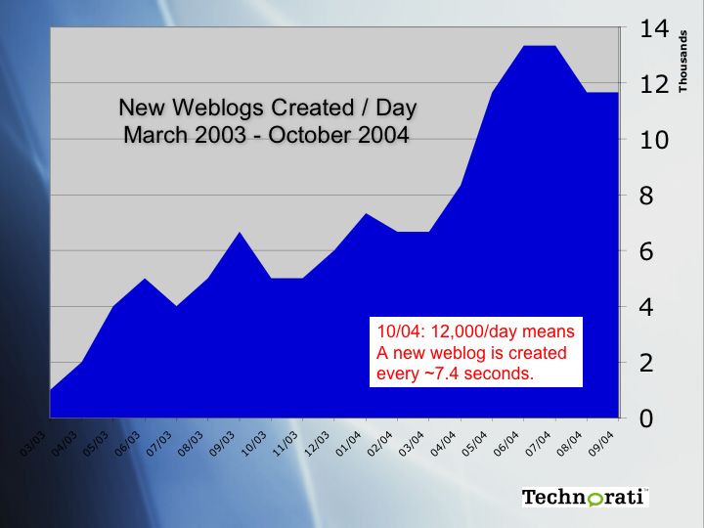
This chart shows the number of new political web logs being created each day from March of 2003 through October of 2004. During this time there were about 12,000 new web logs being created each day, which means that on average, a new web log was created every 7.4 seconds. Web logs or Blogs as they are affectionately termed in the cyber world are online journals that express personal opinions of their creator. 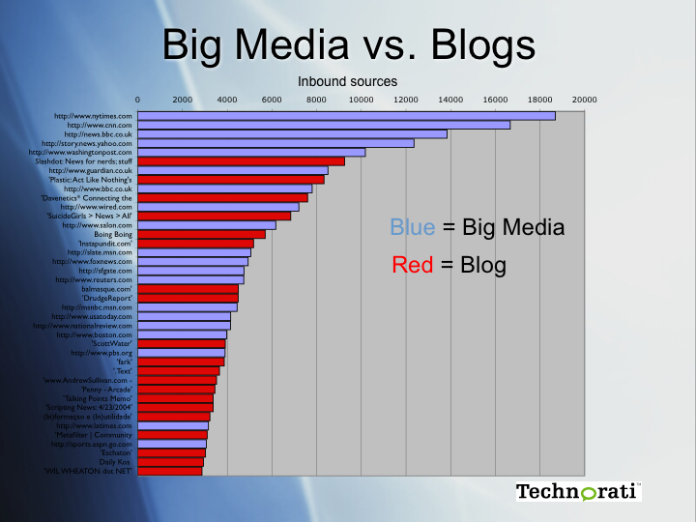

The chart above shows a graph of the most influential or authoritative “blogs” as compared with the most authoritative “big media” sites. Certainly, top-quality journalism, interesting articles, and consistency of quality show why the top big media sites are on top. But it also shows that a large number of people are getting news, information, and opinion from outside of the mainstream media, and that these sources are rivaling or exceeding the attention paid to smaller “professional” sites. These sources of information really serve only to subvert the political process because they obstruct what the media’s purpose truly is. If the public doesn’t get the opportunity to receive correct information then the political decisions they make will not represent the actual will of the people which undermines our nations’ conception of democracy.
If the media is to function properly in our society today there must be reforms so that it can be efficient. The case for media reform is based on two propositions. First, media perform essential political, social, economic, and cultural functions in modern democracies. In such societies, media are the principal source of political information and access to public debate, and the key to an informed, participating, self-governing citizenry. Democracy requires a media system that provides people with a wide range of opinion and analysis and debate on important issues, reflects the diversity of citizens, and promotes public accountability of those that are in power and their influences. In short, the media in a democracy must foster deliberation and diversity, and ensure accountability.
Second, media organization-patterns of ownership, management, regulation, and subsidy-- is a central determinant of media content. This proposition is familiar from discussions of media in China and the former Soviet Union. For those countries, the idea that the media could promote deliberation, diversity, and accountability, while being effectively owned and controlled by the Communist Party, was not even worth refuting. Similarly, we are not surprised to hear that when cronies of the Mexican government owned the country's only TV station, television news coverage was especially favorable to the ruling party. In the United States, in contrast, analysis of the implications of private ownership and advertising support for media content has been limited. For much of the later half of the twentieth century, Americans have heard that we should have little concern over the corporate ownership of media or dependence on commercial advertising because market competition forces commercial media to "give the people what they want," and journalistic professionalism protects the news from the biases of owners and advertisers as well as journalists themselves. Such views now seem very dubious. Consider first the alleged benefits of competition. The main media markets-- film, TV, magazines, music, books, cable, newspapers-- are all oligopolies or semi-monopolies with severe barriers to new entrants. Moreover, media economics make it virtually impossible for a firm to be dominant in just one sector. Because of opportunities that come with having properties in different media markets, the largest media firms all have rushed to establish conglomerates over the past decade. Time Warner, for example, is one of the top five US or global leaders in film production, TV show production, cable TV channels, cable TV systems, movie theater ownership, book publishing, music, and magazine publishing. It also has amusement parks, retail stores, and professional sport teams. Disney, too, seems to have mastered the logic of conglomeration: its animated films Pocahontas and Hunchback of Notre Dame were only marginal successes at the box office, with roughly $100 million in gross US revenues, but both films will generate close to $500 million in profit for Disney, once it has exploited all other venues: TV shows on its ABC network and cable channels, amusement park rides, comic books, CD-ROMs, CDs, and merchandising (through 600 Disney retail stores). Firms without these options simply cannot compete in this market, which is why animation is the province of only the largest media giants. This example is extreme, but it sharply underscores the fundamental principle. These observations about conglomeration, however, barely begin to explain just how noncompetitive the media market is-if we take "competitive" in the economics textbook sense. Firms in specific markets do directly compete, at times ferociously. But these firms are also each other's best customers, as when a film studio sells its product for presentation to a broadcast network's cable channel. Moreover, to reduce risk and competition, the largest media firms have turned to "equity joint ventures" in the 1990s. Under such arrangements, media giants share the ownership of a specific media project: Fox Sports Net is jointly owned by Rupert Murdoch's News Corporation and John Malone's TCI; the Comedy Central cable channel is co-owned by Time Warner and Viacom. Murdoch explains the logic behind joint ventures as only he can: "We can join forces now, or we can kill each other and then join forces." The nine largest American media firms have, on average, joint ventures with nearly six of the other eight giants. Murdoch's News Corp. has at least one joint venture with every single one of them. In such noncompetitive markets, the claim that media firms "give the people what they want" is unconvincing. The firms have enough market power to dictate the content that is most profitable for them. And the easy route to profit comes from increasing commercialism-larger numbers of ads, greater say for advertisers over non-advertising content, programming that lends itself to merchandising, and all sorts of cross promotions with non-media firms. Consumers may not want such hyper-commercialism, but they have little say in the matter. So we have a 50 percent increase in the number of commercials on network TV in the past decade; the development of commercially-saturated kids' programming as arguably the fastest-growing and most profitable branch of the TV industry in the 1990s; becoming standard in motion pictures. On the other side of commercialism is the decline of public service. The notion that there is any purpose to our media except to make money for shareholders. Under such conditions, journalistic norms can hardly be expected to stem the commercial tide. Contemporary commercial journalism is essentially a mix of crime stories, celebrity profiles, consumer news pitched at the upper middle class, and warmed over press releases. Bookstores are filled with dispirited reports by former editors and journalists bemoaning the brave new world of corporate journalism. Journalist unions are very important in this regard, by protecting journalistic norms from the commercial interests of the owners. But without other measures to weaken corporate media power, unions are not likely to be able to resist pressures from the current media system. For democrats, then, media competition and journalistic norms do not suffice for deliberation, diversity, and accountability. If media are central to the formation of a participating and informed citizenry, and if media organization influences media performance, then issues about ownership, regulation, and subsidy need to be matters of public debate. But such debate has been almost non-existent in the United States. Even in broadcasting, where the publicly owned airwaves are licensed to private users, the public has never had any meaningful participation in the formation of policy. Consider the Telecommunications Act of 1996. The law it replaced, the Communications Act of 1934, regulated telephony, radio, and television. The 1996 Act provides the basis for determining the course of radio, television, telephony, the Internet-indeed virtually all aspects of communication as we shift over to digital technologies. Its guiding premise is that the market should rule communication, with government assistance. The politics of the Act consisted largely of powerful corporate communication firms and lobbies fighting behind the scenes to get the most favorable wording. That the corporate sector would control all communication was a given; the only fight was over which sectors and which firms would get the best deals. The public was for the most part unaware of these debates. The drafting and struggles over the Telecommunications Act of 1996 were hardly discussed in the news media, except in the business and trade press, where the legislation was covered as a story of importance to investors and managers, not citizens, or even consumers. The results of the Telecommunications Act, with its relaxation of ownership restrictions to promote competition across sectors, have been little short of disastrous. Rather then produce competition, a far-fetched notion in view of the concentrated nature of these markets; the law has paved the way for the greatest period of corporate concentration in US media and communication history. The seven Baby Bells are now four-if the SBC Communications purchase of Ameritech goes through-with more deals on the way. In radio, where ownership restrictions were relaxed the most, the entire industry has been in upheaval, with 4,000 of the 11,000 commercial stations being sold since 1996. In the 50 largest markets, three firms now control access to over half the radio audience. In 23 of those 50

markets, the three largest firms control 80 percent of the radio audience. The irony is that radio, which is relatively inexpensive and thus ideally suited to local independent control, has become perhaps the most concentrated and centralized medium in the United States. No doubt the United States needed a new communications law. Digital technologies are undermining the traditional distinctions between media and communication sectors that formed the basis for earlier communication regulation. But the legislation we ended up with reflects the failed process that produced it (McChesney).
The failed process allows the political parties to control the media outlets. In this past election there was a significant increase in the amounts of money donated to political parties by media outlets. Continuing a twenty-year trend that has seen advertising expenses skyrocket as traditional political party organizing has fallen by the wayside, the total for political ads this election year is estimated by most industry analysts at over $1.5 billion, $400 million of which will be spent by the presidential campaigns. Over the last 24 years, broadcast TV advertising alone has increased from $90 million to over a $1 billion. So far this election season broadcasters have donated $ 3,592,069 in hard money contributions to candidates. Over the past three years the big five Media companies, Disney (ABC), News Corp (Fox) GE (NBC & Telemundo), Viacom (ABC), Time Warner (CNN & WB) plus the NAB have spent over $ 79, 740,000 on lobbying. So far this election season broadcasters have donated $ 3,592,069 in hard money contributions to candidates.

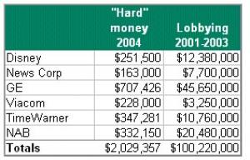

Over the past three years the big five Media companies, Disney (ABC), News Corp (Fox) GE (NBC & Telemundo), Viacom (ABC), Time Warner (CNN & WB) plus the NAB have spent over $ 79, 740,000 on lobbying. It can be hard to determine which partner is leading the dance at any given moment. General Electric, which owns NBC, spent over $45 million dollars on lobbying in 2003 alone. GE is also a defense department contractor with annual revenue of $134.2 billion, profiting handsomely from its government contracts in Iraq. GE's has also been caught up in some controversy involving the coverage of the 2000 presidential election. Congressman Henry Waxman (D-California) has repeatedly accused Jack Welch, then CEO of GE, of interfering with the election coverage by ordering the premature announcement of Bush’s victory on NBC. Welch, a long time Bush supporter, has denied the charges. But according to Neil Gordon, investigator for the Center for Public Integrity, Welch did admit that he was cheering for Bush at NBC headquarters. He reports that after initially promising to turn over an internal videotape of Welch at NBC headquarters on election night, NBC withdrew the offer. On the democratic presidential side, John Kerry has in the past been an outspoken critic of special interest money in politics, co-sponsoring the joint resolution against media consolidation and supporting multiple bills restricting campaign financing. He also recently gave an interview to John Nichols of The Nation magazine, where he used the media democracy rhetoric of the left to express his views. But media remains missing from his campaign platform, and not one of the 400+ press releases on the website has anything to do with media issues. Kerry's virtual quiet on media reform might be related to the fact that his top financial supporters are media companies and the law firms that represent them. Two of Kerry’s top four career patrons are the law firms Mintz, Levin, Cohn, Ferris, Glovsky and Popeo, who represent telecom and cable interests, and Skadden, Arps, Slate, Meagher & Flom, who represent Time Warner and News Corp.. Time Warner also ranks in the top four categories of Kerry supporters. A representation of the type of contributions that President Bush receives from his backers is signified in reports put out by news organizations like ConWebWatch. ConWebWatch calculated that the estimated value of NewsMax's contributions to the Bush re-election campaign to be somewhere around $35 million. So, what is the Bush campaign getting for this in-kind money? The usual, of course -- ranting columnists, slanted headlines and support of anything that can be used to smear Kerry, i.e. the Swift Boat Veterans. Not only do these organizations run smear campaigns they are also known to continue running these campaigns significantly after they advertisement money given to them by the parties has run its course. Under the table contributions are made to these news organizations by the parties that they support if ads are run actively through important time slots such as prime time. So with all of this, what is the ethical duty of the media?
The United States has an ethical constitution for the media which outlines what standards the media is supposed to uphold. The basic principles have to do with ethics, accuracy and objectivity and fair play. There is a noted difference between the U.S. media’s code

and foreign countries whose constitutions are simpler yet the ideas are expressed with greater fervor. Countries like Malaysia acknowledge that the media has a role in the building of the nation where the U.S. media pledge has no mention of the responsibility the media has to the moral fabric of the country. Without a standard of protecting the integrity of the country put on the media then it allows these companies along with the political groups they lie in bed with to use scare tactics to herd the masses.
In this prior election the Bush campaign continued to paint Sen., John Kerry as indecisive and that he wished not to defend America. Now who really believes that a man, who fought in Vietnam, when he didn’t have to, did not wish to defend his country against terrorism? Using the media, the GOP was effective in scaring the public into believing that the enemies were at the gates and if Kerry was in office there would be massive attacks. All of these allegations made by the Bush Whitehouse are completely unfounded and there is no way that they have the knowledge to make such definite and harsh accusations. Comments like the following where Bush suggested his Democratic rival "does not understand the enemy we face and has no idea how to keep America secure" is a prime example of the attempts Bush has made to affect the voter. His campaign reinforced that theme with a new television ad with chilling imagery of prowling wolves in a dense forest. "Weakness attracts those who are waiting to do America harm," an announcer says (ABC News). Not only does our media and politics influence and control our own society it also has a very one-sided view that America dominates the world.

The global commercial system is a very recent development. Until the 1980s, media systems were generally national in scope. While there have been imports of books, films, music and TV shows for decades, the basic broadcasting systems and newspaper industries were domestically owned and regulated. Beginning in the 1980s, pressure from the IMF, World Bank and U.S. government to deregulate and privatize media and communication systems coincided with new satellite and digital technologies, resulting in the rise of transnational media giants. (McChesney). Over the past 20 years, not only has America grown in ability to dominate the world market its gotten to the point where only American opinions and values are deemed valid in the United States. With America only concerned with the information put out by its own media then decisions of the public are rarely made with the thought of other countries around the world. This is evident in the past election, where the majority of the world did not support President Bush but still he was positively represented in our media which is evident in the voter response.
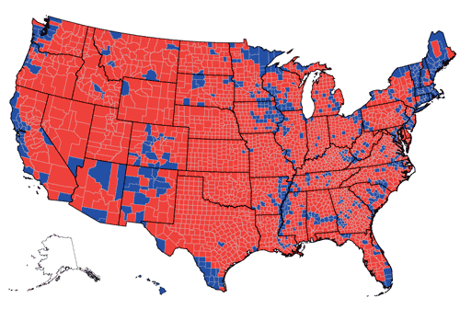

  Square miles of
  counties won
  Bush | 2.54 million
  Kerry | 592,000
  Population (2003) of
  counties won
  Bush | 159,2 million
  Kerry | 130.9 million
  Counties won by less than 5 percentage points
  Bush | 164
  Kerry | 146

Note: County election data is not reported for Alaska,

The support of Bush is amazing especially for a candidate so unpopular around the world. This graphic only further illustrates how the United States media tends to only value its thoughts and the public agrees with that.
Americans look to the press to provide the information they need to make informed political choices. How well the press lives up to its responsibility to provide this information has a direct impact upon Americans: how they think about and act upon the issues that confront them.

