Daisy Ramirez
Ethics of Development in the Global Environment

Protecting ourselves from media manipulation: The use of alternative media as an information source (Reedited June, 2006)

Throughout time it has been clear that the media has had a large influence over our perceptions of the world and of the society in which we live. One has to wonder why it is that we blindly believe whatever we hear on the radio, see on the television, read in newspapers and more currently on the internet? The mass media has acquired great control over the perceptions of how we interpret the world around us; it is only when we allow alternative media to develop and expand to greater parts of the world that we will be able to understand different perspectives and work towards understanding the truth.
There have been past reports on alien invasions, attacks made by giant worms and other exaggerated or made-up stories, often times these events or attacks were based on popular fears of the time. This same phenomenon can also be seen during the “Red Scare.” Americans constantly afraid of being attacked by communists and their spies thus, they proceeded to name anyone or anything as a communist if they did not respond in the way that they had anticipated. These fears were further exaggerated and manipulated by the mass media creating which only lead to the creation of more anxiety.
Timing and making thing believable are equally as important in creating stories or news that can result in anxiety and fear. To fully deceive the public there has to be a plausible story occurring at the right time and place.
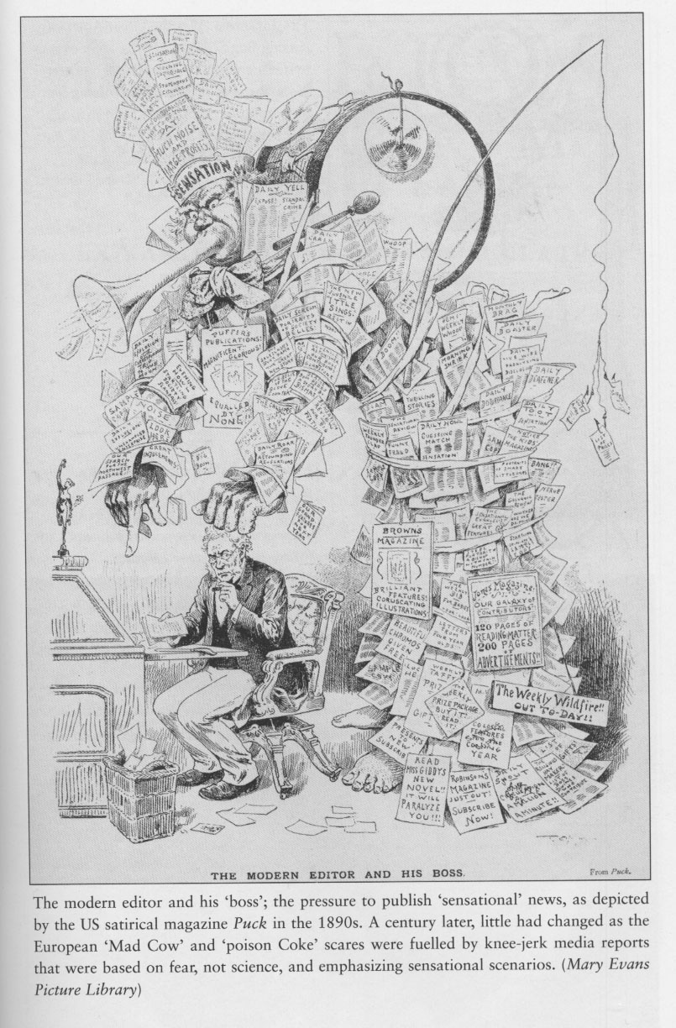
In our post 9/11 world, where many people are already feeling on the edge it is important for the media to be careful in what they produce, and the potential effects it can have on their audience. We would not want to see ourselves confronted with the same tactics as those used during the “Red Scare.” If similar broadcasts were to occur today, they might trigger widespread fear that a biological or chemical terrorism attack was actually underway, even though no actual proof might be visible, as such was seen with the supposed weapons of mass destruction in Iraq.
With this said, it is important to take note of the constant bombarding of images of soldiers in the battlefield and the constant threats of future terrorist attacks provided by the news media. As George Orwell explains, “…if thought corrupts language, language can also corrupt thought. A bad usage can spread by tradition and imitation, even among people who should know better,” this helps explain how the media can use language to influence the perceptions of it’s audience even when the audience normally knows better than to be seduced by that same language.
It is generally agreed that the relationship between terrorism and the media is ‘symbiotic,’ in that defiant terrorist organizations use the media as a means of expression for their political message to be heard by the targeted audience, whilst supplying ‘exciting news’ for the media (Nacos). The media is further seduced into adopting the language that is provided by the terrorist organization. An example of this occurred when former-Italian Premeir Aldo Moro was kidnapped and then murdered, the editor of La Repubblica ran the headline ‘They Have Struck The Heart of The State,’ which seems to be indirectly repeating Red Brigade’s statement ‘…we have carried the attack into the very heart of the state” (Bechelloni).
The media not only adopts some of the language used by the terrorist organization but it also has been pointed out that many times the news media automatically adopts the taxonomy of the government (De Graaf). It is not believed that the media is seduced by the government’s use of language but rather the government’s perceived superiority in information. For this reason, the media is further inclined to use language that describes acts as politically motivated with violence, rather than neutral reporting. This is very dangerous in itself because it means that the media would be afraid of providing the public with information that did not agree with the information that was being provided by the current government, thus causing confusion and possible chaos. This allows us to wonder if we are only learning of one side of the story and there’s a whole other “truth” that we are not learning of.
It is well known that words influence thought and limit the ideas that can be transferred from one individual to another. Based on the example above we can see that the media plays a central role in telling the public what words will be judged by society to be appropriate in any new discourse. Therefore, it is important for both terrorist organizations and state agencies that the media uses their language to describe acts of politically motivated violence.
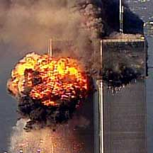
This is just in. You are looking at obviously a very disturbing live shot there. That is the World Trade Center, and we have unconfirmed reports this morning that a plane has crashed into the towers of the World Trade Center. CNN Center right now is just beginning to work on this story, obviously calling our sources and trying to figure out exactly what happened. (CNN Anchor Carol Lin, 8:49:50 a.m., 9/11/01)

This is the report that the American people woke-up to as they watched the horrific scenes of the World Trade Center collapsing, followed by painful images of joyous celebration of the attacks by angry anti-American protesters in many countries of the Middle East. As many policy-makers in the United States decided on a course of action the media was already beginning to unfold what the response should be. As soon as the United State military had a response it was broadcasted not only to the American public but also to the Arab world through different media sources.
In order to understand why the American public began to feel that all Arab countries were anti-American it is important to examine the media tactics provided by U.S. media sources and the not-so-heard-of alternative media attempts in the Middle East. It is also important to wonder if the American media was able to contextualize the news reports presented by this non-Western source and what consequences this had for the range of information available at the time.
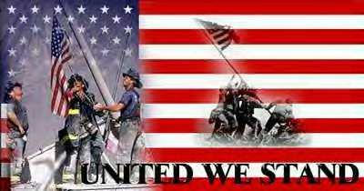
Muller explains that, after the horrific attacks on the world trade center it was natural and understandable for the public and the media to exhibit a “rally around the flag” response, uniting behind the president’s actions. As Dr Jasperson and El-Kikhia found in their report, “this support is seen in terms of public approval from political elites as well.” As explained by Brody in “Policy Failure and Policy Support: The Iran-Contra Affair and Public Assessments of President Reagan.” Since the White House controls information during an international crisis, members of the opposition party will suppress their disagreement with the President in public, thereby creating the appearance of an elite consensus. This goes to support the idea that the media should also be part of this support group to help unify or appear as a unified force.
Jasperson and El-Kikhia also found that many argue that through mechanisms such as framing, priming and spiral of silence the news media can influence, extend and enhance the “rally around the flag” response long after it would have naturally disappeared. The perspectives of the specific media source can prime particular attitudes and shape public opinion differently in political contexts when conducing coverage.
During the Persian Gulf War the language used to cover the war and coverage of dissent reinforced the suppression of opposition views. Patriotic themes were of repeated euphemisms and metaphors, which were used by experts and reporters alike to characterize the military operations (Allen et al.). Further use of this language allowed citizens to process events of the Persian Gulf War without experiencing the true realities of war (Cohn).
The sources the media uses can greatly influence opinion. Sources have different levels of credibility and those that are seen as more credible tend to be the more persuasive in influencing public opinion. During the Persian Gulf War, access to information was strictly controlled and few sources of news existed outside of the Pentagon’s version of events (Allen et al.). This especially limited the perceptions that the media could pass onto its audience.
However, during the War in Afghanistan, the Pentagon has been less successful at limiting the information that has made it’s way to the public. While the Bush administration attempted to control the information being expressed in American media sources, the Taliban also attempted to control the information being expressed in Afghanistan media. This was when Al Jazeera television network was able to emerge as an alternative source of information from behind.
Immediately after the September 11th attacks, Al Jazeera began to work on images they could provide the American media explaining the unfolding of events in Afghanistan. The images being produced began to form a larger impact on the dynamics between the media and decision-makers in the United States. A reporter questioned Secretary of Defense Donald Rumsfeld as a result of the visuals supplied by Al Jazeera to CNN in the United States: “Mr. Secretary, we are getting reports of…from CNN rather, that there are bombs exploding in Kabul, Afghanistan. Are we at the moment striking back and if so, is the target Osama bin Laden and his organization?” According to Rumsfeld, “…in no way is the United States government connected to those explosions” (Jasperson et al). This is particularly important because the American media would not have known to ask these questions without the reports from Middle Eastern sources like Al Jazeera.
Even more interesting is that after Secretary of Defense had explained that the United States was not bombing Afghanistan President Bush went on television and announced his decisive action in the war on terrorism and caused his approval ratings to rise.
On my orders, the United States military has begun strikes against the al Qaeda terrorist training camps and military installations of the Taliban regime in Afghanistan. These carefully targeted actions are designed to disrupt the uses of Afghanistan as a terrorist base of operations and to attack the military capability of the Taliban regime. (Speech of George W. Bush, as reported on CNN, October 7, 2001)

After the speech during the White House briefing it was said, “We are beginning another front in our war against terrorism, so freedom can prevail over fear.” (White House briefing room, as reported by CNN, October 7, 2001). During this time Gallup poll results for Bush’s approval in handling foreign affairs rose from 54 percent in July 10-11, 2001 to 81 percent in early October. By late October, approval for the war had risen to 88 percent (Newport).
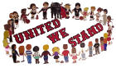
It seemed as if everyone around the world was sympathizing with what had happened on September 11th, 2001. As Judy Woodruff, CNN reporter interviewed Javier Solana, EU Defense Minister, he expressed his agreement with the Western actions against Afghanistan:
Well, we think that this operation is fully legitimate, according to the U.N. Security Council and the European Union has all the solidarity with the United States in these operations. The fight against terrorism is our fight, and together we are going to win it. […] We have full confidence that the United States and Great Britain and other countries of the European Union…that it will be done as a targeted operation, with their objective to defeat terrorism…So, this is a battle in which we are all engaged.

It is important to note that while all of this is going on in the political arena media reporters are also tuning in. Howard Kurtz says during a candid self-reflection, “Journalists, believe it or not, are human beings, and they’re spooked by what’s going on. They want a strong leader so their own emotions made you lean towards giving the guy the benefit of the doubt” (October 13, 2001).
The rhetoric of mirroring the President’s words and repeating the theme of targeting only selected “evil-doers” and not innocent Afghans, caused most people to recognize that the actions taken would not be taken against Afghanistan’s civilian population. Much of the coverage on the news revolved around the military capabilities, precision technology, “clean language” and euphemism by military experts and the media. This technique allowed the Western audience to believe that lives were not being lost in the battles.
Even the protestors were made seen as “loud and noisy, but controlled” (October 13, 2001, CNN Live Event). By documenting and airing reports like these the audience of the American media was made believe that the situation was under control. Jasperson and El-Kikhia noted that, when dealing with what the civilians of Afghanistan were undergoing the media would focus mostly on the humanitarian frame. This meant that another purpose of having the United States in Afghanistan was to aid the people of Afghanistan. These images were put within the frame of American success and generosity.
However, as time went by there began to be signs of disagreement among elites around the world about the objectives that were being accomplished toward the end of October. This disagreement began to bring up questions in the minds of the American public and those around the world. It was difficult for them to understand how these elites could be at such a disagreement as is seen in comments from Victoria Clarke, Pentagon Spokesperson, and Lee Hamilton:
“Rooting out the al Qaeda and the Taliban – clearly we’re doing that, getting them on the run, making it difficult for them to work and coordinate with one another. Clearly, the objective we – we’ve laid out are being accomplished.” (Clarke cited in Jasperson & El-Kikhia).

“I don’t think we can ever declare victory or even a partial victory unless we get the top leaders of al Qaeda, and we have not succeeded in doing that yet.” (Hamilton cited in Jasperson & El-Kikhia).

The confusion in the minds of the American public was reflected in Gallup polls, less than half of Americans thought that the United States was winning the war against terrorism. On October 31, 2001, only 4 in 10 Americans thought that it was likely that we would succeed in removing the Taliban from power. Only one fourth of Americans in a CBS/New Your Times poll felt that the war was going very well (Newport, October, 31, 2001). Yet they were still committed to the general approval of Bush and some sort of military action against terrorism. (This was further seen in the presidential elections of 2004 where President Bush was re-elected.)
The prominent role of Al Jazeera provided a new perspective and generated new questions that were not asked during the 1991 Persian Gulf War. National Public Radio said, “Al Jazeera provides news coverage of all sides to audiences whose stations in their countries are beholden to the local government. It is also the only news network with staff inside of Taliban-controlled Afghanistan and it had a viewer-ship of 20-25 million people around the world before the September 11 attacks (NPR, October 8, 2001). Kurtz, from CNN further stated,
It’s very controversial, but at the same time very popular, because it tells all sides – in other words, it may cover the Palestinian uprising very intensely, but also allows access to Israeli officials. It gets the videotape of Osama bin Laden that every network in the universe, including CNN, has now aired many times, but it also puts Tony Blair on the air to give the Western view. (CNN, October 10, 2001).

In order to maintain this credibility of providing all sides Al Jazeera has the task of also having to deal with the disagreement of terms and usage of language that is see throughout the world. Ahmad Sheikh, Duty Editor for Al Jazeera describes and example of this,
“When it is an American official or someone is saying it, we keep it as terrorism, right? But when we are quoting one of them, we say ‘What he called terrorism.’ We do not use the word ourselves because, you know, this is controversial. Can we agree, first of all, on a definition of what a terrorist act is? Some people may –it’s too wide a definition (NPR, October 8, 2001).

Now we are faced with the fact that no one can agree on the way that language and terms are to be used when reporting information. The United States does not seem to have much trouble using the word “terrorism” or “terrorist” but many other countries around the world have very different definitions of what a terrorist or an act of terrorism is. Al Jazeera reporters can only serve as eyewitness sources for western media outlets such as CNN and is sometimes able to provide video images along with an alternative view of the events compared to those of the pentagon.
Although Al Jazeera was sometimes providing video coverage to CNN it is interesting to note that depending on which media source you were receiving the report from you would have a different impression of what the coverage tape was portraying. If the United States media was primarily interested in how the U.S. military was conducting the war against the Taliban and Al-Qaeda. As Jasperson & El-Kikkhia but it, they would limit themselves to pictures and analysis of U.S. bombs aiming for various areas of Afghanistan where the Taliban and Al-Qaeda forces were thought to be located. However, Al Jazeera, and by extension other Arab media sources, were mostly concerned with the impact this war had on the ordinary Afghan as well as the perceived ineptness and paralysis of Arab regimes in influencing events on the ground. Therefore, much of their coverage revolved around the chaos U. S. bombing hand on Afghanistan’s people, cities, and already falling apart infrastructure. This invariably gave the appearance as though Arab media’s coverage of the US-Afghan war was anti-American. At the same time, if one continues to examine this source a different story can be found.
It is true that the Arab street was already upset with the Bush administration for its unconditional support of Israel’s Prime Minister Sharon and along with Arab satellite television footage showing the brutal repression of Palestinians in the occupied territories of the West Bank and Gaza led them to be suspicious of the United States’ policies. With this said, the initial response from Arab regimes and Middle Eastern regimes including non-Arab Iran was to sympathize with the United States in its war against terror. Especially since most of these regimes had already felt the hurt of radical Islam within their individual societies and therefore were genuinely sympathetic to the disaster that befell the United States on September 11, 2001.
As mentioned previously, this sympathy soon disappeared when the United States began to air reports and announcements, which classified Iraq, Iran, and Syria as part of the “Axis of Evil”, which further increased the suspicion in the minds of the Arab people. However, after this also further upset regimes of the Gulf states which felt confident enough within their societies to permit their media a degree of freedom to do what they as regimes could not do, namely criticize U.S. policies as well as Arab regimes without naming specific countries. This gave room for the venting of their extreme anger and frustration from their apparent paralysis in the Palestinian-Israeli conflict. Jasperson & El-Kikhia found that although there were regimes which felt confident enough to vent these feelings there were still regimes such as the Saudis, Libyans, and the Iraquis who felt less secure and consequentially placed more restrictions on their local media. These regimes continued with their normal coverage, however the Saudis decreased their usual dose of religious programming and instead emphasized the “huge” gap between them and the Bin Ladin’s radicalism. It became very clear that these regimes did their best to distance themselves from the September 11th disaster and the Afghan-US conflict.
Other neighboring countries such as Egypt owned the Nile television and gave full coverage to both the New York and Kabul events but emphasized the intellectual debate on both conflicts. However, it is important to note that Egypt’s state owned media was extremely careful not to antagonize the United States because of the generous benefits it received from the U.S. Inclusively, as a way of protecting themselves the Egyptian regime imprisoned individuals, which could be classified as part of the Muslim Brotherhood, even though not all those imprisoned actually belonged to radical Muslim organizations. This was mainly an effort to assure the Bush Administration and the U. S. Congress that Egypt was cracking down on the religious element within it’s society and was therefore an ally against terror. This is especially interesting because Egypt was to receive a 300 million dollar grant to Israel by the Bush Administration to fight terror.
There is no denying that the Egyptian government came out financially ahead in the 1991 Gulf War against Saddam Hussein and the President Mubarak’s regime was not going to permit an anti-American media bombardment to take place in Egypt attacking the US invasion of Afghanistan. This demonstrated that money helps countries decide what side they should be on, just the same way a candy can help school children side with the playground bully.
This environment was able to provide the information that Al Jazeera needed to continue on its feet. Initially viewer-ship for Al Jazeera was very small but it rapidly increased after the network began to take on controversial topics. Al Jazeera is considered to be one of the most “liberal” of the Arab broadcasting networks. Given that the Saudi daily Al-Sharq Al-Awsat was the dominating printed media this was the best opportunity for Al Jazeera to dominate the televised media. For Al Jazeera the establishment of the second Intifadah in the occupied Palestinian territories and the Afgahn campaign were huge turning points in the media history for the Middle East. This turning point was something similar to what the Vietnam War was to America’s media coverage. Therefore, Al Jazeera spared no cost or effort in order to acquire the latest technology equipment and did its best to provide the best coverage they could.
However, because Al Jazeera tried to remain neutral by not supporting Bin Ladin and not portraying themselves to be based on the zero-sum environment, imposed by the Bush Administration, any country not supporting the United States was classified as anti-US. The Bush Administration began to realize that Al Jazeera could be used as a forum for American policy makers to address the Arab world. It also became clear that dismissing these new Arab stations as censored and irrelevant was detrimental to the interests of the United States in the region. Therefore, they went out of their way to give interviews during the Afghan campaign and in its aftermath, to explain America’s reasoning and position on the Arabs and Islam.
The Afghan War was the first real war to be covered by any Arab network and Al Jazeera was lucky enough to have had a monopoly on some of the coverage of that conflict. In order to remain as neutral as possible Al Jazeera thought that covering the Afghan war from a humanitarian perspective was the safest venue, until they acquired more familiarity with how the media worked.
Soon after this decision was made the Bush Administration began to have second thoughts about this newly formed connection. In a report from October 9, Al Jazeera reported, “As you have seen, the American missiles have actually hit a humanitarian aids building and a poor populated area was completely destroyed. But is seems that the fighting concentrates on airports and the air defense installations.” “There were pictures from the hospital inside Kabul, which showed some injuries, showed some children, women and men who the Taliban claim have been injured in the previous night’s attack. Reports of fear from ordinary civilians.” (October 13, 2001, CNN LIVE). This type of reports caused further headaches for US military officials. CNN Senior White House correspondent John King discussed the role that inside coverage had on their ability to get the Bush Administration to give details about the operations in Afghanistan,
We will ask the Pentagon and the White House, although we should tell you, the Pentagon and the White House both have been very reluctant to discuss any details of any of the military activities. At first the Pentagon did not even acknowledge all that one of its spy planes was missing about two weeks ago, finally the defense secretary, Donald Rumsfeld, did acknowledge it was missing.

Another reporter adds:
And John, we’re seeing that video. You just saw the video that we ran moments ago. Do you think, because we did bring pictures about that the Pentagon will have to respond? And what do you think about those pictures? Is this something that we definitely should believe in?

King responds by adding:

Well, the Pentagon will have to respond to our questions…Very reluctant to discuss any operational details. (CNN, October 6, 2001).

These seems to further the idea that there is no real way for reporters to know what is going on in Afghanistan because there is not access to soldiers even after they have returned from their missions. “It took Al Jazeera to tell Americans that a helicopter had a problem” (October 23, 2001, CNN Tonight). The US government responded to this type of reporting by attempting to regain control over American sources and exert influence over Al Jazeera’s discussions with American outlets. According to Hafez Al Mirazi, Washington Bureau Chief for Al Jazeera, Secretary of State Colin Powell complained to the government of Qatar, a partial financer of Al Jazeera, to “tone down the anti-American framing of its newscasts, he proceeded to say:
The U.S. government in general made a big mistake. Instead of encouraging the independent media in the Middle East – Al Jazeera is a unique case, it was actually trying to influence the government of Qatar to use any influence that the government of Qatar might have on Al Jazeera to drag down or censor us, which is really a very bad precedent, and I think many international organizations criticized the U.S. government for doing that” (October 13, 2001).

After much debate the U.S. government decided that once again they would attempt to foster a relationship between Al Jazeera and the American media. In an effort to do so they further encouraged American media to work with the newly created sources in the Arab countries. This was also supported by the fact that as Fouad Ajami said, “[…] Al Jazeera was on the ground. […] –let’s face it, it had access to Osama Bin Laden, and these were advantages it brought to this particular story, and we had to basically take pretty much what Al Jazeera gave us.” (NPR, Talk of the Nation, November 13, 2001).

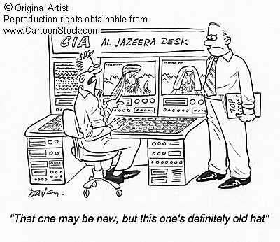
Overall Al Jazeera would provide an alternative viewpoint where the pictures and information would be crucial to CNN reporters, as well as to representatives of the Western media, to question information from official sources. It is noteworthy that Al Jazeera network, in particular, has been successful in making US and European media serves take notice, CNN has worked very closely with Al Jazeera to provide balanced coverage.
Although most local US broadcasters have developed this connection with Al Jazeera and continue to attempt to provide balance coverage there is one exception, Murdoch’s US Fox network. Fox network continues to air anti-Arab and anti-Muslim criticism. This has also been apparent in Mr. Murdoch’s European based Sky News. Finally, the United States government was able to see the needs to create a new US Arab network to compete with others in providing the Arab world of its position on various global issues.
It is interesting that so much of this discourse could have been avoided had alternative media been available and deemed credible. Most Arabs saw Afghanistan as a sideshow for the Arabian people. Many saw it as remote, narrow, and quite alien. Secondly, there was very little tolerance for the Taliban, their ideology and domestic policies among the Arab masses. Only two Arab countries maintained diplomatic relations with the Taliban, Saudi Arabia and the UAE. Thirdly, Arab people were more focused on the Occupied Territories, the Palestinians, and Israeli-US policies in the area. For all these reasons we were led to believe that initially there were no serious attempts by the Arab media to cover the war in Afghanistan. However, due to the transmission of Bin Ladin’s tapes and interviews Al Jazeera was able to move into the forefront of networks covering the war.
The manifestation of this newly acquired power also played a large role in America’s not-so-secret plan to invade Iraq and remove Saddam Hussein from power. This early in time it was made clear through official and unofficial polls that opposed to America’s invasion plans, however as we have seen before the United States government will act in what it believes to be best even if it does not agree with the public opinon. Even America’s closest allies in the region such as Kuwait and Saudia Arabia cannot publicly endorse America’s plans, which then place them in a situation where they find themselves not only speaking out against it but also publicly denying the United State use of their territories as launching pads that were to be used against Saddam.
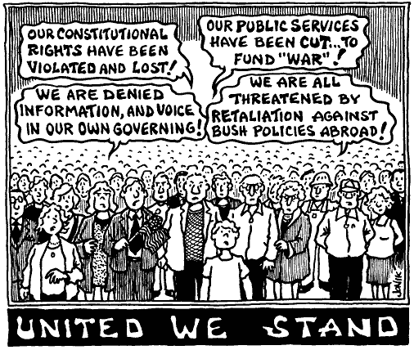

As time goes by the American public is also learning of the tactics used within the Bush Administration and its hidden agenda. Therefore, alternative media has also come to have a larger role within the American audience and not only in the Middle Easter countries. In response to this newly available information there have been many protest and large efforts to remove the President during the 2004 Presidential elections. However, due to much of the past media influence and current limits on information President Bush was able to win re-election. We are now faced with a war in Iraq and even after Saddam Hussein has lost power in his country we continue to be bombarded with images of “terrorists” and constant threats of future terrorist attacks.
Through the analysis of American media and alternative media in the Middle East it has become clear that the only way that one can learn of the truth and other perspectives around the world is through further exploration of perspectives from alternative media.
Currently Al-Jazeera continues to be a strong alternative source and has gained world-wide attention after the September 11th 2001 attacks and now rivals the BBC.
Bibliography

Alex Schmid and Janny de Graaf, Violence as Communication: Insurgent Terrorism and the Western News Media (London: Sage Publications, 1982) p.88.

Allen, Barbara, O’Loughlin, Paula, Jasperson, Amy and John L. Sullivan. 1994. The Media and the Gulf War: Framing, Priming and the Spiral of Silence, “ Polity, vol. 27, #2, pp. 255-284.

Bartholomew, Robert E. and Hilary Evans, Pani Attacks: Media Manipulation and Mass Delusion, (United Kingdom, Sutton Publishing Limited, 2004) pp 112-114.

Brody, Richard A. and Catherine Shapiro, Policy Failure and Poicy Support: The Iran-Contra Affair and Public Assessments of President Regan Political Behavior (November 1989), pp 353-369.

Cohen,Carol,, The Language of the Gulf War, Center Review: Publication of the Center for Psychological Studies in the Nuclear Age, 5 (Cambridge, Harvard Medical School), pp.14-15.

Giovanni Bechelloni, ‘llColpo di Stato in Diretta’, La Repubblica, (17 March 1978) cited in Robin Erica Wagner-Pacifici, The Moro Morality Play: Terrorism as Social Drama (Chicago: The University Chicago Press, 1986) p. 65, 90.

Jasperson, Amy E. and El-Kikhia, Mansour. "U.S. and Middle Eastern Media Perspectives on the Aftermath of the Sept. 11 Terrorist Attacks" Harvard Symposium: Restless Searchlight: The Media and Terrorism. 8/25/2002

Mueller, John E. War, Presidents and Public Opinion (New York: John Wiley, 1973).

Newport, Frank, Public Opinion of the War in Afghanistan, Gallup News Service Poll Analyses, (31 October 2001) (http://www.gallup.com/poll/Releases/Pr011031e.asp)

Orwell, George, Politics and the English Language in The Collected Essays of George Orwell (Harmondsworth: Penguin, 1968) p. 167.

Page, B., Shapiro, R. and Dempsey. 1987. What moves Public Opinion,
American Political Science Review, 81, March, 23-43.

Speech of George W. Bush, as reported on CNN, October 7, 2001

United We Stand Flag, cartoon: http://www.tkdtutor.com/01Site/9-11Images/united-1.jpg

United We Stand, Holding Hands, Cartoonstock,
http://www.cartoonstock.com/newscartoons/nc_search.asp?x=a&keyword=&Category=Bin+Laden%2C+Osama&Boolean=Or&Artist=Not+Selected&submit=Search

World Trade Center, Image: http://bulatlat.com/images/5-32/World-Trade-Center-9-11.jpg

