Sheila Joglekar
EDGE Final Paper
Autumn 2004

Propaganda in World War II – Britain and Germany

Introduction

As Baird states in his book, “Nazi War Propaganda,” propaganda is a word that is used more often than it is understood. He believes that the reason for this confusion is evident, because there has never been a definition of propaganda to which all scholars will subscribe. Some scholars describe it as the “attempt to influence behavior…by affecting through the use of mass media of communications, the manner in which a mass audience perceives and ascribes meaning to the material world.” However, others believe it is closer to the “management of mass communications for power purposes”(3). However, there is not a definition of propaganda that is satisfactory in describing and explaining British and Nazi propaganda techniques during World War II, for they were too fundamentally different. However, Balfour believes that ultimately, each side sought to convince its own people, neutrals and the enemy not only that it would win because it was stronger, but also that its victory would be in the general interest because the principles by which it was motivated were more likely to bring peace and plenty. Each side set out to establish its own credibility and to destroy that of the enemy (426). Thus, the underlying motives for the propaganda were the same for Britain and Germany, though their approach might have been different.

Baird believes that Nazi propaganda merged practical and political events with mythical ones, and that Hitler focused on the irrational through myths and symbols in his propaganda. The Jewish people were defined as the enemy and as a group that the collective fears of the nation could be directed at, but all the while offering a renewed pride in the German nation. According to Baird, “The peculiar genius of Hitler and Goebbels was to merge the themes of traditional German patriotism with Nazi ideological motifs, a course pursued from the days of the earliest Munich rallies in 1919 to 1945”(4).
British propaganda was a bit different in that it emphasized the veracity of its news reports and inspirational words, whether they were actually true or not. The BBC played a large part in this, for its principles that “Comment is free, fact is sacred” (430), insisted on the rigid separation of “news” and “views.” However, this led to conflicts with the government, for the BBC’s opposition to government control at the start of the war was largely due to a fear that they would be made to give up their tradition of objective reporting and instead be forced to “slant” the news. However, as Balfour points out, this raises questions as to whether there exists such a thing as objectivity in the news, and whether or not it is possible during wartime when lifting the morale of the people is such an essential task. Perhaps it would benefit us to investigate the structure of propaganda in each country a bit more thoroughly.

Propaganda in Britain

In July 1935, a sub-committee of the Committee of Imperial Defense was examining the question of censorship in wartime (45). Thus, the Ministry of Information was set up, with five divisions: Administration, News, Control (Censorship), Publicity, and Collecting (Intelligence). The Ministry was to be the center of distribution of all information concerning the war, and the press and public were encouraged to view it as such. It’s main function was to present the national case at home and abroad. The News division’s job was to ensure the rapid dissemination of information as opposed to prepared propaganda. The idea for the Collecting division was that there should be a single organization to obtain all the information, which the Department needed for successful operation. Information would fall into two categories: confidential and non-confidential. Part of the division was always intended to deal with conditions and opinions on the home front. (72)
It is said that the supposed success of the German Propaganda Ministry may also have played a part, for there was a widespread view that, if they were to fight the Germans again, they should have the same weapons in place. Also, the Government expected heavy air raids immediately after the war began, and wanted an organization to prevent public panic. However, early on, problems with censorship occurred, as departments made announcements without warning the censors, and they attacked the content of the announcements later. Also, a deeper problem was that submission to censorship was voluntary. Any correspondent was free to write, and any editor free to print any story they got a hold of. (59)
Another key element in Britain’s arsenal was the BBC. The BBC played such an indispensable part in the average Briton’s life between 1939 and 1945 as to make a war without it hard to imagine. Yet, as late as March 1939, the Foreign Office told the MOI that the future of the BBC in wartime was still undecided. The primary reason for this was the fear that BBC transmitters would be taken over by German aircraft as beacons guiding them to their targets. To overcome this danger, BBC engineers devised a plan such that any machine would have to get within a 25-mile radius before being able to use it. Also, they were afraid that the war would increase the Government’s power over the BBC, which was supposed to be an independent entity. Finally, after negotiations, they decided to allow the BBC to carry on as before, with a very close liaison between them and the government.
However, regardless, the BBC and the government got off to a bad start. In the beginning they were told by the government not to broadcast a message from the National Council of labor to the German people, thus there was always a fear that the “objective” programs would turn into propaganda. A further cause of resentment was the obligation imposed on the BBC to read official communiqués in full and to check other official news with the department concerned before putting it out. Finally, the BBC was forbidden by the MOI to use news items until there had been time for them to get published in the press; this led on occasion to British news coming out on the German wireless before it did on the BBC. This made it look like the BBC gave the Ministry preferential treatment. (81)
Finally, in 1940, the struggle between the government and the heads of the BBC came to a climax. One of the heads of MOI drew a distinction between “propaganda” in the common sense of the term, the perversion of public opinion, and “executive information.” Then in 1941 the BBC acquired a Director of Propaganda in its European Service and in 1942 a Propaganda unit in its home one. However, in all of this confusion, the BBC was not asking to be relieved of responsibility of “taking sides” between Britain and Germany, or to abandon the standpoint that Britain and her Allies could or should win the war. They could not be that different from the British official announcements, because if they had started openly to question to veracity of these publications, the government certainly would have made short work of them. (87)
According to Balfour, there were two levels on which their fears could have been justified: 1) The BBC was averse to taking sides inside Britain, though they would take sides against the Germans. Therefore, if the country had been badly split on a major issue, for example, if the country should continue the war in 1940, the government might have sought to suppress the view that it did not itself accept. The other level of fear was at the more pedestrian level of presentation. An internal memorandum dating from the early 1940’s headed “War-time Propaganda” laid down as principles for propaganda programs, “no deliberate perversion of truth and avoidance of cheapness and personal ridicule.” The objection to such tings was not based on grounds of morality, but simply that the public would not believe them. (88)
In 1937, the Foreign office decided that a European Service would be necessary as well, to offset the stream of Anti-British vituperation pouring into the Middle East from Italy and Germany. Therefore, they asked the BBC to begin the job from the short wave in Britain. The service began in 1938, and then expanded to Spain, Portugal, and Latin America. Wartime plans put this division into very close contact with the MOI, and they believed that propaganda could not possibly be effective if criticism at home was continually forcing its devisers to justify themselves in public. This, clearly, was easing the way for Black propaganda later on.
However, soon after its inception, the BBC Overseas Services became the External Services, with separate divisions for Europe and Overseas. They adopted, in conscious imitation of Goebbels, the practice of issuing a weekly written directive on the policies to be followed in output.
Two points need to be remembered about the German Service. First, it consisted chiefly of news bulletins, for the view was taken that people listening at the risk of their lives did not want to be entertained. They tried to show that they had some idea of what everyday life was like in Germany and tried to sound sympathetic rather than aggressive.
The second point is that the German service was only one of many, for many people who listened were intensely suspicious of propaganda. Therefore, more balance was put on keeping sympathizers on the side of the British rather than converting the enemies.
Black propaganda, according to Balfour, not related to the BBC, began to develop in the last three years of the war, after the 1942 acquisition of American media wave transmitters. The first black stations were run ostensibly by secret resistance groups, inside the countries to which they were directed. Though the radio waves could easily be detected and unmasked, few possessed the technology to do so. The bulk of the news bulletins contained “straightforward” news services that were slanted unfavorably towards the Nazis. Other black tactics were the production of leaflets and the propagation of rumors. The leaflets were usually not dropped by aircraft, but infiltrated by members of the SOE and other organizations. Rumors usually consisted of stories devised to inconvenience the enemy, such as the luxurious living of Nazi bosses, and were passed onto organizations with agents in the field, but never to the BBC. The role of black propaganda led to rumor and suspicion within the ranks of Germany, and helped separate leaders from the public, creating an atmosphere of weariness and defeatism. If the separate Black propaganda had not developed, the BBC would have been compelled to lend themselves to such deception, even more than they already were, and thus even further damage their reputation.

Propaganda in Germany

Although it was Hitler that first uttered the words, “Propaganda, propaganda, propaganda. All that matters is Propaganda,” it was Joseph Goebbels, the Minister of Propaganda that really controlled the German propaganda machine. The American Journalist Edgar Mowrer tells how once, when Hitler was to speak on economic affairs, Goebbels was asked for and advance text. “No need for text,” was the answer, “the message is simple: under National Socialism, everything will be different.”
The Ministry of People’s enlightenment and propaganda was brought into existence by a presidential decree signed in 1933, with Hitler stating that a great Propaganda effort was needed to prevent “lethargy.” The ministry was a small department, mainly because Goebbels desired the organization limited to what was essential rather than what was possible. However, the task, so it seems, that they set out to accomplish was a large one.
The senior division of the ministry, after administration, was propaganda. The main function of the division was to manage the propaganda campaigns in which the party from time to time engaged against Communism, the Jews, and the churches, or in favor of racial purity. It was also responsible for organizing major state occasions, not to mention the various street collections, which Goebbels regarded as an excellent way of testing public opinion.
The chief function of the Broadcasting Division was to supervise the Reich Broadcasting Company. This body, set up in 1925, was in some ways like the BBC, but differed from it in two major respects. First, 51 percent of the capital was owned by the Broadcasting Commissioner, and second, it had at the outset no way over programs which were the concern of the nine regional broadcasting companies, leading to a lack of central control.
The third division of the ministry was the Press division, which became the nerve center of the organization, because responsibility for managing the day-to-day issue of news made it the point at which short-term publicity policy was laid down.
In 1933, Hitler decided “in order to influence public opinion abroad, an organization is necessary which is not at present available. The task of spreading abroad the meaning of our own decisions can only be performed by an agency specially equipped and financed for that purpose”(Balfour 36). Thus, the foreign division of the ministry was set up to control propaganda to Germans abroad.
A fifth division of the ministry was the Film Division, which passed a Censorship Law, restricting which films could be shown to the German Public. In 1934, another step was added to the Law, which made censorship of films possible on grounds of politics and race and legalized certain additional political predicates which, if bestowed on a film, could reduce the rate of entertainment tax payable. Another post was created shortly after, to whom all film scripts must be submitted before shooting could begin. This post was intended to solve the problem of applying Nazi principles to film production. However, at least in the early years of the war, great care was taken to separate actual Propaganda films from those meant purely for entertainment, for they did not want to turn away audiences and thus decrease their potential revenues.
Because Hitler professed to be such a patron of the arts, a few divisions were set up to be devoted to culture: the Theater Division, and Divisions for Literature, Music, and Fine Arts. The Theater Division instituted the Reich Theater Law in 1934, which gave the government control over private theaters and the right to ban individual pieces. Hitler himself also had strong feelings when it came to the evolution of Modern Art. He stated in Goebbels, “Supposing that you were in control of all propaganda for the Reich government. I want you to consider how we are to put an end to this monstrosity. Admittedly art has nothing to do with propaganda, but it is the profoundest expression of a people’s true soul. This soul has however been besmirched and led astray by Jewish and Bolshevik propaganda, so that it is cut off from its roots. To that extent, the task of propaganda is to help the healthy perceptions of the public back to freedom and truth” (41).

Public Sentiment Before the War

There is ample unofficial evidence that the German people went into the war in a mood which has been described as “reluctant loyalty,:” but the best evidence of all is contained in a report before the start of the war, submitted by the government, which summed up the general attitude of the masses, “In contrast to the enthusiasm which expressed itself in overwhelming demonstrations at the outbreak of the First World War in the early days of August 1914, the German people took the start of the long-desired reply to Polish provocation and the British and French declarations of war with a mood of calm and determination.” This actually prompted Hitler to address his editors and stress how important it was to strengthen the self-confidence of the German people, and Goebbels sent a circular out to the party stating that leadership was more difficult in War than in Peace, so “all possibilities and means must be deployed to influence the mental attitudes of the entire population” (148).
To this end, with respect to all foreign policy actions, weight was placed on the defensive character of the German action, which was always to be described as a counter attack, or a defensive stroke. Thus, the motivations for war on the British side were glossed over, so it looked as if the British interfering in a matter which did not concern them. One example of this is how it was described that, “British chauvinists broke the peace by presenting a 2 hour ultimatum at the moment when Mussolini’s plan had prospect of success” (149). In addition, these positive hints of how to think were accompanied by Gestapo instruction that anyone expressing doubts about victory or the justice of the German cause was to be arrested, infractions of which could at maximum incur the death penalty (149). Another example of the defensive nature of initial propaganda was the way that the march on Warsaw was described, not as a stroll through the country, for to represent the enemy as cowardly and despicable would undermine the efforts of the army.
As the war went on, and it became increasingly unpleasant for the German people, question began to arise asking if the war were really necessary. The first response to this was that the war had been forced on the Germans against the Government’s wishes, such as in the 1943 statement, “War is hard and it is understandable if the people should ask if it is necessary. Such questions must always be answered by a clear realization that we did not want war and that the war is not age in the interests of the Government” (149).
Another example of this is how the Government took to dating the war: September 3, the day that Britain and France declared it, rather than September 1, the day that Germany invaded Poland.
Public sentiment in Britain was a bit different. The policy of appeasement that Chamberlain followed until 1939 left the public impatient when its primary purpose failed and the country was forced into war. However, the public still gave the government their support, and at no stage prior to 1940 did a majority of respondents to British Public Opinion polls indicate dissatisfaction with Chamberlain or his policy towards the war. At the end of the September right before the war, 77 percent of the British public said they would disapprove of further peace discussions with Germany” (Balfour 153).
George Orwell summed up the position of the people quite humorously in his essay “England, your England”:
In spite of the campaigns of a few thousand left-wingers, it is fairly certain that the bulk of the English people were behind Chamberlain's foreign policy. More, it is fairly certain that the same struggle was going on in Chamberlain's mind as in the minds of ordinary people. His opponents professed to see in him a dark and wily schemer, plotting to sell England to Hitler, but it is far likelier that he was merely a stupid old man doing his best according to his very dim lights. It is difficult otherwise to explain the contradictions of his policy, his failure to grasp any of the courses that were open to him. Like the mass of the people, he did not want to pay the price either of peace or of war. And public opinion was behind him all the while, in policies that were completely incompatible with one another. It was behind him when he went to Munich, when he tried to come to an understanding with Russia, when he gave the guarantee to Poland, when he honoured it, and when he prosecuted the war half-heartedly. Only when the results of his policy became apparent did it turn against him; which is to say that it turned against its own lethargy of the past seven years. Thereupon the people picked a leader nearer to their mood, Churchill, who was at any rate able to grasp that wars are not won without fighting.
At the beginning of the war, as always, there was the assurance, as Chamberlain put it, that “ the Allies are bound to win in the end and then only question is how long it will take them to achieve their purpose” (Balfour 156). He quoted the immense staying power of the Allied army, and stated that the “Nazis must win quickly if they are to win at all.” Of course, this proved true in the end, but it left out all that was to happen in between, and the crucial question for the Allies was not if they could win in the long run, but if they could beat out their well-equipped enemy in the short run.

The Battle of Britain

The diversity in dates for the Battle of Britain is the first evidence of differences in government historical recordings of the time. British historians state that the battle ran from July 10 to October 31, 1940 was the most intense period of daylight air raiding. However, German sources begin the battle in mid-August 1940 and end it in May 1941.
A major campaign of World War II, the Battle of Britain is the name for the attempt by Germany’s Luftwaffe to gain control of British airspace and destroy the Royal Air Force (RAF). Secondary objectives were to destroy aircraft production and intimidate the nation into neutrality or surrender. The campaign was launched as preparation for a planned invasion of Britain.
The Battle of Britain was not the first major battle to be fought entirely in the air, as the British mainland had already suffered a campaign of attacks by Zeppelins and long-range bombers during WWI. However, the battle was the largest and most sustained bombing campaign yet attempted and the first real test of the strategic bombing theories that had emerged since the previous World War.
This date was also notable in that it was a major shift in the propaganda technique that the Nazis used. Before the Battle of Britain, Nazi propaganda on the English question had reflected a measure of constraint attributable to the fact that Hitler still clung to the chimera that England might sue for peace. However, once he was forced to face the hopelessness of this illusion, Goebbels was allowed to begin a propaganda war in which his invective knew no restraint, and he ordered an intensification of the anti-English propaganda campaign. He began to propagate ideas such as: there was an English conspiracy to take over the world, and Jewish financial interests and English lords who had sold their birthright to the Jews were combined in a plot to achieve this horrendous objective. Also, he spread that England’s goal was to annihilate Germany, to destroy the accomplishments of the Third Reich, and to enslave a brave people. Goebbels also realized that music added another dimension to his propaganda tactics, and he had the song Englandlied developed, which became the symbol of the struggle against England. Thus, he brought anti-English sentiment to a fever pitch in Germany, and after Hitler’s “final peace offer” was rejected by the British, it was established that the “plutocrats wanted war, not peace”(Baird 124).
Goebbels propaganda can be separated into the three phases of the Battle of Britain. The first, from August 13 until September 17, was characterized by channel battles and the unsuccessful attempts to get the British RAF out of the skies. Propaganda during this time consisted of overoptimistic appraisal of German chances for victory and indicated that England was approaching its doom. This led to the popular belief that the war would soon be ended with a total German victory, and eventually Goebbels was to regret this direction of his propaganda campaign.

The Blitz

The second phase of the Battle of Britain was the Blitz, which occurred after the defeat of France, in July 1940. From July to September, the Luftwaffe was pursuing a strategy of directly challenging the RAF in an attempt to gain air superiority. Then, on September 5, Hitler issued a directive stating a requirement “for disruptive attacks on the population and air defenses of major British cities, including London, by day and night”. Germany consequently modified its previous strategy of attacking airfields in favor of the bombing of London and other cities (BBC).
The first air raids were on London and were mainly aimed at the docks. For several weeks the raids took place both by day and night. In November1940 the Luftwaffe began bombing other towns and cities too, such as Birmingham, Coventry, Manchester, Sheffield and, in 1941, Liverpool. They were major manufacturing areas, and the action was also aimed at causing fear among the workers. London continued to be bombed but the raids were less frequent.
The Blitz was a trying time in British history, for its effect on the country was crippling, as the relentless siege on London lasted for such a long period of time. The question remains as to whether a full account of the destruction was given by the British government at the time, or was there an effort to keep up the morale of the people?
It is without question that the reality of the situation was not what the myth would make it seem. As members of the establishment were able to take refuge in country houses, in comfort and out of the way of the bombs, the lower-middle and working classes were forced to stay in the cities and face up to the deadly raids with inadequate provision for shelter. However, at the time, the Blitz was said to be the great equalizer between the classes, bringing everyone together against the common enemy. As Orwell stated in his article, “England, your England, “This war, unless we are defeated, will wipe out most of the existing class privileges. There are every day fewer people who wish them to continue. Nor need we fear that as the pattern changes life in England will lose its peculiar flavour.”
In the first years of the Blitz, the government provided Anderson shelters, and 150,000 of these were distributed to houses with gardens. They were constructed of corrugated iron, many quite poorly, and were usually cold and damp, but they did provide a little private shelter for those who had them.
But what about those people who were without a Morrison or Anderson shelter, without a garden, and who lived in high-density housing? For these people, communal shelters were constructed in the basements of certain houses, to be used by those who happened to be out and about when the raid happened. The government also decided to build surface shelters, in streets. These were built of brick, with concrete roofs, and were for families in surrounding estates.
Due to the inefficiency of the Government's construction specification, however, an ambiguous instruction was misinterpreted, and the dark shelters quickly became squalid, unsanitary and dangerous. When the bombs began to fall, these inadequate shelters simply crumbled, and many people sheltering in them died.
On September 7, 1940, as the bombs began to fall on London, it quickly became clear to those seeking shelter that there was not enough space for everyone, for even those in the poorly constructed surface shelters weren't safe. Without anywhere to sleep at night, public anger rose, and people felt that it was time to take the responsibility for shelter into their own hands.
The demand for deep shelter returned, and the obvious and most popular move in London was to take over the underground tube system. The government had previously forbidden the use of the tube, but for many it was the last place of refuge. So by simply buying a ticket and staying underground for the duration of the raid, people slowly began to occupy the underground system. Following the occupation of the tube stations, people began to occupy the safe basements of other public buildings. When the city was hit on 3 May 1941, British morale had never been so low. Liverpool and its leadership collapsed. Its citizens were caught up in a war that they did not want to be involved in, and that many of them probably did not even understand. They were ready to surrender, but what could they do? Their story was suppressed by government censorship.
In a lame attempt to hide low morale, the government made what has come to be seen as a huge mistake. They tried to show that life in London was carrying on as normal, and there was much coverage in the press of people going to parties, dining out and clubbing in the West End. This propaganda positively backfired in London. The majority of the population, particularly in the East End, were not dining and partying in reinforced basement clubs. For them, shelter was either completely non-existent, or extremely poor.
In response, on the evening of 15 September 1940, about 100 people burst into the Savoy Hotel, on the Thames Embankment, demanding shelter. During the confusion the air raid alert sounded, and the manager realized that he could not send the invaders out into danger. The police were called for advice, but before the manager had to decide where to put his unwelcome East Enders, the 'all clear' sounded, and the interlopers retreated. They had made their point for specially designed, comfortable and safe shelter. They were sure that officialdom would now take notice of their concerns.
Nazi propaganda glorified in this attack on England. Day after day, headlines spoke of London as the “city damned and helpless” before the Germans, who reigned supreme over them. Churchill was attacked for not providing the adequate shelter for the poor, as described before, while insinuations that the upper classes were enjoying the good life in their luxurious shelters abounded. The Nazis declared this was a prime example of an unjust state, which was pursuing an unjust war by unjust methods. They also tried to show that Germany was only attacking Military targets in London, while they were clearly attacking civilians as well. However, the propaganda efforts were not faring well, in fact they were almost counterproductive. People complained about the fact that the air raids were taking so long, over three weeks, while the Warsaw and Rotterdam raids took only a matter of days. While the Blitz was a crippling force in the Battle of Britain, the tide was unquestionably turning, for the British were not yet defeated. To add to the disquiet, the British had begun bombing Germany as well, as they were forced to evacuate women and children from major cities, just as in England. There was an unsuccessful attempt to cover this fact up, which added to the sentiment to create a mild panic. British propaganda leaflets capitalized on this insecurity, for disguised as Nazi pamphlets, they were told that the “harsh winter” would see many food and coal shortages ahead. With the unsuccessful attempts of Nazi propaganda to cover the turn of the war, the German public began to become wary, and Goebbels anti-English propaganda of 1941 began to be received with a grain of salt and a little resentment (Baird 135-137).

Germany – The Cult of the Leader

An explanation of Propaganda during World War II would not be complete without an investigation into the tactics that made Hitler not only a recognized leader of the German nation, but a demigod in the eyes of the German people. The cult of the leader, which surpassed any normal level of trust in political leadership, is central to an understanding of the appeal of National Socialism in Germany and one of the most important themes running through Nazi propaganda.
The Nazis turned to völkisch thought (a product of nineteenth-century German romanticism) and the notion of Führerprinzip ('the leadership principle'), to embody their ideas, and Hitler was shown in posters as a mystical figure, guiding the nation's destiny. In practical terms, the leadership principle meant that decisions came down from above, instead of being worked out by discussion and choice from below. The essentially negative anti-parliamentarianism of Nazi propaganda led to the projection of the 'Führer-myth', which depicted Hitler as both charismatic superman and man of the people.
A veritable industry of paintings and posters showed Hitler in familiar 'renaissance pose', alongside the propaganda slogan: Ein Volk, ein Reich, ein Führer ('One People, One Nation, One Leader').

Treatment of the Holocaust in Propaganda

According to Balfour, there were two main ways in which British political warfare publicized German crimes and terrorism. First, at various stages in the war, documents were published in Britain summarizing what was known in this field. For example, in October 1939, the British Government issued a White Paper giving the information then in possession about concentration camps in Germany. Also in 1942, two notes were published on German crimes in Russia and a report on German methods in Poland was published soon afterward. Later that year, the United Nations published a white paper as a Statement of War Crimes, which was accompanied by a mass of evidence. Finally, an Inter-Allied Information committee was set up which thereafter put out statements.
Secondly, individual developments were reported as news, including the first mass execution of the Jews in early 1940, the deportation of children from Poland in 1943, the Communist trial of 1943 and the horrors uncovered at the various camps throughout the end stages of the war. Thus, there is no reason to suppose that the British were ignorant or indifferent to the facts, but a number of reasons made crimes a difficult subject for propaganda. After WWI, the Allies had gotten a bad name for exaggerating the German war crimes, so Germany suggested that the same trick was being played again in the Second World War. Also, there was the concern that by playing up the ruthlessness and inhumanity of the Germans, people opposed to them in occupied countries and in Germany itself would be afraid to resist.
In Germany, on the other hand, a strict ban was placed inside the country throughout the war with respect to references of what was happening to the Jews. Concentration camps and Extermination camps went unmentioned at ministerial conferences – once when a question was asked regarding this subject, the reply was, “We are only concerned here with subjects which lend themselves to exploitation in propaganda”(302). The biggest exception to this rule was when Goebbels proclaimed that all Jewish people had to wear a distinguishing Yellow while on the street.
However, a silence regarding the actual tactics does not mean that there was silence about the Jewish question in general. Before the start of the war, the increasingly fanatical tone of Nazi propaganda reflected the growing radicalization of the regime's anti-Semitic policies. The Jewish stereotypes shown in such propaganda served to reinforce anxieties about modern developments in political and economic life, without bothering to question the reality of the Jewish role in German society. In November 1937 'The Eternal Jew' exhibition opened in Munich, and ran until 31 January 1938, claiming to show the 'typical outward features' of Jews and to demonstrate their allegedly Middle Eastern and Asiatic characteristics. The exhibition attracted 412,300 visitors, over 5,000 per day. The Secret Police reports claimed that it helped to promote a sharp rise in anti-Semitic feelings, and in some cases violence against the Jewish community.
The slogan, “Jews are Guilty” became the theme on which the propaganda Minister devised variations at every stage of the war, and he was known to be vulgar and crude when the subject of the Jews came up. A plethora of propaganda films cropped up in line with this theme. The exhibition and slogan also attempted to 'expose' a world-wide 'Jewish-Bolshevik' conspiracy.
Thus, this subject also justified the attack on Russia, as Hitler claimed that there was a conspiracy between Jews and democrats, Bolshevists and reactionaries. Goebbels followed his Master’s line as well, stating that, “ Through his diabolical system of Bolshevism, the Jew has imposed on the peoples of the Soviet Union unspeakable conditions of human misery” (303). As the UN Statement of 1942 came out, the Anti-Semitic propaganda became even more hysterical. Goebbels stated that “we are going to step up out anti-Semitic propaganda so much that the work ‘Jew’ will again be pronounced in the decisive manner that it deserve,” and 70 to 80 percent of German foreign broadcasts were said to be devoted to Anti-Semitic propaganda. The response to the atrocity stories in British and French newspapers was that it was a pathetic attempt to answer German stories with lies, and he wanted to bring up English and American violence all over world. He hoped that with a general outcry about atrocities, the whole subject might be dropped (304). However, according to Balfour, in the closing days of the war, people in Berlin were heard to be talking about the guilt in which the Germans had brought themselves and how they would be made to pay.

Propaganda against Russia

After not being able to invade Britain 1940, Hitler switched his attack and invaded the Soviet Union on 22 June 1941. The anti-Bolshevik motif was central to the Nazi Weltanschauung ('world view'). The movement had created an environment in which Communists, together with Jews, formed the main target of Nazi propaganda and violence. Russia figured not only as the center of world Communism, but also as the repository of international Jewry.
However, it was difficult to convince the German people of this change in heart regarding their former Russian allies, when Goebbels had to convince the German people that they were friends with the Russians after the Russo-German Non-aggression Treaty of 1939. At the time, the public could not be persuaded that Hitler and Stalin’s “friendship” was genuine (Baird 147). Public distrust of Russian aims took the form of rumors about serious differences between Hitler and Stalin during the winter of 1939-1940. Therefore, as Baird puts it, despite Nazi propaganda at the time, which tried to convince German audiences of the opposite, it became increasingly clear to the German people that war with the Soviet Union was inevitable (148). Thus, as Balfour states, “the idea of war with Russia was familiar enough after years of anti-Communist propaganda, yet the ordinary man had not expected it to break out when it did (226). The public reacted positively, no one at the time doubted what the outcome would be, but people did complain that instead of finishing off England, Germany was taking on a major new enemy.
Using typical Nazi tactics, Hitler and Goebbels put a spin on the new enemy to make it seem that Germany had no choice but to fight her. Forgetting the pact of 1939, the leaders proclaimed to be returning to a policy, which had had to be suspended for political and military expediency. “But the new war was not one that Germany wanted, but had to undertake as duty to Europe”(227).

Conclusion
In conclusion, the question of the effectiveness of propaganda arises. A German Broadcaster said on the day that Mussolini fell, “The sword of Propaganda has great effect in war. But wars are decided on the battlefield alone”(Balfour 433). However, it would be ridiculous to suggest that the forces of Propaganda did not greatly influence public opinion during World War Two, even if it did not decide the outcome of specific battles. Balfour states that external propaganda from Britain and Germany had little to no effect on the morale or sentiment of their enemies. “German propaganda to Britain had little practical effect…and British propaganda to Germany must be said to have failed”(438). German propaganda on the home front worked well in raising the morale of the people in the beginning, however towards the end of the war, it is believed that even Goebbels realized the limitations of the propaganda, even if he was loathe to admit it. Britain, on the other hand, managed to acquire a reputation of honest dealing, especially the BBC, which helped it retain some of its influence over its people, although that was lacking as well. Churchill’s leadership had a great influence as well, as it did much to counteract the influence of those who might have wanted to end the war, as Balfour states. Thus, as the German Broadcaster stated, the propaganda of World War Two fulfilled its purpose for the most part, though, by itself, it could not win the war.

Appendix

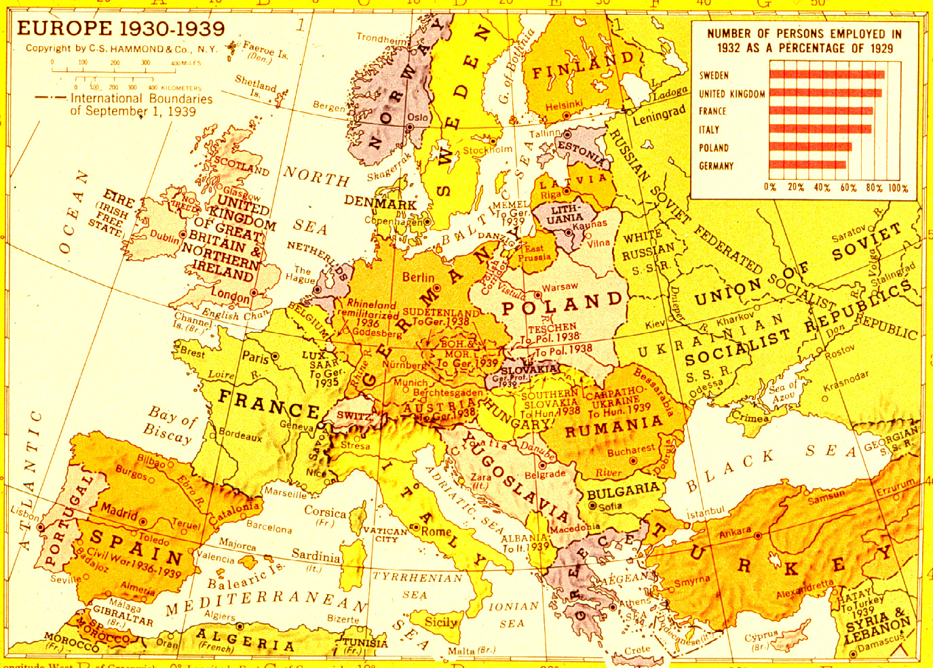
Graph of Europe before World War 2

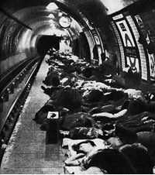
People crowded in the Tube during the Blitz
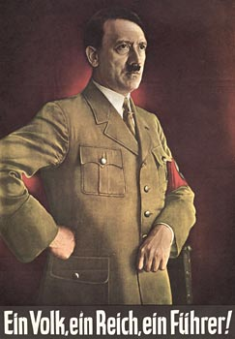
Hitler Propaganda Poster – “One Nation, One People, One Leader”
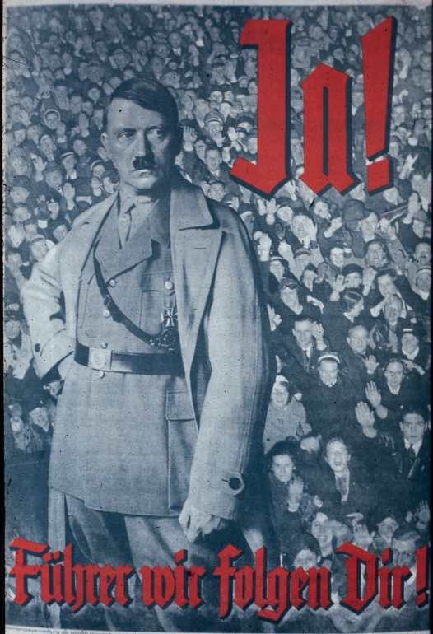
“Fuhrer, we will follow you”
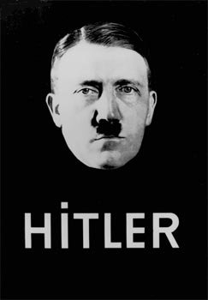
Hitler Propaganda Poster
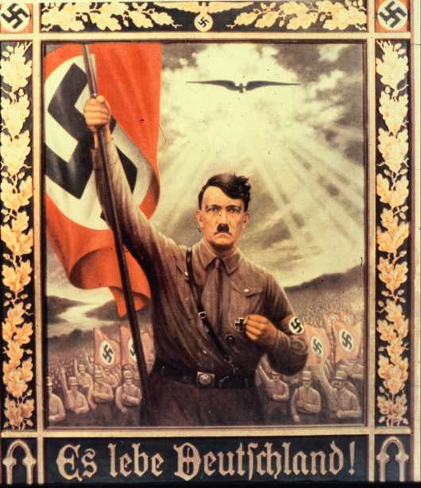
“Long Live Germany”
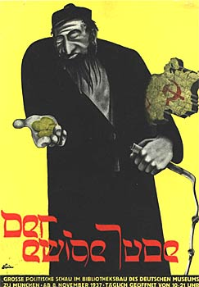
Poster from the “Eternal Jew” exhibit
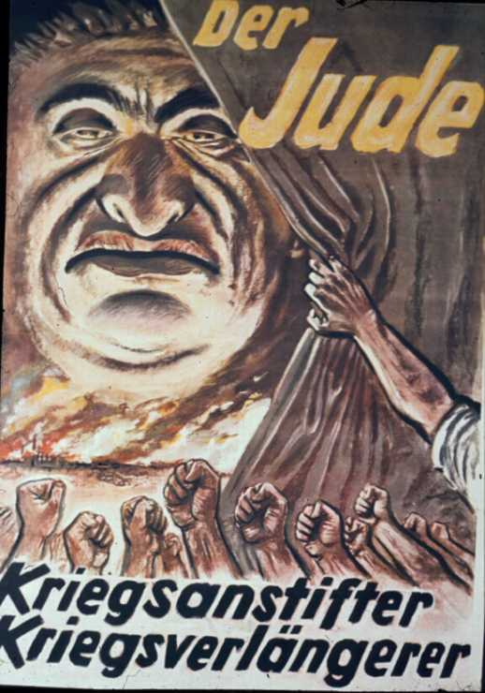
“The Jew – The prolonger of War”

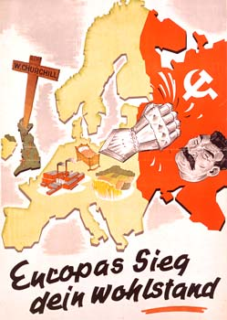
“Europe’s Victory is your prosperity”
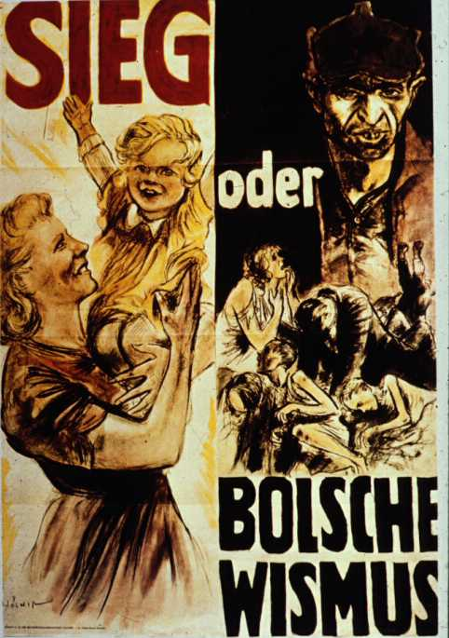
“Victory or Bolshevism”

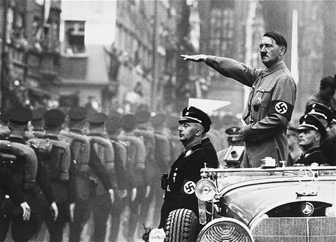
Hitler looking over his troops during the war

Bibliography

Orwell, George. “England, your England.” 1941 Secker and Warburg, London
http://orwell.ru/library/essays/lion/english/e_eye 11/28/04

Baird, Jay “Nazi War Propaganda.” Oxford University Press, London 1974

Balfour, Michael, “Propaganda in War 1939-1945.” Routledge & Kegan Paul, London 1979

Cole, Robert, “Britain and the War of Words in Neutral Europe 1939-45.” MacMillan Press, London 1990.

Winkler, Allan, “The Politics of Propaganda: The Office of War Information 1942-1945.” Yale University Press, London 1978.

Martland, Peter, “Lord Haw Haw: The English Voice of Nazi Germany.” The National Archives Kew 2003.

Chapman, James, “The British at War: Cinema, State and Propaganda." I.B.Tauris & Co, London, 1998.

.
Encyclopedia Online http://en.wikipedia.org/wiki/Battle_of_Britain 11/20/04

Encyclopedia Online http://en.wikipedia.org/wiki/The_Blitz 11/18/04

BBC Website http://www.bbc.co.uk/history/war/wwtwo/blitz_05.shtml 11/18/04

Calvin Online, German Propaganda Archive http://www.calvin.edu/academic/cas/gpa/goebmain.htm 11/2/04

BBC Website 10/25/04
http://www.bbc.co.uk/history/war/wwtwo/nazi_propaganda_gallery_03.shtml
http://www.bbc.co.uk/history/war/wwtwo/nazi_propaganda_gallery_05.shtml
http://www.bbc.co.uk/history/war/wwtwo/nazi_propaganda_gallery_06.shtml

