Sally Leigh Mills
Jonathon David Cochran
Ethics of Development in a Global Environment
June 2, 2004
Bruce Lusingan

Media Biases in Post 9/11 America:
The Effect on Presidential Popularity

Throughout the history of the United States, media has been the source in which the public receives information over all aspects of life, both within the borders of the United States as well as foreign matters deemed important to the American public. The media plays a very significant role in day to day life within this country, but also has a large impact on long term decisions due to certain events that are taking place all over the world. Unfortunately many of the events that have been reported on from overseas are during such instances as wartime that our country has endured. During the wartime events many aspects of the conflict can be reported on, including conflicts and fights that occurred, humanitarian aid acts that the United States Armed Forces contributed to, rebuilding projects, casualties of the day, and many other possible topics, both positive and negative. The media uses propaganda and other techniques to put controversial twists on political issues, in this instance post 9/11 events. This in turn has a direct effect on the popularity of the president, hurting his popularity after a while despite attempts from the government and other entities such as large corporations to control the mass media.
Propaganda and Past Instances of War and Bias in the Media:

The positive and negative aspects of any story can always be covered and whichever is covered will put a certain outlook on a situation that could be looked at from a completely different stance. In these instances the reporter’s judgment makes the decision of how to report on a specific event which leads to a bias forced by the aspects that the reporter thinks are pertinent. Karl Kraus, German playwright and philosopher, whose propaganda helped lead to World War I, viewed journalism in a very interesting manner. “[Kraus] saw the journalist not as a messenger of bad news so much as a producer of it” (Coker 52). With journalists producing the bad news if something should go wrong with a plan put forth by a president, who is constantly under the watchful eye of the media, it will be exploited. Not only the presidents mistakes will be blown out of proportion; therefore, during wartime, when there is bad going on throughout our country, the effect will be amplified by the media. Similarly Kraus stated, “A newspaper was as much a weapon of war as a grenade… Journalism had so impoverished the imagination that humanity was now prepared to fight a war of annihilation against itself” (Coker 52).
Reporters and the media as a whole use very selective word choices when writing and/or covering a story, because as the journalistic society knows simple word manipulation can effect on how a story is perceived by the public. As Christopher Coker argues that the mass media has injected words into wartime events to raise a greater emotion out of the public.
Nuclear missiles soon became ‘weapons of mass destruction’. War became ‘conflict’. Winning was too loaded a term. Nations preferred not to win, but to ‘prevail’. ‘First strikes’ and ‘second strikes’ masked the full impact of a provoked or unprovoked attack. (1994, 51)
In addition to word manipulation the media can also use many words that will associate a person with an organization or political faction to create a familiarity associating a person with a more well known aspect of the coverage. When the coverage of events of is following a presidential decision, such as the declaration of war, the media has a significant impact on presidential popularity due to the journalistic reverberation of events. Word manipulation is distinct part of Propaganda put forth by the media to inspire the public to react a certain way towards our Commander in Chief.
Propaganda put forth by the media during war time has a great influence on the American public. Here we will introduce what the media does in general to talk about terrorism and wartime issues and how they use certain tactics that link propaganda and semantics to get a certain concept across. It is argued today that “what we perceive and how we think are restricted by the language we speak” (Schaffert 67). So by choosing to use specific words, reporters and journalists can twist the facts to make propaganda seem to be all about lies. Inherent to propaganda models are four basic elements: (1) the target of the deception, (2) the medium for delivering the message (the atrocity), (3) the purpose (the influencing of political behavior), and (4) the truth (the facts that are to be distorted). Elizabeth and Alfred Lee of the Institute for Propaganda Analysis developed what they call the “Tricks of the Trade” that are used in propaganda. The first they call “bandwagon” which refers to telling the public that everyone else is accepting the concept and they should join the crowd. The second called “name calling” implies that the media affixes a derogatory label to a concept encouraging rejection. This one seems to be one of the more prominent means to condemn something. The third is the opposite of the latter. The fourth is called “testimonial” where the media connects a popular or disliked personality to a concept encourage its acceptance or rejection. The fifth they call “card stacking” which is a selectively accumulating fact or fiction to support or discredit a concept. Sixth is called “transfer” which relates a concept to an existing generally accepted or rejected program. The final “trick” is called “plain folks” portraying the promoters of a concept as ordinary people, therefore the concept in acceptable (Schaffert 66-67). The combination of these tricks and models, the mass media has no problem controlling the minds of America.
The era leading up to World War II was one filled with propaganda, put forth by the government and the media alike to control reactions of the public surrounding decisions that were made to begin combat. There was a lot of propaganda put forth by our opposition also, Hitler’s Nazi party used propaganda to gain strength within Germany, and eventually the party became so strong that he was able to overthrow the government and take control. The propaganda used by our government and media was largely used to arouse patriotism within the United States. Propaganda was use in many forms to reach the public when trouble started overseas. The signature of this era of propaganda were posters arousing many different ideas, but evoking one response, to work together to beat Hitler.
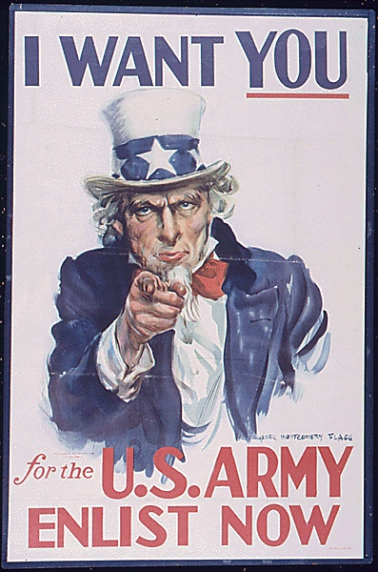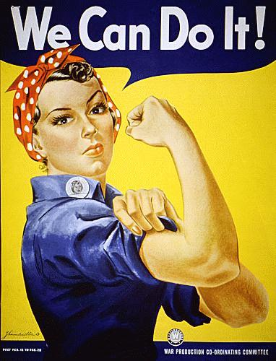

With posters such as these portraying everybody in America being able to help win the war, the United States became a unified nation and popularity for our troops and our President soared to an all time high. Our president at the start of World War II was Franklin D. Roosevelt who had been in office since 1932. When the Japanese attacked Pearl Harbor on December 7, 1941 Roosevelt made a very important decision that would affect his popularity. He immediately started setting up and alliance to fight the Axis powers which is currently known as the United Nations. With this in place Roosevelt’s popularity grew to an all time high and propaganda helped his cause. He would have gone on to win another election; however, during a vacation at Warm Springs, Georgia, on April 12, 1945, he suffered a massive stroke and died at the age of 63. His death came on the eve of complete military victory in Europe and within months of victory over Japan in the Pacific.
Legitimization of political terrorists and terrorism is another way that the media uses their press to influence the thoughts of Americans. The public’s perception of terrorism can be swayed by legitimizing terrorists guilty of heinous crimes, thus sucking the public into the events involved with the terrorist and then makes is easier for the media to attack the concept and make their side the believable one (Schaffert 64). By creating a figure for the public to hate, the media is able to gain support easier for their cause, and thus they are able to have power over Americans.
The mass media has caused drastic popularity shifts within the population of the United States of America surrounding many wartime decisions. These shifts are heavily influenced due to the media’s perception of the president’s decisions. The media’s role has made great influences on many instances especially during the 20th and now 21st centuries. Occurrences of hostility directed towards citizens of the United States seem to have been steadily rising over the last 70 years.
One of the many influential instances of the media contributing to the demise of a president’s popularity was during the Iranian Hostage Crisis of 1979 and 1980. Within the time from then president, Jimmy Carter’s, formal news conference, on November 28, 1979, that informed the nation of the events that had transpired in Iran, 24 days prior, to Carter’s exit from office in 1980 his popularity endured many changes. From November 28 to his State of the Union Address on January 23, 1980, Carter’s popularity was steadily growing with the help of the media. However after this time period Carter’s popularity fell drastically due to a significant shift in the media’s perception and coverage of how the president was handling the hostage crisis. The reason for the initial surge in Carter’s popularity was suspected to be results from the media making the Iranian Hostage Crisis parallel the siege that had taken placed earlier in 1979 in the United States Embassy in Tehran which was very short-lived. However in the period prior to the State of the Union Address the media focused on those members of congress who were very critical of Carter and his progress to remove the hostages from their situation.
Republican Senator Robert Dole was covered very heavily surrounding this issue due his disbelief in President Carter and was quoted as stating, “it becomes increasingly clear that pleading with the Ayatollah is producing no tangible results” (Nacos 107). With opponents of the president so high up in the government being covered and quoted in such a manner there was little hope for Carter to retain his position in the White House. In fact following Senator doles remarks many members of the media began attacking the president for doing nothing in his time in the oval office. David Broder of the Washington Post asked of Carter during a broadcast of Meet the Press,
With all due respect, we still have 5.8 percent unemployment. Inflation has risen from 4.8 percent to 13 percent. We still don’t have a viable energy policy. Russian troops are in Cuba and Afghanistan. The dollar is falling. Gold is rising. And the hostages, after 78 days, are still in Tehran. Just what have you done, sir, to deserve re-nomination? (Nacos 110)

Less than a week following Senator Dole’s remarks and Carter’s lashing on Meet the Press his popularity began to fall dramatically. Within a two month span, February and March of 1980, Carter’s popularity with the American people dropped over 12 percent due to the negative publicity he had received on national television (Nacos 110).
During this entire conflict in Iran, President Carter was very willing to address the media with his thoughts on the activities in Iran. What is now being called the “rose garden” strategy, relied on Carter being very open with the American public surrounding the conditions and terms that were being negotiated in attempts to keep the hostages alive. Many academics believe that this strategy of not downplaying the crisis and making sure the press was writing about it led to the demise of the President. With this approach came a major saturation of the media and as Susan Carruthers comments, “the US networks’ insatiable interest in the Iranian Embassy siege placed undue pressure on Carter to act resolutely, thereby throwing his subsequent impotence into greater relief” (Media 174). Due to the mass media in the United States interest and the rose garden strategy valuable efforts to return the hostages to the United States were disrupted by the many attempts of members of the media’s attempts to contact the perpetrators in hopes of gaining some extra insight into their reasons for the siege. Also as we see today satellite feeds from the locations were used throughout the siege which greatly hindered rescue attempts that the white House attempted. The lights necessary to produce footage for the nightly news often completely illuminated the streets surrounding the Embassy, which made it impossible for a ground based rescue attempt. Consequently President Carter’s actions would have to be carefully thought through to not make a huge scene when trying to rescue the hostages and with limited options, more time is needed. President Carter needed time to perform operations; however, that is the only he didn’t have at his expense once his popularity ratings started to decrease.
What is newsworthy and what isn’t gives the media an edge over what is important and what isn’t in the world. Due to the shear fact that the media can choose what that want to cover and what they want to keep quiet makes them the ultimate power holders of the public. By making concepts “’newsworthy,’ media executives can exercise ultimate authority, with no appeal, on what information will be broadcast or published for public consumption and what information will be ignored” (Schaffert 67). We will see lots of examples of newsworthiness in the timeline of post 9/11 events.
In the end after looking at everything that the mass media can do to get its point across, we find that media is power; if one has control over the media one has a sort of control over all America. Theodore H. White once said that “power, said Karl Marx over a century ago, is control over the means of production; that phrase, said Arthur Schlesinger, Jr., recently, should be changed – power in America today is control of the media of communication” (Nacos 16). Roger Hilsman observed, “No one doubts that whoever controls the press wields power” (Nacos 16). Media gives a sense of legitimacy to stories and people, what is written then becomes the truth. Hilsman again says that if we recognize that “one dimension of power can be construed as the ability to have one’s account become the perceived reality of others” then we can understand the role of media in power. Those who are able to get their stories in the mass media are more likely to have the authority over American people.
During the Vietnam War the mass media was largely integrated with troops for the first time, which presented an interesting situation for the United States military since largely the could no longer control what was written over the days occurrences. With this new obstacle within the war the military and the government as a whole suddenly became more cautious with actions that were being taken because quickly the media began exploiting actions taken by the United States. The country was widely dispersed with anti-war activists and the media was adding fuel to the fire every single day by reporting on the negative aspects of the United States and their actions. Although the reporting was hurting the government and specifically the president’s, who happened to be Lyndon B. Johnson at the time, popularity; the fact is the government and military had no right to censor the media throughout the Vietnam War. This comes from the United States Bill of Rights, which was written in 1791. Amendment 1 states:
Congress shall make no law respecting an establishment of religion, or prohibiting the free exercise thereof; or abridging the freedom of speech, or of the press; or the right of the people peaceably to assemble, and to petition the government for a redress of grievances (U.S. National).
The military and government have used the case of war as a basis for being able to take control of and censor information that normally should be the press’ responsibility to report to the American public. However, due to Amendment One of the Constitution the military and government cannot specifically censor what information and actions are being covered, but have instated a nation wide self-censorship program during the time of war.
The parameters that were set for reporters, especially reporters that are embedded within companies of soldiers, are they have the right to cover whatever they want, but since this is a time of war they should not report on anything that could jeopardize other troops. This program was needed very badly within the era of Vietnam; however, the press was so widely against the war that the government had very little control over what was being covered. Members of the press were including violent and graphic details in their reporting because an arms race of who could get the most in-depth or racy footage of action in Vietnam began. The arms race ultimately led to the demise of not only the Military, but onto President Johnson. There came a point in which words couldn’t get the message across so reporters started using gruesome images left nothing to the imagination. Like this picture depicting a Buddhist monk who has undergone immolation to protest the war. This is one of many typical images that the American family would see throughout the news broadcasts and throughout the newspapers every day during the war.
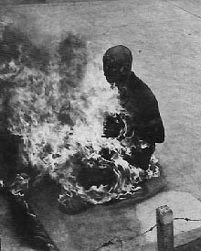
With images such as these, American’s quickly realized the horrors of war; however, without the media’s coverage of humanitarian aid that the troops provided for members of the South Vietnamese public, Americans had only one vantage point and this was very negative.
As Johnson’s popularity shows throughout his tenure during the war, the media coverage led to a drastic decrease in his popularity with the United States public. The decrease was so great that LBJ pulled out of the presidential election in 1968 on March 31, 1968 following is four years in office. Later that year Richard Nixon won the presidential election with 43.4% of the popular vote. At the start of Nixon’s presidency he enter with obvious support of the public and the media so, the media cooled their intensity on Vietnam, because it was expected that Nixon would pull our troops out of Vietnam. However, to keep his popularity at a reasonably high level he somehow kept bombing raids under wraps and withdrew 60,000 troops from Vietnam in September of 1969. Once the bombing raids continued Nixon was largely constrained by the press the way Johnson was throughout his tenure of the war. Both were highly criticized throughout the press in Vietnam as well as the members of the media who remained in the United States for their actions during this war. Following the Tet offensive under Nixon’s administration, beloved anchorman Walter Cronkite commented, “The only rational way out then will be to negotiate, not as victors but as honorable people who lived up to their pledge to defend democracy, and did the best they could” (newseum).

Timeline of Media Coverage of Post 9/11 Events:

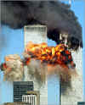
No one will forget where they were when the start of today’s world’s mess began, when the September 11 suicide hijackings began. How did the media cover the atrocity and what effect did that have on the public? In turn what effect did this have on Bush? Obviously there were feelings of fear, pain, sadness, and many other feelings unique to each American. However, it was the way in which the media chose to cover this event that jacked up the hysteria and fear to such great heights. With such titles as “A Day of Terror” and “America under Terrorist Attack” it helped get to a state of fear where all they knew to do was look to the president for help. The photograph of the Twin Towers is an example of the type of pictures being displayed in the media and such, terrible almost surreal images of fire, smoke, and fear. Also, headlines and pictures began to appear commemorating and celebrating those who helped save lives at “ground zero,” like in the picture below for example.

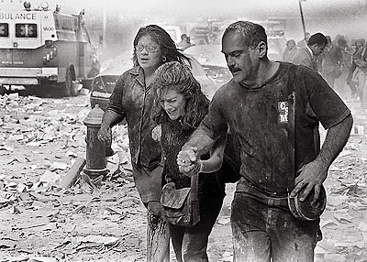
Titles like, “America’s Heroes” and “Home of the Brave” did a great job of rallying support and patriotism for America, and respectively for Bush. Just as suspected, after the 9/11 attacks, Bush’s popularity skyrocketed to a near 90% approval rating (Russell 1). This was most likely directly link to the type of reporting and coverage done for these attacks, instilling fear and patriotism in the public so that they would look to the president for what steps to take next.
Only three days after the Twin Towers incident a threat of infections to the drug anthrax poured over the news. Noting that its effects could be lethal to those exposed to it, the anthrax scare created a sort of mass hysteria among the American public, while at the same time rallying up support for Bush and war against terrorism, mostly because the anthrax threat was immediately assumed to be from the same terrorists as befell on the country just three days prior. “The media, with the tacit encouragement of the Bush administration and congressional leader, encourages the notion that the anthrax attacks represent a second wave of Middle East-based terrorism, following the September 11 suicide hijackings” (“US Anthrax Scare” 1-2). Basically as long as it seemed possible to attribute the anthrax scare to Osama bin Laden or some other foreign terrorist, shrieking headlines and such from government official were okay (“Once again” 1). For one it seemed as though the anthrax scare was somehow a justification of the Bush Administration’s intervention in Central Asia, but that notion at that time was kept out of the media (“Once again” 3). It is interesting to point out however that after investigations were done it appeared that the anthrax came from domestic sources. Thus the threats become largely unreported in the media (“US anthrax scare” 2). “The staggering fact, however, has been met with a strange silence by the media, government officials and the Democrats themselves, including the two senators who were targeted. As the military link to the attacks came to light, the media sought to blunt the significance of the exposure (White 1). The government justifies the cover-up and anti-democratic actions of the government as necessary steps in the “war on terrorism” (“US Media Silent” 1). Thus the media was still able to keep up a positive image on Bush and keep the level of patriotism up at this point in the post September 11 drama. Sure enough, according to the polls, Bush’s popularity remained fairly high (Russell 1).
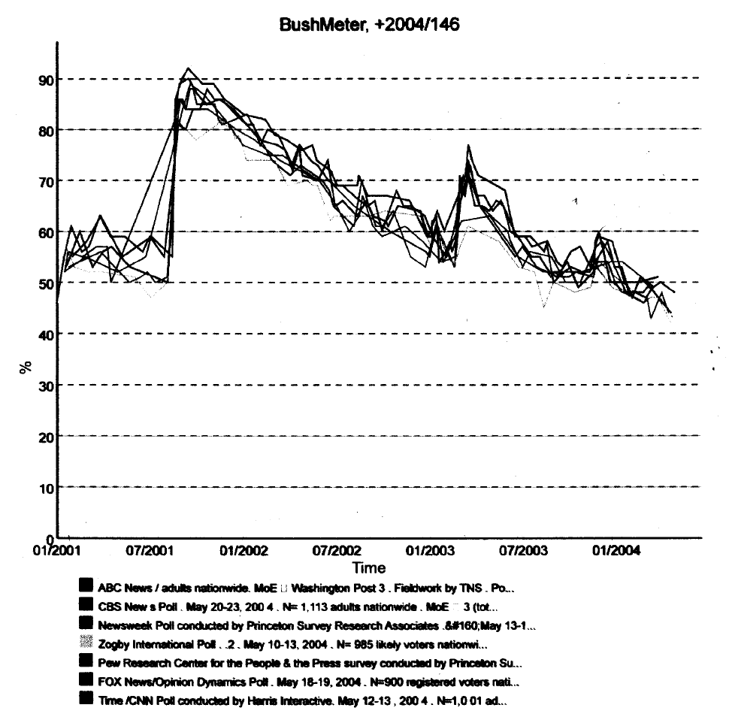
With the passing of the anthrax attacks, the issues with finding Osama bin Laden and capturing and prosecuting others linked to the 9/11 suicide hijackings came into focus in the mass media. First the media uses labeling and specific terminology to enhance the idea that bin Laden is the ultimate bad guy of the century. For example he is known by the FBI and an “international terrorist and he has been called a terrorist mastermind as well by other media organizations. He is also on the FBI’s most wanted list and is know as one of the most dangerous men in the world today, and the media tends to use the same headshot that the FBI uses deeming him a terrible criminal even more, as in this image of bin Laden
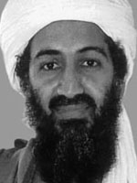
The media also has used the tactic of legitimizing the enemy. By doing so and making the terrorists political figures, when they are labeled as terrorists that labeling has more authenticity to the public. So the media demonized bin Laden for quite a while until that was drown out by the fact that he wasn’t found. The media really had an effect on the bin Laden and Afghanistan issues when major networks did not cover the innocent civilian casualties that were being suffered in Afghanistan for the sake of Bush’s popularity with the American public. “Doctors Without Borders has stated that civilian casualties are already in the hundreds and rising (NPR, 12/6/01). However, “on the high end, a compilation of international press reports by a University of New Hampshire professor suggests there might be over 3.500 civilian deaths” (Action Alert 1). As said before “none of the three major networks’ nightly newscasts are offering even rough tallies of the mounting civilian casualties in Afghanistan” (Action Alert 1). The media has even gone to lengths to suggest that “Afghans don’t mind being killed by US bombs” (Action Alert 1). I am sure any person minds being killed at least a little in war; this was just one of the media’s ways to get their beliefs into the public’s minds. NBC correspondent Dan Lothian gave a report about America’s battle “’to protect its image as a compassionate nation”’ basically trying to portray reports of civilian casualties as an attack on America (“Action Alert” 2). As time went on Bush’s popularity was slowly decreasing but the media was able to keep it at a low rate (Russell 1).
The Iraqi Regime under Saddam Hussein has been widely thought of as a cruel dictatorship. Saddam Hussein started his political career in 1958 when he successfully assassinated then military leader Abdul-Karim Qassim in a coup known as the Baath Coup. Hussein was involved with a decade long war that was fought between Iraq and Iran. During this time Hussein started secretly creating warfare that consisted of nerve agents and other forms of chemical agents. Hussein made a name for himself in the United States and the United Kingdom public when he invaded Kuwait which led to Desert Storm in 1990. Hussein has been working very diligently since the conflict to produce warheads again. Recently the United Nations have found some warheads that had been hidden for quite some time. When discovered the media in the United States brushed off the news and didn’t pay much attention to the findings. Therefore in a complete reversal from World War II, there was very little propaganda supporting a conflict with Iraq and subsequently the public of the United State had very little knowledge of what was taking place in Iraq.
Members of the media that received notice that warheads had been discovered began questioning President Bush’s intent for the eventual actions that the United States was going to take in Iraq for a second time within a decade and a half. These questions were finally answered on December 12, 2002 when President Bush gave a speech to the United Nations about the intent of the United States. Within the speech President Bush told of immediate and harsh actions that were going to be taken if Saddam Hussein did not comply with the United States’ demands. The statement that took the world by surprise and started this media frenzy was, “The Security Council resolutions will be enforced, the just demands of peace and security will be met or action will be unavoidable and a regime that has lost its legitimacy will also lose its power” (Bush). Along with this threat President Bush presented many reasons in why the UN should act against the Iraqi Regime. He included such facts as Saddam Hussein’s blatant disregard for UN resolutions in “over a decade of defiance” and Iraq’s capabilities of producing and firing nuclear warheads (Bush). As the United Nations knew, no new evidence was presented in Mr. Bush’s speech, but it was obvious to them that Iraq had to do something or action would in fact be taken soon. Iraq was presented with this threat while four representatives from Iraq were in the audience for President Bush’s speech; the interesting part was the four representatives remain emotionless throughout the President’s address.
Following this speech the president had a severe decline in his popularity ratings. Members of the media were referring to Bush’s address of the United Nations as a smoke screen of sorts to enter Iraq for reasons either than what was stated during the speech. As seen throughout the coverage of the first days of conflict many news broadcasts were keeping a close eye on one of the many oil fields in Iraq. The media started a by pointing that the president wanted to go to war with Hussein simply to gain control over his massive amounts of oil.
After the explosion of bombs and war in Iraq settled a bit the media began rallying for support to rebuild Iraq and help them get out of the state they were in. On March 20, 2003 the US launched the first air strikes against Iraq after Bush’s ultimatum expired (“Iraq Timeline” 5). On May 1, 2003 President Bush declares the end of major combat fighting in Iraq and even before that, the US Commander started sending air and naval forces home (“Iraq Timeline” 5). However, despite Bush’s requests, there was and is still continued fighting in Iraq. From May 1, 2003 to July 20, 2003 many US troops were killed because of escalating unrest in Iraq (“Iraq Timeline” 5). As everyone can remember, despite the happiness that many felt that the US was taking strides to help rebuild Iraq, there was more unrest over America’s troops still being in Iraq. People saw signs and bold headlines screaming to bring our troops home. There were sob stories on main media channels such as CNN and PBS, and even NBC talking of sons and husbands lost to this fighting. The media was able to project these feelings and concepts well, thus America too followed along. Since May, President Bush has suffered severe decreases in popularity because this time the media decided to report everything instead of hiding certain facts, or at least twisting the facts (Russell 1). Recently, Bush’s popularity has been reported to have reached a record low most likely because of an accumulation of things reported and the atrocities covered involving the tortured Iraqi prisoners. The media did the job of making American soldiers and the war in Iraq in general to be something appalling and inhumane well.
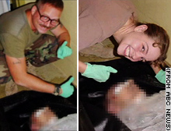
Pictures such as those in these photographs are good examples of the way prisoners were being treated, although these are deceased, and how it is highly understandable why people are so against the war and thus Bush’s population is declining.
Manipulating the Media:

Up until a point the government seemed to have a strong hold on the media, the government had control of the media thus is had control of the people and total power. It is evident though that Bush’s popularity went from fairly high, and is now at its record low. Knowing that the government has this reasonable level of control over mainstream media, why then did the popularity of Bush go down so low if he is the head honcho of the government? How then also was he able to manipulate the media to gain support in the first place? Overall throughout the entire timeline of post 9/11 events it is evident that what the media chooses to report and how they report it has a direct effect on how the public feels about how the president is doing his job.
Many magazines and sites on the internet warn of government control of the media, especially involving US government and America concealing information from the public. First off, the Federal Communications Commission (FCC) is moving towards the elimination of rules “that prohibit the same company from owning daily newspapers and TV stations in the same market” (Bennett 1). Kevin Ramirez of AWOL magazine spoke out against this idea saying that
“the media by and large has become a funnel for information for the Pentagon and Department of Defense to manufacture consent and create the atmosphere of mainstream approval for the way Bush is executing the war on terrorism and the imperial aggression in Iraq. It is clear that the media is being held accountable to the corporations that own it, that are also involved in the industries of arms manufacturing. I oppose the possible FCC decision because further media consolidation will only make this worse” (Bennett 3).
Kevin Ramirez thoughts on government may not be far from the truth as evident in the testimonies of many famous and popular journalists where they were prevented from reporting scandalous news. For example, Jane Akre of Fox News said that she attempted to report an honest story but was not allowed by the Fox manager, he said, “we paid 3 billion dollars for these TV stations…we’ll tell you what the news it…the news in what we say it is” (“Media Cover-up” 1). Similarly, Kristina Borjesson of CBS observed a man swiftly removed from a press conference for asking a controversial question (“Media Cover-up” 1).
Since the incident of 9/11, guided by top strategist Karl Roves, the Bush administration has strived to exploit this tragedy at every turn. Then after the Iraq invasion when Bush’s popularity was decreasing dramatically, they had to rely heavily on images and rhetoric about September 11, frequent invocation of 9/11 events were a form of patriotism for America. However, it is evident the Bush and Roves have run out of tricks to control the media and thus Bush’s popularity is at its lowest point (Solomon 1-2). Today it is really the military that is pursuing a policy of “embedding” journalists with US units, and the Bush administration did well for a while, but they can only do so much until the all powerful media completely takes over again.

Conclusion:

As we have shown the media uses many tools to its advantage to control many different aspects of life in the United States. Through such outlets as propaganda they can sway support for the country and the President exponentially. The media has a lot of power to direct focus of the nation where they want and due to many factors that control media sectors biases toward the president are seen through the types of stories and stance seen throughout the media. There are perpetual changes seen in the media when different president decisions affect large corporations and other outlets. Since 9/11 the media has changed its stance on United States actions many times and with each of these shifts in stance major movement is seen within the public’s opinion of actions being taken. With their power, the media effects how the American public responds to the president and his decisions.
Works Cited

“Action Alert: How Many Dead? Major networks aren’t counting”.
December 12, 2001. FAIR: Fairness & Accuracy In Reporting.
May 23, 2004.
<http://www.fair.org/activism/afghanistan-casualties.html >.

American Propaganda. <http://propaganda.vygo.net/am_wwii.html>.

Bennett, Hans. “Media Activists Challenge FCC”. May 2003. Z
Magazine Online. May 12, 2004.
<http://www.zmag.org/ZMagSite/May2003/bennett0503.html >.

Bush, George W. United Nations Conference. 9 Dec. 2002

Carruthers, Susan L. The Media at War. New York City: St. Martin's
Press Inc., 2000. 174-179.

“Iraq Timeline”. March 8, 2004. ABCNEWS.com: Special Report. May
26, 2004.
<http://abcnews.go.com/sections/world/Iraq_special_report/Iraq_special_030115_timeline.fbk.html>.

Martin, Patrick. “US anthrax scare: Why the silence on the right-wing
terrorism?”. October 27, 2001. World Socialist Web Site. May 19, 2004. <http://www.wsws.org/articles/2001/oct2001/anth-o27.shtml>.

“Media Cover-up : Leading Journalists Expose the Myth of a Free Press”.
Want to Know. May 26, 2004.
<http://www.wanttoknow.info/mediacover-up>.

Nacos, Brigette L. New York City: Columbia UP, 1994. 19-109.

War Stories. <http://www.newseum.org/warstories/index.htm>.

“Once again: government, media silent on right-wing role in US anthrax
attacks”. November 28, 2001. World Socialist Web Site. May 19, 2004. <http://www.wsws.org/articles/2001/nov2001/anth-n28.shtml >.

Russell, Sean. “BushMeter”. 2004. May 25, 2004.
<http://www.germane-software.com/~ser/BushMeter/ >.

Solomon, Norman. “The Media Politics of 9/11”. March 25, 2004.
Common Dreams News Center. May 26, 2004.
<http://www.commondreams.org/views04/0325-18.htm >.

Schechter, Danny. “US media in bed with military”. January 20, 2003.
Japan Today. May 20, 2004.
<http://www.japantoday.com/e/?content=comment&id=326 >.

“US media silent on anthrax cover-up charge”. July 5, 2002. World
Socialist Web Site. May 19, 2004.
<http://www.wsws.org/articles/2002/jul2002/anth-j05.shtml>.

Vietnam War and The Aftermath.
<http://www.beyondmedia.org/tech37/tosin/gallery/gallery.html>.
White, Jerry. “US anthrax attackers aimed to assassinate Democratic
leaders”. January 23, 2002. World Socialist Web Site. May 19,
2004.
<http://www.wsws.org/articles/2002/jan2002/anth-j23.shtml >.

